**The Strangemen IV Investment Club (HBHXX74T) - may have changed TBC**

Minutes of the twenty third meeting - Held Wednesday 26th June, 2019 at The Mill Street Club, Mill Street, Leek.

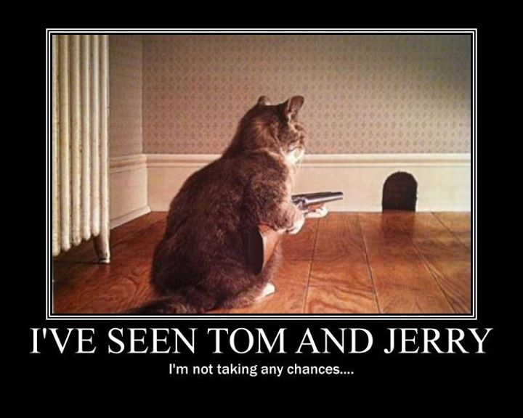

|  |  |
| --- | --- |
| Attendees:   * James Taylor (JT) ,Alan Whitmore (AJW), Neil C Pickford (NCP), David McNeaney (DMcN), Dean Goodwin (DG), Dave Swarbrook (DS),   Apologies:   * Mike Helm (MH) - Bro's birthday - crept up out of nowhere again, like every year ;-) * Gareth Ekin (GE) - all for the sell * Sri Madadi (SM) - last minute apols * Andy Bradley (AMB) – pimping the cobbler * Matt Culverwell (MC) - otherwise engaged * Emma Chadwick (EC) - otherwise engaged * Newton (the guffin's dog) - otherwise engaged * Jes Challand (JC) - "C*outer la peau des fesses.*" This month, Jes shares his initials with John Courage, founder of the Courage Brewery in 1787. http://takecourage.info/sitebuilder/images/JohnCouragepic_edited_2_2-140x233.jpg | |
| **Agenda:**   * 1. Okay Previous Minutes   2. Previous Actions   3. Treasurers Report  1. Current Share Update 2. Current Digital Update 3. Financial Statement 4. Dividends    1. Homework (Current Portfolio)    2. Strategy for New Investment 5. New Companies 6. Re-investment in Existing Portfolio    1. Fantasy Shares    2. Peston    3. AOB    4. Next Meeting | |
| 1. Okay Previous Minutes What, there were minutes - no way - seriously, does anyone read this ?  In Switzerland, it’s illegal to own only one guinea pig. Switzerland has quite a few pet-related laws in place, but one of the weirdest is that [you cannot own only one guinea pig.](https://www.zmescience.com/other/feature-post/guinea-pig-switzerland/)These cute little creatures need social interaction to be happy, so owning a single guinea pig is considered abuse and is forbidden by Swiss law. Guinea pigs grow very attached to their guinea pig partners, and if one dies, its owner needs to get a new one quickly. In fact, there are [guinea pig matchmaking agencies](https://abcnews.go.com/International/rent-guinea-pig-service-takes-off-switzerland/story?id=14573692) in Switzerland for this very reason. |  |
| **2. Previous Actions**  **2.3.1** - NCP to email TDW re: currency error on account and what is needed to trade in US - Info received but memberships require sorting with TDW - back to NCP - NCP to grab papers. **NCP asking again for assistance, in a GDPR style spat.**  **22.4.3.2** - JT to chase House Crowd for profit details - awaiting 3 properties to be sold.  **23.6.1 -** Agreed to revert to old style - just need a date agreeing. Probably September 2019 meeting.  **23.8.1 -** AGM next meeting - vote everyone off and in again if happy. | **NCP**  **JT**  **All**  **All** |
| **3. Treasurers Report**   1. **Current Share Update**  |  |  |  |  |  |  |  |  |  |  |  | | --- | --- | --- | --- | --- | --- | --- | --- | --- | --- | --- | | **Symbol** | **Qty.** | **Description** | **Champion** | **Mid Price** | **Price Change** | **Market Value** | **Book Cost** | **Gain/Loss** | **Prev Month** | **Variance** | | BOO | 414 | BOOHOO GROUP | DMcN | 207.90p | -2.10p | 860.71 | 998.09 | -137.38 | 992.36 | -131.65 | | CDM | 438 | CODEMASTERS GROUP | DS | 224.00p | -1.00p | 981.12 | 999.95 | -18.83 | 974.55 | 6.57 | | HAYD | 3312 | HAYDALE GRAPHENE INDUSTRIES PLC | JT | 1.90p | 0.00p | 62.93 | 557.52 | -494.59 | 67.07 | -4.14 | | IMMO | 3935 | IMMOTION GROUP | DG | 8.85p | -0.30p | 348.25 | 499.91 | -151.66 | 314.8 | 33.45 | | JE. | 193 | JUST EAT | DS | 624.80p | 0.00p | 1205.86 | 1493.07 | -287.21 | 1208.95 | -3.09 | | MERL | 262 | MERLIN | DMcN | 393.10p | -1.90p | 1029.92 | 997.71 | 32.21 | 871.15 | 158.77 | | PRU | 48 | PRUDENTIAL | DG | 1679.00p | -3.00p | 805.92 | 749.34 | 56.58 | 788.16 | 17.76 | | PURP | 148 | PURPLE BRICKS | AJW | 97.80p | -2.00p | 144.74 | 747.41 | -602.67 | 140.16 | 4.58 | | KETL | 516 | STRIX GROUP PLC | NCP | 154.60p | 1.60p | 797.74 | 748.91 | 48.83 | 828.7 | -30.96 | | SUMO | 432 | SUMO GROUP | AJW | 149.50p | 1.75p | 645.84 | 748.72 | -102.88 | 583.2 | 62.64 | | TSTR | 1156 | TRI-STAR RESOURCES | SM | 39.50p | 0.50p | 456.62 | 750 | -293.38 | 508.64 | -52.02 | | VRS | 547 | VERSARIEN | JT | 93.00p | 3.00p | 508.71 | 999.74 | -491.03 | 541.53 | -32.82 | | VOD | 372 | VODAFONE | SM | 125.76p | 1.52p | 467.83 | 749.37 | -281.54 | 467.46 | 0.37 | | FAN | 410 | VOLUTION | NCP | 171.50p | -2.50p | 703.15 | 748.31 | -45.16 | 709.3 | -6.15 |  1. **Current Digital Update**   **23.3.2.1** £827.99 in Crypto currencies. It was agreed to take £500 profit - MC to be asked to facilitate   1. **Financial Statement**   **23.3.3.1** - The club has cash of £7,279.20. Cash at Barclays is approx £237.32**.** £990 each in 33 units, now worth £1070.41.     1. **Dividends**   **23.3.4.1** 3/6, £24.25 Strix.    **4. Homework (Current Portfolio)**  Areas of focus - owners - Aerospace & Defense – AJW, Automobiles & Parts – EC, Electronic & Electrical Equipment – DMcN, Gas, Water & Multi Utilities – DSW & AJW, Health Care Equipment & Services – EC & NCP, Mining – JT, Mobile Telecommunications – MC, Pharmaceuticals & Biotechnology – DSW & JT & NCP, Software & Computer Services – MC, Travel & Leisure – DMcN  Bohoo - getting flack as is the rest of the fast fashion industry. Codemasters - Partnering in China - revenues up 12%. Haydale - Volatlie analyst opinion (long term bet). Immotion - new 3yr deal with Chicago aquariums. Just Eat - signed Uber Eats director, being squeezed by other larger players. Merlin - 19% down over 12 months, but analysts remain upbeat for a 3 year turnaround. Prudential - 3 Directors reinvesting - good sign. PurpleBricks - now being criticised for poor MI. Strix - introducing new recycling initiatives. Sumo - well positioned to take advantage in the sector, which will be worth $192 bn by 2022. Tri-star - no new is news for us. Versarien - criminal proceedings being taken against the US boss. Vodafone - Dutch bank UBS recommends strong buy. Volution - several healthy buy ratings.  **5. Strategy for New Investment**   1. **New Companies**   **23.5.1.1 -** Discussions took place around DS Smith (packaging) and Future Publishing (thanks Dean and Slater). £750 each of both to be purchased.  **2. Re-investment in Existing Portfolio**  **23.5.2.1 -** No additional re-investment purchases  **6. Fantasy Shares**  **23.6.1 -** Agreed to revert to old style - just need a date agreeing. Probably September 2019 meeting.  **7. Peston**  Seals trained to sing Star Wars theme and Twinkle Twinkle. Man in US arrested at airport, had 24 birds hidden in hair curlers. You-tuber buys small US town in Michigan and names it "Gay Hell" as Trump bait. Boy aged 4 drove Great Grandad's car a mile to buy sweets. Spurious image on Mars satellite feed, looks like Star Trek Federation logo. Boy aged 11 eating 5 meals a day to bulk up for bone marrow op to save dad. The friendship tree planted at the Whitehouse by Trump / Macron, has died. A Canadian man opened an antique safe on the first attempt at Alberta's Vermillion Museum. It has been unopened for decades and punters try every day. He tried 20-4-60. Pensioner gets rabies from bat bite, bat was hiding in iPAD case. A driver missed a speeding fine by divine intervention, when a passing dove appeared over his face on the photo, so he could not be charged. Satnav error sends Newcastle man to Rom in Germany and not Rome. A man stabbed to death on London tube, in front of 14yr old son, after an argument about blocking the isle. Scented flatulence pills makes farts smell like chocolate or roses. Man spends £3K getting the cast of "Only Fools and Horses" on his back. Man breaks record (oop north), eating a 65 item big breakfast in 12 mins - massive full English. A woman ordered a Mariah Carey cake for a friend's birthday and was presented with a Marie Curie cake instead. A brazen Monkey gate crashes family pic and appears to give them the finger! Trans lady gets £13K inflatable boobs - they go and down.  **8. AOB**  **22.8.1 -** Xmas do at some point still to be organised. Early summer seems a goer. Dates potentially are 15/6, 22/6 or 6/7.  **23.8.1 -** AGM next meeting - vote everyone off and in again if happy.  **9. Next Meeting**  Wednesday xx July or August, 2019. Usual Venue at 8.15. It was decided to just muck in on pizza payment - it is soooo much easier that way!  **Side Note - Pizza area for future reference - 18" (254.24") - 14" (153.93") - 12" (113.09") - 9" (63.61")**  To cost the skin off one’s arse - Meaning: "To cost a fortune." | **NCP**  **NCP**  **All** |