**The Strangemen IV Investment Club (HBHXX74T)**

Minutes of the eighteenth meeting - Held Wednesday 28th November, 2018 at The Mill Street Club, Mill Street, Leek.

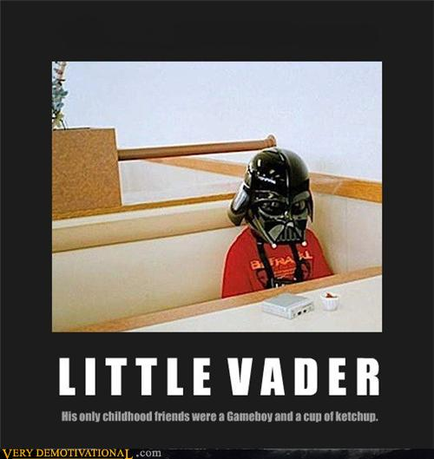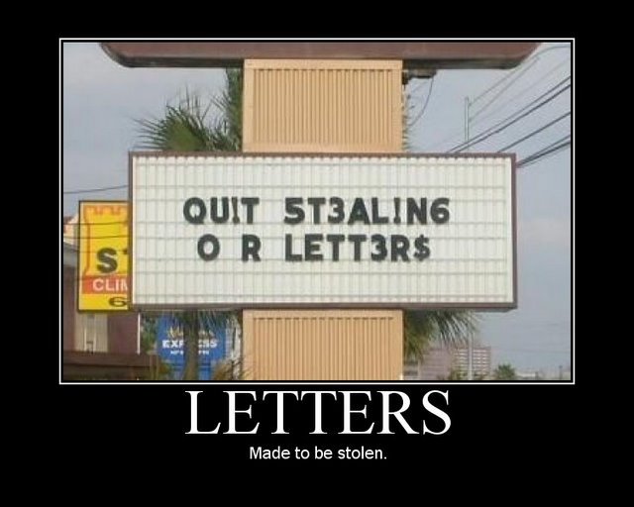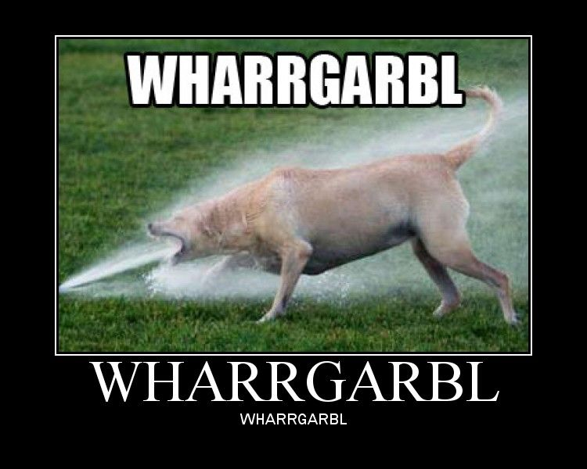

|  |  |
| --- | --- |
| Attendees:   * James Taylor (JT) ,Alan Whitmore (AJW), Neil C Pickford (NCP), Dave Swarbrook (DS), David McNeaney (DMcN), Sridar Madadi (SM), Dean Goodwin (DG) and tonight's "Guest Star" - Steve Smudger Smith!   Apologies:   * Mike Helm (MH) - he will bloom again * Gareth Ekin (GE) - Treading the boards with the middle class hordes. * Andy Bradley (AMB) – yes yes yes yes, no - Vicar of Dibley bloke! * Matt Culverwell (MC) - better offer. * Emma Chadwick (EC) - influencing! * Newton (the guffin' dog) (NTD) - parping on greens. * Jes Challand (JC) - “ Il vaut mieux faire que dire” - This month, Jes shares his initials with "Jason Collet" - guitarist with brilliant Canadian indie rock band - Broken Social Scene! Image result for jason collett | |
| **Agenda:**   * 1. Okay previous minutes   2. Previous Actions   3. Treasurers Report & current portfolio update   4. Investment strategy & Homework (share updates)   5. Fantasy Shares   6. Peston   7. AOB   8. Next Meeting | |
| 1. Okay Previous Minutes What, there were minutes - no way - seriously, does anyone read this ? To produce a single pound of honey, a single bee would have to visit 2 million flowers. |  |
| **2. Previous Actions**  **2.3.1 - NCP to email TDW re: currency error on account and what is needed to trade in US - Info received but memberships require sorting with TDW - back to NCP - NCP to grab papers. ongoing**  **5.11.1 - Sri to investigate YU Group - nuclear rod reuse? Still to do – No news**  7.16.1 - DMcN advised he would come up with some tweaks to the agenda that he has been mulling. -to be passed to NCP - still waiting!  7.16.2 - Steve Smith (Cheadle ex BBS) is apparently interested in joining - to be invited to attend. - Sri to do, as Steve double booked this month. Steve attended.  4.18.1 - Tabled shares and info – dotdigital, alliance pharma, nextis communications, restore plc, Farn (pharma), N4P (Pharma), GGP - Gold. NCP to buy £750 of GGP  4.18.2 - JT to increase xfer to £480 from £450  7.18.1 - Steve to be given details re: joining. NCP/ JT to sort | **NCP**  **SM**  **DMcN**  **SM**  **NCP**  **JT**  **NCP/JT** |
| **3. Treasurers Report & current portfolio update**  The club has cash of £4148.21. Cash at Barclays is £1468.56 - Dean's £782.24. £1,000 in House Crowd (JT chasing), £270.49 in Crypto. Divi - £11.86 (26/10) from Strix. Each member has 26 units purchased at £30 each. Each unit now worth £30.45, an increase of 1.47%. £780 now worth £791.57.  **Portfolio**   |  |  |  |  |  |  |  |  |  | | --- | --- | --- | --- | --- | --- | --- | --- | --- | | **Symbol** | **Qty.** | **Description** | **Champion** | **Market Value** | **Book Cost** | **Gain/Loss** | **Prev Month** | **Variance** | | HLMA | 70 | HALMA | JT | 947.10 | 990.12 | -43.02 | 875.00 | 72.10 | | HAYD | 414 | HAYDALE GRAPHENE INDUSTRIES PLC | DMcN | 146.97 | 499.56 | -352.59 | 120.06 | 26.91 | | IMMO | 3935 | IMMOTION GROUP | DG | 383.66 | 499.91 | -116.25 | 393.50 | -9.84 | | JE. | 129 | JUST EAT | DS | 759.81 | 996.07 | -236.26 | 761.36 | -1.55 | | MERL | 262 | MERLIN | DMcN | 915.95 | 997.71 | -81.76 | 815.87 | 100.08 | | PURP | 148 | PURPLE BRICKS | AJW | 266.84 | 747.41 | -480.57 | 305.77 | -38.93 | | KETL | 516 | STRIX GROUP PLC | NCP | 720.34 | 748.91 | -28.57 | 748.20 | -27.86 | | SUMO | 432 | SUMO GROUP | AJW | 591.84 | 748.72 | -156.88 | 686.88 | -95.04 | | TSTR | 1156 | TRI-STAR RESOURCES | SM | 445.06 | 750.00 | -304.94 | 520.20 | -75.14 | | VRS | 547 | VERSARIEN | JT | 659.14 | 999.74 | -340.60 | 618.11 | 41.03 | | VOD | 372 | VODAFONE | SM | 627.49 | 749.37 | -121.88 | 544.68 | 82.81 |   **4. Investment Strategy and Homework (Share updates)**  Areas of focus - owners - Aerospace & Defense – AJW, Automobiles & Parts – EC, Electronic & Electrical Equipment – DMcN, Gas, Water & Multi Utilities – DSW & AJW, Health Care Equipment & Services – EC & NCP, Mining – JT, Mobile Telecommunications – MC, Pharmaceuticals & Biotechnology – DSW & JT & NCP, Software & Computer Services – MC, Travel & Leisure – DMcN  Homework – Halma - 84% trade outside of UK. Haydale, making smartlocking car nits, Just Eat - challenge from deliveroo - 50,000 drivers and restaraunts. Merlin - Single line queuing initiative. Purple Bricks - 2% rise in revenue. Strix - some discussion of accounting irregularities. Sumo - internal purchases - buy rating. Tri-Star - testing underway - Q1/Q2 plant activation. Versarien - chinese setup in Jinan. Vodafone - new net, TV and phone package deals.  4.18.1 - Tabled shares and info – dotdigital, alliance pharma, nextis communications, restore plc, Farn (pharma), N4P (Pharma), GGP - Gold. NCP to buy £750 of GGP  4.18.2 - JT to increase xfer to £480 from £450  **5. Fantasy Shares**  5.14.1 - New competition up and running - not everyone taking part it appears. Position at Sunday 27.01.2019  .  Discussion took place about reverting back to the previous competition next year, as this iteration doesn't seem to be as good as anticipated.  **6. Peston**  Woman in US spent time in prison as cops mistook blue candy floss for meth. pilot over shot Tunisia by 29 miles as asleep. brits spend 8 months of adult life on the loo. rogue ATM in USA got large crowds as $100 bills given instead of $20 bills. Leon Sterber banned from opticians as found glasses wearing women attractive and helped woman try on sunglasses whilst masturbating in shop. porn vids offered under grilling items on Amazon. Orang Utan trained to work in brothel in Indonesia. Mel B keeps a surgically removed tattoo in a jar of her ex hubbies initials. brazillian restaraunt in london had cattle being slaughtered soundtrack piped in by Vegan activists. labelling error in US hospital meant man died having lungs cleaned with cleaning fluid. Maggie Thatcher touted as scientist for £50 note for her work of soft scoop icecream at Lyons prior to politics. a research team swallowed lego 4x4 brick to see how long it takes to pass. average 1.7 days. first time handglider not strapped in and had to hang on for over a minute when slipped off until descended.  **7. AOB**  7.18.1 - Steve to be given details re: joining. NCP/ JT to sort  **8. Next Meeting**  Wednesday 30th January, 2019 - agreed post email vote . Usual Venue at 8.15. It was decided to just muck in on pizza payment - it is soooo much easier that way!  **Side Note - Pizza area for future reference - 18" (254.24") - 14" (153.93") - 12" (113.09") - 9" (63.61")**  “Doing is better than saying.” | **NCP**  **JT**  **JT/ NCP** |