The Strangemen IV Investment Club (HBHXX74T)
Minutes of the fifteenth meeting - Held Wednesday 1st August, 2018 at The Mill Street Club, Mill Street, Leek.


Attendees:
- James Taylor (JT) ,Alan Whitmore (AJW), Dave Swarbrook (DS), David McNeaney (DMcN), Matt Culverwell (MC), Emma Chadwick (EC), Newton (the guffin' dog) (NTD)
Apologies:
- Mike Helm (MH) - seems to have moved to Abersoch!
- Neil Pickford (NCP) – Talking to the great white telephone
- Sridar Madadi (SM) – Not sure
- Gareth Ekin (GE) - Script doctoring - adding in more casual racism.
- Andy Bradley (AMB) – Karen’s birthday!!!
- Jes Challand (JC) - "Il n’y a que les imbéciles qui ne changent pas d’avis." - This month, Jes shares his initials with "Justin Cartwright" - S African born, London based author and filmmaker. 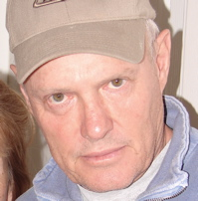

Agenda:
  - Okay previous minutes
  - Previous Actions
  - Treasurers Report & current portfolio update
  - Investment strategy & Homework (share updates)
  - Fantasy Shares
  - Peston
  - AOB
8. Next Meeting
1. Okay Previous Minutes What, there were minutes - no way - seriously, does anyone read this ? Until 1994, world maps and globes sold in Albania only had Albania on them.
2. Previous Actions  2.3.1 - NCP to email TDW re: currency error on account and what is needed to trade in US - Info received but memberships require sorting with TDW - back to NCP - NCP to grab papers. back with iii  5.11.1 - Sri to investigate YU Group - nuclear rod reuse? Still to do – No news  7.12.1 - can we see a breakdown of holdings asked Matt C - JT and NCP to rustle something up for dropping into the minutes - working on it! - in progress. – Looked OK to me! | NCP  SM
3. Treasurers Report & current portfolio update
The club has cash of £6642.06 with £450 on its way between Barclays and TDW. Cash at Barclays is £176.32. £1,000 in House Crowd, £480.03 in Crypto. Each member has 22 units purchased at £30 each. Each unit now worth £34.87, an increase of 16.23%.. £660 now worth £767.11.
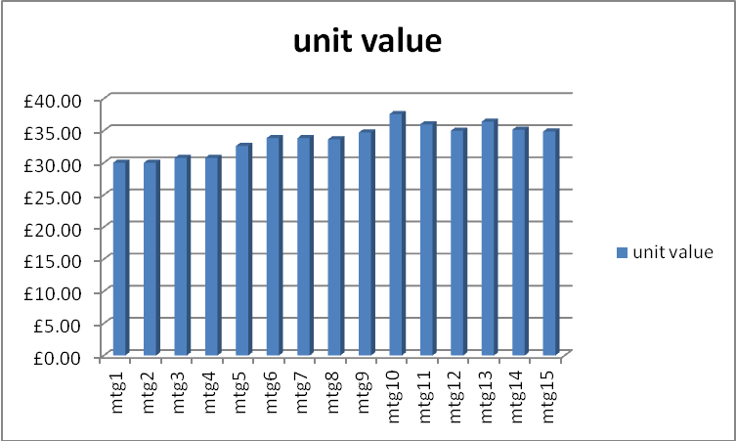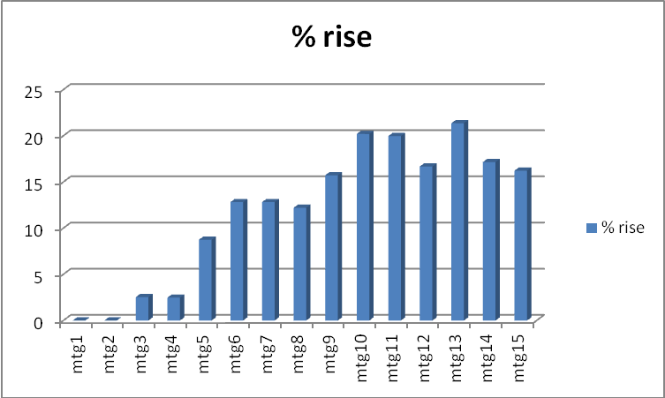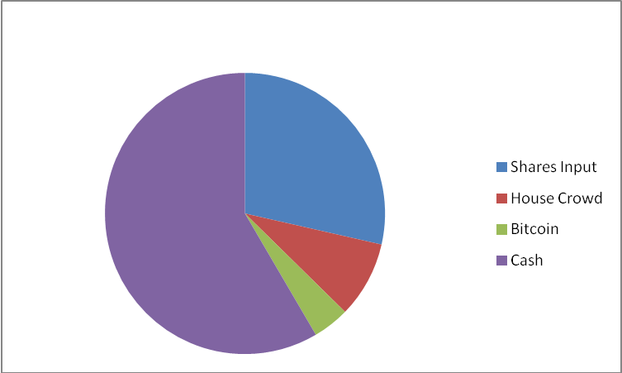
Portfolio
Symbol | Qty. | Description | Champion | Market Value | Book Cost | Gain/Loss | Prev Month | Variance
HAYD | 414 | HAYDALE GRAPHENE INDUSTRIES PLC | JT | 190.44 | 499.56 | -309.12 | 291.87 | -101.43
PURP | 148 | PURPLE BRICKS | AJW | 425.06 | 747.41 | -322.35 | 497.58 | -72.52
KETL | 516 | STRIX GROUP PLC | NCP | 861.72 | 748.91 | 112.81 | 837.98 | 23.74
TSTR | 1156 | TRI-STAR RESOURCES | SM | 479.74 | 750 | -270.26 | 508.64 | -28.90
VRS | 608 | VERSARIEN | DMcN | 741.76 | 499.98 | 241.78 | 653.60 | 88.16
VOD | 372 | VODAFONE | SM | 685.82 | 749.37 | -63.55 | 683.51 | 2.31

4. Investment Strategy and Homework (Share updates)
Areas of focus - owners - Aerospace & Defense – AJW, Automobiles & Parts – EC, Electronic & Electrical Equipment – DMcN, Gas, Water & Multi Utilities – DSW & AJW, Health Care Equipment & Services – EC & NCP, Mining – JT, Mobile Telecommunications – MC, Pharmaceuticals & Biotechnology – DSW & JT & NCP, Software & Computer Services – MC, Travel & Leisure – DMcN
Homework – Haydale launched a drone made of graphene and were up 10% on the day this happened. Purple Bricks – still seen as a good long term investment. Their international growth has cost more than predicted, but still got potential. Strix are still on to meet half year targets. Tri Star – no news. Varsarien – Good time to buy. Versarien have deals with 24 different companies in China. Whereas last week that was just 1.
4.12.1 - Tabled shares and info – Halfords – up because they are beating others in their sector due to offering click and collect and sales were up due to Tour de France. Just Eat – orders in the last 6 months by 30%. Wiggle tabled, but discovered that they are owned by private investors. Halma – this maybe a long term share. Quiz – produced good trading figures £116.4m profit for 2018 and predicted £150m for 2019. Merlin – they have been creeping up –probably to do with the weather and possibly even Brexit influencing people to stay at home. Buy £1000 Just Eat, £1000 Halma and £1000 Merlin. Matt to investigate syndicate room as well as other vegan food producers.
5. Fantasy Shares
5.14.1 - New competition up and running - not everyone taking part it appears. Position at Sunday 23.09.2018
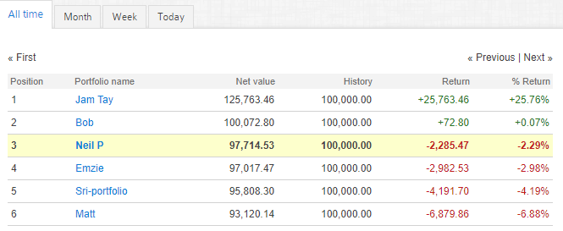.

6. Peston
Missing cat of 13years turns up on Wednesday, but dead by Sunday. This was 17year old cat so quite understandable. Teenager with extra arms growing out of his body to finally have them removed. 100’s of prisoners in Idaho used tablets to hack software to inflate their cash balances for use in prison, one as high as $225,000. Terminator will be built within the next 30 years “Skynet will become self aware”. Spain could see temperatures of 48 degrees this week. Swedish royal family crown jewels were stolen by men in a speedboat from a Catherdal.

7. AOB

Matt to investigate Nielsen Nerswira???? Can’t remember what this was.
Emma asked to minute the fact that if we sell or trade in Versarien, Strix or Purple Bricks she will not be able to vote due to a conflict of interest with her new job that asks her to monitor these shares.

8. Next Meeting

Wednesday 19th or 26th September as we are assuming this meeting was actually July really and we don’t normally have an August meeting. Usual Venue at 8.15. It was decided to just muck in on pizza payment - it is soooo much easier that way!

Side Note - Pizza area for future reference - 18" (254.24") - 14" (153.93") - 12" (113.09") - 9" (63.61")
“There are only imbeciles who don’t change their opinions"

