The Strangemen IV Investment Club (HBHXX74T)
Minutes of the fourteenth meeting - Held Wednesday 27th June, 2018 at The Mill Street Club, Mill Street, Leek.

Attendees:
- James Taylor (JT) Neil Pickford (NCP) ,Alan Whitmore (AJW), Sridar Madadi (SM), Dave Swarbrook (DS), David McNeaney (DMcN)
Apologies:
- Matt Culverwll (MC) - parental duties
- Emma Chadwick (EC) - parental duties
- Newton (the guffin' dog) (NTD) - eating grass
- Mike Helm - on the up n down.
- Gareth Ekin (GE) - brushing up his lewd script no doubt!
- Andy Bradley (AMB) - he talks a good game - apparently missing from the workplace too now!
- Jes Challand (JC) - “Quand on a pas ce que l’on aime, il faut aimer ce que l’on a” - This month, Jes shares his initials with Jim Cantalupo - CEO of McDonald's until a his death from heart attack at 60, in 2004.

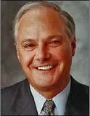
Agenda:
  - Okay previous minutes
  - Previous Actions
  - Treasurers Report & current portfolio update
  - Investment strategy & Homework (share updates)
  - Fantasy Shares
  - Peston
  - AOB
8. Next Meeting
1. Okay Previous Minutes What, there were minutes - no way - seriously, does anyone read this ? There are more trees on earth than there are stars in the galaxy. ( NASA estimates that there are between 100 billion and 400 billion stars in the Milky Way galaxy. And according to a paper in Nature , there are more than 3 trillion trees on Earth.)
2. Previous Actions  2.3.1 - NCP to email TDW re: currency error on account and what is needed to trade in US - Info received but memberships require sorting with TDW - back to NCP - NCP to grab papers. back with iii  5.11.1 - Sri to investigate YU Group - nuclear rod reuse? Still to do  7.12.1 - can we see a breakdown of holdings asked Matt C - JT and NCP to rustle something up for dropping into the minutes - working on it! - in progress. | NCP  SM
3. Treasurers Report & current portfolio update
The club has cash of £6214.56 in TDW. Cash at Barclays is £549.32. £1,000 in House Crowd, £384.25 in Crypto. Each member has 21 units purchased at £30 each. Each unit now worth £35.15 an increase of 17.16%.. £630 now worth £738.13. Strix divi 1st June - £9.80. Fevertree divi 25th May - £3.89.
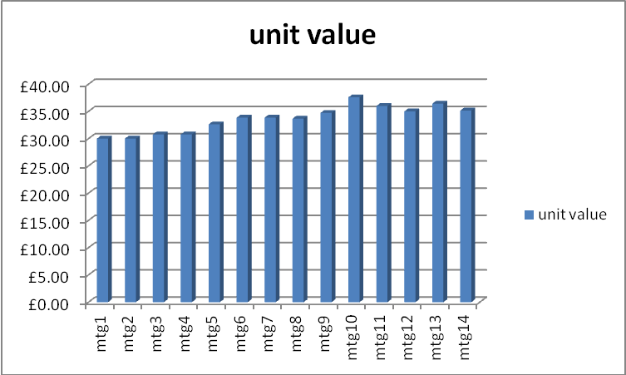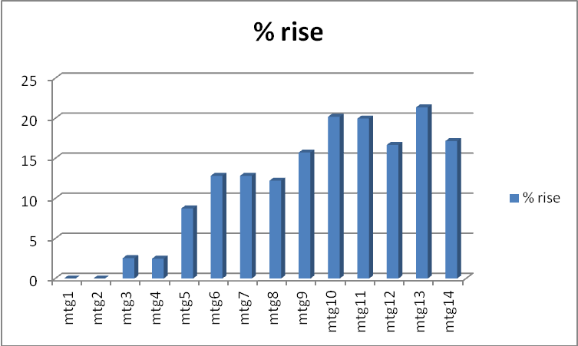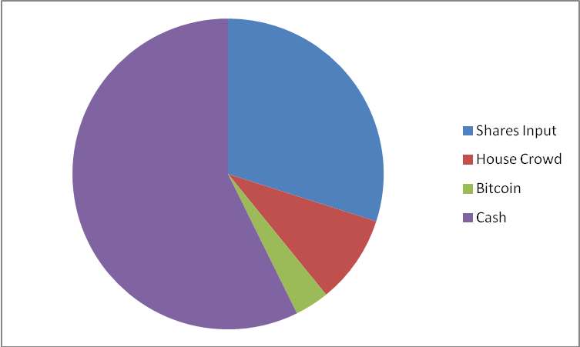
Portfolio
Symbol | Qty. | Description | Champion | Market Value | Book Cost | Gain/Loss | Prev Month | Variance
HAYD | 414 | HAYDALE GRAPHENE INDUSTRIES PLC | JT | 291.87 | 499.56 | -207.69 | 405.72 | -113.85
PURP | 148 | PURPLE BRICKS | AJW | 497.58 | 747.41 | -249.83 | 592 | -94.42
KETL | 516 | STRIX GROUP PLC | NCP | 837.98 | 748.91 | 89.07 | 727.56 | 110.42
TSTR | 1156 | TRI-STAR RESOURCES | SM | 508.64 | 750 | -241.36 | 508.64 | 0
VRS | 608 | VERSARIEN | DMcN | 653.6 | 499.98 | 153.62 | 510.72 | 142.88
VOD | 372 | VODAFONE | SM | 683.51 | 749.37 | -65.86 | 683.51 | 0

4. Investment Strategy and Homework (Share updates)
Areas of focus - owners - Aerospace & Defense – AJW, Automobiles & Parts – EC, Electronic & Electrical Equipment – DMcN, Gas, Water & Multi Utilities – DSW & AJW, Health Care Equipment & Services – EC & NCP, Mining – JT, Mobile Telecommunications – MC, Pharmaceuticals & Biotechnology – DSW & JT & NCP, Software & Computer Services – MC, Travel & Leisure – DMcN
Homework - Haydale paid £150K to fast track products and added to the Manchester Uni Graphene Engineering Innovation Centre. Purplebricks being quizzed in US - others taking legal action, current agent fees are 5-6% of sale - upto $30K in LA! Strix - court cases to protect IP from grey imports and city analysts advise undervalued. Versarien - also added to Manchester Uni innovation centre.
4.12.1 - Tabled shares and info - Barclays looking to buy Standard Chartered. Italy in 2.3tn euro debt - possible Itexit. Decision to buy Tristar again and Vodafone - £750 of each. NCP to action - Done
No purchases made.
5. Fantasy Shares
5.14.1 - New competition up and running - not everyone taking part it appears. Position at Sunday 29.07.2017.
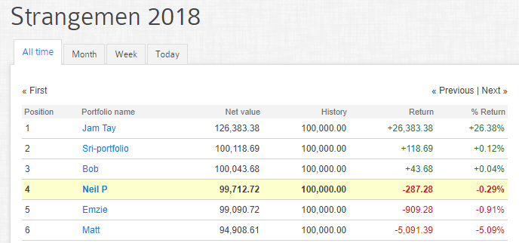
6. Peston
Fisherman mugged 3 miles of the coast by 2 blokes in a dinghy in the channel. Woman kills party guests (5) as they ridiculed her cooking - in India - awaiting death penalty. TUC trying to legislate that folks should be allowed home if office is over 30 degrees and over 27degrees if a manual worker. A man born without a penis has had one built for £5ok. A lost pig was roaming Kent for 5 days, despite the RSPCA and Police attending twice to sightings. An 85 year old gynaecologist has been accused of stealing a baby 50 years ago. Alleged that 300,000 kids were stolen from parents in Franco ruled Spain - parents were advised that babies had died but given away out of Spain to stop political views against Franco.

7. AOB
7.12.1 - can we see a breakdown of holdings asked Matt C - JT and NCP to rustle something up for dropping into the minutes - working on it! - in progress.

8. Next Meeting

Wednesday 1st August. Usual Venue at 8.15. It was decided to just muck in on pizza payment - it is soooo much easier that way!

Side Note - Pizza area for future reference - 18" (254.24") - 14" (153.93") - 12" (113.09") - 9" (63.61")
“When one doesn’t have the things that one loves, one must love what one has"

