The Strangemen IV Investment Club (HBHXX74T)
Minutes of the twelfth meeting - Held Wednesday 25th April, 2018 at The Mill Street Club, Mill Street, Leek.
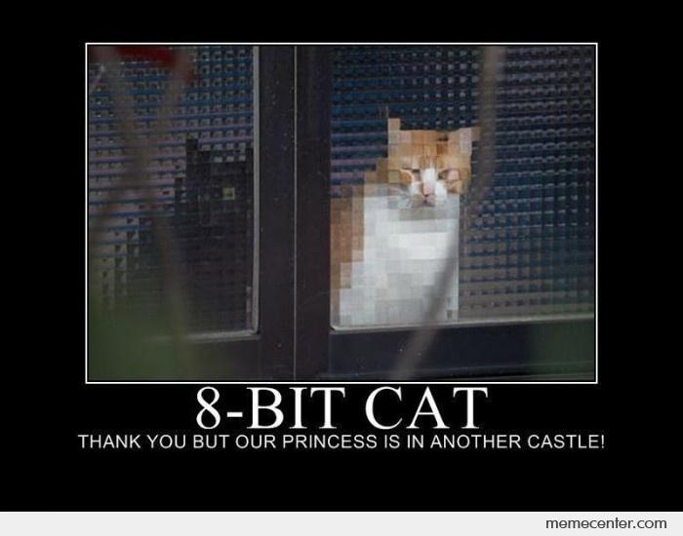
Attendees:
- James Taylor (JT) Neil Pickford (NCP) ,Matt Culverwell (MC), Sridar Madadi (SM), Emma Chadwick (EC), Newton (the guffin' dog) (NTD) , David McNeaney (DMcN)
Apologies:
- Gareth Ekin (GE) - i later found out he was writing a play!!
- Andy Bradley (AMB) - Wedding anniversary, but the wife is in hospital!
- Alan Whitmore (AJW) - sick mofo
- Mike Helm (MH) - poorly dude - doesn't like the thought of these fecks - and neither do I!
- Dave Swarbrook (DS) - Living the life of retired Riley in Manchester gigging.

Jes Challand (JC) - “Quand on a pas ce que l'on aime, il faut aimer ce que l'on a”. This month, Jes shares his initials with Justin Cronin - US Author, who has his "Passage" trilogy coming to TV soon. Kerching


Agenda:
  - Okay previous minutes
  - Previous Actions
  - Treasurers Report & current portfolio update
  - Investment strategy & Homework (share updates)
  - Fantasy Shares
  - Peston
  - AOB
8. Next Meeting
1. Okay Previous Minutes What, there were minutes - no way - seriously, does anyone read this ? The very first bomb dropped by the Allies on Berlin in World War II killed the only elephant in the Berlin Zoo.
2. Previous Actions  2.3.1 - NCP to email TDW re: currency error on account and what is needed to trade in US - Info received but memberships require sorting with TDW - back to NCP - NCP to grab papers. still in progress!!!  5.11.1 - Sri to investigate YU Group - nuclear rod reuse? To do  5.11.2 - NCP to buy £750 of Conviviality - went tits up. trade cancelled.  7.12.1 - can we see a breakdown of holdings asked Matt C - JT and NCP to rustle something up for dropping into the minutes | NCP  SM  JT/NCP
3. Treasurers Report & current portfolio update  The club has cash of £4263.08 in TDW. Cash at Barclays is £433.32. £1,000 in HouseCrowd, £500 Matt C Mintos Cash, £539.27 Bitcoin. Each member has 19 units purchased at £30 each. Each unit now worth £35, an increase of 16.68%.. £570 now worth £665.06.  Portfolio  4. Investment Strategy and Homework (Share updates)  Areas of focus - owners - Aerospace & Defense – AJW, Automobiles & Parts – EC, Electronic & Electrical Equipment – DMcN, Gas, Water & Multi Utilities – DSW & AJW, Health Care Equipment & Services – EC & NCP, Mining – JT, Mobile Telecommunications – MC, Pharmaceuticals & Biotechnology – DSW & JT & NCP, Software & Computer Services – MC, Travel & Leisure – DMcN  Homework - Strix issued a target of 210 from current 139. Haydale - negative earnings due to a capital raise. Tristar - loan repaid in June/July . Versarien - all looks good.  5.11.1 - Tabled shares - Conviviality (due to their collapse) and Yu group (nuclear rod reuse) - Sri to investigate - to do  5.11.2 - NCP to buy £750 of Conviviality - not done due to insolvency!  4.12.1 - Powerhouse Energy tabled - not purchased.  5. Fantasy Shares  5.12.1 - New contest coming soon!!!!!! NCP to sort out and email folk after meeting.  6. Peston  No Peston, due to Peston being poorly bad.  7. AOB  7.12.1 - can we see a breakdown of holdings asked Matt C - JT and NCP to rustle something up for dropping into the minutes  8. Next Meeting  Wednesday 16th/ 23rd or 30th May. Usual Venue at 8.15. It was decided to just muck in on pizza payment - it is soooo much easier that way!  Side Note - Pizza area for future reference - 18" (254.24") - 14" (153.93") - 12" (113.09") - 9" (63.61") | SM  NCP  JT/NCP
  Symbol | Qty. | Description | Champion | Mid Price | Price Change | Market Value | Book Cost | Gain/Loss | Prev Month | Variance
  FEVR | 51 | FEVERTREE DRINKS PLC | DSW | 2695.00p | -129.00p | 1374.45 | 1207.11 | 167.34 | 1431.57 | -57.12
  HAYD | 414 | HAYDALE GRAPHENE INDUSTRIES PLC | JT | 111.00p | 0.00p | 459.54 | 499.56 | -40.02 | 447.12 | 12.42
  PURP | 148 | PURPLE BRICKS | AJW | 345.40p | 8.6p | 511.19 | 747.41 | -236.22 | 532.8 | -21.61
  KETL | 516 | STRIX GROUP PLC | NCP | 139.20p | -0.8p | 718.27 | 748.91 | -30.64 | 698.66 | 19.61
  TSTR | 726744 | TRI-STAR RESOURCES | SM | 0.0325p | 0.00p | 236.19 | 250 | -13.81 | 236.19 | 0
  VRS | 608 | VERSARIEN | DMcN | 61.50p | -0.50p | 373.92 | 499.98 | -126.06 | 507.68 | -133.76

