The Strangemen IV Investment Club (HBHXX74T)
Minutes of the eleventh meeting - Held Wednesday 14th March, 2018 at The Mill Street Club, Mill Street, Leek.

Attendees:
- James Taylor (JT) Neil Pickford (NCP) ,Matt Culverwell (MC), Sridar Madadi (SM), Alan Whitmore (AJW), David McNeaney (DMcN)
Apologies:
- Gareth Ekin (GE) - being very quiet on social media we have noticed!
- Andy Bradley (AMB) - spends more time in Rochdale than Lisa Stansfield.
- Emma Chadwick (EC) - first fail - we'll let her off
- Newton (the guffin' dog) (NTD) - chowing down on some primo vegan fart inducing food no doubt!
- Mike Helm (MH) - poorly dude
- Dave Swarbrook (DS) - Keswick getting "blown off" apparently

Jes Challand (JC) - hommes sans chapeaux (https://www.youtube.com/watch?v=FTVtfzOeELE) This month, Jes shares his initials with Jamie Cook, guitarist with Arctic Monkeys.

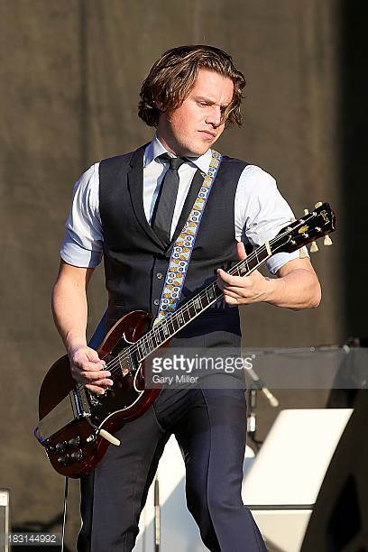
Agenda:
  - Okay previous minutes
  - AGM
  - Previous Actions
  - Treasurers Report & current portfolio update
  - Investment strategy & Homework (share updates)
  - Fantasy Shares
  - Peston
  - AOB
9. Next Meeting
1. Okay Previous Minutes What, there were minutes - no way - seriously, does anyone read this ? The very first bomb dropped by the Allies on Berlin in World War II killed the only elephant in the Berlin Zoo.
2. AGM  2.11.1 - All roles resigned and voted unanimously back into same roles - as you were!  3. Previous Actions  2.3.1 - NCP to email TDW re: currency error on account and what is needed to trade in US - Info received but memberships require sorting with TDW - back to NCP - NCP to grab papers. in progress  5.11.1 - Sri to investigate YU Group - nuclear rod reuse?  5.11.2 - NCP to buy £750 of Conviviality  9.11.1 - NCP to email re night out and curry (Sri sorting) | NCP  SM  NCP  NCP/SM
4. Treasurers Report & current portfolio update  The club has cash of £2835.58 in TDW. Cash at Barclays is £238.32 (ish). Divis from Voda (2/2) - £28.75.Each member has 18 units purchased at £30 each. Each unit now worth £35.99, an increase of 19.97%.. £540 now worth £647.86.  Portfolio  5. Investment Strategy and Homework (Share updates)  Areas of focus - owners - Aerospace & Defense – AJW, Automobiles & Parts – EC, Electronic & Electrical Equipment – DMcN, Gas, Water & Multi Utilities – DSW & AJW, Health Care Equipment & Services – EC & NCP, Mining – JT, Mobile Telecommunications – MC, Pharmaceuticals & Biotechnology – DSW & JT & NCP, Software & Computer Services – MC, Travel & Leisure – DMcN  Homework - Purplebricks - Fined in Aus. re terms and conditions Strix - sales up and secured contract with Bots via Aqua Optima.  5.11.1 - Tabled shares - Conviviality (due to their collapse) and Yu group (nuclear rod reuse) - Sri to investigate  5.11.2 - NCP to buy £750 of Conviviality  6. Fantasy Shares  New contest coming soon!!!!!! NCP to sort out and email folk.  7. Peston  Peston showed us a pic of a person sitting on cracking cliff at Seaford Head - they had removed the safety rope! A piss poor police photofit actually caught a criminal in Pensylvania due to his odd appearance. Fossil of spider with a scorpion style tail found. $800 for platform Crocs at Paris fashion show - sold out. Dimethylpolysiloxane used to cook chips at McDs can apparently cure baldness. Canadian lady ordered to trim bush - as 3 times higher than house and blocking light to neighbours. Crems are having to check prior to burning deceased due to items slipped in exploding - like phones, booze and a coconut. New 4K yr old tomb found in T'gypt - Priestess Hetfet. Pics shown of a rented house full of beer cans - and I mean full! Saudi Arabia had snow in v rare storm. Woman joked with her colleagues at work about being taken out by a sniper - uploaded the same to social media and 4 days later was shot dead in Pensylvania. Big game hunter shot and killed by friend in accident whilst aiming at lion. Good! You can now order Yoni beer - made from vaginal yeast. Photo shown of lorry driver and damage to one side of face from driving with it in the sun for 28 years. Shittens - new disposable mittens for baby arse wiping. Couple hid house by putting false garage door in front of house. Bloke arrested on suspicion of swallowing drugs held for 76 days and refused to shit - let go. Masturbation kills 100 folk a year in Germany - most due to auto erotic asphyxiation - but one man found in diving suit ad raincoat covered in cheese. Finally, a couple were hospitalised after the man got his face stuck in the woman's vagina!  8. AOB  7.8.1 - Discuss Xmas do and new Fantasy comp at next meeting - C/F - Date agreed - Sat 24th March - we will go out to see Andrea!!  9. Next Meeting  Wednesday 25th April. Usual Venue at 8.15. It was decided to just muck in on pizza payment - it is soooo much easier that way!  9.11.1 - NCP to email re night out and curry (Sri sorting)  Side Note - Pizza area for future reference - 18" (254.24") - 14" (153.93") - 12" (113.09") - 9" (63.61") | SM  NCP  NCP
  Symbol | Qty. | Description | Champion | Mid Price | Price Change | Market Value | Book Cost | Gain/Loss | Prev Month | Variance
  FEVR | 51 | FEVERTREE DRINKS PLC | DSW | 2807.00p | 8.17% | 1431.57 | 1207.11 | 224.46 | 1431.57 | 0
  HAYD | 414 | HAYDALE GRAPHENE INDUSTRIES PLC |  | 108.00p | -2.70% | 447.12 | 499.56 | -52.44 | 447.12 | 0
  PURP | 148 | PURPLE BRICKS | AJW | 360.00p | -2.91% | 532.8 | 747.41 | -214.61 | 663.04 | -130.24
  KETL | 516 | STRIX GROUP PLC | NCP | 135.4p | -0.59% | 698.66 | 748.91 | -50.25 | 766.78 | -68.12
  TSTR | 726744 | TRI-STAR RESOURCES |  | 0.0325p | -1.54% | 236.19 | 250 | -13.81 | 236.19 | 0
  VRS | 608 | VERSARIEN |  | 83.50p | -1.95% | 507.68 | 499.98 | 7.7 | 507.68 | 0

