The Strangemen IV Investment Club (HBHXX74T)
Minutes of the Ninth meeting - Held Wednesday 29th November, 2017 at The Mill Street Club, Mill Street, Leek.
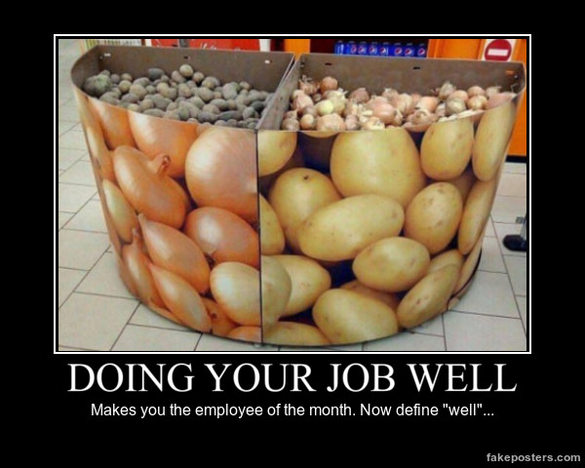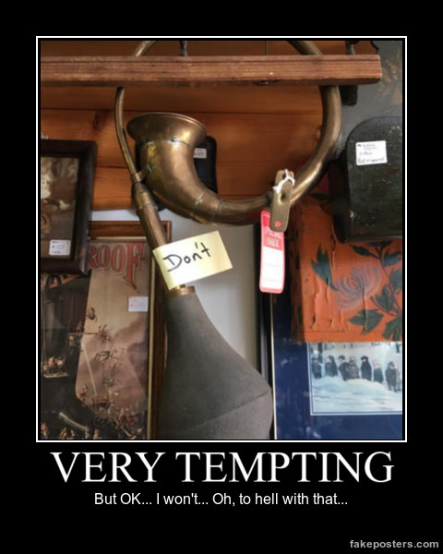
Attendees:
- James Taylor (JT) Neil Pickford (NCP) ,Matt Culverwell (MC) Emma Chadwick (EC) Newton (the guffin' dog) (NTD) Sridar Madadi (SM) (avec poulet!), Alan Whitmore (AJW) David McNeaney (DMcN)
Apologies:
- Gareth Ekin (GE) - "page not found"
- Pete Shepherd (PS) - Weather/ commute rage
- Dave Swarbrook (DS) - Now a free man, but not free tonight
- Andy Bradley (AMB) - A broken man
- Mike Helm (MH) - Yes, I thought 3 in a year was pushing it too Mike.

Jes Challand (JC) - pounding the streets of Le France - getting fit for retirement, when he will spend his francs on fine wine and finer ladies.

Shares his initials with Jessica Crisp - former World champion wind-surfer from Australia. 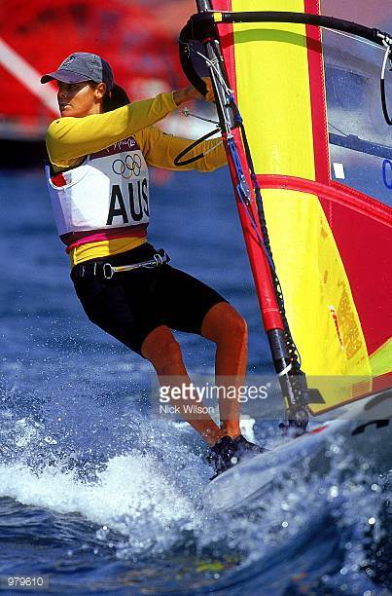
Agenda:
  - Okay previous minutes
  - Previous Actions
  - Treasurers Report & current portfolio update
  - Investment strategy & Homework (share updates)
  - Fantasy Shares
  - Peston
  - AOB
8. Next Meeting
1. Okay Previous Minutes What, there were minutes - no way - seriously, does anyone read this ? There is enough DNA in an average person’s body to stretch from the sun to Pluto and back — 17 times
2. Previous Actions  2.3.1 - NCP to email TDW re: currency error on account and what is needed to trade in US - Info received but memberships require sorting with TDW - back to NCP - NCP to grab papers. NCP to prep papers  3.7.1 - NCP raised AMB query re: legacy buyout - NCP to email out - small response. AMB and DSW have swapped brown envelopes.  4.9.1 - NCP to sell Treatt  4.9.2 - MC/MH to buy £500 Mintos  7.8.1 - Discuss Xmas do and new Fantasy comp at next meeting - C/F | NCP  NCP  MC/MH
3. Treasurers Report & current portfolio update  The club has cash of £2610.70 in TDW. Cash at Barclays is £238.32. Each member has 14 units purchased at £30 each. Each unit now worth £34.72, an increase of 15.73%.  Portfolio  4. Investment Strategy and Homework (Share updates)  Areas of focus - owners - Aerospace & Defense – AJW, Automobiles & Parts – EC, Electronic & Electrical Equipment – DMcN, Gas, Water & Multi Utilities – DSW & AJW, Health Care Equipment & Services – EC & NCP, Mining – JT, Mobile Telecommunications – MC, Pharmaceuticals & Biotechnology – DSW & JT & NCP, Software & Computer Services – MC, Travel & Leisure – DMcN  Homework - Purplebricks - ongoing issues with a potential crowd-funded legal action. Treatt - profits up 24%. Year end 2017 at 202 levels. Strix - sold their 2 billionth item! Fevertree - Dave away, probably drinking their profits.  Tabled share - Sirius Real Estate.  4.9.1 - NCP to sell Treatt  4.9.2 - MC/MH to buy £500 Mintos  5. Fantasy Shares  Tough month again, but no show Mike Helm took the win with a 10.41% hike with Apple. And he retains overall lead with a month to go!  "But who will tend our infrastructure now Carillion has gone" is the cry - not these capitalists that's for sure, they're hedging their bets here:-  6. Peston  Smart condom - collects data from wearer and detects STIs/STDs. Alexander Chechik took selfie in his car with grenade minus pin - he blew up! Man in China gets small padlock wedged in bladder after pushing up his bellend, just months after another Chinese fell a had 15 needles removed from his. Dog owner in Greater Manchester fined after huge amounts of excrement filmed in garden. Passengers removed from an Easyjet flight to Geneva, as man found hiding in the loo. He had sneaked on, as he had missed his previous flight! Clancy's bar-b-q nuts recalled by Aldo, as they didn't have the "may contain nuts "warning. Bloke left a suitcase containing £1million jewels on a luggage rack on the London to B'ham train - stolen bizarrely! a gig economy cleaner blcoked by the company's app and fined £25 for falling ill. Since re-instated and a crowd-funded amount of cash raised for her. Man splashed out on £3K laptop and had a mop delivered in error. Aussie man doing favour for neighbour dies falling into wood chipper (Fargo the movie). Brittney Spears auctioned a painting for charity - piss poor but made $10K.  7. AOB  7.8.1 - Discuss Xmas do and new Fantasy comp at next meeting - C/F  Need an AGM either Feb or March at the latest.  AJW dropped the bombshell that he was possibly moving to the Shetland Isles!!!!!!!!!!!!  8. Next Meeting  Wednesday 24th January. Usual Venue at 8.15. It was decided to just muck in on pizza payment - it is soooo much easier that way! We STILL need to go an visit Andrea in her pub in Newcastle - TBA - c'mon! Seriously now, we are useless at getting there! Really effin' useless! Dave S has actually seen her!!!!!!!  Side Note - Pizza area for future reference - 18" (254.24") - 14" (153.93") - 12" (113.09") - 9" (63.61")  pete_shepherd316@hotmail.co.uk | NCP  MC/MH
  Symbol | Qty. | Description | Champion | Mid Price | Price Change | Market Value | Book Cost | Gain/Loss | Prev Month | Variance
  FEVR | 32 | FEVERTREE DRINKS PLC | DSW | 2185.00p | -1 | 651.2 | 728.1 | -76.9 | 699.2 | -48
  PURP | 148 | PURPLE BRICKS | AJW | 364.00p | 12.25 | 526.51 | 747.41 | -220.9 | 538.72 | -12.21
  KETL | 516 | STRIX GROUP PLC | NCP | 141.00p | 1 | 727.56 | 748.91 | -21.35 | 727.56 | 0
  TET | 130 | TREATT | JT | 437.00p | -7.75 | 626.28 | 498.46 | 127.82 | 568.1 | 58.18
  Period -12 | SHARE | EPIC | START PRICE | Period -12 | SHARE | EPIC | START PRICE
  Dave S | Fevertree | FEVR | 2006.00 | Jes C | Marks and Spencer | MKS | 312.10
  Gareth E | BAE | BA.L | 550.00 | Dave McN | Angling Direct | ANG | 81.00
  Mike H | Apple ($) | AAPL | 170.43 | Glynn G | London Stock Exchange | LSE | 3791.00
  Neil P | Sirius | SRE.L | 63.25 | Alan W | Just Eat | JE.L | 800.00
  James T | Oxford Biodynamics | OBD.L | 207.00 | Sri M | Tristar | TSTR | 0.12
  Matt C | NetFlix | NFLX ($) | 190.31 | Emma C | Amazon | AMZN ($) | 1167.10
  Andy B | Standard Life | SLA.L | 425.50 | Pete S | Vodafone | VOD | 224.50

