The Strangemen IV Investment Club (HBHXX74T)
Minutes of the Eighth meeting - Held Wednesday 18th October, 2017 at The Mill Street Club, Mill Street, Leek.
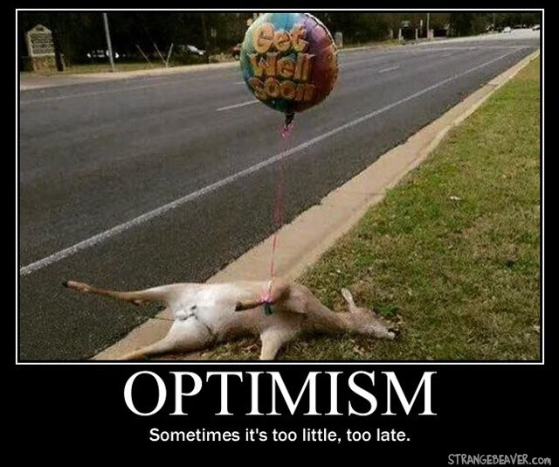
Attendees:
- James Taylor (JT) Neil Pickford (NCP) Mike Helm (MH) Matt Culverwell (MC) Emma Chadwick (EC) Newton (the guffin' dog) (NTD) Dave Swarbrook (DS) Alan Whitmore (AJW) David McNeaney (DMcN) Pete Shepherd (PS) - welcome back pete_shepherd316@hotmail.co.uk
Apologies:
- Gareth Ekin (GE) - "page not found"
- Andy Bradley (AMB) - hmmm, ummm, errr, Strawberry please. Less decisive than Alberto Frog!
- Sridar Madadi (SM) - Yup, I'll be back in October. Is it October, apologies, I cannot make it.

Jes Challand (JC) - Thinking of coming home for Xmas, but avoiding striking pilots and tigers wandering the streets of Paris

(http://www.bbc.co.uk/news/world-europe-42117644?intlink_from_url=http://www.bbc.co.uk/news/topics/c302m85qenyt/france&link_location=live-reporting-story). Shares his initials with Justin Chancellor, Bass player for rock band Tool - check them out! 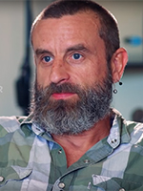
Agenda:
  - Okay previous minutes
  - Previous Actions
  - Treasurers Report & current portfolio update
  - Investment strategy & Homework (share updates)
  - Fantasy Shares
  - Peston
  - AOB
8. Next Meeting
1. Okay Previous Minutes What, there were minutes - no way - seriously, does anyone read this ? France was still executing people by guillotine when the first Star Wars movie came out. (Convicted murderer Hamida Djandoubi became the last person to meet his end by the “National Razor” after he was executed by the guillotine in 1977. Still, the machine's 189-year reign only officially came to an end in September 1981, when France abolished capital punishment for good.)
2. Previous Actions  1.7.1 - Babies are born without kneecaps. They don't appear until the child reaches 2-6 years of age. Mike to check - Mike "Googled it" in the meeting - erm, fail!  2.3.1 - NCP to email TDW re: currency error on account and what is needed to trade in US - Info received but memberships require sorting with TDW - back to NCP - NCP to grab papers. NCP to prep papers  3.7.1 - NCP raised AMB query re: legacy buyout - NCP to email out - small response. To try again.  3.8.1 - JT also advised we were missing 2 payments from Sri - JT to chase.  4.7.1 - Matt to reinvest Bitcoin cash.  4.7.2 - Mike and Matt to investigate Onecoin and other crypto-currency IPOs. Nick Evans had advised of a scam re: onecoin.  7.7.2 - Revisited buy options and decided to buy £750 of Fevertree - NCP to sort - Done  7.8.1 - Discuss Xmas do and new Fantasy comp at next meeting | MH  NCP  NCP  JT  MC  MH/MC  NCP
3. Treasurers Report & current portfolio update  The club has cash of £3409.61 in TDW. Cash at Barclays is £203.32. Conviviality sold for £989.03 (£241.11 profit). Then a divi from them of £19.99 on 5.10. Each member has 13 units purchased at £30 each. Each unit now worth £33.66, an increase of 12.21%. - these figures are minus the bitcoin info - we own (0.1163 coins).  3.8.1 - JT also advised we were missing 2 payments from Sri - JT to chase.  Portfolio  4. Investment Strategy and Homework (Share updates)  Areas of focus - owners - Aerospace & Defense – AJW, Automobiles & Parts – EC, Electronic & Electrical Equipment – DMcN, Gas, Water & Multi Utilities – DSW & AJW, Health Care Equipment & Services – EC & NCP, Mining – JT, Mobile Telecommunications – MC, Pharmaceuticals & Biotechnology – DSW & JT & NCP, Software & Computer Services – MC, Travel & Leisure – DMcN  Homework - Purplebricks have had advertising issues - complaints around flat fee. Treatt - revenus up 24% in 2nd half of year. Fevertree are only one of 2 mixer suppliers  Discussion re: crypto currency and Strix (makers of kettle parts).  4.7.1 - Matt to reinvest Bitcoin cash.  4.7.2 - Mike and Matt to investigate Onecoin and other crypto-currency IPOs. Nick Evans had advised of a scam re: onecoin.  4.8.1 - Another £500 to MC and (MH) to purchase cryptocurrencies)  4.8.2 - NCP to purchase £750 of Strix  5. Fantasy Shares  Tough month but Dave McN pulled out an 11.89% rise on Wincanton to take the win. Mike Helm still leads overall on 70 points, with James staling behind on 68!  Wondering if breast feeding counts as sexual exploitation and harassment this month are :-  6. Peston  Australian judge rules that the "c" word is no longer offensive due to over use in Australia. Indonesian goalie collapsed and died after colliding with an opponent and team-mate. UK teenager moved into 186m² microhome. Woman ordered to pay £24.5K parking fine after failing to argue with Dundee court that tickets were unenforceable. Thousands of Atlantic salmon escape fish farm and end up in the Pacific. Family in M Harborough had ceiling collapse due to huge bee hive above. Row in China between security guard an woman led to her car being placed on roof of a building via crane. Couple in San Francisco have bought the streets of a 35 mansion filled gated community, as residents would not pay the $14 tax. Cost the couple $70K but they can charge for parking now. A remote village in the Dom Republic has 90% of girls growing a penis by age of 12 - pseudo hermaphrodites - missing enzyme. Rozzers called after lady reports man injecting into his balls at Liverpool McDs. Device to cut weight of washing machines invented at Notts Uni - concrete block swapped for sealable container that is filled with water in situ. Edinburgh student offered free flat in Paris from man who wanted to lick her feet. Calf born in Texas that looks like Gene Simmons in make-up (Kiss). Facebook AI robots shut down after developing own language and communicating in it (Bob and Alice). Telescope captures gamma ray explosion - 40 seconds is the equivalent to the entire lifetime output of our own sun.  7. AOB  7.7.2 - Revisited buy options and decided to buy £750 of Fevertree - NCP to sort - Done  7.8.1 - Discuss Xmas do and new Fantasy comp at next meeting  8. Next Meeting  Wednesday 15th or 22nd November, but plumped later due to Emma having an op on her mush on the 15th. Usual Venue at 8.15. It was decided to just muck in on pizza payment - it is soooo much easier that way! We STILL need to go an visit Andrea in her pub in Newcastle - TBA - c'mon! Seriously now, we are useless at getting there! Really effin' useless! Dave S has actually seen her!!!!!!!  Side Note - Pizza area for future reference - 18" (254.24") - 14" (153.93") - 12" (113.09") - 9" (63.61") | JT  MC  MH/MC  MH/MC  NCP
  Symbol | Qty. | Description | Champion | Mid Price | Price Change | Market Value | Book Cost | Gain/Loss | Prev Month | Variance
  FEVR | 32 | FEVERTREE DRINKS PLC | DSW | 2185.00p | -1 | 699.2 | 728.1 | -28.9 | 699.2 | 0
  PURP | 148 | PURPLE BRICKS | AJW | 364.00p | 12.25 | 538.72 | 747.41 | -208.69 | 553.52 | -14.8
  TET | 130 | TREAT | JT | 437.00p | -7.75 | 568.1 | 498.46 | 69.64 | 577.2 | -9.1
  Period -11 | SHARE | EPIC | START PRICE | Period -10 | SHARE | EPIC | START PRICE
  Dave S | Fevertree | FEVR | 2178.00 | Jes C | Marks and Spencer | MKS | 350.70
  Gareth E | BAE | BA.L | 606.00 | Dave McN | Wincanton | WIN.L | 249.50
  Mike H | Apple ($) | AAPL | 156.75 | Glynn G | London Stock Exchange | LSE | 3905.00
  Neil P | Strix | KETL | 139.50 | Alan W | Lloyds | LLOY | 66.58
  James T | Oxford Biodynamics | OBD.L | 263.00 | Sri M | Tristar | TSTR | 0.12
  Matt C | NetFlix | NFLX ($) | 193.01 | Emma C | Amazon | AMZN ($) | 990.00
  Andy B | Standard Life | SLA.L | 433.50 | Pete S | Vodafone | VOD | 216.10

