The Strangemen IV Investment Club (HBHXX74T)
Minutes of the Sixth meeting - Held Wednesday 20th September, 2017 at The Mill Street Club, Mill Street, Leek.
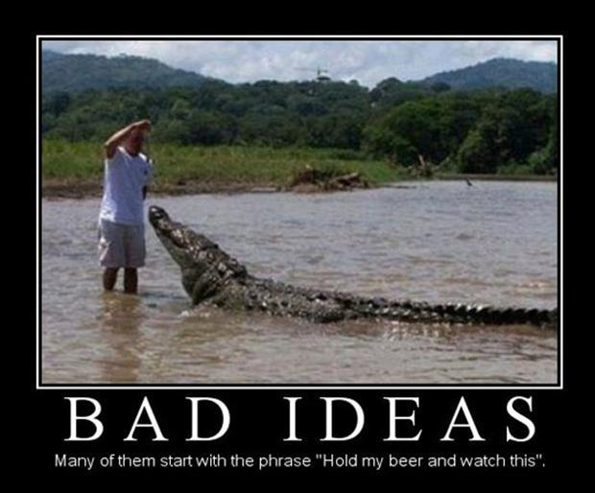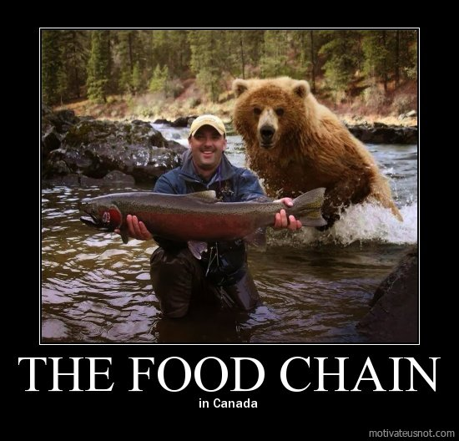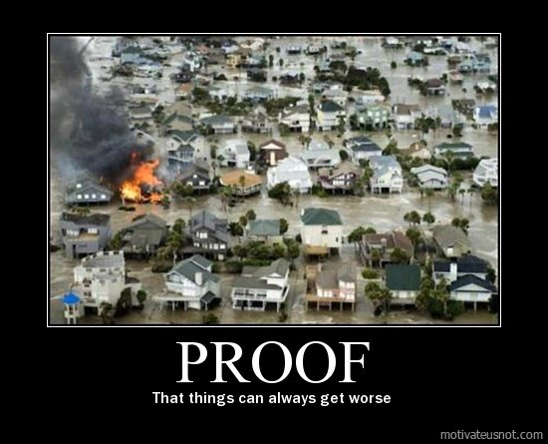
Attendees:
- James Taylor (JT)
- Neil Pickford (NCP)
- Mike Helm (MH)
- Matt Culverwell (MC)
- Emma Chadwick (EC)
- Newton (the dog) (NTD)
- Dave Swarbrook (DS)
- Alan Whitmore (AJW)
Apologies:
- Gareth Ekin (GE) - flatlined?
- Andy Bradley (AMB) - coming, not coming, coming, not coming - Hokey Cokey!
- David McNeaney (DMcN) - busy running the Co-op bank - it was his turn on the rota
- Sridar Madadi (SM) - Unavailable until October - the learning cycle is nearly complete. Has the pupil become the master?
- Jes Challand (JC) - Trying to secure the Brexit rights around brie for us all. Shares his initials with JC Chasez, former member of US pop band NSync. 
Agenda:
  - Okay previous minutes
  - Previous Actions
  - Treasurers Report & current portfolio update
  - Investment strategy & Homework (share updates)
  - Fantasy Shares
  - Peston
  - AOB
8. Next Meeting
1. Okay Previous Minutes What, there were minutes - no way - seriously, does anyone read this ? On a Canadian two dollar bill, the flag flying over the Parliament building is an American flag
2. Previous Actions  1.7.1 - Babies are born without kneecaps. They don't appear until the child reaches 2-6 years of age. Mike to check  2.3.1 - NCP to email TDW re: currency error on account and what is needed to trade in US - Info received but memberships require sorting with TDW - back to NCP - NCP to grab papers  3.7.1 - NCP raised AMB query re: legacy buyout - NCP to email out  4.6.1 Discussion around PurpleBricks and Metro Bank, led to purchase of £750 of PurpleBricks and possibly £500 Conviviality on 01.08 (TBC). NCP to sort. - Done  4.7.1 - Matt to reinvest Bitcoin cash.  4.7.2 - Mike and Matt to investigate Onecoin and other crypto-currency IPOs.  7.7.1 - Pete Shepherd has asked to rejoin. After discussing the angry, opinionated Vegan, it was unanimously agreed that we would take him back. NCP to email him the bad news!  7.7.2 - Revisited buy options and decided to buy £750 of Fevertree - NCP to sort | MH  NCP  NCP  NCP MC  MH/MC  NCP  NCP
3. Treasurers Report & current portfolio update  The club has cash of £2678.69 in TDW. Cash at Barclays is £216.32. Strangemen 3 share "Punch" was sold in a buy-out for £5.40. Blue Prism sold for £1553.96 on 15/8. Divis - Treatt £1.88, Vodafone £60.80 and Royal Mail £72.38. Each member has 12 units purchased at £30 each. Each unit now worth £33.85, an increase of 12.82%.  Portfolio  3.7.1 - NCP raised AMB query re: legacy buyout - NCP to email out  4. Investment Strategy and Homework (Share updates)  Areas of focus - owners - Aerospace & Defense – AJW, Automobiles & Parts – EC, Electronic & Electrical Equipment – DMcN, Gas, Water & Multi Utilities – DSW & AJW, Health Care Equipment & Services – EC & NCP, Mining – JT, Mobile Telecommunications – MC, Pharmaceuticals & Biotechnology – DSW & JT & NCP, Software & Computer Services – MC, Travel & Leisure – DMcN  Homework - Avon Rubber - AJW presented info but not sold on the idea after a vote.  4.7.1 - Matt to reinvest Bitcoin cash.  4.7.2 - Mike and Matt to investigate Onecoin and other crypto-currency IPOs.  5. Fantasy Shares  Drunk on the win this month was Dave S up 30.21% with Fevertree. Mike Helm still leads overall on 63 points  Those who would Weinstein this month are:-  6. Peston  US father kills son after son found pics of dad dressed as a lady eating shit from a nappy. AUS family trapped in house by spider as big as dinner plate. PETA are suing the photographer of the famous Macaque selfie as he didn't take the pic. Man in US stuck in ATM after fixing it for 12 hours and got out by slipping notes to customers with the cash. Notts - houses built behind existing bus shelter so folk unable to get out of house. Jefferson county morgue employee cremated in error, whilst sleeping off a 16 hour shift on a gurney. Kentucky - tutor found students in vents trying to steal exams. A girl killed her father in India, by squeezing his bollock until it burst, over cockfighting. Shop changed name from Singhbury's after cease and desist from Sainsbury's - now called Morrisinghs - Morrisons love it. Chinese flight delayed after 80yr old chinese woman threw coins into engine for luck. Girl fell to bungee death in Spain as she was not attached and mis-heard the Spanish jump owner. New super shuttle London - Edinburgh in 8 minutes by 2040 (Hyperloop). San Diego woman marries train station - visits every day. Wigan man found a mummified act in his new build house wall - old custom. Edinburgh student left a pineapple at art exhibit and it became an exhibit. Lelo - company selling £10,000 golden vibrator and other gold and steel items!!  7. AOB  There were Dilberts!  7.7.1 - Pete Shepherd has asked to rejoin. After discussing the angry, opinionated Vegan, it was unanimously agreed that we would take him back. NCP to email him the bad news!  7.7.2 - Revisited buy options and decided to buy £750 of Fevertree - NCP to sort  8. Next Meeting  Wednesday 18th October - Usual Venue at 8.15. It was decided to just muck in on pizza payment - it is soooo much easier that way! We STILL need to go an visit Andrea in her pub in Newcastle - TBA - c'mon! Seriously now, we are useless at getting there! Really effin' useless! Dave S has actually seen her!!!!!!!  Side Note - Pizza area for future reference - 18" (254.24") - 14" (153.93") - 12" (113.09") - 9" (63.61") | NCP  MC  MH/MC  NCP  NCP
  Symbol | Qty. | Description | Champion | Mid Price | Price Change | Market Value | Book Cost | Gain/Loss | Prev Month | Variance
  CVR | 238 | CONVIVIALITY | NCP | 393.00p | -0.5 | 935.34 | 747.92 | 187.42 | 878.22 | 57.12
  PURP | 148 | PURPLE BRICKS | AJW | 374.00p | -6 | 553.52 | 747.41 | -193.89 | 553.52 | 0
  TET | 130 | TREAT | JT | 444.00p | -15 | 577.2 | 498.46 | 78.74 | 635.38 | -58.18
  Period -10 | SHARE | EPIC | START PRICE | Period -10 | SHARE | EPIC | START PRICE
  Dave S | Fevertree | FEVR | 2237.00 | Andy B | Croda | CRDA | 3732.00
  Gareth E | BAE | BA.L | 624.00 | Jes C | Marks and Spencer | MKS | 347.70
  Mike H | Apple ($) | AAPL | 155.80 | Dave McN | Wincanton | WIN.L | 225.00
  Neil P | Metrobank | MTRO | 3363.00 | Glynn G | London Stock Exchange | LSE | 3800.00
  James T | BHP | BLT.L | 1334.00 | Alan W | Diageo | DGE.L | 2426.50
  Matt C | Tesla | TSLA ($) | 374.90 | Sri M | Tristar | TSTR | 0.14
  Andy B | Croda | CRDA | 3732.00 | Emma C | Unilever | ULVR.L | 4329.00

