The Strangemen IV Investment Club (HBHXX74T)
Minutes of the Sixth meeting - Held Wednesday 12th July, 2017 at The Mill Street Club, Mill Street, Leek.
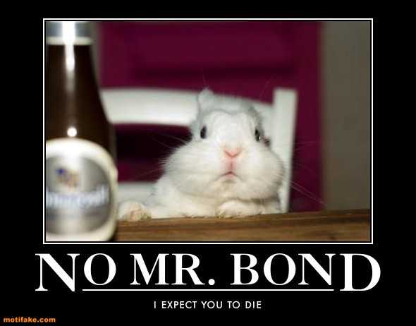
Attendees:
- James Taylor (JT)
- Neil Pickford (NCP)
- David McNeaney (DMcN)
- Matt Culverwell (MC)
- Emma Chadwick (EC)
- Newton (the dog) (NTD)
- Dave Swarbrook (DS)
Apologies:
- Gareth Ekin (GE) - Wayne Rooney's chauffeur?
- Andy Bradley (AMB) - Hips don't lie - said Shaikra
- Mike Helm (MH) - Wondering if he will ever see all his team in work at the same time
- Sridar Madadi (SM) - Unavailable until October - learning and doing educational athletics
- Alan Whitmore (AJW) - Poorly mother - hopefully on the mend now it seems. But Al's back is on the wane too!
- Jes Challand (JC) - Was Macron a good idea? Did he sleep with his wife when she was his teacher ? Jes knows and he ain't telling, because he shares his initials with Jerry Casale, the bass guitarist from legendary oddballs Devo. 
Agenda:
  - Okay previous minutes
  - Previous Actions
  - Treasurers Report & current portfolio update
  - Investment strategy & Homework (share updates)
  - Fantasy Shares
  - Peston
  - AOB
8. Next Meeting
1. Okay Previous Minutes What, there were minutes - no way - seriously, does anyone read this ? Babies are born without kneecaps. They don't appear until the child reaches 2-6 years of age.
2. Previous Actions  2.3.1 - NCP to email TDW re: currency error on account and what is needed to trade in US - Info received but memberships require sorting with TDW - back to NCP - Still Ongoing - what did we agree?  3.4.1 - Discussion about which property to invest in and decided £1,000 to House Crowd and £1,000 to Savingsstream (JT to get details via MC) - Lendy - new name for Savingsstream - still to do - closed not doing  4.6.1 Discussion around PurpleBricks and Metro Bank, led to purchase of £750 of PurpleBricks and possibly £500 Conviviality on 01.08 (TBC). NCP to sort.  4.6.2 Discussion around taking profit from Poloniex or leaving it in, as Matt has driven £350 from £250 quickly. Decided to leave in and MC/JT to speculate. | NCP  NCP JT/MC
3. Treasurers Report & current portfolio update  The club has holdings of £1281.68 on 01.08. Cash at Barclays is £186.32.  Each member has 10 units purchased at £30 each. Each unit now worth £33.85, an increase of 12.82%.  Portfolio  4. Investment Strategy and Homework (Share updates)  Areas of focus - owners - Aerospace & Defense – AJW, Automobiles & Parts – EC, Electronic & Electrical Equipment – DMcN, Gas, Water & Multi Utilities – DSW & AJW, Health Care Equipment & Services – EC & NCP, Mining – JT, Mobile Telecommunications – MC, Pharmaceuticals & Biotechnology – DSW & JT & NCP, Software & Computer Services – MC, Travel & Leisure – DMcN  Homework - None!  4.6.1 Discussion around PurpleBricks and Metro Bank, led to purchase of £750 of PurpleBricks and possibly £500 Conviviality on 01.08 (TBC). NCP to sort.  4.6.2 Discussion around taking profit from Poloniex or leaving it in, as Matt has driven £350 from £250 quickly. Decided to leave in and MC/JT to speculate.  5. Fantasy Shares  In a slim pickings month, up 5.81%, the winner is Matt C with Deutsche Bank. James T still winning on 63, but only 2 behind is Mike H.  Hoping to avoid Storms, Hurricanes, Earthquakes and Newton's farts this month are:-  6. Peston  No Peston, as Peston's mum is poorly, as it Peston's back!  7. AOB  There were Dilberts!  8. Next Meeting  Wednesday 20th September (post summer holiday escapees) - Usual Venue at 8.15. It was decided to just muck in on pizza payment - it is soooo much easier that way! We STILL need to go an visit Andrea in her pub in Newcastle - TBA - c'mon! Seriously now, we are useless at getting there! Really effin' useless!  Side Note - Pizza area for future reference - 18" (254.24") - 14" (153.93") - 12" (113.09") - 9" (63.61") | NCP  JT/MC
  Symbol | Qty. | Description | Champion | Mid Price | Price Change | Market Value | Book Cost | Gain/Loss | Prev Month | Variance
  PRSM | 167 | BLUE PRISM GROUP | TBC | 828.00p | -27 | 1382.76 | 1244.9 | 137.86 | 1382.76 | 0
  CVR | 238 | CONVIVIALITY | TBC | 369.00p | 19 | 878.22 | 747.92 | 130.3 | 759.22 | 119
  TET | 130 | TREAT | TBC | 498.75p | 18.75 | 635.38 | 498.46 | 136.92 | 656.5 | -21.12
   |  |  |  |  | Totals | 2896.36 | 2491.28 | 405.08 | 2798.48 | 97.88
  Period - 9 | SHARE | EPIC | START PRICE
  Dave S | Fevertree | FEVR | 1721.00
  Gareth E | BAE | BA.L | 617.50
  Mike H | Apple ($) | AAPL | 145.50
  Neil P | Gear4Music | G4M | 780.00
  James T | Sirius | SXX.L | 28.50
  Matt C | Facebook | FB ($) | 158.74
  Andy B | Standard Life | SL.L | 408.20
  Jes C | Marks and Spencer | MKS | 316.20
  Dave McN | Wincanton | WIN.L | 245.25
  Glynn G | Punch Taverns | PUB | 179.75
  Alan W | Diageo | DGE.L | 2309.00
  Sri M | Tristar | TSTR | 0.15
  Emma C | Samsung | 005930.KS | 2504000.00

