The Strangemen IV Investment Club (HBHXX74T)
Minutes of the Fifth meeting - Held Wednesday 7th June, 2017 at The Mill Street Club, Mill Street, Leek.
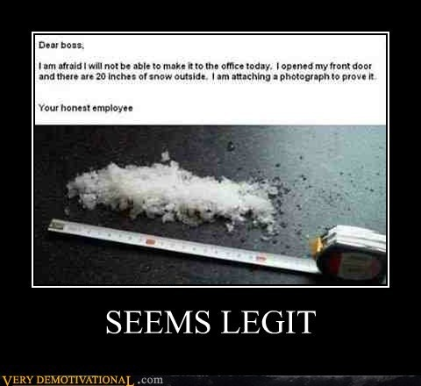
Attendees:
- James Taylor (JT)
- Neil Pickford (NCP)
- David McNeaney (DMcN)
- Matt Culverwell (MC)
- Emma Chadwick (EC)
- Newton (the dog) (NTD)
- Dave Swarbrook (DS)
Apologies:
- Gareth Ekin (GE) - last seen lurking in the background on Love Island
- Andy Bradley (AMB) - Is he under house arrest?
- Mike Helm (MH) - Mike? Mike? I have threatened him that we will have the next meeting at his house if doesn't turn up!
- Sridar Madadi (SM) - Unavailable until October - prepping his young 'un for school - through the holidays too - boo!!
- Alan Whitmore (AJW) - Poorly mother
- Jes Challand (JC) - Thinking he is better off being a French remainer, our man shares his initials with John Convertino, the drummer from both Calexico and Giant Sand - great bands! 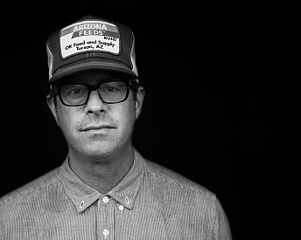
Agenda:
  - Okay previous minutes
  - Previous Actions
  - Treasurers Report & current portfolio update
  - Investment strategy & Homework (share updates)
  - Fantasy Shares
  - Peston
  - AOB
8. Next Meeting
1. Okay Previous Minutes What, there were minutes - no way - seriously, does anyone read this ? Horses cannot vomit!
2. Previous Actions  2.3.1 - NCP to email TDW re: currency error on account and what is needed to trade in US - Info received but memberships require sorting with TDW - back to NCP - Still Ongoing  2.4.1 - Decided to invest £1,000 in funded loan - JT to organise - missed the boat - trying again - attempt 2? - We have invested £1K  3.4.1 - Discussion about which property to invest in and decided £1,000 to House Crowd and £1,000 to Savingsstream (JT to get details via MC) - Lendy - new name for Savingsstream - still to do  4.3.1 - This is due to Mike not paying since December 2016 - JT to chase him up to restart S.O. and back payment of £124 - Mike has Paid  4.4.1 Discussion around purchases and agreed - £500 to Lendy, £750 each of Conviviality and Blue Prism. JT and NCP to arrange. - Done  4.5.1 Discussion led to purchase of £500 Blue Prism and £250 into Bitcoin trading via Poloniex.com. MC/ JT and NCP to sort. | NCP  JT  JT  MC/JT/NCP
3. Treasurers Report & current portfolio update  The club has holdings of £1127.11 for trading. Cash at Barclays is £171.32 - fixed now Mike has paid.  Each member has 9 units purchased at £30 each. Each unit now worth £32.62, an increase of 8.75%.  Portfolio  4. Investment Strategy and Homework (Share updates)  Areas of focus - owners - Aerospace & Defense – AJW, Automobiles & Parts – EC, Electronic & Electrical Equipment – DMcN, Gas, Water & Multi Utilities – DSW & AJW, Health Care Equipment & Services – EC & NCP, Mining – JT, Mobile Telecommunications – MC, Pharmaceuticals & Biotechnology – DSW & JT & NCP, Software & Computer Services – MC, Travel & Leisure – DMcN  Homework - None!  4.5.1 Discussion led to purchase of £500 Blue Prism and £250 into Bitcoin trading via Poloniex.com. MC/ JT and NCP to sort.  5. Fantasy Shares  Dave McN takes the yellow jersey - well flowered yellow Hawaiian shirt in his case with a 6.13% rise with CRTRX! James T still overall leader with 55 points.  It's a terror filled fire fuelled waste land out there and hoping to avoid it this month are:-  6. Peston  No Peston, as Peston's mum is poorly.  7. AOB  There were Dilberts!  8. Next Meeting  Wednesday 5th July - Usual Venue at 8.15. It was decided to just muck in on pizza payment - it is soooo much easier that way! We STILL need to go an visit Andrea in her pub in Newcastle - TBA - c'mon! Seriosuly now, we are useless at getting there!  Side Note - Pizza area for future reference - 18" (254.24") - 14" (153.93") - 12" (113.09") - 9" (63.61") | MC/JT/NCP
  Symbol | Qty. | Description | Champion | Mid Price | Price Change | Market Value | Book Cost | Gain/Loss | Prev Month | Variance
  PRSM | 107 | BLUE PRISM GROUP |  | 805.00p | -5.07 | 861.35 | 745.1 | 116.25 | 861.35 | 0
  CVR | 238 | CONVIVIALITY |  | 319.00p | -7.5 | 759.22 | 747.92 | 11.3 | 759.22 | 0
  TET | 130 | TREAT |  | 505.00p | -3.5 | 656.5 | 498.46 | 158.04 | 522.6 | 133.9
   |  |  |  |  | Totals | 2277.07 | 1991.48 | 285.59 | 2143.17 | 133.9
  Period - 8 | SHARE | EPIC | START PRICE
  Dave S | National Grid | NG.L | 1016.00
  Gareth E | BAE | BA.L | 666.50
  Mike H | Apple ($) | AAPL | 155.25
  Neil P | Blue Prism | PRSM | 810.00
  James T | Sirius | SXX.L | 31.00
  Matt C | Deutsche Bank (€) | DBK.DE | 15.50
  Andy B | Croda | CRDA | 3910.00
  Jes C | Marks and Spencer | MKS | 365.60
  Dave McN | Sequaris ($) | SQNS | 4.29
  Glynn G | Punch Taverns | PUB | 176.25
  Alan W | Diageo | DGE.L | 2327.00
  Sri M | Tristar | TSTR | 0.15
  Emma C | EE | BT-A.L | 303.20

