The Strangemen IV Investment Club (HBHXX74T)
Minutes of the fourth meeting - Held Wednesday 3rd May, 2017 at The Mill Street Club, Mill Street, Leek.
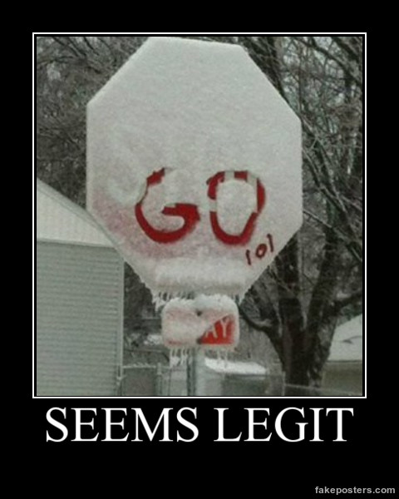
Attendees:
- James Taylor (JT)
- Neil Pickford (NCP)
- Alan Whitmore (AJW)
- David McNeaney (DMcN)
- Matt Culverwell (MC)
- Emma Chadwick (EC)
- Newton (the dog) (NTD)
- Dave Swarbrook (DS)
Apologies:
- Gareth Ekin (GE) - crops up in email conversation, but i think it is actually a spambot
- Andy Bradley (AMB) - only leaves the house for SLF
- Mike Helm (MH) - c'mon Mike - the cooing has got to wear off soon!
- Sridar Madadi (SM) - Unavailable until October - schooling the lad!
- Jes Challand (JC) - Macron championer and croissant collector, our man shares his initials with Johann Carlo - US TV actress from Quiz Show, The Sopranos and Pee-Wee's Playhouse and many more 
Agenda:
  - Okay previous minutes
  - Previous Actions
  - Treasurers Report & current portfolio update
  - Investment strategy & Homework (share updates)
  - Fantasy Shares
  - Peston
  - AOB
8. Next Meeting
1. Okay Previous Minutes What, there were minutes - no way - seriously, does anyone read this ? Blue whale fart bubbles are large enough to enclose a horse.
2. Previous Actions  2.3.1 - NCP to email TDW re: currency error on account and what is needed to trade in US - Info received but memberships require sorting with TDW - back to NCP - Ongoing  2.4.1 - Decided to invest £1,000 in funded loan - JT to organise - missed the boat - trying again - attempt 2?  3.4.1 - Discussion about which property to invest in and decided £1,000 to House Crowd and £1,000 to Savingsstream (JT to get details via MC) - Lendy - new name for Savingsstream  3.4.2 - JT tables Treat share and it was decided to buy £500 of the share - bought  3.4.3 - Sectors discussed and members chose/ were allocated areas to look at for homework - NCP to e-mail out - done with slight disagreement from Emma (didn't get the email - now added to group!)  4.3.1 - This is due to Mike not paying since December 2016 - JT to chase him up to restart S.O. and back payment of £124  4.4.1 Discussion around purchases and agreed - £500 to Lendy, £750 each of Conviviality and Blue Prism. JT and NCP to arrange. | NCP  JT  JT  NCP  JT  NCP/JT
3. Treasurers Report & current portfolio update  The club has holdings of £2170.13 for trading, £1,000 to go to House Crowd. Cash at Barclays is - low!  4.3.1 - This is due to Mike not paying since December 2016 - JT to chase him up to restart S.O. and back payment of £124  Each member has 8 units purchased at £30 each. Each unit now worth £30.77, an increase of 2.48% due, in the main, to the inclusion of previous Strangemen dividends.  Portfolio  4. Investment Strategy and Homework (Share updates)  Homework - AJW: Defence - Avon Rubber up 46% in 12mnths. Utilities: Nat Grid -special divi, through share consolidation (84p) held at 19/05. DMcN: Electronics - Pipehawk up by 81% in 12mnths. Travel: Dart grp up 13% and Easyjet up 17%, following Brexit vote fall. NCP: Healthcare - NCP showed a Deloitte doc around future growth areas - 3d printing of tech/drugs included. JT: Mining - BHP and Rio down - JT to "dig" deeper.  4.4.1 Discussion around purchases and agreed - £500 to Lendy, £750 each of Conviviality and Blue Prism. JT and NCP to arrange.  5. Fantasy Shares  James T shines with his Blue Prism this month, up 32% and takes an overall 4 point lead!  Still hoping to sit on the pointy end of the "swingometer" on 8/6 are:-  6. Peston  Blokeon plane asked for gluten free meal and got a banana. Thai Psychic medium dies after stabbing herself in heart trying to prove immortality. 12yr old pulled over driving from Kendal to Perth in Aus, after cops spotted duff bumper. PE teacher in Telford sent down for touching girl at swimming - Mr Badman! in USA 8yr old drove him and 4yr old sister to McDs as wanted a Big Mac. New jeans with unzippable ass - £85! Man buys tank on ebay for £30k and finds £2mn gold inside. Groom faced with £25k bill when jilted at alter for another woman. Marylebone school confiscated consoles from pupils homes to improve behaviour. Man eats £375 of seafood and then tries to escape in the sea - caught by jet-ski cops. Man injured after 12 seconds on fastest rollercoaster in europe as bird hits him. A wife changed her name for a Russian supermarket promotion and her husband was so angry he filled her car with concrete. Man found old betting slip in deceased relatives belongings and William Hill paid out £130 - Red Rum to win National. Kim Kardashian arse shaped lilo for sale in US! 87yr old postie in US has 1300 kids DNA test proves. Denver competition for eating 1/2lb glazed donut. Shia Lebouf movie Man Down makes £7 in UK - 1 ticket sold at cinema. Man saved whilst having heart attack in Carrington Arms Milton Keynes, but family gave bad trip advisor review as they were charged for breakfast. Manchester Royal Mail left a docket stating "really sorry your parcel may be down the loo" after leaving it in outhouse. A new cure for old age has seen hair re-growth in mice. A mini tornado in Queensland sucked up a shark and left it on main road. Stewardess lands flight from Hanover to Mallorca after crew fall ill. Uber lady driver picked up a fair and realised she was taking her to her own boyfriend. He was having an affair but said he was out of the area visiting a sick relative.  7. AOB  There were Dilberts!  8. Next Meeting  Wednesday 7th June - Usual Venue at 8.15. It was decided to just muck in on pizza payment - it is soooo much easier that way! We STILL need to go an visit Andrea in her pub in Newcastle - TBA - c'mon!  Side Note - Pizza area for future reference - 18" (254.24") - 14" (153.93") - 12" (113.09") - 9" (63.61") | JT  NCP/JT
  Symbol | Qty. | Description | Champion | Mid Price | Price Change | Market Value | Book Cost | Gain/Loss | Prev Month | Variance
  TET | 130 | TREAT | JT | 402.00p | 4.25 | 522.6 | 498.46 | 24.14 | 522.6 | 0
  Period - 7 | SHARE | EPIC | START PRICE
  Dave S | National Grid | NG.L | 1002.50
  Gareth E | BAE | BA.L | 636.50
  Mike H | Apple ($) | AAPL | 146.52
  Neil P | Avon Rubber | AVON.L | 1045.00
  James T | BHP | BLTL.L | 1131.5
  Matt C | Facebook | FB ($) | 150.17
  Andy B | Croda | CRDA | 3771.00
  Jes C | Marks and Spencer | MKS | 365.90
  Dave McN | CRTRX | CYTR ($) | 0.49
  Glynn G | Punch Taverns | PUB | 175.00
  Alan W | Diageo | DGE.L | 2256.50
  Sri M | Tristar | TSTR | 0.17

