The Strangemen IV Investment Club (HBHXX74T)
Minutes of the first meeting - Held Wednesday 22nd February, 2017 at The Mill Street Club, Mill Street, Leek.
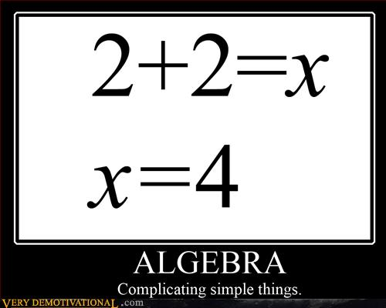
Attendees:
- James Taylor (JT)
- Neil Pickford (NCP)
- Alan Whitmore (AJW)
- David McNeaney (DMcN)
- Matt Culverwell (MC)
- Emma Chadwick (EC)
- Newton (the dog) (NTD)
- Sridar Madadi (SM)
- Dave Swarbrook (DS)
Apologies:
- Gareth Ekin (GE) - can only be a matter of time before his corpse turns up?!
- Andy Bradley (AMB) - forgotten this fella - is he Glynn Griffiths?
- Mike Helm (MH) - dad duties - needs to drive the work/life/baby balance
- Jes Challand (JC) - Trump denier and Euro-mystic, our man shares his initials with Jose Luis Chilavert, former goalkeeper for Paraguay. 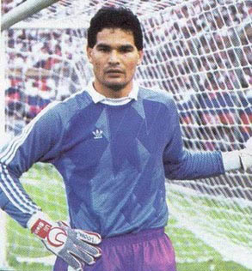
Agenda:
  - Okay previous minutes
  - Previous Actions
  - Treasurers Report & current portfolio update
  - Investment strategy & Homework (share updates)
  - Fantasy Shares
  - Peston
  - AOB
8. Next Meeting
1. Okay Previous Minutes What, there were minutes - no way - seriously, does anyone read this ? When you blush, the lining of your stomach also turns red.
2. Previous Actions  2.3.1 - NCP to email TDW re: currency error on account and what is needed to trade in US  2.4.1 - Decided to invest £1,000 in funded loan - JT to organise | NCP  JT
3. Treasurers Report & current portfolio update  The club has holdings of £2311.65 for trading. Cash at Barclays is - £150.32.  Each member has 4 units purchased at £30 - these are now worth £30.82, due, again, to the inclusion of previous Strangemen dividends. A rise of 2.74% already!  1.3.1 - JT to amend monthly transfer to £450 - Done  1.3.2 - JT to make one off transfer of £600 still in Barclays to the TDW account - Done  Side Note - Pizza area for future reference - 18" (254.24") - 14" (153.93") - 12" (113.09") - 9" (63.61")  2.3.1 - NCP to email TDW re: currency error on account and what is needed to trade in US  4. Investment Strategy and Homework (Share updates)  Chatted about Divi shares - sectors and crowd funded loans.  MC detailed his info re: crowd-funded loans No purchases made this month  2.4.1 - Decided to invest £1,000 in funded loan - JT to organise  5. Fantasy Shares  Dave McN enjoys the win this month, up 14.67% with Porvair.  Thinking of the safest place to avoid terror attacks and finding that to be the Co-Op bank are:-  6. Peston  A 75 yr old woman stuck to chair - sat in it for 7 mnths. She was 550lbs and Hasmat suits were worn by those removing her. Small cafe in France awarded Michelin star in error - inundated with foodies. End terrace in London up for £900k - 7ft wide. Italian BJ lady from last month to visit Italians resident in UK. Parents advised to destroy talking doll toy in US, as it gives answers unsecured over the net to personal questions. £600K London house - 6ft across (290ft sqaured). Benefits cheat has to sell house - claimed £37K had £35 p/week paper round. Dom Republic newspaper used pic of Alec Baldwin's Trump from SNL in error. 794lbs of Coke washed up in Norfolk! 130 space underground car park in Knightsbridge sells for £20million. Unemployed man with 90p in bank went £1.2 million overdrawn in Barclays error. Man failed driving test in 5 seconds - pulled out of car park onto wrong side of road. Woman taken to A&E as a snake stuck in her ear - in her pierced lobe! One of the engraved fivers has been found and donated to charity to help young folk.  7. AOB  No Dilberts.  MC asked if we could start a tad earlier - we will go for 8.15.  SM advised he would not be at a meeting again until October.  JT asked to sell his units in old Strangemen 3 - DMcN, DSW and NCP snaffled them up - all to pay James £110.  8. Next Meeting  TBC - probably - Wednesday 22nd or 29th March - Usual Venue at 8.15. It was decided to just muck in on pizza payment - it is soooo much easier that way! We STILL need to go an visit Andrea in her pub in Newcastle - TBA | NCP  JT
  Period -5 | SHARE | EPIC | START PRICE
  Dave S | Merlin | MERL | 501.00
  Gareth E | BAE | BA.L | 612.00
  Mike H | Apple ($) | AAPL | 137.38
  Neil P | Mortice | MORT | 92.50
  James T | Randgold | RRS | 7435
  Matt C | Amazon | AMZN | 857.57
  Andy B | Croda | CRDA | 3344.00
  Jes C | Marks and Spencer | MKS | 326.10
  Dave McN | Porvair | PRV | 510.00
  Glynn G | Punch Taverns | PUB | 177.75
  Alan W | ASOS | ASC.L | 5376.00
  Sri M | Tristar | TSTR | 0.20

