The Strangemen III.0 Investment Club (HBHXX74T)
Minutes of the thirty-ninth (and last) meeting - Held Wednesday 30th November, 2016 at The Mill Street Club, Mill Street, Leek.
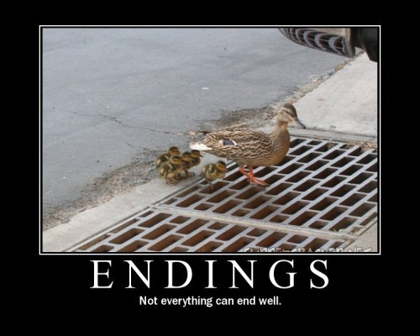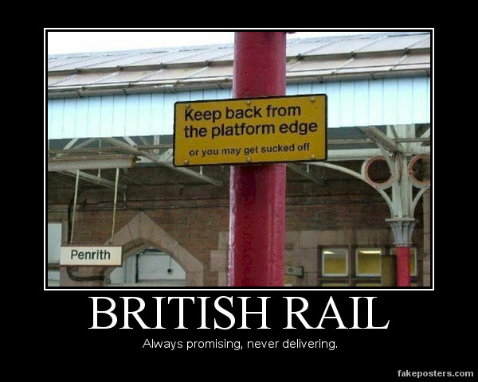
Attendees:
- James Taylor (JT)
- Neil Pickford (NCP)
- Dave Swarbrook (DS)
- Alan Whitmore (AJW)
- Mike Helm (MH)
- David McNeaney (DMcN) - denying the gout, but not the thrush or crabs?!
- Sridar Madadi (SM) - Having it large in Malaga apparently last month - my error I tough he was Trump baiting in the US of A!
Apologies:
- Gareth Ekin (GE) - Lives in Cheshire and has deleted Staffordshire from his memory
- Andy Bradley (AMB) - old man syndrome - creaky bones!
- Jes Challand (JC) - Negotiating a Strangemen presence in the post Brexit world, our man shares his initials with John Curtin, the 14th Prime Minister of Australia, serving from 1941 to 1945. 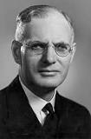
Agenda:
  - Okay previous minutes
  - Previous Actions
  - Treasurers Report & current portfolio update
  - Investment strategy & Homework (share updates)
  - Fantasy Shares
  - Peston
  - AOB
8. Next Meeting
1. Okay Previous Minutes What, there were minutes - no way - seriously, does anyone read this ? Donald Duck comics were banned from Finland because he doesn't wear any pants.
2. Previous Actions
38.4.1 - Sell Flybe and Easyjet - done
39.8.1 - Elect officials again - to be done for Strangemen IV
3. Treasurers Report & current portfolio update
£8,443.38 in TDW, £465.32 in Barc. Flybe sold £402.22 on 27/10 - EasyJet sold £37.97 on 27/10.
 |  | Meeting 26 |  | Meeting 27 |  | Meeting 28 |  | Meeting 29 |  | Meeting 30 |  | Meeting 31 |  | Meeting 32 |  | Meeting 33 |  | Meeting 34 |  | Meeting 35 |  | Meeting 36 |  |  | Meeting 37 | Meeting 38 | Meeting 39
Club £ |  | £14,667.78 |  | £15,032.57 |  | £15,248.15 |  | £15,552.17 |  | £16,627.02 |  | £16,842.94 |  | £16,920.09 |  | £17,537.32 |  | £17,997.10 |  | £18,455.46 |  | £19,983.65 |  |  | £12,984.80 | £12,878.64 | £13,009.82
Std units |  | 35 |  | 36 |  | 37 |  | 38 |  | 39 |  | 40 |  | 42 |  | 43 |  | 44 |  | 45 |  | 46 |  |  | 27 | 28 | 30
Tot input |  | £12,900.00 |  | £13,200.00 |  | £13,500.00 |  | £13,800.00 |  | £14,100.00 |  | £14,400.00 |  | £15,000.00 |  | £15,300.00 |  | £15,600.00 |  | £15900 |  | £16,200.00 |  |  | £16,200.00 | £16,500.00 | £16,800.00
member input(*) |  | £1,050.00 |  | £1,080.00 |  | £1,110.00 |  | £1,140.00 |  | £1,170.00 |  | £1,200.00 |  | £1,260.00 |  | £1,290.00 |  | £1,320.00 |  | £1350 |  | £1,380.00 |  |  | £810.00 | £840.00 | £900.00
now worth |  | £1,193.89 |  | £1,193.89 |  | £1,253.74 |  | £1,284.74 |  | £1,379.69 |  | £1,403.58 |  | £1,421.29 |  | £1,478.64 |  | £1,478.64 |  | £1,566.97 |  | £1,566.97 |  |  | £1,001.68 | £1,001.67 | £1,027.09
% increase |  | 13.7 |  | 13.88 |  | 12.95 |  | 12.7 |  | 17.92 |  | 16.96 |  | 12.8 |  | 14.62 |  | 15.37 |  | 16.07 |  | 23.36 |  |  | 23.66 | 19.25 | 14.12
total units |  | 430 |  | 440 |  | 450 |  | 460 |  | 470 |  | 480 |  | 500 |  | 510 |  | 520 |  | 530 |  | 540 |  |  | 350 | 360 | 380
unit worth |  | £34.11 |  | £34.16 |  | £33.88 |  | £33.81 |  | £35.38 |  | £35.09 |  | £33.84 |  | £34.39 |  | £34.61 |  | £34.82 |  | £37.01 |  |  | £37.10 | £35.77 | £34.24
 | Name |  | Units |  | Invested |  | Value |  | Rise (£) |  | Rise (%) |  | Name |  | Units |  | Invested |  | Value |  | Rise (£) |  | Rise (%)
 | Alan W |  | 62 |  | 1877.6 |  | 2122.65 |  | £245.05 |  | 13.05 |  | Dave M |  | 38 |  | 1144.4 |  | 1300.98 |  | £156.58 |  | 13.68
 | Dave S |  | 46 |  | 1388.8 |  | 1574.87 |  | £186.07 |  | 13.40 |  | Mike H |  | 30 |  | 900 |  | 1027.09 |  | £127.09 |  | 14.12
 | Sri M |  | 38 |  | 1144.4 |  | 1300.98 |  | £156.58 |  | 13.68 |  | James T |  | 30 |  | 900 |  | 1027.09 |  | £127.09 |  | 14.12
 | Andy B |  | 38 |  | 1144.4 |  | 1300.98 |  | £156.58 |  | 13.68 |  | Jes C |  | 30 |  | 900 |  | 1027.09 |  | £127.09 |  | 14.12
 | Neil P |  | 38 |  | 1144.4 |  | 1300.98 |  | £156.58 |  | 13.68 |  | Gareth E |  | 30 |  | 900 |  | 1027.09 |  | £127.09 |  | 14.12

4. Investment strategy & Homework (share updates)
Symbol | Qty. | Description | Champion | Mid Price | Price Change | Market Value | Book Cost | Gain/Loss | Prev Month | Variance
RMG | 464 | ROYAL MAIL PLC | SM | 459.70p | -4.5 | 2133.01 | 2596.88 | -463.87 | 2174.3 | -41.29
VOD | 679 | VODAFONE | AMB | 190.50p | -0.9 | 1293.5 | 1497.88 | -204.38 | 1316.58 | -23.08
WPG | 324 | WORLDPAY GRP PLC | NCP | 259.20p | -0.6 | 839.81 | 996.98 | -157.17 | 872.21 | -32.4

Homework - Royal Mail - letters business down. euro business up. potential increase in divi. Vodafone - n/a. World Pay - buy rating and adding partners to portfolio of deals.
Meeting 19 - brief discussion about Tullow Oil, EasyJet, De La Rue, Virgin Money, Stephen O'Hara and microbes to change health as a supplement.
Meeting 20 - discussed what to sell to fund the shortfall in cash to pay Matt - Tesco, Alent and Colefax placed on Neil P watch
Meeting 21 - discussed, Easyjet, Kaz minerals, BHP Billiton, Arm, Prudential, Unilever, Sabmiller, Trainline and Halfords.
Meeting 22 - discussed - VPC IPO, SCS IPO, DFS IPO, Center Parcs IPO, Aldermere IPO, Revolution Bars IPO. Laing IPO, Alumasc, Wentworth, United Utilities, Inland Homes, Afran and the divis on Vodafone, Centrica, Sky and BT. Sri suggested 10-20% of the portfolio should be high risk.
Meeting 23 - discussed - LSE, ARM, Persimmon, eg Solutions and BT.
Meeting 24 - discussed - Diageo, Unilever, Reckit Benkhauser for divis potentially. No purchases - pre election!
Meeting 25 - discussed IPOs - Easyproperty and Purple Bricks. Also Burberry. - no purchase decided.
Meeting 26 - discussed Astra Zeneca, Glaxo, BP, Centrica, Shell, Vodafone, Sabmiller, Dignity and Britvic. Along with reinvest in Royal Mail and Randgold.
Meeting 27 - Vodafone discussed and buying into existing shares from portfolio.
Meeting 28 - more of the same - FTSE is on its arse - opportunity?
Meeting 29 - Capita, Flybe, Synthomer, EasyProperty?
Meeting 30 - More Astra Zeneca and Worldpay?
Meeting 31 - no buys - sit on cash
Meeting 32 - no buys - sit pretty - bloody Brexit!
Meeting 33 - Nowt
Meeting 34 - Nowt
Meeting 35 - Nowt - Brexit!!!!!!!!!
Meeting 36 - Sell Tate and Lyle and Sell Glaxo and set a low limit on Sabmiller
Meeting 37 - Syria and Korea - stick - no purchases.
Meeting 38 - no talk of buying all talk of sell!
Meeting 39 - The end times. It was agreed to close this version of Strangemen at 30/11. All 3 remaining shares (4 with Punch) and the associated dividends will be the solely owned and sold and paid out to only Strangemen 3.0 members (as of the date 30/11/2016) in the future should the opportunity arise.
It was agreed that sleeping members would be invited to Strangemen IV and they would be charged the same £31 per month as active members, with the £1 over the £30 being a contribution to running costs - paper, Conservative Club Membership etc, instead of the monthly competition, as their membership status would be "sleeping" - hence not communicated with on a regular decision based basis.

38.3.1 - Sell Flybe and Easyjet - Done

Side Note - Pizza area for future reference - 18" (254.24") - 14" (153.93") - 12" (113.09") - 9" (63.61")

5. Fantasy Shares
Last year's Spoon man is off and running! Gareth mops up the points with an 11.70% rise on BAE.
If it's like 2016, they're wondering which Strangemen member will die first this month - runners and riders are:-
Period -3 | SHARE | EPIC | START PRICE
Dave S | ARM  Softbank (JP) | 9984:TYO | 6874.00
Gareth E | BAE | BA.L | 599.00
Mike H | Apple ($) | AAPL | 110.37
Neil P | Prudential | PRU.L | 1539.00
James T | Rio Tinto | RIO | 3024.5
Matt C | AMD | AMD ($) | 8.92
Andy B | Nighthawk Energy | HAWK.L | 1.39
Jes C | Marks and Spencer | MKS | 326.10
Dave McN | Nano Vibronix | NAOV | 5.90
Glynn G | Punch Taverns | PUB | 117.50
Alan W | ASOS | ASC.L | 5020.00
Sri M | Hargreaves Lansdown | HL.L | 1169.00
6. Peston
A woman farting during her op burns her cervix - ignited a laser. Parrot exposed affair to wife by repeating flirty phrases hubby used on maid. A man in Wilko's cut off his toe and started to eat it! We were shown hand made vagina bags for keeping your coins in. 3 folk in a USA care home injured by mad squirrel. Disabled driver painted own parking bay and was fined. New silly sausage game for kids - looks like a sex toy. Man from the Canadian mint stole £133K of gold over the years - up his ass. Vegan single mum of 2 drinks a semen smoothie every day. A reported large rabbit found in Newhall was actually a sex toy. Cardiff's xmas tree is only 40 ft tall, not 40meteres as thought. a translation error in the 3 year lease deal from China occurred. Ed Sheeran had face cut by Princess Beatrice with a sword whilst playing knighthoods. A Japanese theme park has taken up an ice rink that featured fish frozen in the ice due to complaints. The world's first cheese advent calendar has hit the shops. Belgium and the Netherlands have had to redraw their borders due to a river changing course

7. AOB
Dilberts
Next time we are Strangemen IV
8. Next Meeting
Will be the first meeting of Strangemen IV - Wednesday 25th January 2016 - Usual Venue!
It was decided to just muck in on pizza payment - it is soooo much easier that way!
We need to go an visit Andrea in her pub in Newcastle - TBA

