The Strangemen III.0 Investment Club (HBHXX74T)
Minutes of the thirty-eighth meeting - Held Wednesday 26th October, 2016 at The Mill Street Club, Mill Street, Leek.
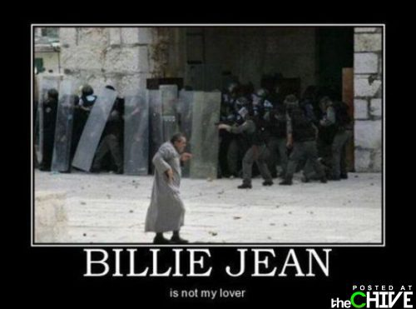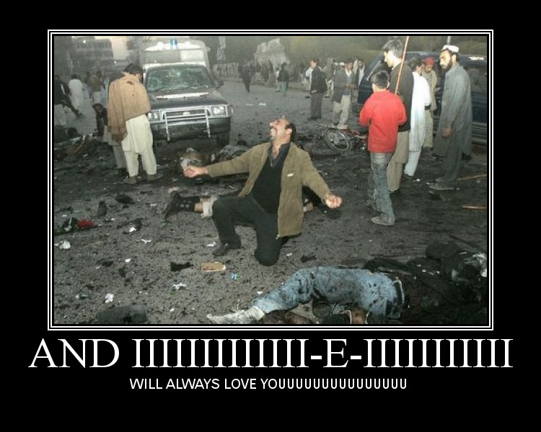
Attendees:
- James Taylor (JT)
- Neil Pickford (NCP)
- Dave Swarbrook (DS)
- Alan Whitmore (AJW)
- Mike Helm (MH) - Shorted and on-site!
- David McNeaney (DMcN) - but suffering from gout, thrush or crabs - one of these.
Apologies:
- Sridar Madadi (SM) - we texted him and he was on holiday in the USA - Trump insurgent
- Sri's Dad (Mr SM) - lying down belching following excessive bitter consumption
- Gareth Ekin (GE) - incommunicado - also a track from Marillion's fourth album - "Clutching at Straws"
- Andy Bradley (AMB) - Work related shenanigans - must run the gaff by now?
- Jes Challand (JC) - Our "European" correspondent is still watching from afar, cheese chomping and sharing his initials with Julian Chagrin - twice Oscar nom's comedy actor and mime. Also the secret lemonade drinker in the R-White's ads from the 1970's and 80's. 
Agenda:
  - Okay previous minutes
  - Previous Actions
  - Treasurers Report & current portfolio update
  - Investment strategy & Homework (share updates)
  - Fantasy Shares
  - Peston
  - AOB
8. Next Meeting
- 1. Okay Previous Minutes What, there were minutes - no way - seriously, does anyone read this ? The person who invented the Frisbee was cremated and made into frisbees after he died!
2. Previous Actions  35.4.1 - Meeting 36 - Sell Tate and Lyle and Sell Glaxo and set a low limit on Sabmiller - Update from previous is that Sabmiller autosold, as part of corporate action  38.4.1 - Sell Flybe and Easyjet | NCP
3. Treasurers Report & current portfolio update  £7343.03 in TDW, £453.32 in Barc. Divi £2.10 from WorldPay  4. Investment strategy & Homework (share updates)  Homework - Easy - ana;ysts move to sell. Profit warning. Flybe - fuel costs -profits hit. extending Avios rewards scheme. Royal Mail - taking loans to make purchases. Attacked in the press (D Mail) for not tackling fraud post. Voda - £4.6m fine for poor customer service. Worldpay - implicated loosely in Israeli fraud and tying up a deal with apple pay for voice phone use.  Meeting 19 - brief discussion about Tullow Oil, EasyJet, De La Rue, Virgin Money, Stephen O'Hara and microbes to change health as a supplement.  Meeting 20 - discussed what to sell to fund the shortfall in cash to pay Matt - Tesco, Alent and Colefax placed on Neil P watch  Meeting 21 - discussed, Easyjet, Kaz minerals, BHP Billiton, Arm, Prudential, Unilever, Sabmiller, Trainline and Halfords.  Meeting 22 - discussed - VPC IPO, SCS IPO, DFS IPO, Center Parcs IPO, Aldermere IPO, Revolution Bars IPO. Laing IPO, Alumasc, Wentworth, United Utilities, Inland Homes, Afran and the divis on Vodafone, Centrica, Sky and BT. Sri suggested 10-20% of the portfolio should be high risk.  Meeting 23 - discussed - LSE, ARM, Persimmon, eg Solutions and BT.  Meeting 24 - discussed - Diageo, Unilever, Reckit Benkhauser for divis potentially. No purchases - pre election!  Meeting 25 - discussed IPOs - Easyproperty and Purple Bricks. Also Burberry. - no purchase decided.  Meeting 26 - discussed Astra Zeneca, Glaxo, BP, Centrica, Shell, Vodafone, Sabmiller, Dignity and Britvic. Along with reinvest in Royal Mail and Randgold.  Meeting 27 - Vodafone discussed and buying into existing shares from portfolio.  Meeting 28 - more of the same - FTSE is on its arse - opportunity?  Meeting 29 - Capita, Flybe, Synthomer, EasyProperty?  Meeting 30 - More Astra Zeneca and Worldpay?  Meeting 31 - no buys - sit on cash  Meeting 32 - no buys - sit pretty - bloody Brexit!  Meeting 33 - Nowt  Meeting 34 - Nowt  Meeting 35 - Nowt - Brexit!!!!!!!!!  Meeting 36 - Sell Tate and Lyle and Sell Glaxo and set a low limit on Sabmiller  Meeting 37 - Syria and Korea - stick - no purchases.  Meeting 38 - no talk of buying all talk of sell!  38.3.1 - Sell Flybe and Easyjet  Side Note - Pizza area for future reference - 18" (254.24") - 14" (153.93") - 12" (113.09") - 9" (63.61")  5. Fantasy Shares  Another year, another monthly win for Sri M - up 20% with Tri-star Resources.  Looking beautiful in Donald Trump hairstyles this month are:-  6. Peston  Loads - Venezuelan prisoner eaten during a siege. Ryanair customer fined £2.7K for shitting on runway in Italy. Nutmeg became the world's oldest cat at 31 - 140 human years. Young man killed Pokemon hunting. 24yr old marries 68yr old millionaire - her grandad. Siberian teen survives 23 storey fall whilst doing pull-ups. 1mtr wide barrel sized wasp nest found in Northampton house. Dam workers in Sa America found a 400kg 33ft long anaconda! Busty mum banned from Thorpe park due to her big knockers. Largest piece of jade found - 175 tonnes - £145million. During hurricane Matthew a missing lady was located as she dialled for a Papa John's pizza. Youngest ever airline pilot - 19yrs old from Reigate. Youtube prankster drilled headphone socket in iphone7 and folk copied. Indian man swallowed 40 knives as he liked the taste. When joining Palace, Christian Benteke tweeted he had joined Burnley. Viral video of Australian spider carrying a dead mouse.  7. AOB  Dilberts  NCP read out note that TDI now sold to iii  JT - advised that Fay's parents interested in being silent members  Re-baseline discussion next time.  8. Next Meeting  Wednesday 30th November, 2016 at Mill Street Club, 210 Mill Street – with Pizza. Biggest 18" in Leek - Still - even now! They keep texting me to tell me! Stop it, enough is enough Shiraz!  Christ knows who bought the Pizza again!? (?) bought the Pizza (-1) , (Neil - 2), (Alan and James -3),(Gareth and Sri -4), (Dave and Dave -5) (Neil and Mike -6 gen) | NCP
   |  | Meeting 25 |  | Meeting 26 |  | Meeting 27 |  | Meeting 28 |  | Meeting 29 |  | Meeting 30 |  | Meeting 31 |  | Meeting 32 |  | Meeting 33 |  | Meeting 34 |  | Meeting 35 |  |  | Meeting 36 | Meeting 37 | Meeting 38
  Club £ |  | £14,330.77 |  | £14,667.78 |  | £15,032.57 |  | £15,248.15 |  | £15,552.17 |  | £16,627.02 |  | £16,842.94 |  | £16,920.09 |  | £17,537.32 |  | £17,997.10 |  | £18,455.46 |  |  | £19,983.65 | £12,984.80 | £12,878.64
  Std units |  | 34 |  | 35 |  | 36 |  | 37 |  | 38 |  | 39 |  | 40 |  | 42 |  | 43 |  | 44 |  | 45 |  |  | 46 | 27 | 28
  Tot input |  | £12,600.00 |  | £12,900.00 |  | £13,200.00 |  | £13,500.00 |  | £13,800.00 |  | £14,100.00 |  | £14,400.00 |  | £15,000.00 |  | £15,300.00 |  | £15,600.00 |  | £15900 |  |  | £16,200.00 | £16,200.00 | £16,500.00
  member input(*) |  | £1,020.00 |  | £1,050.00 |  | £1,080.00 |  | £1,110.00 |  | £1,140.00 |  | £1,170.00 |  | £1,200.00 |  | £1,260.00 |  | £1,290.00 |  | £1,320.00 |  | £1350 |  |  | £1,380.00 | £810.00 | £840.00
  now worth |  | £1,160.11 |  | £1,193.89 |  | £1,193.89 |  | £1,253.74 |  | £1,284.74 |  | £1,379.69 |  | £1,403.58 |  | £1,421.29 |  | £1,478.64 |  | £1,478.64 |  | £1,566.97 |  |  | £1,566.97 | £1,001.68 | £1,001.67
  % increase |  | 13.74 |  | 13.7 |  | 13.88 |  | 12.95 |  | 12.7 |  | 17.92 |  | 16.96 |  | 12.8 |  | 14.62 |  | 15.37 |  | 16.07 |  |  | 23.36 | 23.66 | 19.25
  total units |  | 420 |  | 430 |  | 440 |  | 450 |  | 460 |  | 470 |  | 480 |  | 500 |  | 510 |  | 520 |  | 530 |  |  | 540 | 350 | 360
  unit worth |  | £34.12 |  | £34.11 |  | £34.16 |  | £33.88 |  | £33.81 |  | £35.38 |  | £35.09 |  | £33.84 |  | £34.39 |  | £34.61 |  | £34.82 |  |  | £37.01 | £37.10 | £35.77
   | Name |  | Units |  | Invested |  | Value |  | Rise (£) |  | Rise (%) |  | Name |  | Units |  | Invested |  | Value |  | Rise (£) |  | Rise (%)
   | Alan W |  | 60 |  | £1,817.60 |  | £2,146.44 |  | £328.84 |  | 18.09 |  | Dave M |  | 36 |  | £1,084.40 |  | £1,287.86 |  | £203.46 |  | 18.76
   | Dave S |  | 44 |  | £1,328.80 |  | £1,574.06 |  | £245.26 |  | 18.46 |  | Mike H |  | 28 |  | £840.00 |  | £1,001.67 |  | £161.67 |  | 19.25
   | Sri M |  | 36 |  | £1,084.40 |  | £1,287.86 |  | £203.46 |  | 18.76 |  | James T |  | 28 |  | £840.00 |  | £1,001.67 |  | £161.67 |  | 19.25
   | Andy B |  | 36 |  | £1,084.40 |  | £1,287.86 |  | £203.46 |  | 18.76 |  | Jes C |  | 28 |  | £840.00 |  | £1,001.67 |  | £161.67 |  | 19.25
   | Neil P |  | 36 |  | £1,084.40 |  | £1,287.86 |  | £203.46 |  | 18.76 |  | Gareth E |  | 28 |  | £840.00 |  | £1,001.67 |  | £161.67 |  | 19.25
  Qty. | Description | Champion | Mid Price | Price Change | Market Value | Book Cost | Gain/Loss | Prev Month | Variance | Qty.
  Symbol | Qty. | Description | Champion | Mid Price | Price Change | Market Value | Book Cost | Gain/Loss | Prev Month | Variance
  EZJ | 44 | EASYJET | MH | 944.00p | 19 | 415.36 | 744.05 | -328.69 | 453.64 | -38.28
  FLYB | 1123 | FLYBE GROUP PLC | AJW | 37.00p | -3.5 | 415.51 | 999.19 | -583.68 | 583.96 | -168.45
  RMG | 464 | ROYAL MAIL PLC | SM | 487.00p | -2.3 | 2259.68 | 2596.88 | -337.2 | 2417.44 | -157.76
  VOD | 679 | VODAFONE | AMB | 226.25p | 0.25 | 1536.24 | 1497.88 | 38.36 | 1520.96 | 15.28
  WPG | 324 | WORLDPAY GRP PLC | NCP | 280.50p | -1.4 | 908.82 | 996.98 | -88.16 | 984.96 | -76.14
  Period -2 | SHARE | EPIC | START PRICE
  Dave S | EDF (€) | EDF.PA | 10.32
  Gareth E | BAE | BA.L | 538.50
  Mike H | Apple ($) | AAPL | 115.39
  Neil P | LSE | LSE.L | 2810.00
  James T | Royal Mail | RMG | 487.6
  Matt C | Amazon | AMZN ($) | 831.24
  Andy B | Standard Life | SL.L | 335.40
  Jes C | Marks and Spencer | MKS | 340.10
  Dave McN | Dominos Pizza | DOM.L | 336.20
  Glynn G | Punch Taverns | PUB | 105.00
  Alan W | SSE | SSE.L | 1579.00
  Sri M | Tri-star Resources | TSTR | 0.12

