The Strangemen III.0 Investment Club (HBHXX74T)
Minutes of the thirty-seventh meeting - Held Wednesday 21st September, 2016 at The Mill Street Club, Mill Street, Leek.
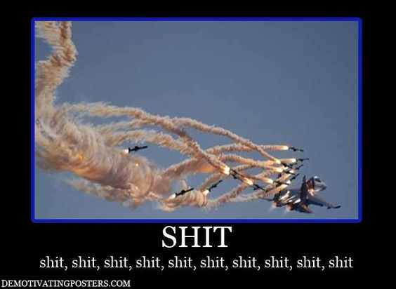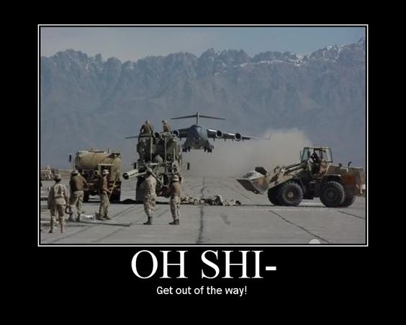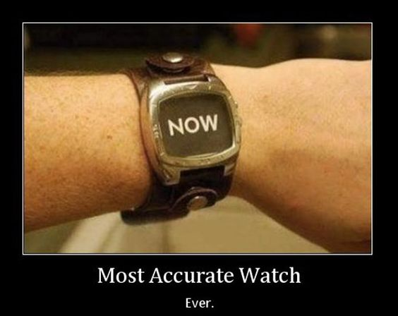
Attendees:
- James Taylor (JT)
- Neil Pickford (NCP)
- Dave Swarbrook (DS)
- Sridar Madadi (SM)
- Sri's Dad (Mr SM)
- Alan Whitmore (AJW)
Apologies:
- David McNeaney (DMcN) - In Hong Kong Ding Dong
- Mike Helm (MH) - Poorly girl!
- Gareth Ekin (GE) - Piltdown Man
- Andy Bradley (AMB) - The Shits!
- Jes Challand (JC) - Our "European" correspondent is still "over there", kicking migrant kids our way and sharing his initials with Joe Carnahan - Director of Narc and Mission Impossible 3 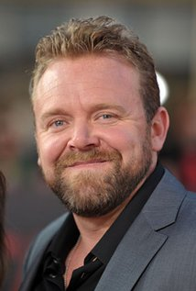
Agenda:
  - Okay previous minutes
  - Previous Actions
  - Treasurers Report & current portfolio update
  - Investment strategy & Homework (share updates)
  - Fantasy Shares
  - Peston
  - AOB
8. Next Meeting
1. Okay Previous Minutes What, there were minutes - no way - seriously, does anyone read this ? Human saliva has a boiling point three times that of regular water

2. Previous Actions
35.4.1 - Meeting 36 - Sell Tate and Lyle and Sell Glaxo and set a low limit on Sabmiller - just in case - done
35.4.2 - JT to look at cash-out values - done
35.4.3 - NCP to e-mail info out and get it moving - done

3. Treasurers Report & current portfolio update
£5,781.34 in TDW, £238.32 in Barc. Divi £60.19 Tate - 29/9, £70.06 Royal Mail - £29/7, £52.75 Voda - 31/8, £19.93 Sab - 12/8, £30.22 Astra - 12/9. Sold Tate £2,121.17 - 21/7, Glaxo £1,129.54 - 21/7, Astra £2,224.24 - 16/9
 |  | Meeting 24 |  | Meeting 25 |  | Meeting 26 |  | Meeting 27 |  | Meeting 28 |  | Meeting 29 |  | Meeting 30 |  | Meeting 31 |  | Meeting 32 |  | Meeting 33 |  | Meeting 34 |  |  | Meeting 35 | Meeting 36 | Meeting 37
Club £ |  | £13,353.02 |  | £14,330.77 |  | £14,667.78 |  | £15,032.57 |  | £15,248.15 |  | £15,552.17 |  | £16,627.02 |  | £16,842.94 |  | £16,920.09 |  | £17,537.32 |  | £17,997.10 |  |  | £18,455.46 | £19,983.65 | £12,984.80
Std units |  | 33 |  | 34 |  | 35 |  | 36 |  | 37 |  | 38 |  | 39 |  | 40 |  | 42 |  | 43 |  | 44 |  |  | 45 | 46 | 27
Tot input |  | £12,300.00 |  | £12,600.00 |  | £12,900.00 |  | £13,200.00 |  | £13,500.00 |  | £13,800.00 |  | £14,100.00 |  | £14,400.00 |  | £15,000.00 |  | £15,300.00 |  | £15,600.00 |  |  | £15900 | £16,200.00 | £16,200.00
member input(*) |  | £990.00 |  | £1,020.00 |  | £1,050.00 |  | £1,080.00 |  | £1,110.00 |  | £1,140.00 |  | £1,170.00 |  | £1,200.00 |  | £1,260.00 |  | £1,290.00 |  | £1,320.00 |  |  | £1350 | £1,380.00 | 810
now worth |  | £1,122.24 |  | £1,160.11 |  | £1,193.89 |  | £1,193.89 |  | £1,253.74 |  | £1,284.74 |  | £1,379.69 |  | £1,403.58 |  | £1,421.29 |  | £1,478.64 |  | £1,478.64 |  |  | £1,566.97 | £1,566.97 | £1,001.68
% increase |  | 13.36 |  | 13.74 |  | 13.7 |  | 13.88 |  | 12.95 |  | 12.7 |  | 17.92 |  | 16.96 |  | 12.8 |  | 14.62 |  | 15.37 |  |  | 16.07 | 23.36 | 23.66
total units |  | 410 |  | 420 |  | 430 |  | 440 |  | 450 |  | 460 |  | 470 |  | 480 |  | 500 |  | 510 |  | 520 |  |  | 530 | 540 | 350
unit worth |  | £34.01 |  | £34.12 |  | £34.11 |  | £34.16 |  | £33.88 |  | £33.81 |  | £35.38 |  | £35.09 |  | £33.84 |  | £34.39 |  | £34.61 |  |  | £34.82 | £37.01 | £37.10
 | Name |  | Units |  | Invested |  | Value |  | Rise (£) |  | Rise (%) |  | Name |  | Units |  | Invested |  | Value |  | Rise (£) |  | Rise (%)
 | Alan W |  | 59 |  | £1,787.60 |  | £2,188.87 |  | £401.27 |  | 22.45 |  | Dave M |  | 35 |  | £1,054.40 |  | £1,298.48 |  | £244.08 |  | 23.15
 | Dave S |  | 43 |  | £1,298.80 |  | £1,595.28 |  | £296.48 |  | 22.83 |  | Mike H |  | 27 |  | £810.00 |  | £1,001.68 |  | £191.68 |  | 23.66
 | Sri M |  | 35 |  | £1,054.40 |  | £1,298.48 |  | £244.08 |  | 23.15 |  | James T |  | 27 |  | £810.00 |  | £1,001.68 |  | £191.68 |  | 23.66
 | Andy B |  | 35 |  | £1,054.40 |  | £1,298.48 |  | £244.08 |  | 23.15 |  | Jes C |  | 27 |  | £810.00 |  | £1,001.68 |  | £191.68 |  | 23.66
 | Neil P |  | 35 |  | £1,054.40 |  | £1,298.48 |  | £244.08 |  | 23.15 |  | Gareth E |  | 27 |  | £810.00 |  | £1,001.68 |  | £191.68 |  | 23.66

4. Investment strategy & Homework (share updates)
Qty. | Description | Champion | Mid Price | Price Change | Market Value | Book Cost | Gain/Loss | Prev Month | Variance | Qty.
EZJ | 44 | EASYJET | MH | 1031.00p | -10 | 453.64 | 744.05 | -290.41 | 473.44 | -19.8
FLYB | 1123 | FLYBE GROUP PLC | AJW | 52p | 1 | 583.96 | 999.19 | -415.23 | 429.55 | 154.41
RMG | 464 | ROYAL MAIL PLC | SM | 521.00p | 1.5 | 2417.44 | 2596.88 | -179.44 | 2378 | 39.44
SAB | 28 | SABMILLER | DMcN | 4437.50p | -5 | 1242.5 | 963.58 | 278.92 | 1224.44 | 18.06
VOD | 679 | VODAFONE | AMB | 224.00p | 1.3 | 1520.96 | 1497.88 | 23.08 | 1590.22 | -69.26
WPG | 324 | WORLDPAY GRP PLC | NCP | 304.00p | 0.5 | 984.96 | 996.98 | -12.02 | 1001.16 | -16.2

Homework - EAsy - Brexit impact on airline values, pilot dispute over hours. Flybe - more flights from Sheffield and Doncaster to 10 euro destinations. Royal Mil - upgraded by JP Morgan, looking at more euro markets. Sabmiller - corp action. Vodafone - nuisance call blocking tech, TV supplier - soft launch in Oct 2016. Worldpay - sold off 350 million shares, advising that cash is on its way out - contactless.

Meeting 15 - more of same, TSB, TESLA, Arrow, Cineworld, Bellway, Bunzl

Meeting 16 - a chat about supermarkets

Meeting 17 - mort portfolio stuff, Just Eat, Colefax and Sell Vodafone
Meeting 18 - Lloyds - possible 7% divi by 2016, BHP Biliton, Glencore
Meeting 19 - brief discussion about Tullow Oil, EasyJet, De La Rue, Virgin Money, Stephen O'Hara and microbes to change health as a supplement.
Meeting 20 - discussed what to sell to fund the shortfall in cash to pay Matt - Tesco, Alent and Colefax placed on Neil P watch
Meeting 21 - discussed, Easyjet, Kaz minerals, BHP Billiton, Arm, Prudential, Unilever, Sabmiller, Trainline and Halfords.
Meeting 22 - discussed - VPC IPO, SCS IPO, DFS IPO, Center Parcs IPO, Aldermere IPO, Revolution Bars IPO. Laing IPO, Alumasc, Wentworth, United Utilities, Inland Homes, Afran and the divis on Vodafone, Centrica, Sky and BT. Sri suggested 10-20% of the portfolio should be high risk.
Meeting 23 - discussed - LSE, ARM, Persimmon, eg Solutions and BT.
Meeting 24 - discussed - Diageo, Unilever, Reckit Benkhauser for divis potentially. No purchases - pre election!
Meeting 25 - discussed IPOs - Easyproperty and Purple Bricks. Also Burberry. - no purchase decided.
Meeting 26 - discussed Astra Zeneca, Glaxo, BP, Centrica, Shell, Vodafone, Sabmiller, Dignity and Britvic. Along with reinvest in Royal Mail and Randgold.
Meeting 27 - Vodafone discussed and buying into existing shares from portfolio.
Meeting 28 - more of the same - FTSE is on its arse - opportunity?
Meeting 29 - Capita, Flybe, Synthomer, EasyProperty?
Meeting 30 - More Astra Zeneca and Worldpay?
Meeting 31 - no buys - sit on cash
Meeting 32 - no buys - sit pretty - bloody Brexit!
Meeting 33 - Nowt
Meeting 34 - Nowt
Meeting 35 - Nowt - Brexit!!!!!!!!!
Meeting 36 - Sell Tate and Lyle and Sell Glaxo and set a low limit on Sabmiller
Meeting 37 - Syria and Korea - stick - no purchases.

5. Fantasy Shares
Winner with a huge 19.45% hike in Standard Life, was Andy Brad. And this helped not a jot to secure him last place overall in the annual competition! See table below - Dave McN, Mike H and Dave S take the Gold, Silver and Bronze. Andy has got "Wood" as it were with the spoons - wrestling them away from the boy Ekin!
Reset and starting from scratch are these men who are not looking to feel the wrath of Gary Lineker this month:-
Period -1 | SHARE | EPIC | START PRICE | Dave McN | 94 | 1st
Dave S | Playtech | PTEC | 905.50 | Mike H | 87 | 2nd
Gareth E | BAE | BA.L | 536.00 | Dave S | 82 | 3rd
Mike H | Apple ($) | AAPL | 114.35 | Matt C | 76 | 4th
Neil P | Colefax | CFX | 455.00 | Neil P | 75 | 5th
James T | Rio Tinto | RIO.L | 2524.5 | Gareth E | 73 | 6th
Matt C | Deutsche Bank | DBK.DE | 11.31 | James T | 73 | 7th
Andy B | Standard Life | SL.L | 356.40 | Alan W | 71 | 8th
Jes C | Marks and Spencer | MKS | 318.80 | Sri M | 65 | 9th
Dave McN | Valeant Pharma | VRX ($) | 27.32 | Jes C | 56 | 10th
Glynn G | Punch Taverns | PUB | 107.00 | Andy B | 50 | Spoons
Alan W | SSE | SSE.L | 1531.00
Sri M | Tri-star Resources | TSTR | 0.10
6. Peston
Big Al was back and offered - fisherman finds £76million pearl (77lbs) in the Philipines. Reykjavik - elfs rock uncovered and holding up roadworks. £1700 (3.3lb) truffle found. Lawnmower triggers northern lights sensor. hedge nicked in Kent - 127 shrubs gone overnight. Norway looking to gift a mountain to Finland for a century of independence from Russia. Complaints after a judge verbally abused a defendant in Chelmsford. Straight journo hitting up gay athletes via app at Rio Olympics. Giles Hemworth was given a tax code of £14trillion by HMRC. Woman posted pics black duck on social media - twas a dildo! Australia is moving. GPS co-ords being altered by 7cm ea year as 5ft out. Asian hornets in UK post Brexit killing honey bees in Alderney and Jersey. Tesco Truro closed due to a pigeon attacking folk in store. 370KG found in Coca-cola factory in France. a horror room in Leytonstone for sale on Right moves for £1.2 million. Pensioner in NYC took to hospital by fully body-suited CDC folk as his apartment had 350 pigeons and was 2ft deep in droppings. Pub in Bruges piping beer direct from the brewery. A second device didn't explode in NYC as the case it was in was knicked!
7. AOB
37.7.1 - Sabmiller corp action choice - full value @ £45 per share or % shares value and shares in new US company - voted, chose the cash!
8. Next Meeting
Wednesday 26th October, 2016 at Mill Street Club, 210 Mill Street – with Pizza. Biggest 18" in Leek - Still - even now! They keep texting me to tell me! Stop it, enough is enough Shiraz!
Christ knows who bought the Pizza again!? (?) bought the Pizza (-1) , (Neil - 2), (Alan and James -3),(Gareth and Sri -4), (Dave and Dave -5) (Neil and Mike -6 gen)

