The Strangemen III.0 Investment Club (HBHXX74T)
Minutes of the thirty-sixth meeting - Held Wednesday 20th July, 2016 at The Mill Street Club, Mill Street, Leek.
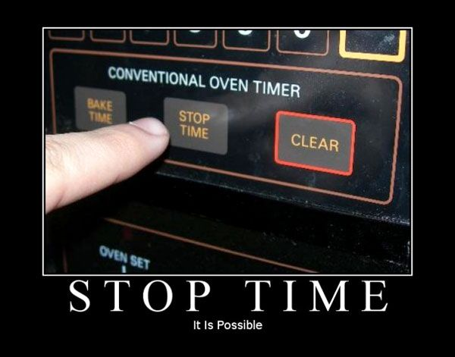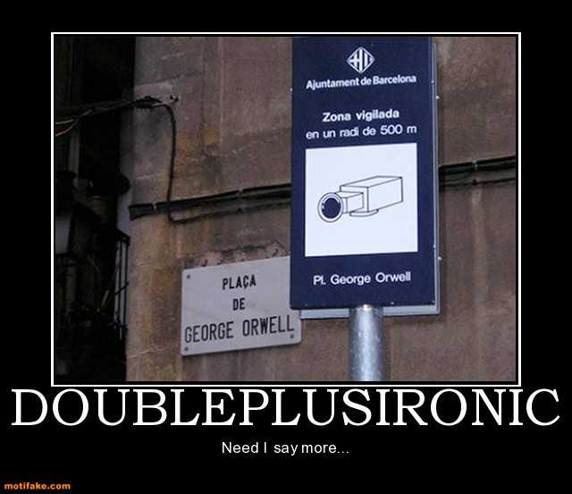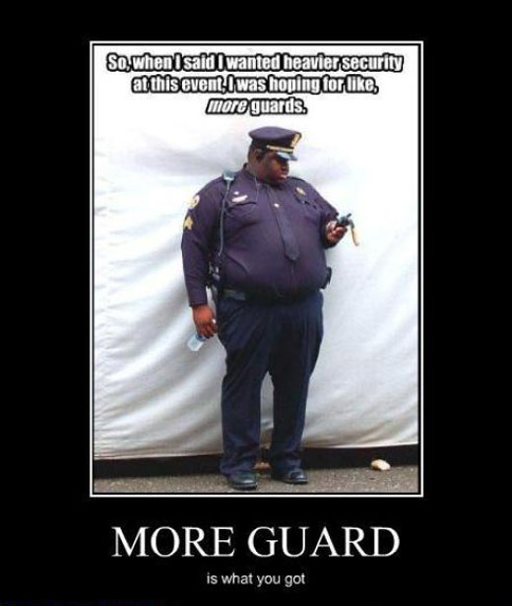
Attendees:
- James Taylor (JT)
- Neil Pickford (NCP)
- Mike Helm (MH) - bulbed up!
- Dave Swarbrook (DS)
- David McNeaney (DMcN)
Apologies:
- Sridar Madadi (SM) - we rang again - he failed again
- Alan Whitmore (AJW) - poorly sick
- Gareth Ekin (GE) - Piltdown Man
- Andy Bradley (AMB) - cream-crackered and northern bound!
- Jes Challand (JC) - Our "European" correspondent is still "over there", sharing Jorge Calderon - a multi instrumentalist most famous for appearing on Werewolves of London with Warren Zevon. 
Agenda:
  - Okay previous minutes
  - Previous Actions
  - Treasurers Report & current portfolio update
  - Investment strategy & Homework (share updates)
  - Fantasy Shares
  - Peston
  - AOB
8. Next Meeting
1. Okay Previous Minutes What, there were minutes - no way - seriously, does anyone read this ? Amount American Airlines saved in 1987 by eliminating one olive from each salad served in first class: $440,000

2. Previous Actions  35.4.1 - Meeting 36 - Sell Tate and Lyle and Sell Glaxo and set a low limit on Sabmiller - just in case  35.4.2 - JT to look at cash-out values  35.4.3 - NCP to e-mail info out and get it moving | NCP  JT  NCP
3. Treasurers Report & current portfolio update  £6875.34 in TDW, £218.32 in Barcs. Divi - £13.11 from Glaxo on 14/7  4. Investment strategy & Homework (share updates)  Homework - Astra - Brexit win due to falling pound. Easy - Brexit loser - pound and oil. Flybe - fucked. Glaxo - new app tracking arthritic folk - new ad campaign and Brexit winner - pound. Royal Mail - revenues up 1%. Sab - shareholder disquiet - poss higher purchase price? Tate - revised upwards -poss Brexit winner. Voda - estimated upto £3.10p. Worldpay - 2 week outage - ouch. China Eastern Airlines Deal.  Meeting 15 - more of same, TSB, TESLA, Arrow, Cineworld, Bellway, Bunzl  Meeting 16 - a chat about supermarkets  Meeting 17 - mort portfolio stuff, Just Eat, Colefax and Sell Vodafone  Meeting 18 - Lloyds - possible 7% divi by 2016, BHP Biliton, Glencore  Meeting 19 - brief discussion about Tullow Oil, EasyJet, De La Rue, Virgin Money, Stephen O'Hara and microbes to change health as a supplement.  Meeting 20 - discussed what to sell to fund the shortfall in cash to pay Matt - Tesco, Alent and Colefax placed on Neil P watch  Meeting 21 - discussed, Easyjet, Kaz minerals, BHP Billiton, Arm, Prudential, Unilever, Sabmiller, Trainline and Halfords.  Meeting 22 - discussed - VPC IPO, SCS IPO, DFS IPO, Center Parcs IPO, Aldermere IPO, Revolution Bars IPO. Laing IPO, Alumasc, Wentworth, United Utilities, Inland Homes, Afran and the divis on Vodafone, Centrica, Sky and BT. Sri suggested 10-20% of the portfolio should be high risk.  Meeting 23 - discussed - LSE, ARM, Persimmon, eg Solutions and BT.  Meeting 24 - discussed - Diageo, Unilever, Reckit Benkhauser for divis potentially. No purchases - pre election!  Meeting 25 - discussed IPOs - Easyproperty and Purple Bricks. Also Burberry. - no purchase decided.  Meeting 26 - discussed Astra Zeneca, Glaxo, BP, Centrica, Shell, Vodafone, Sabmiller, Dignity and Britvic. Along with reinvest in Royal Mail and Randgold.  Meeting 27 - Vodafone discussed and buying into existing shares from portfolio.  Meeting 28 - more of the same - FTSE is on its arse - opportunity?  Meeting 29 - Capita, Flybe, Synthomer, EasyProperty?  Meeting 30 - More Astra Zeneca and Worldpay?  Meeting 31 - no buys - sit on cash  Meeting 32 - no buys - sit pretty - bloody Brexit!  Meeting 33 - Nowt  Meeting 34 - Nowt  Meeting 35 - Nowt - Brexit!!!!!!!!!  35.4.1 - Meeting 36 - Sell Tate and Lyle and Sell Glaxo and set a low limit on Sabmiller - just in case  35.4.2 - JT to look at cash-out values  35.4.3 - NCP to e-mail info out and get it moving  5. Fantasy Shares  Winner with a 7.99% jump was eternally missing man Gareth! Overall, with 1 round to go, Dave McN is out in front on 84, from Mike H on 76!  Not giving a heap of shit when Clarkson is back on TV this month are:-  6. Peston  As AJW sickly bad - NCP delivered:-Restaurant owner sacks own son for calling customer fatty/ Two Spanish men manage to skive work for 15 years/ 19 year old becomes Easyjet's youngest pilot/ big "ruby roman" grapes sell for £8,500 at auction in Japan/ Flock of Seagulls wigs available on net/22lb lump of ancient of bog butter found in Eire/ Eddie Hall from SoT is first man to deadlift 500KG/ Uni of North Texas selling mugs with UNT on - when held in a certain direction, with the handle, it becomes C-UNT/Alien Skeleton on NASA pics of mars claims alien hunter/ Woman 71, marries teen 3 weeks after meeting him at her son's funeral!  7. AOB  Dave McN shared the Dilbert love.  8. Next Meeting  Wednesday 21st September, 2016 at Mill Street Club, 210 Mill Street – with Pizza. Biggest 18" in Leek - Still - even now! They keep texting me to tell me! Stop it, enough is enough Shiraz!  ? bought the Pizza (Neil - 1)(Alan and James -2)(Gareth and Sri -3) (Dave and Dave -4) (Neil and Mike -5 gen) | NCP  JT  NCP
   |  | Meeting 23 |  | Meeting 24 |  | Meeting 25 |  | Meeting 26 |  | Meeting 27 |  | Meeting 28 |  | Meeting 29 |  | Meeting 30 |  | Meeting 31 |  | Meeting 32 |  | Meeting 33 |  |  | Meeting 34 | Meeting 35 | Meeting 36
  Club £ |  | £13,353.02 |  | £13,353.02 |  | £14,330.77 |  | £14,667.78 |  | £15,032.57 |  | £15,248.15 |  | £15,552.17 |  | £16,627.02 |  | £16,842.94 |  | £16,920.09 |  | £17,537.32 |  |  | £17,997.10 | £18,455.46 | £19,983.65
  Std units |  | 32 |  | 33 |  | 34 |  | 35 |  | 36 |  | 37 |  | 38 |  | 39 |  | 40 |  | 42 |  | 43 |  |  | 44 | 45 | 46
  Tot input |  | £12,000.00 |  | £12,300.00 |  | £12,600.00 |  | £12,900.00 |  | £13,200.00 |  | £13,500.00 |  | £13,800.00 |  | £14,100.00 |  | £14,400.00 |  | £15,000.00 |  | £15,300.00 |  |  | £15,600.00 | £15900 | £16,200.00
  member input(*) |  | £960.00 |  | £990.00 |  | £1,020.00 |  | £1,050.00 |  | £1,080.00 |  | £1,110.00 |  | £1,140.00 |  | £1,170.00 |  | £1,200.00 |  | £1,260.00 |  | £1,290.00 |  |  | £1,320.00 | £1350 | £1,380.00
  now worth |  | £1,068.24 |  | £1,122.24 |  | £1,160.11 |  | £1,193.89 |  | £1,193.89 |  | £1,253.74 |  | £1,284.74 |  | £1,379.69 |  | £1,403.58 |  | £1,421.29 |  | £1,478.64 |  |  | £1,478.64 | £1,566.97 | £1,566.97
  % increase |  | 11.28 |  | 13.36 |  | 13.74 |  | 13.7 |  | 13.88 |  | 12.95 |  | 12.7 |  | 17.92 |  | 16.96 |  | 12.8 |  | 14.62 |  |  | 15.37 | 16.07 | 23.36
  total units |  | 400 |  | 410 |  | 420 |  | 430 |  | 440 |  | 450 |  | 460 |  | 470 |  | 480 |  | 500 |  | 510 |  |  | 520 | 530 | 540
  unit worth |  | £33.38 |  | £34.01 |  | £34.12 |  | £34.11 |  | £34.16 |  | £33.88 |  | £33.81 |  | £35.38 |  | £35.09 |  | £33.84 |  | £34.39 |  |  | £34.61 | £34.82 | £37.01
   | Name |  | Units |  | Invested |  | Value |  | Rise (£) |  | Rise (%) |  | Name |  | Units |  | Invested |  | Value |  | Rise (£) |  | Rise (%)
   | Alan W |  | 78 |  | £2,357.60 |  | £2,886.53 |  | £528.93 |  | 22.44 |  | Dave M |  | 54 |  | £1,624.40 |  | £1,998.37 |  | £373.97 |  | 23.02
   | Dave S |  | 62 |  | £1,868.80 |  | £2,294.42 |  | £425.62 |  | 22.78 |  | Mike H |  | 46 |  | £1,380.00 |  | £1,702.31 |  | £322.31 |  | 23.36
   | Sri M |  | 54 |  | £1,624.40 |  | £1,998.37 |  | £373.97 |  | 23.02 |  | James T |  | 46 |  | £1,380.00 |  | £1,702.31 |  | £322.31 |  | 23.36
   | Andy B |  | 54 |  | £1,624.40 |  | £1,998.37 |  | £373.97 |  | 23.02 |  | Jes C |  | 46 |  | £1,380.00 |  | £1,702.31 |  | £322.31 |  | 23.36
   | Neil P |  | 54 |  | £1,624.40 |  | £1,998.37 |  | £373.97 |  | 23.02 |  | Gareth E |  | 46 |  | £1,380.00 |  | £1,702.31 |  | £322.31 |  | 23.36
  Qty. | Description | Champion | Mid Price | Price Change | Market Value | Book Cost | Gain/Loss | Prev Month | Variance | Qty.
  AZN | 44 | ASTRAZENECA | DSW | 5177.00p | -13 | 2277.88 | 1942.03 | 335.85 | 1710.28 | 567.6
  EZJ | 44 | EASYJET | MH | 1076.00p | 37 | 473.44 | 744.05 | -270.61 | 667.48 | -194.04
  FLYB | 1123 | FLYBE GROUP PLC | AJW | 38.25p | 0.25 | 429.55 | 999.19 | -569.64 | 544.66 | -115.11
  RMG | 464 | ROYAL MAIL PLC | SM | 512.50p | 0.5 | 2378 | 2596.88 | -218.88 | 2500.96 | -122.96
  SAB | 28 | SABMILLER | DMcN | 4373.00p | 13 | 1224.44 | 963.58 | 260.86 | 1194.76 | 29.68
  VOD | 679 | VODAFONE | AMB | 234.20p | 1 | 1590.22 | 1497.88 | 92.34 | 1469.7 | 120.52
  WPG | 324 | WORLDPAY GRP PLC | NCP | 309.00p | 7.6 | 1001.16 | 996.98 | 4.18 | 938.95 | 62.21
  Period -12 | SHARE | EPIC | START PRICE
  Dave S | Playtech | PTEC | 865.50
  Gareth E | BAE | BA.L | 539.50
  Mike H | Apple ($) | AAPL | 99.83
  Neil P | LSE | LSE | 2662.00
  James T | Royal Mail | RMG.L | 514.50
  Matt C | Infineon Tech | IFX.DE (€) | 14.15
  Andy B | Standard Life | SL.L | 291.50
  Jes C | Marks and Spencer | MKS | 335.80
  Dave McN | Valeant Pharma | VRX ($) | 24.48
  Glynn G | Punch Taverns | PUB | 87.50
  Alan W | Lloyds | LLOY | 56.59
  Sri M | Herencia Resources | HER | 0.04

