The Strangemen III.0 Investment Club (HBHXX74T)
Minutes of the thirty-fifth meeting - Held Wednesday 22nd June, 2016 at The Mill Street Club, Mill Street, Leek.
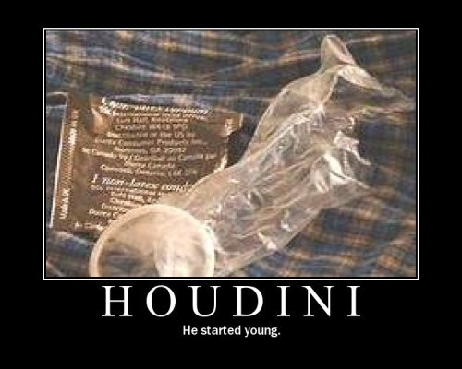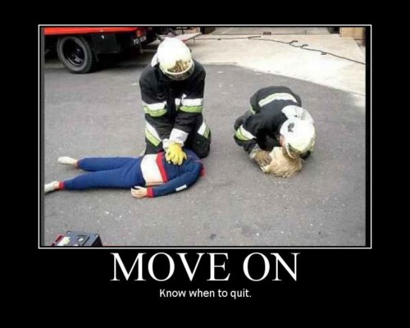

Attendees:
- James Taylor (JT)
- Neil Pickford (NCP)
- Alan Whitmore (AJW)
- Dave Swarbrook (DS)
- David McNeaney (DMcN)
Apologies:
- Sridar Madadi (SM) - we rang, he failed
- Mike Helm - Failed due to bulb issues - very poor electricianing (is that a word?) indeed
- Gareth Ekin (GE) - Back to the silent treatment - think he was an embarrassed Brexit type - he could have sat with Alan!
- Andy Bradley (AMB) - Long days, short nights -0 welcome to summer - no actual sun though!
- Jes Challand (JC) - Now then ,will he leave his UKness behind and go full francophile? He shares his initials with John Carter Cash - the imaginatively named guitarist son of Johnny Cash. 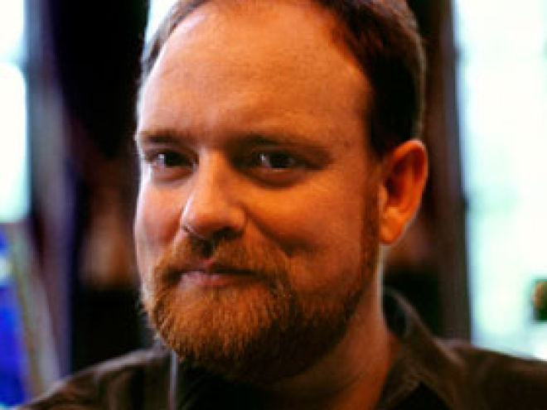
Agenda:
  - Okay previous minutes
  - Previous Actions
  - Treasurers Report & current portfolio update
  - Investment strategy & Homework (share updates)
  - Fantasy Shares
  - Peston
  - AOB
8. Next Meeting
1. Okay Previous Minutes What, there were minutes - no way - seriously, does anyone read this ? The king of hearts is the only king without a moustache on a standard playing card!
2. Previous Actions
29.4.2 - Barclays statement for Sep - Oct a no show now! NCP to chase - JT to scan a copy in for NCP - hopefully resolved by NCP - we wait until March! NCP to Chase Again! - Barclays - grovelled by letter, gave us £50 and have restarted the statements - win!

3. Treasurers Report & current portfolio update
£6562.89 in TDW, £208.32 in Barcs.
 |  | Meeting 22 |  | Meeting 23 |  | Meeting 24 |  | Meeting 25 |  | Meeting 26 |  | Meeting 27 |  | Meeting 28 |  | Meeting 29 |  | Meeting 30 |  | Meeting 31 |  | Meeting 32 |  |  | Meeting 33 | Meeting 34 | Meeting 35
Club £ |  | £12,993.77 |  | £13,353.02 |  | £13,353.02 |  | £14,330.77 |  | £14,667.78 |  | £15,032.57 |  | £15,248.15 |  | £15,552.17 |  | £16,627.02 |  | £16,842.94 |  | £16,920.09 |  |  | £17,537.32 | £17,997.10 | £18,455.46
Std units |  | 31 |  | 32 |  | 33 |  | 34 |  | 35 |  | 36 |  | 37 |  | 38 |  | 39 |  | 40 |  | 42 |  |  | 43 | 44 | 45
Tot input |  | £11,700.00 |  | £12,000.00 |  | £12,300.00 |  | £12,600.00 |  | £12,900.00 |  | £13,200.00 |  | £13,500.00 |  | £13,800.00 |  | £14,100.00 |  | £14,400.00 |  | £15,000.00 |  |  | £15,300.00 | £15,600.00 | 15900
member input(*) |  | £930.00 |  | £960.00 |  | £990.00 |  | £1,020.00 |  | £1,050.00 |  | £1,080.00 |  | £1,110.00 |  | £1,140.00 |  | £1,170.00 |  | £1,200.00 |  | £1,260.00 |  |  | £1,290.00 | £1,320.00 | 1350
now worth |  | £1,032.84 |  | £1,068.24 |  | £1,122.24 |  | £1,160.11 |  | £1,193.89 |  | £1,193.89 |  | £1,253.74 |  | £1,284.74 |  | £1,379.69 |  | £1,403.58 |  | £1,421.29 |  |  | £1,478.64 | £1,478.64 | £1,566.97
% increase |  | 11.06 |  | 11.28 |  | 13.36 |  | 13.74 |  | 13.7 |  | 13.88 |  | 12.95 |  | 12.7 |  | 17.92 |  | 16.96 |  | 12.8 |  |  | 14.62 | 15.37 | 16.07
total units |  | 390 |  | 400 |  | 410 |  | 420 |  | 430 |  | 440 |  | 450 |  | 460 |  | 470 |  | 480 |  | 500 |  |  | 510 | 520 | 530
unit worth |  | £33.32 |  | £33.38 |  | £34.01 |  | £34.12 |  | £34.11 |  | £34.16 |  | £33.88 |  | £33.81 |  | £35.38 |  | £35.09 |  | £33.84 |  |  | £34.39 | 34.61 | 34.82
 | Name |  | Units |  | Invested |  | Value |  | Rise (£) |  | Rise (%) |  | Name |  | Units |  | Invested |  | Value |  | Rise (£) |  | Rise (%)
 | Alan W |  | 77 |  | £2,327.60 |  | £2,681.26 |  | £353.66 |  | 15.19 |  | Dave M |  | 53 |  | £1,594.40 |  | £1,845.55 |  | £251.15 |  | 15.75
 | Dave S |  | 61 |  | £1,838.80 |  | £2,124.12 |  | £285.32 |  | 15.52 |  | Mike H |  | 45 |  | £1,350.00 |  | £1,566.97 |  | £216.97 |  | 16.07
 | Sri M |  | 53 |  | £1,594.40 |  | £1,845.55 |  | £251.15 |  | 15.75 |  | James T |  | 45 |  | £1,350.00 |  | £1,566.97 |  | £216.97 |  | 16.07
 | Andy B |  | 53 |  | £1,594.40 |  | £1,845.55 |  | £251.15 |  | 15.75 |  | Jes C |  | 45 |  | £1,350.00 |  | £1,566.97 |  | £216.97 |  | 16.07
 | Neil P |  | 53 |  | £1,594.40 |  | £1,845.55 |  | £251.15 |  | 15.75 |  | Gareth E |  | 45 |  | £1,350.00 |  | £1,566.97 |  | £216.97 |  | 16.07

4. Investment strategy & Homework (share updates)
Qty. | Description | Champion | Mid Price | Price Change | Market Value | Book Cost | Gain/Loss | Prev Month | Variance | Qty.
44 | ASTRAZENECA | DSW | 3887.00p | 14.5 | 1710.28 | 1942.03 | -231.75 | 1730.3 | -20.02 | 44
44 | EASYJET | MH | 1517.00p | -3 | 667.48 | 744.05 | -76.57 | 653.84 | 13.64 | 44
1123 | FLYBE GROUP PLC | AJW | 48.50p | -0.75 | 544.66 | 999.19 | -454.53 | 623.27 | -78.61 | 1123
69 | GLAXOSMITHKLINE | JT | 1419.50p | 3 | 979.46 | 986.18 | -6.72 | 1017.75 | -38.29 | 69
464 | ROYAL MAIL PLC | SM | 539.00p | 8.5 | 2500.96 | 2596.88 | -95.92 | 2311.18 | 189.78 | 464
28 | SABMILLER | DMcN | 4267.00p | -19.5 | 1194.76 | 963.58 | 231.18 | 1184.4 | 10.36 | 28
304 | TATE & LYLE | NCP | 620.50p | -4.5 | 1886.32 | 2091.1 | -204.78 | 1851.36 | 34.96 | 304
679 | VODAFONE | AMB | 216.45p | 1.9 | 1469.7 | 1497.88 | -28.18 | 1509.42 | -39.72 | 679
324 | WORLDPAY GRP PLC | NCP | 289.80p | 2.3 | 938.95 | 996.98 | -58.03 | 852.77 | 86.18 | 324

Homework - Astra - expired patents hitting bottom lin. Easyjet - terror issues 16% down yr on yr. analysts like 'em. Flybe - terror - 46% down on yr. Sales up 8.7%. Top for punctuality. Glaxo - no news - hold. Royal mail - euro business up. spanish parcel network acquired. Sab - competition hearing 22-24 June. Tate - Brexit folk - want to leave says top guy - due to previous issues with EU rulings. Voda - n/a. Worldpay - tipped as strong buy

Meeting 15 - more of same, TSB, TESLA, Arrow, Cineworld, Bellway, Bunzl

Meeting 16 - a chat about supermarkets

Meeting 17 - mort portfolio stuff, Just Eat, Colefax and Sell Vodafone
Meeting 18 - Lloyds - possible 7% divi by 2016, BHP Biliton, Glencore
Meeting 19 - brief discussion about Tullow Oil, EasyJet, De La Rue, Virgin Money, Stephen O'Hara and microbes to change health as a supplement.
Meeting 20 - discussed what to sell to fund the shortfall in cash to pay Matt - Tesco, Alent and Colefax placed on Neil P watch
Meeting 21 - discussed, Easyjet, Kaz minerals, BHP Billiton, Arm, Prudential, Unilever, Sabmiller, Trainline and Halfords.
Meeting 22 - discussed - VPC IPO, SCS IPO, DFS IPO, Center Parcs IPO, Aldermere IPO, Revolution Bars IPO. Laing IPO, Alumasc, Wentworth, United Utilities, Inland Homes, Afran and the divis on Vodafone, Centrica, Sky and BT. Sri suggested 10-20% of the portfolio should be high risk.
Meeting 23 - discussed - LSE, ARM, Persimmon, eg Solutions and BT.
Meeting 24 - discussed - Diageo, Unilever, Reckit Benkhauser for divis potentially. No purchases - pre election!
Meeting 25 - discussed IPOs - Easyproperty and Purple Bricks. Also Burberry. - no purchase decided.
Meeting 26 - discussed Astra Zeneca, Glaxo, BP, Centrica, Shell, Vodafone, Sabmiller, Dignity and Britvic. Along with reinvest in Royal Mail and Randgold.
Meeting 27 - Vodafone discussed and buying into existing shares from portfolio.
Meeting 28 - more of the same - FTSE is on its arse - opportunity?
Meeting 29 - Capita, Flybe, Synthomer, EasyProperty?
Meeting 30 - More Astra Zeneca and Worldpay?
Meeting 31 - no buys - sit on cash
Meeting 32 - no buys - sit pretty - bloody Brexit!
Meeting 33 - Nowt
Meeting 34 - Nowt
Meeting 35 - Nowt - Brexit!!!!!!!!!

5. Fantasy Shares
Winner with a 7.86% leap was Arm for AWOL ex-member Matt C. Mr McN still out in front with 77. Point of order raised and agreed in that - those physically present will have their choice first, prior to Neil announcing "postal votes". Although "Squatters rights" do exist for all.
That cheap holiday in Turkey is now looking a great deal this month for:-
Period -11 | SHARE | EPIC | START PRICE
Dave S | Playtech | PTEC | 806.00
Gareth E | BAE | BA.L | 500.50
Mike H | Apple ($) | AAPL | 95.94
Neil P | LSE | LSE | 2681.00
James T | FlyBe | FLYB | 49.00
Matt C | NetFlix | NFLX | 90.62
Andy B | Standard Life | SL.L | 343.20
Jes C | Marks and Spencer | MKS | 364.00
Dave McN | Chariot Oil & Gas | CHAR | 6.46
Glynn G | Punch Taverns | PUB | 98.00
Alan W | Lloyds | LLOY | 71.17
Sri M | Herencia Resources | HER | 0.03
6. Peston
Tory councillor suspended for commenting "i have just donated the steam from my piss" on Jo Cox memorial site. £350 p/m room under the stairs on offer in London. 2p coin auctioned for £1350 - silver. 113 times failure of driving theory test by a lady. bloke next with 107 fails - both from Ilford! School boy 15 rushed to hospital in china - eating coins, needles, stones and toothpicks. Man charged 25cents for being a smartarse on his restaraunt receipt in the US! £50m diamond (110 karats) been on display in London. Woman quit job to breast feed her 36yr old boyfriend full time - he is a bodybuilder.
And finally a Jordan Henderson won't vote in EU ref because he can't put a cross in a box joke!
7. AOB
Dave McN shared the Dilbert love.
In Jan it's been 4 years - what are our plans - equity take perhaps and on-boarding? - Discuss at each meeting.
8. Next Meeting
Wednesday 20th July, 2016 at Mill Street Club, 210 Mill Street – with Pizza. Biggest 18" in Leek - Still - even now! They keep texting me to tell me! Neil bought the Pizza (Alan and James -1)(Gareth and Sri -2) (Dave and Dave -3) (Neil and Mike -4 gen)

