The Strangemen III.0 Investment Club (HBHXX74T)
Minutes of the thirty-second meeting - Held Wednesday 9th March, 2016 at The Mill Street Club, Mill Street, Leek.
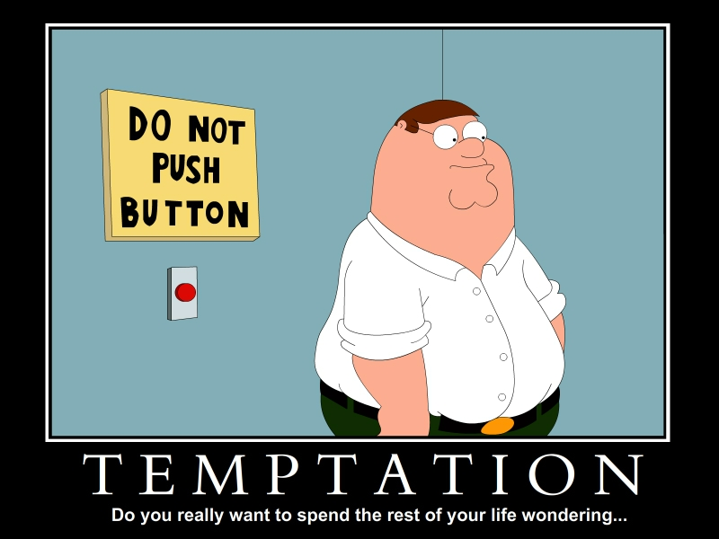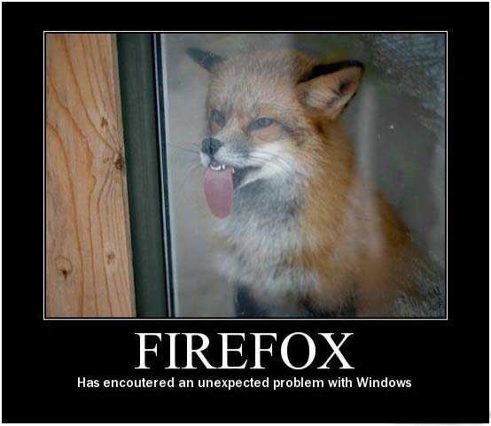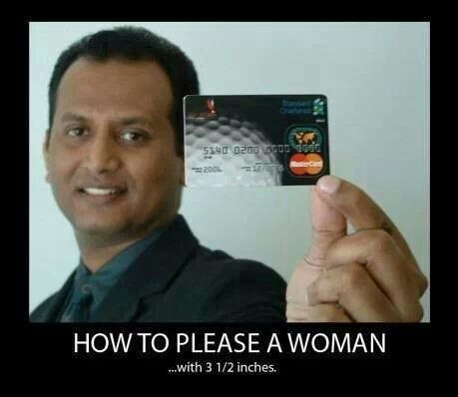
Attendees:
- James Taylor (JT)
- Neil Pickford (NCP)
- Alan Whitmore (AJW)
- Dave Swarbrook (DS)
- Mike Helm (MH)
- David McNeaney (DMcN)
- Sridar Madadi (SM)
Apologies:
- Gareth Ekin (GE) - looming into view for his next appearance. Only slightly rarer than Hayley's Comet!
- Andy Bradley (AMB) - homework - he's the next Niall Booker you know!
- Jes Challand (JC) - Still in Franceland - now has beaucoup travail and shares his initials with Jamie Catto - former and founding member of band Faithless. 
Agenda:
  - Okay previous minutes
  - Previous Actions
  - Treasurers Report & current portfolio update
  - Investment strategy & Homework (share updates)
  - Fantasy Shares
  - Peston
  - AOB
8. Next Meeting
1. Okay Previous Minutes What, there were minutes - no way - seriously, does anyone read this !it's goodnight from me and it's goodnight from him!"
Yup!
2. Previous Actions  29.4.2 - Barclays statement for Sep - Oct a no show now! NCP to chase - JT to scan a copy in for NCP - hopefully resolved by NCP - we wait until March! NCP to Chase  31.3.1 - 2 cheques to write at end of meeting £110 Dougie Macc charity cheque and £48 memberships - JT to move some money to Barclays to cover - Done | NCP
3. Treasurers Report & current portfolio update  £4445.10 in TDW, £128.32 in Barcs. Divis:-3/2 £24.98 - Vodafone. Randgold sold for profit of £229.98  4. Investment strategy & Homework (share updates)  Homework - Astra - new breast cancer drug and a renewed push to oncology. Easy - passenger no.s up - 4% projected divi. Flybe - poor customer service, as removing liverpool to amsterdam flights but didn't communicate to ticket holders. Glaxo. cash down. 6% divi. new asthma drug. Royal mial - newly announced pick-up service for parcels - web based. Sab - take over in Q3 possibly. Synth - raised divi. growth expected. Tate - directors buying shares at a low - good sign. World Pay and Voda - n/a  Meeting 13 - Topps Tiles, Aviva, L&G, Kingfisher, more of portfolio.  Meeting 14 - Astra Z, GAME IPO, B&M IPO, UK Mail, Merlin and TT Electronics (Motley tip)  Meeting 15 - more of same, TSB, TESLA, Arrow, Cineworld, Bellway, Bunzl  Meeting 16 - a chat about supermarkets  Meeting 17 - mort portfolio stuff, Just Eat, Colefax and Sell Vodafone  Meeting 18 - Lloyds - possible 7% divi by 2016, BHP Biliton, Glencore  Meeting 19 - brief discussion about Tullow Oil, EasyJet, De La Rue, Virgin Money, Stephen O'Hara and microbes to change health as a supplement.  Meeting 20 - discussed what to sell to fund the shortfall in cash to pay Matt - Tesco, Alent and Colefax placed on Neil P watch  Meeting 21 - discussed, Easyjet, Kaz minerals, BHP Billiton, Arm, Prudential, Unilever, Sabmiller, Trainline and Halfords.  Meeting 22 - discussed - VPC IPO, SCS IPO, DFS IPO, Center Parcs IPO, Aldermere IPO, Revolution Bars IPO. Laing IPO, Alumasc, Wentworth, United Utilities, Inland Homes, Afran and the divis on Vodafone, Centrica, Sky and BT. Sri suggested 10-20% of the portfolio should be high risk.  Meeting 23 - discussed - LSE, ARM, Persimmon, eg Solutions and BT.  Meeting 24 - discussed - Diageo, Unilever, Reckit Benkhauser for divis potentially. No purchases - pre election!  Meeting 25 - discussed IPOs - Easyproperty and Purple Bricks. Also Burberry. - no purchase decided.  Meeting 26 - discussed Astra Zeneca, Glaxo, BP, Centrica, Shell, Vodafone, Sabmiller, Dignity and Britvic. Along with reinvest in Royal Mail and Randgold.  Meeting 27 - Vodafone discussed and buying into existing shares from portfolio.  Meeting 28 - more of the same - FTSE is on its arse - opportunity?  Meeting 29 - Capita, Flybe, Synthomer, EasyProperty?  Meeting 30 - More Astra Zeneca and Worldpay?  Meeting 31 - no buys - sit on cash  Meeting 32 - no buys - sit pretty - bloody Brexit!  5. Fantasy Shares  Winner with a huge up swing of 50% was Sri with Tristar Resources - in reality, up from 0.06 to 0.09! Mr McN still out in front by 8 points!  Wondering why Ant and Dec can't go the way of the Two Ronnies this month are:-  6. Peston  Thieves swipe $70k worth of cheese from a trailer. $90k of parmesan stolen just days before! French lady went on a lottery winning spree - jewels, clothes and then found out she hadn't won. Woman paints a pic of Trump using her boobs. £100k of stiffed animals stolen from a taxidermist in Wandsworth. Baby found hidden in hand luggage on an Instanbul flight. a student pary was found to be so boozy and hot 37 degrees - that the air was over the limit. Alan then shared the top 10 things not to "google".  7. AOB  Dave McN shared the Dlibert love.  Sri suggested we all go on a boys outing to Amsterdam next year!  8. Next Meeting  Wednesday 6th April, 2016 at Mill Street Club, 210 Mill Street – with Pizza. Biggest 18" in Leek - Still - even now! Dave and Dave paid for Pizza. (Neil and Mike previous month) | JT
   | Meeting 19 | Meeting 20 |  | Meeting 21 |  | Meeting 22 | Meeting 23 | Meeting 24 | Meeting 25 | Meeting 26 | Meeting 27 | Meeting 28 | Meeting 29 | Meeting 30 | Meeting 31 | Meeting 32
  Club £ | £15,612.53 | £13,872.56 |  | £12,414.96 |  | £12,993.77 | £13,353.02 | £13,353.02 | £14,330.77 | £14,667.78 | £15,032.57 | £15,248.15 | £15,552.17 | £16,627.02 | £16,842.94 | £16,920.09
  Std units | 28 | 29 |  | 30 |  | 31 | 32 | 33 | 34 | 35 | 36 | 37 | 38 | 39 | 40 | 42
  Tot input | £16,885.32 | £16,885.32 |  | £11,444.00 |  | £11,700.00 | £12,000.00 | £12,300.00 | £12,600.00 | £12,900.00 | £13,200.00 | £13,500.00 | £13,800.00 | £14,100.00 | £14,400.00 | £15,000.00
  member input(*) | £840.00 | £870.00 |  | £900.00 |  | £930.00 | £960.00 | £990.00 | £1,020.00 | £1,050.00 | £1,080.00 | £1,110.00 | £1,140.00 | £1,170.00 | £1,200.00 | £1,260.00
  now worth | £871.36 | £845.21 |  | £980.13 |  | £1,032.84 | £1,068.24 | £1,122.24 | £1,160.11 | £1,193.89 | £1,193.89 | £1,253.74 | £1,284.74 | £1,379.69 | £1,403.58 | £1,421.29
  % increase | 3.73 | -2.85 |  | 8.9 |  | 11.06 | 11.28 | 13.36 | 13.74 | 13.7 | 13.88 | 12.95 | 12.7 | 17.92 | 16.96 | 12.8
  total units | 562 | 370 |  | 380 |  | 390 | 400 | 410 | 420 | 430 | 440 | 450 | 460 | 470 | 480 | 500
  unit worth | £31.12 | £29.15 |  | £29.15 |  | £33.32 | £33.38 | £34.01 | £34.12 | £34.11 | £34.16 | £33.88 | £33.81 | £35.38 | £35.09 | £33.84
  Name | Units | Invested | Value |  | Rise (£) |  | Rise (%) | Name | Units | Invested | Value | Rise (£) | Rise (%)
  Alan W | 74 | £2,237.60 | £2,504.17 |  | £266.57 |  | 11.91 | Dave M | 50 | £1,504.40 | £1,692.01 | £187.61 | 12.47
  Dave S | 58 | £1,748.80 | £1,962.73 |  | £213.93 |  | 12.23 | Mike H | 42 | £1,260.00 | £1,421.29 | £161.29 | 12.80
  Sri M | 50 | £1,504.40 | £1,692.01 |  | £187.61 |  | 12.47 | James T | 42 | £1,260.00 | £1,421.29 | £161.29 | 12.80
  Andy B | 50 | £1,504.40 | £1,692.01 |  | £187.61 |  | 12.47 | Jes C | 42 | £1,260.00 | £1,421.29 | £161.29 | 12.80
  Neil P | 50 | £1,504.40 | £1,692.01 |  | £187.61 |  | 12.47 | Gareth E | 42 | £1,260.00 | £1,421.29 | £161.29 | 12.80
  Symbol | Qty. | Description | Champion | Mid Price | Price Change | Market Value | Book Cost | Gain/Loss | Prev Month | Variance
  AZN | 44 | ASTRAZENECA | DSW | 4076.00p | 21.5 | 1793.44 | 1942.03 | -148.59 | 1968.12 | -174.68
  EZJ | 44 | EASYJET | MH | 1533.00p | -3 | 674.52 | 744.05 | -69.53 | 692.12 | -17.6
  FLYB | 1123 | FLYBE GROUP PLC | AJW | 62.25p | -0.5 | 699.07 | 999.19 | -300.12 | 948.94 | -249.87
  GSK | 69 | GLAXOSMITHKLINE | JT | 1403.00p | 3 | 968.07 | 986.18 | -18.11 | 990.84 | -22.77
  RMG | 464 | ROYAL MAIL PLC | SM | 451.90p | 1.8 | 2096.82 | 2596.88 | -500.06 | 2122.8 | -25.98
  SAB | 28 | SABMILLER | DMcN | 4220.50p | -3 | 1181.74 | 963.58 | 218.16 | 1175.72 | 6.02
  SYNT | 304 | SYNTHOMER | MH | 312.70p | -2.8 | 950.61 | 996.84 | -46.23 | 896.8 | 53.81
  TATE | 304 | TATE & LYLE | NCP | 573.00p | 1 | 1741.92 | 2091.1 | -349.18 | 1827.04 | -85.12
  VOD | 679 | VODAFONE | AMB | 215.40p | -2.25 | 1462.57 | 1497.88 | -35.31 | 1515.53 | -52.96
  WPG | 324 | WORLDPAY GRP PLC | NCP | 279.70p | 1.9 | 906.23 | 996.98 | -90.75 | 978.48 | -72.25
  AZN | 44 | ASTRAZENECA | DSW | 4076.00p | 21.5 | 1793.44 | 1942.03 | -148.59 | 1968.12 | -174.68
  Period -8 | SHARE | EPIC | START PRICE
  Dave S | Playtech | PTEC | 824.00
  Gareth E | Qinetiq | QQ.L | 237.10
  Mike H | Nighthawk | HAWK | 1.20
  Neil P | Admiral Insurance | ADM | 1960.00
  James T | Glaxo | GSK | 1411.50
  Matt C | Netflix | NFLX ($) | 98.18
  Andy B | Croda | CRDA | 2929.00
  Jes C | Marks and Spencer | MKS | 421.20
  Dave McN | Sabmiller | SAB | 4220.00
  Glynn G | Punch Taverns | PUB | 98.00
  Alan W | United Utilities | UU.L | 903.50
  Sri M | Tristar | TSTR | 0.07

