The Strangemen III.0 Investment Club (HBHXX74T)
Minutes of the thirty-first meeting - Held Wednesday 27th January, 2016 at The Mill Street Club, Mill Street, Leek.
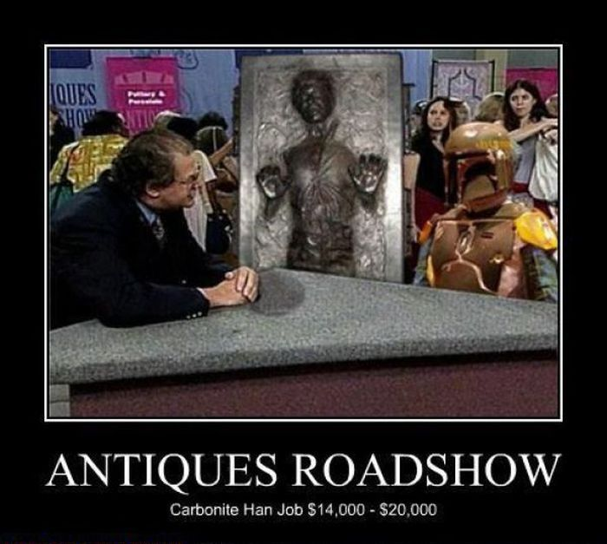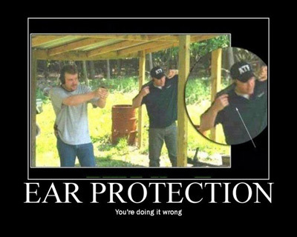
Attendees:
- James Taylor (JT)
- Neil Pickford (NCP)
- Alan Whitmore (AJW)
- Dave Swarbrook (DS)
- Mike Helm (MH)
- Andy Bradley (AMB)
Apologies:
- Gareth Ekin (GE) - in a parallel universe - he comes to the meetings. In this one he is helping his in-laws move house.
- Sridar Madadi (SM) - like Keyser Soze - enigmatic. but tonigh actually working!
- David McNeaney (DMcN) - a rare miss for thehawaii five nooooooooo shirted fella.
- Jes Challand (JC) - Still in Franceland - now has beaucoup travail and shares his initials with Josef Čapek - Czech Avant-gardist artist, cubist and inventor of the word Robot. 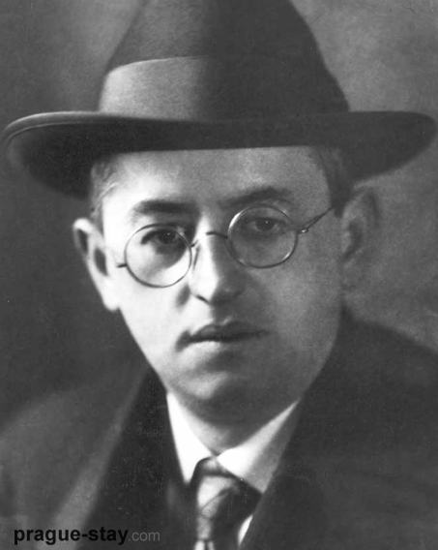
Agenda:
  - Okay previous minutes
  - Previous Actions
  - Treasurers Report & current portfolio update
  - Investment strategy & Homework (share updates)
  - Fantasy Shares
  - Peston
  - AOB
8. Next Meeting
1. Okay Previous Minutes What, there were minutes - no way - seriously, does anyone read this Donald Trump Ruler of all Gremlins?
Yup!
2. Previous Actions  30.4.1 - Neil P to buy £1000 each of Astra Zeneca and WorldPay - done  29.4.2 - Barclays statement for Sep - Oct a no show now! NCP to chase - JT to scan a copy in for NCP - hopefully resolved by NCP - we wait until March! | NCP
3. Treasurers Report & current portfolio update  £2715.40 in TDW, £354.32 in Barcs. Divis:- 4/12 - Sabmiller £5.21, Tate - 4/1 - £24.92, RMG - 13/1 - £32.48, Glaxo - 14/1 - £13.11  31.3.1 - 2 cheques to write at end of meeting £110 Dougie Macc charity cheque and £48 memberships - JT to move some money to Barclays to cover  4. Investment strategy & Homework (share updates)  Homework - Resilient shares. Patent issues in USA - buy/hold, Easyjet - growth - working with other airlines. terrorism demand affected. also good that oil is cheaper. Flybe - award wins, new Southampton and Cardiff routes. Glaxo - hold - defensive share tip. Randgold - ivory coast and congo mines doing good. Royal Mail - n/a, Sabmiller - n/a, Synth - Green focus - new materials being developed. Tate - house in order. good growth by 2020. Vod - n/a and Worldpay - n/a  Meeting 12 - just discussed Pets @ home IPO  Meeting 13 - Topps Tiles, Aviva, L&G, Kingfisher, more of portfolio.  Meeting 14 - Astra Z, GAME IPO, B&M IPO, UK Mail, Merlin and TT Electronics (Motley tip)  Meeting 15 - more of same, TSB, TESLA, Arrow, Cineworld, Bellway, Bunzl  Meeting 16 - a chat about supermarkets  Meeting 17 - mort portfolio stuff, Just Eat, Colefax and Sell Vodafone  Meeting 18 - Lloyds - possible 7% divi by 2016, BHP Biliton, Glencore  Meeting 19 - brief discussion about Tullow Oil, EasyJet, De La Rue, Virgin Money, Stephen O'Hara and microbes to change health as a supplement.  Meeting 20 - discussed what to sell to fund the shortfall in cash to pay Matt - Tesco, Alent and Colefax placed on Neil P watch  Meeting 21 - discussed, Easyjet, Kaz minerals, BHP Billiton, Arm, Prudential, Unilever, Sabmiller, Trainline and Halfords.  Meeting 22 - discussed - VPC IPO, SCS IPO, DFS IPO, Center Parcs IPO, Aldermere IPO, Revolution Bars IPO. Laing IPO, Alumasc, Wentworth, United Utilities, Inland Homes, Afran and the divis on Vodafone, Centrica, Sky and BT. Sri suggested 10-20% of the portfolio should be high risk.  Meeting 23 - discussed - LSE, ARM, Persimmon, eg Solutions and BT.  Meeting 24 - discussed - Diageo, Unilever, Reckit Benkhauser for divis potentially. No purchases - pre election!  Meeting 25 - discussed IPOs - Easyproperty and Purple Bricks. Also Burberry. - no purchase decided.  Meeting 26 - discussed Astra Zeneca, Glaxo, BP, Centrica, Shell, Vodafone, Sabmiller, Dignity and Britvic. Along with reinvest in Royal Mail and Randgold.  Meeting 27 - Vodafone discussed and buying into existing shares from portfolio.  Meeting 28 - more of the same - FTSE is on its arse - opportunity?  Meeting 29 - Capita, Flybe, Synthomer, EasyProperty?  Meeting 30 - More Astra Zeneca and Worldpay?  Meeting 31 - no buys - sit on cash  5. Fantasy Shares  Winner with a huge up swing of 1.94% was Sabmiller for Dave McN. Overall he keeps his lead too.  Wondering if speaking to Adam Johnson's Facebook pals was a good idea this month are:-  6. Peston  A parked RV had shit siphoned out instead of fuel, condom machine that vends free by checking breath, couple in Spain arrested for allowing 10yr old to drive beemer! New bandages made from crab shells promote faster healing, $50K bull semen stole from truck in California, chinese artist made a brick out shitty Beijing air in 100 day, 53 yr old man found dead in sex swing surrounded by gas canisters, Equadorians rescue frightened sloth from traffic post, Oregon land issues/ Militia sent glitter and sex toys and 55gn drum of lube by the public, LOndon commuter pays £6K to have train mop cupoard to self.  7. AOB  No Dave McN, no dlibert.  Cheques for membership and charity written.  8. Next Meeting  Wednesday 9th March, 2016 at Mill Street Club, 210 Mill Street – with Pizza. Biggest 18" in Leek - Still - even now! Neil paid for Pizza, Mike paid also, but owes Dave S £5 | JT
   | Meeting 18 | Meeting 19 |  | Meeting 20 |  | Meeting 21 | Meeting 22 | Meeting 23 | Meeting 24 | Meeting 25 | Meeting 26 | Meeting 27 | Meeting 28 | Meeting 29 | Meeting 30 | Meeting 31
  Club £ | £15,612.53 | £15,612.53 |  | £13,872.56 |  | £12,414.96 | £12,993.77 | £13,353.02 | £13,353.02 | £14,330.77 | £14,667.78 | £15,032.57 | £15,248.15 | £15,552.17 | £16,627.02 | £16,842.94
  Std units | 27 | 28 |  | 29 |  | 30 | 31 | 32 | 33 | 34 | 35 | 36 | 37 | 38 | 39 | 40
  Tot input | £16,285.30 | £16,885.32 |  | £16,885.32 |  | £11,444.00 | £11,700.00 | £12,000.00 | £12,300.00 | £12,600.00 | £12,900.00 | £13,200.00 | £13,500.00 | £13,800.00 | £14,100.00 | £14,400.00
  member input(*) | £810.00 | £840.00 |  | £870.00 |  | £900.00 | £930.00 | £960.00 | £990.00 | £1,020.00 | £1,050.00 | £1,080.00 | £1,110.00 | £1,140.00 | £1,170.00 | £1,200.00
  now worth | £777.75 | £871.36 |  | £845.21 |  | £980.13 | £1,032.84 | £1,068.24 | £1,122.24 | £1,160.11 | £1,193.89 | £1,193.89 | £1,253.74 | £1,284.74 | £1,379.69 | £1,403.58
  % increase | -3.98 | 3.73 |  | -2.85 |  | 8.9 | 11.06 | 11.28 | 13.36 | 13.74 | 13.7 | 13.88 | 12.95 | 12.7 | 17.92 | 16.96
  total units | 542 | 562 |  | 370 |  | 380 | 390 | 400 | 410 | 420 | 430 | 440 | 450 | 460 | 470 | 480
  unit worth | £28.81 | £31.12 |  | £29.15 |  | £29.15 | £33.32 | £33.38 | £34.01 | £34.12 | £34.11 | £34.16 | £33.88 | £33.81 | £35.38 | £35.09
  Name | Units | Invested | Value |  | Rise (£) |  | Rise (%) | Name | Units | Invested | Value | Rise (£) | Rise (%)
  Alan W | 72 | £2,177.60 | £2,526.44 |  | £348.84 |  | 16.02 | Dave M | 48 | £1,434.40 | £1,684.29 | £249.89 | 17.42
  Dave S | 56 | £1,688.80 | £1,965.01 |  | £276.21 |  | 16.36 | Mike H | 40 | £1,200.00 | £1,403.58 | £203.58 | 16.97
  Sri M | 48 | £1,434.40 | £1,684.29 |  | £249.89 |  | 17.42 | James T | 40 | £1,200.00 | £1,403.58 | £203.58 | 16.97
  Andy B | 48 | £1,434.40 | £1,684.29 |  | £249.89 |  | 17.42 | Jes C | 40 | £1,200.00 | £1,403.58 | £203.58 | 16.97
  Neil P | 48 | £1,434.40 | £1,684.29 |  | £249.89 |  | 17.42 | Gareth E | 40 | £1,200.00 | £1,403.58 | £203.58 | 16.97
  Symbol | Qty. | Description | Champion | Mid Price | Price Change | Market Value | Book Cost | Gain/Loss | Prev Month | Variance
  AZN | 44 | ASTRAZENECA | DSW | 4473.00p | 57.5 | 1968.12 | 1942.03 | 26.09 | 1968.12 | 0
  EZJ | 44 | EASYJET | MH | 1573.00p | -6 | 692.12 | 744.05 | -51.93 | 731.72 | -39.6
  FLYB | 1123 | FLYBE GROUP PLC | AJW | 84.50p | 0.25 | 948.94 | 999.19 | -50.25 | 988.24 | -39.3
  GSK | 69 | GLAXOSMITHKLINE | JT | 1436.00p | 20.5 | 990.84 | 986.18 | 4.66 | 950.82 | 40.02
  RRS | 21 | RANGOLD | AJW | 4815.00p | -5 | 1011.15 | 1034.75 | -23.6 | 881.79 | 129.36
  RMG | 464 | ROYAL MAIL PLC | SM | 457.50p | 4.2 | 2122.8 | 2596.88 | -474.08 | 2256.9 | -134.1
  SAB | 28 | SABMILLER | DMcN | 4199.00p | 7 | 1175.72 | 963.58 | 212.14 | 1132.74 | 42.98
  SYNT | 304 | SYTNTHOMER | MH | 295.00p | 4.6 | 896.8 | 996.84 | -100.04 | 982.22 | -85.42
  TATE | 304 | TATE & LYLE | NCP | 601.00p | 10.5 | 1827.04 | 2091.1 | -264.06 | 1831.6 | -4.56
  VOD | 679 | VODAFONE | AMB | 223.20p | 4.55 | 1515.53 | 1497.88 | 17.65 | 1509.42 | 6.11
  WPG | 324 | WORLDPAY GRP PLC | NCP | 302.00p | -0.7 | 978.48 | 996.98 | -18.5 | 978.48 | 0
  Period -7 | SHARE | EPIC | START PRICE
  Dave S | Playtech | PTEC | 765.00
  Gareth E | Qinetiq | QQ.L | 232.90
  Mike H | Nighthawk | HAWK | 0.96
  Neil P | Colefax | CFX | 457.50
  James T | Vodafone | VOD | 218.55
  Matt C | Netflix | NFLX ($) | 92.00
  Andy B | Croda | CRDA | 2830.00
  Jes C | Marks and Spencer | MKS | 422.50
  Dave McN | Sabmiller | SAB | 4165.00
  Glynn G | Punch Taverns | PUB | 118.00
  Alan W | LLOYDS | LLOY | 64.83
  Sri M | Tristar | TSTR | 0.06

