The Strangemen III.0 Investment Club (HBHXX74T)
Minutes of the thirtieth meeting - Held Wednesday 2nd December, 2015 at The Mill Street Club, Mill Street, Leek.
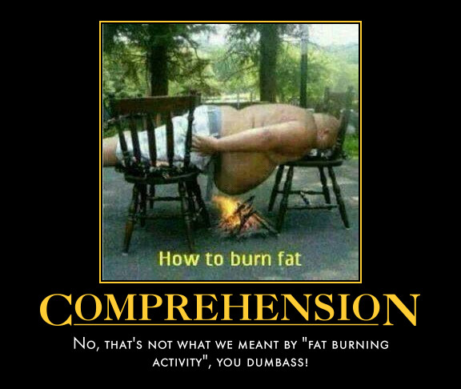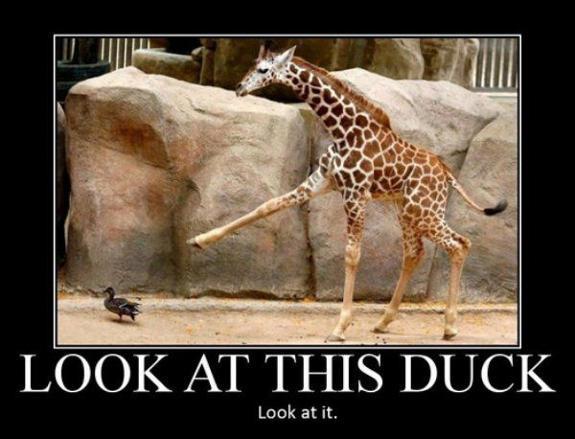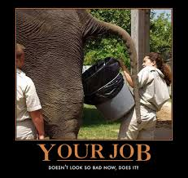
Attendees:
- James Taylor (JT)
- Neil Pickford (NCP)
- David McNeaney (DMcN)
- Alan Whitmore (AJW)
- Dave Swarbrook (DS)
- Mike Helm (MH)
Apologies:
- Gareth Ekin (GE) -A figment of his own imgination!
- Sridar Madadi (SM) - woggle issues!
- Andy Bradley (AMB) - been working looooong days - needs his zzzz. nearly as old as Alan you know!
- Jes Challand (JC) - Still in Franceland - now has beaucoup travail and shares his initials with Jannelle Commissiong - Miss Universe 1977 ( Trinidad and Tobago )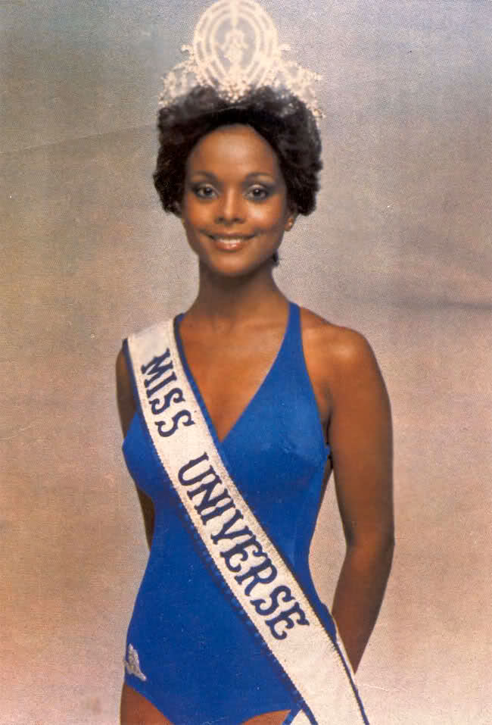
Agenda:
  - Okay previous minutes
  - Previous Actions
  - Treasurers Report & current portfolio update
  - Investment strategy & Homework (share updates)
  - Fantasy Shares
  - Peston
  - AOB
8. Next Meeting
1. Okay Previous Minutes What, there were minutes - no way - seriously, does anyone read this Trumpton Riots by Half Man Half Biscuit?
Yup!
2. Previous Actions  30.4.1 - Neil P to buy £1000 each of Astra Zeneca and WorldPay  29.4.2 - Barclays statement for Sep - Oct a no show now! NCP to chase - JT to scan a copy in for NCP  29.7.1 - SM and JT Treasury training at work. - done apparently | NCP  NCP
3. Treasurers Report & current portfolio update  £4307.59 in TDW, £86.32 in Barcs. No Divis.  4. Investment strategy & Homework (share updates)  Homework - Astra - overweight buy recommend. Easy - record profits, affected by terrorist attacks in Egypt. Bought 36 more A320. Glaxo - new asthma drug in USA. Hold. Rangold - gold price decline - medium term keeper. Royal Mail - Nowt. Sabmiller - got to sell Grolsch and Peroni to appease regulator for merger. Tata - tipped for profit again. Voda - CEO Qatar replaced by Voda Egypt CEO. Flybe n/a. Synth N/a.  Meeting 12 - just discussed Pets @ home IPO  Meeting 13 - Topps Tiles, Aviva, L&G, Kingfisher, more of portfolio.  Meeting 14 - Astra Z, GAME IPO, B&M IPO, UK Mail, Merlin and TT Electronics (Motley tip)  Meeting 15 - more of same, TSB, TESLA, Arrow, Cineworld, Bellway, Bunzl  Meeting 16 - a chat about supermarkets  Meeting 17 - mort portfolio stuff, Just Eat, Colefax and Sell Vodafone  Meeting 18 - Lloyds - possible 7% divi by 2016, BHP Biliton, Glencore  Meeting 19 - brief discussion about Tullow Oil, EasyJet, De La Rue, Virgin Money, Stephen O'Hara and microbes to change health as a supplement.  Meeting 20 - discussed what to sell to fund the shortfall in cash to pay Matt - Tesco, Alent and Colefax placed on Neil P watch  Meeting 21 - discussed, Easyjet, Kaz minerals, BHP Billiton, Arm, Prudential, Unilever, Sabmiller, Trainline and Halfords.  Meeting 22 - discussed - VPC IPO, SCS IPO, DFS IPO, Center Parcs IPO, Aldermere IPO, Revolution Bars IPO. Laing IPO, Alumasc, Wentworth, United Utilities, Inland Homes, Afran and the divis on Vodafone, Centrica, Sky and BT. Sri suggested 10-20% of the portfolio should be high risk.  Meeting 23 - discussed - LSE, ARM, Persimmon, eg Solutions and BT.  Meeting 24 - discussed - Diageo, Unilever, Reckit Benkhauser for divis potentially. No purchases - pre election!  Meeting 25 - discussed IPOs - Easyproperty and Purple Bricks. Also Burberry. - no purchase decided.  Meeting 26 - discussed Astra Zeneca, Glaxo, BP, Centrica, Shell, Vodafone, Sabmiller, Dignity and Britvic. Along with reinvest in Royal Mail and Randgold.  Meeting 27 - Vodafone discussed and buying into existing shares from portfolio.  Meeting 28 - more of the same - FTSE is on its arse - opportunity?  Meeting 29 - Capita, Flybe, Synthomer, EasyProperty?  Meeting 30 - More Astra Zeneca and Worldpay?  30.4.1 - Neil P to buy £1000 each of Astra Zeneca and WorldPay  5. Fantasy Shares  Winner with his Netflix and chill was Matt C up 20.82% with the home streaming network. Overall lead is Dave McN with 37 points thus far.  Wondering which 69ish year old musician is next this month are:-  6. Peston  Sexy lingerie colouring in books, grandad used same carrier bag for 34 years, woman shot in foot by dog called trigger, big diamond find 23.16karrots - 2nd biggest ever, winner of $1mn scratchcard in Masachsetts second $1mn win! US police pulled over a Google self driving car for going too slow, Drone slices toddler's eye in half. Bizarre creepy youtube video allegedly causes madness and death. frozen poo from plane smashes domestic roof.  7. AOB  Dave McN Dilbert'd once more!  Possible do in Feb and a £100 donation to Dougie Macc at next meeting.  8. Next Meeting  Wednesday 27th January, 2016 at Mill Street Club, 210 Mill Street – with Pizza. Biggest 18" in Leek! | NCP
   | Meeting 17 | Meeting 18 |  | Meeting 19 |  | Meeting 20 | Meeting 21 | Meeting 22 | Meeting 23 | Meeting 24 | Meeting 25 | Meeting 26 | Meeting 27 | Meeting 28 | Meeting 29 | Meeting 30
  Club £ | £15,826.33 | £15,612.53 |  | £15,612.53 |  | £13,872.56 | £12,414.96 | £12,993.77 | £13,353.02 | £13,353.02 | £14,330.77 | £14,667.78 | £15,032.57 | £15,248.15 | £15,552.17 | £16,627.02
  Std units | 26 | 27 |  | 28 |  | 29 | 30 | 31 | 32 | 33 | 34 | 35 | 36 | 37 | 38 | 39
  Tot input | £15,518.62 | £16,285.30 |  | £16,885.32 |  | £16,885.32 | £11,444.00 | £11,700.00 | £12,000.00 | £12,300.00 | £12,600.00 | £12,900.00 | £13,200.00 | £13,500.00 | £13,800.00 | £14,100.00
  member input(*) | £780.00 | £810.00 |  | £840.00 |  | £870.00 | £900.00 | £930.00 | £960.00 | £990.00 | £1,020.00 | £1,050.00 | £1,080.00 | £1,110.00 | £1,140.00 | £1,170.00
  now worth | £788.28 | £777.75 |  | £871.36 |  | £845.21 | £980.13 | £1,032.84 | £1,068.24 | £1,122.24 | £1,160.11 | £1,193.89 | £1,193.89 | £1,253.74 | £1,284.74 | £1,379.69
  % increase | 1.06 | -3.98 |  | 3.73 |  | -2.85 | 8.9 | 11.06 | 11.28 | 13.36 | 13.74 | 13.7 | 13.88 | 12.95 | 12.7 | 17.92
  total units | 522 | 542 |  | 562 |  | 370 | 380 | 390 | 400 | 410 | 420 | 430 | 440 | 450 | 460 | 470
  unit worth | £30.32 | £28.81 |  | £31.12 |  | £29.15 | £29.15 | £33.32 | £33.38 | £34.01 | £34.12 | £34.11 | £34.16 | £33.88 | £33.81 | £35.38
  Name | Units | Invested | Value |  | Rise (£) |  | Rise (%) | Name | Units | Invested | Value | Rise (£) | Rise (%)
  Alan W | 71 | £ 2,147.60 | £ 2,511.74 |  | £364.14 |  | 16.96 | Dave M | 47 | £ 1,414.40 | £ 1,662.70 | £248.30 | 17.56
  Dave S | 55 | £ 1,658.80 | £ 1,945.72 |  | £286.92 |  | 17.30 | Mike H | 39 | £ 1,170.00 | £ 1,379.69 | £209.69 | 17.92
  Sri M | 47 | £ 1,414.40 | £ 1,662.70 |  | £248.30 |  | 17.56 | James T | 39 | £ 1,170.00 | £ 1,379.69 | £209.69 | 17.92
  Andy B | 47 | £ 1,414.40 | £ 1,662.70 |  | £248.30 |  | 17.56 | Jes C | 39 | £ 1,170.00 | £ 1,379.69 | £209.69 | 17.92
  Neil P | 47 | £ 1,414.40 | £ 1,662.70 |  | £248.30 |  | 17.56 | Gareth E | 39 | £ 1,170.00 | £ 1,379.69 | £209.69 | 17.92
  Symbol | Qty. | Description | Champion | Mid Price | Price Change | Market Value | Book Cost | Gain/Loss | Prev Month | Variance
  AZN | 23 | ASTRAZENECA | DSW | 4582.50p | 67 | 1053.98 | 971.37 | 82.61 | 933.57 | 120.41
  EZJ | 44 | EASYJET | MH | 1663.00p | 17 | 731.72 | 744.05 | -12.33 | 749.76 | -18.04
  FLYB | 1123 | FLYBE GROUP PLC | AJW | 88.00p | -3 | 988.24 | 999.19 | -10.95 | 988.24 | 0
  GSK | 69 | GLAXOSMITHKLINE | JT | 1378.00p | 27 | 950.82 | 986.18 | -35.36 | 906.32 | 44.5
  RRS | 21 | RANGOLD | AJW | 4199.00p | 52 | 881.79 | 1034.75 | -152.96 | 942.9 | -61.11
  RMG | 464 | ROYAL MAIL PLC | SM | 486.40p | -2.8 | 2256.9 | 2596.88 | -339.98 | 2081.04 | 175.86
  SAB | 28 | SABMILLER | DMcN | 4045.50p | -6.5 | 1132.74 | 963.58 | 169.16 | 1110.2 | 22.54
  SYNT | 304 | SYTHHOMER | MH | 323.10p | 0.3 | 982.22 | 996.84 | -14.62 | 982.22 | 0
  Period - 5 | SHARE | EPIC | START PRICE
  Dave S | Playtech | PTEC | 812.50
  Gareth E | Qinetiq | QQ.L | 267.20
  Mike H | Apple ($) | AAPL | 116.55
  Neil P | Worldpay | WPG.L | 307.75
  James T | Vodafone | VOD | 222.85
  Matt C | Netflix | NFLX ($) | 129.62
  Andy B | Nighthawk Energy | HAWK | 1.30
  Jes C | Marks and Spencer | MKS | 510.00
  Dave McN | Sabmiller | SAB | 4040.00
  Glynn G | Punch Taverns | PUB | 126.00
  Alan W | LLOYDS | LLOY | 74.30
  Sri M | Tristar | TSTR | 0.10

