The Strangemen III.0 Investment Club (HBHXX74T)
Minutes of the twenty-ninth meeting - Held Wednesday 14th October, 2015 at The Mill Street Club, Mill Street, Leek.
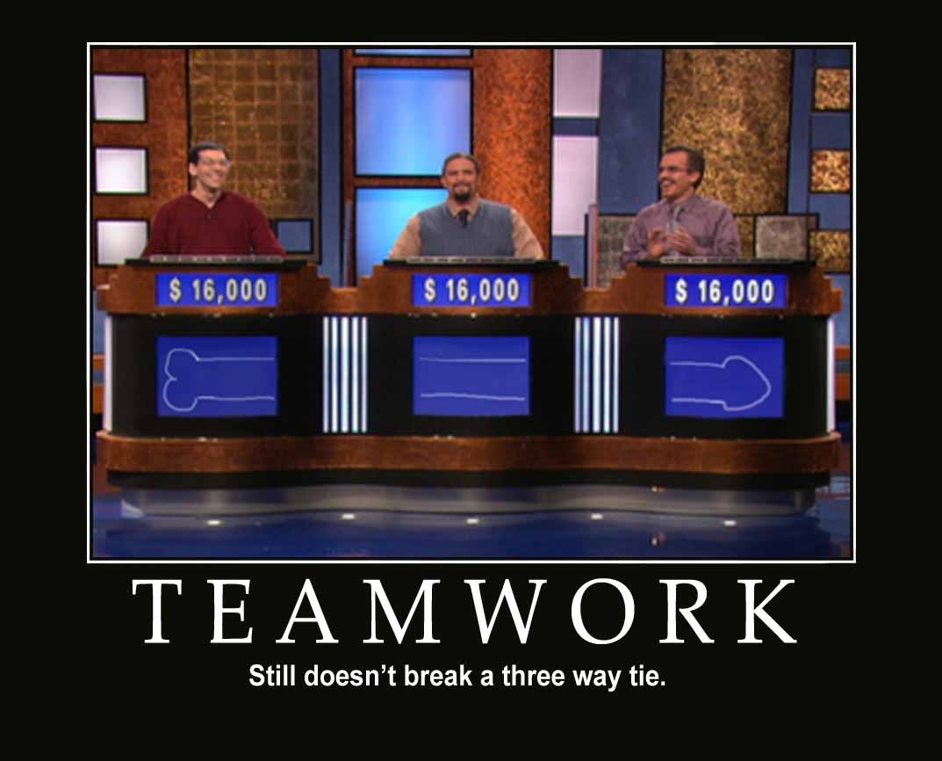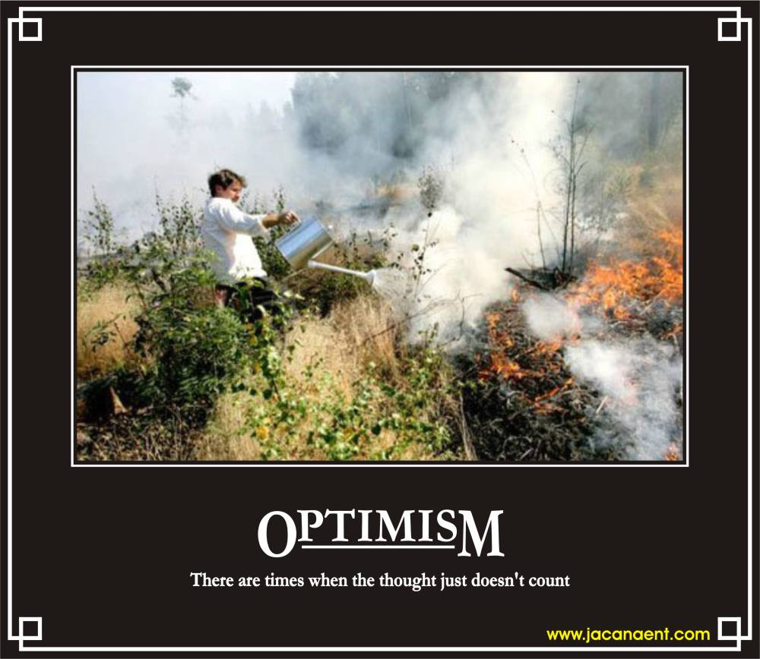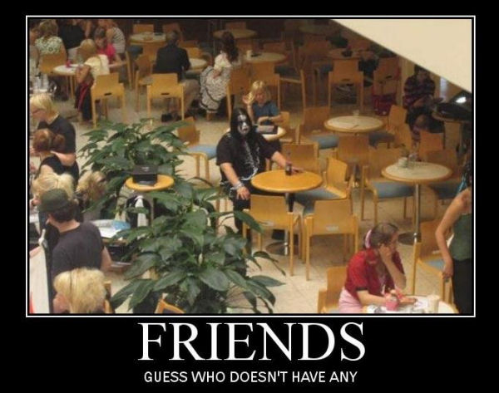
Attendees:
- James Taylor (JT)
- Neil Pickford (NCP)
- David McNeaney (DMcN)
- Alan Whitmore (AJW)
- Dave Swarbrook (DS)
- Sridar Madadi (SM)
- Mike Helm (MH)
Apologies:
- Gareth Ekin (GE) - enemy of the state!
- Andy Bradley (AMB) - still messing in Lisa Stansfield's IT cupboard.
- Jes Challand (JC) - Still in Franceland - now has beaucoup travail and shares his initials with Jeremy Corbyn - woodwork teacher looking leader of Labour party 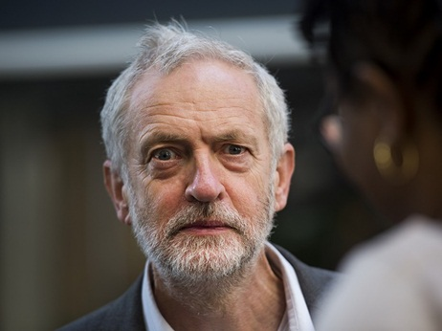
Agenda:
  - Okay previous minutes
  - Previous Actions
  - Treasurers Report & current portfolio update
  - Investment strategy & Homework (share updates)
  - Fantasy Shares
  - Peston
  - AOB
8. Next Meeting
1. Okay Previous Minutes What, there were minutes -no way - seriously, does anyone read this arse fish troubador?
Yup!
2. Previous Actions  29.4.1 - Neil P to buy £1000 each of Synthomer and Flybe  29.4.2 - Barclays statement for Sep - Oct a no show now! NCP to chase | NCP  NCP
3. Treasurers Report & current portfolio update  £5709.40 in TDW, £66.32 in Barcs. Divis from Glaxo - 1/10 - £6.65  4. Investment strategy & Homework (share updates)  Homework - Astra - FDA ruled against diabetes drug - profits down 51% in quarter. Easy - Rise in numbers. Better than FTSE tracking. Glaxo - lots and lots of holds. Randgold - 138% growth this year. Royal Mail - Shares down - Gov offloaded theirs and market saturated. Sabmiller - potential £44bn take over thingy. Tate & Lyle - growing again -in line with post accounting scandal guidance. Vod - 3G into country, using pubs as hubs!  Meeting 10 - Alent, Dart Group, Rurelec, CBG, Sable Mining, Topps Tiles, Air Partner, Dotdigital, JD Wetherspoon, James Halstead, Tracsis  Meeting 11 - Game (to float), Royal Mail, TmobileUSA, Optimal Payments, Balfour Beatty, Merliln  Meeting 12 - just discussed Pets @ home IPO  Meeting 13 - Topps Tiles, Aviva, L&G, Kingfisher, more of portfolio.  Meeting 14 - Astra Z, GAME IPO, B&M IPO, UK Mail, Merlin and TT Electronics (Motley tip)  Meeting 15 - more of same, TSB, TESLA, Arrow, Cineworld, Bellway, Bunzl  Meeting 16 - a chat about supermarkets  Meeting 17 - mort portfolio stuff, Just Eat, Colefax and Sell Vodafone  Meeting 18 - Lloyds - possible 7% divi by 2016, BHP Biliton, Glencore  Meeting 19 - brief discussion about Tullow Oil, EasyJet, De La Rue, Virgin Money, Stephen O'Hara and microbes to change health as a supplement.  Meeting 20 - discussed what to sell to fund the shortfall in cash to pay Matt - Tesco, Alent and Colefax placed on Neil P watch  Meeting 21 - discussed, Easyjet, Kaz minerals, BHP Billiton, Arm, Prudential, Unilever, Sabmiller, Trainline and Halfords.  Meeting 22 - discussed - VPC IPO, SCS IPO, DFS IPO, Center Parcs IPO, Aldermere IPO, Revolution Bars IPO. Laing IPO, Alumasc, Wentworth, United Utilities, Inland Homes, Afran and the divis on Vodafone, Centrica, Sky and BT. Sri suggested 10-20% of the portfolio should be high risk.  Meeting 23 - discussed - LSE, ARM, Persimmon, eg Solutions and BT.  Meeting 24 - discussed - Diageo, Unilever, Reckit Benkhauser for divis potentially. No purchases - pre election!  Meeting 25 - discussed IPOs - Easyproperty and Purple Bricks. Also Burberry. - no purchase decided.  Meeting 26 - discussed Astra Zeneca, Glaxo, BP, Centrica, Shell, Vodafone, Sabmiller, Dignity and Britvic. Along with reinvest in Royal Mail and Randgold.  Meeting 27 - Vodafone discussed and buying into existing shares from portfolio.  Meeting 28 - more of the same - FTSE is on its arse - opportunity?  Meeting 29 - Capita, Flybe, Synthomer, EasyProperty?  29.4.1 - Neil P to buy £1000 each of Synthomer and Flybe  29.4.2 - Barclays statement for Sep - Oct a no show now! NCP to chase  5. Fantasy Shares  Winner in a very poor month was Dave McN with Sabmiller up a boozy 8.01%!  Preferring milk shake to Sharm El this month are;-  6. Peston  Peston - Dell acquires MC for $67bn. back to the future ad examples. £2.9mn mansion bought by professional Minecraft player. someone with 75ft square bed - sleeps with cats n dogs. Suffolk phone scam £1m to fraudulent caller. London flat £500 per month - H Potter cupbaord under stairs. Montana hunter fights of bear by shoving arm down throat. Pilot crashed on Idaho highway - out of gas! Conneticut lawyer sues 12yr old boy nephew for wrist damage when he jumped and hugged her. Worst excuse for work - sword stuck in bum - self treatment of piles. Reptile pet store owner rescued from own python by police - all wrapped up! duck in pub drank pint - fought dog and lost. pics ogf oops marketing - phallic hot dog stand.  7. AOB  Dave McN Dilbert'd once more!  7.29.1 - SM and JT Treasury training at work.  7.29.2 - Macca 50th bash at Blue Mugge on 26th November - all welcome  8. Next Meeting  Wednesday 18th November, 2015 at Mill Street Club, 210 Mill Street – with Pizza or possibly curry! Most likely pizza! | NCP  NCP  NCP  JT/SM
   | Meeting 16 | Meeting 17 | Meeting 18 | Meeting 19 | Meeting 20 | Meeting 21 | Meeting 22 | Meeting 23 | Meeting 24 | Meeting 25 | Meeting 26 | Meeting 27 | Meeting 28 | Meeting 29
  Club £ | £14,513.98 | £15,826.33 | £15,612.53 | £15,612.53 | £13,872.56 | £12,414.96 | £12,993.77 | £13,353.02 | £13,353.02 | £14,330.77 | £14,667.78 | £15,032.57 | £15,248.15 | £15,552.17
  Std units | 25 | 26 | 27 | 28 | 29 | 30 | 31 | 32 | 33 | 34 | 35 | 36 | 37 | 38
  Tot input | £15,518.62 | £15,518.62 | £16,285.30 | £16,885.32 | £16,885.32 | £11,444.00 | £11,700.00 | £12,000.00 | £12,300.00 | £12,600.00 | £12,900.00 | £13,200.00 | £13,500.00 | £13,800.00
  member input(*) | £750.00 | £780.00 | £810.00 | £840.00 | £870.00 | £900.00 | £930.00 | £960.00 | £990.00 | £1,020.00 | £1,050.00 | £1,080.00 | £1,110.00 | £1,140.00
  now worth | £722.81 | £788.28 | £777.75 | £871.36 | £845.21 | £980.13 | £1,032.84 | £1,068.24 | £1,122.24 | £1,160.11 | £1,193.89 | £1,193.89 | £1,253.74 | £1,284.74
  % increase | -3.63 | 1.06 | -3.98 | 3.73 | -2.85 | 8.9 | 11.06 | 11.28 | 13.36 | 13.74 | 13.7 | 13.88 | 12.95 | 12.7
  total units | 502 | 522 | 542 | 562 | 370 | 380 | 390 | 400 | 410 | 420 | 430 | 440 | 450 | 460
  unit worth | £28.91 | £30.32 | £28.81 | £31.12 | £29.15 | £29.15 | £33.32 | £33.38 | £34.01 | £34.12 | £34.11 | £34.16 | £33.88 | £33.81
  Name | Units | Invested | Value | Rise (£) | Name | Units | Invested | Value | Rise (£)
  Alan W | 70 | £2,117.60 | £2,366.63 | £249.03 | Dave M | 46 | £1,384.40 | £1,555.22 | £170.82
  Dave S | 54 | £1,628.80 | £1,825.69 | £196.89 | Mike H | 38 | £1,140.00 | £1,284.74 | £144.74
  Sri M | 46 | £1,384.40 | £1,555.22 | £170.82 | James T | 38 | £1,140.00 | £1,284.74 | £144.74
  Andy B | 46 | £1,384.40 | £1,555.22 | £170.82 | Jes C | 38 | £1,140.00 | £1,284.74 | £144.74
  Neil P | 46 | £1,384.40 | £1,555.22 | £170.82 | Gareth E | 38 | £1,140.00 | £1,284.74 | £144.74
  Symbol | Qty. | Description | Champion | Mid Price | Price Change | Market Value | Book Cost | Gain/Loss | Prev Month | Variance
  AZN | 23 | ASTRAZENECA | DSW | 4059.00p | -73.31 | 933.57 | 971.37 | -37.8 | 994.29 | -60.72
  EZJ | 44 | EASYJET | MH | 1704.00p | -14.68 | 749.76 | 744.05 | 5.71 | 774.84 | -25.08
  GSK | 69 | GLAXOSMITHKLINE | JT | 1313.50p | -13.26 | 906.32 | 986.18 | -79.86 | 895.62 | 10.7
  RRS | 21 | RANGOLD | AJW | 4490.00p | 73.32 | 942.9 | 1034.75 | -91.85 | 791.7 | 151.2
  RMG | 464 | ROYAL MAIL PLC | SM | 448.50p | -4.24 | 2081.04 | 2596.88 | -515.84 | 2175.23 | -94.19
  SAB | 28 | SABMILLER | DMcN | 3965.00p | 17 | 1110.2 | 963.58 | 146.62 | 1011.92 | 98.28
  TATE | 304 | TATE & LYLE | NCP | 570.00p | -1.86 | 1732.8 | 2091.1 | -358.3 | 1703.92 | 28.88
  VOD | 679 | VODAFONE | ? | 204.15p | -2.85 | 1386.18 | 1497.88 | -111.7 | 1386.18 | 0
  Period - 3 | SHARE | EPIC | START PRICE
  Dave S | Playtech | PTEC | 801.50
  Gareth E | Qinetiq | QQ.L | 227.00
  Mike H | Apple ($) | AAPL | 110.93
  Neil P | Synthomer | SYNT | 323.20
  James T | Burberry | BRBY | 1255.00
  Matt C | Netflix | NFLX ($) | 103.77
  Andy B | Nighthawk Energy | HAWK | 3.89
  Jes C | Marks and Spencer | MKS | 486.20
  Dave McN | Sabmiller | SAB | 3965.00
  Glynn G | Punch Taverns | PUB | 124.00
  Alan W | SSE PLC | SSE | 1553.00
  Sri M | Tristar | TSTR | 0.11

