The Strangemen III.0 Investment Club (HBHXX74T)
Minutes of the twenty-eighth meeting - Held Wednesday 16th September, 2015 at The Mill Street Club, Mill Street, Leek. Then curry or pIzza during (not fussy!)
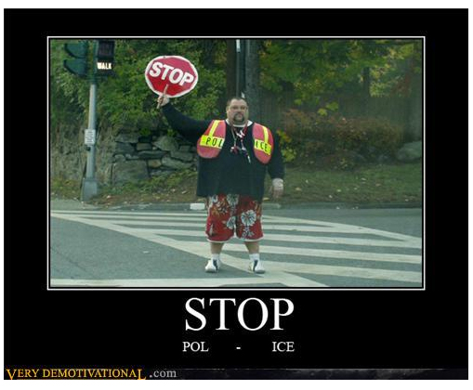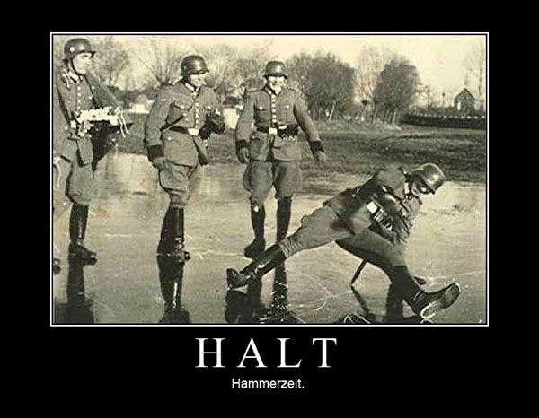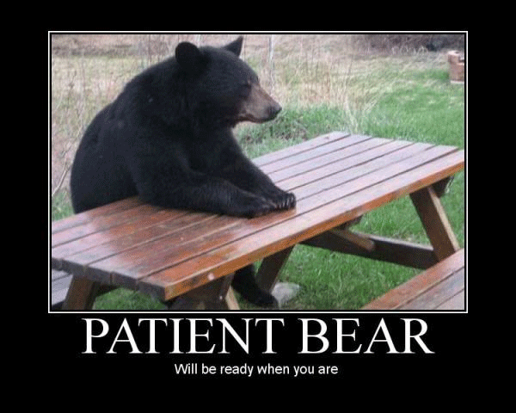
Attendees:
- James Taylor (JT)
- Neil Pickford (NCP)
- David McNeaney (DMcN)
- Alan Whitmore (AJW)
- Dave Swarbrook (DS)
- Sridar Madadi (SM)
Apologies:
- Mike Helm (MH) - Bloody welsh Wales - half-arsed surfboarding!
- Gareth Ekin (GE) - Who?
- Andy Bradley (AMB) - off to see Lisa Stansfield early doors
- Jes Challand (JC) - Still in Franceland - now has beaucoup travail and shares his initials with Johnny Cochran - leader of the OJ Simpson trial defense 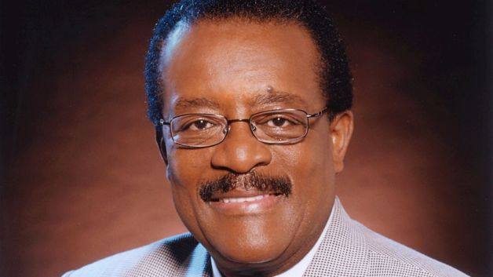
Agenda:
  - Okay previous minutes
  - Previous Actions
  - Treasurers Report & current portfolio update
  - Investment strategy & Homework (share updates)
  - Fantasy Shares
  - Peston
  - AOB
8. Next Meeting
1. Okay Previous Minutes What, there were minutes -no way - seriously, does anyone read this blowtorch aqueduct?
Yup!
2. Previous Actions  28.4.1 - Neil P to buy £1500 of Vodafone shares.  28.4.2 - Barclays statement for Aug-Sep was a no show - NCP to chase. | NCP  NCP
3. Treasurers Report & current portfolio update  £6,900.63 in TDW, £56 in Barcs. Divis from Sabmiller - £7.79, Astra Z - £13.22 - Dollars converted - $1352 to £859.61  4. Investment strategy & Homework (share updates)  Homework - Astra - hold to buy - diabetes and lung cancer drug work. Easyjet - pimping 20th anniversary. harder to make cash due to competition such as ryanair. Glaxo - mainly hols no news. Royal Mail - good divi, may get better. Sabmiller - possible merger takeover with Bud owners. Tate & Lyle - sell rating - looks a bit dodgy!  Meeting 9 - Good divi payers - BP, Royal Dutch Shell, Thomas Cook, Centrica - also Tate & Lyle and more Vodafone  Meeting 10 - Alent, Dart Group, Rurelec, CBG, Sable Mining, Topps Tiles, Air Partner, Dotdigital, JD Wetherspoon, James Halstead, Tracsis  Meeting 11 - Game (to float), Royal Mail, TmobileUSA, Optimal Payments, Balfour Beatty, Merliln  Meeting 12 - just discussed Pets @ home IPO  Meeting 13 - Topps Tiles, Aviva, L&G, Kingfisher, more of portfolio.  Meeting 14 - Astra Z, GAME IPO, B&M IPO, UK Mail, Merlin and TT Electronics (Motley tip)  Meeting 15 - more of same, TSB, TESLA, Arrow, Cineworld, Bellway, Bunzl  Meeting 16 - a chat about supermarkets  Meeting 17 - mort portfolio stuff, Just Eat, Colefax and Sell Vodafone  Meeting 18 - Lloyds - possible 7% divi by 2016, BHP Biliton, Glencore  Meeting 19 - brief discussion about Tullow Oil, EasyJet, De La Rue, Virgin Money, Stephen O'Hara and microbes to change health as a supplement.  Meeting 20 - discussed what to sell to fund the shortfall in cash to pay Matt - Tesco, Alent and Colefax placed on Neil P watch  Meeting 21 - discussed, Easyjet, Kaz minerals, BHP Billiton, Arm, Prudential, Unilever, Sabmiller, Trainline and Halfords.  Meeting 22 - discussed - VPC IPO, SCS IPO, DFS IPO, Center Parcs IPO, Aldermere IPO, Revolution Bars IPO. Laing IPO, Alumasc, Wentworth, United Utilities, Inland Homes, Afran and the divis on Vodafone, Centrica, Sky and BT. Sri suggested 10-20% of the portfolio should be high risk.  Meeting 23 - discussed - LSE, ARM, Persimmon, eg Solutions and BT.  Meeting 24 - discussed - Diageo, Unilever, Reckit Benkhauser for divis potentially. No purchases - pre election!  Meeting 25 - discussed IPOs - Easyproperty and Purple Bricks. Also Burberry. - no purchase decided.  Meeting 26 - discussed Astra Zeneca, Glaxo, BP, Centrica, Shell, Vodafone, Sabmiller, Dignity and Britvic. Along with reinvest in Royal Mail and Randgold.  Meeting 27 - Vodafone discussed and buying into existing shares from portfolio.  Meeting 28 - more of the same - FTSE is on its arse - opportunity?  28.4.1 - Neil P to buy £1500 of Vodafone shares.  28.4.2 - Barclays statement for Aug-Sep was a no show - NCP to chase.  5. Fantasy Shares  Winner in a very poor month was Dave S up 1.19 with Astra Z!  After Jim Diamond, Gordon Honeycombe, Hugh Scully and Geoffrey Howe, will it be one of these 10 next in the "Dead Pool"?  Chasing up ebay seller for spoon details.  6. Peston  Peston had slightly more ink than previous. EE Cancellation swears at customer, Russian MP stuck in tank, Pensioner in Uttar Pradesh built scale model of Taj Mahal, bloke drunk on spuds - medical issue, a one stone scrotum, £30,000 for a shed as home outside Bristol. Man doesn't wash for 12 years uses bacterial spray. Air India sacks attendants for being too fat. First 8K TVs may hit by October. An empty Spanish airport welcomed its first flight in 4 years from Ryanair.  7. AOB  Dave McN Dilbert'd once more!  7.27.1 - Outstanding currency conversion at TDI for NCP to sort. - Done  Culverton has said he would welcome a return at the next reset.  8. Next Meeting  Wednesday 14th October, 2015 at Mill Street Club, 210 Mill Street – with Pizza or possibly curry! Most likely pizza! | NCP  NCP  NCP
   | Meeting 15 | Meeting 16 | Meeting 17 | Meeting 18 | Meeting 19 | Meeting 20 | Meeting 21 | Meeting 22 | Meeting 23 | Meeting 24 | Meeting 25 | Meeting 26 | Meeting 27 | Meeting 28
  Club £ | £14,312.76 | £14,513.98 | £15,826.33 | £15,612.53 | £15,612.53 | £13,872.56 | £12,414.96 | £12,993.77 | £13,353.02 | £13,353.02 | £14,330.77 | £14,667.78 | £15,032.57 | £15,248.15
  Std units | 24 | 25 | 26 | 27 | 28 | 29 | 30 | 31 | 32 | 33 | 34 | 35 | 36 | 37
  Tot input | £15,019.47 | £15,518.62 | £15,518.62 | £16,285.30 | £16,885.32 | £16,885.32 | £11,444.00 | £11,700.00 | £12,000.00 | £12,300.00 | £12,600.00 | £12,900.00 | £13,200.00 | £13,500.00
  member input(*) | £720.00 | £750.00 | £780.00 | £810.00 | £840.00 | £870.00 | £900.00 | £930.00 | £960.00 | £990.00 | £1,020.00 | £1,050.00 | £1,080.00 | £1,110.00
  now worth | £712.67 | £722.81 | £788.28 | £777.75 | £871.36 | £845.21 | £980.13 | £1,032.84 | £1,068.24 | £1,122.24 | £1,160.11 | £1,193.89 | £1,193.89 | £1,253.74
  % increase | -1.02 | -3.63 | 1.06 | -3.98 | 3.73 | -2.85 | 8.9 | 11.06 | 11.28 | 13.36 | 13.74 | 13.7 | 13.88 | 12.95
  total units | 482 | 502 | 522 | 542 | 562 | 370 | 380 | 390 | 400 | 410 | 420 | 430 | 440 | 450
  unit worth | £29.69 | £28.91 | £30.32 | £28.81 | £31.12 | £29.15 | £29.15 | £33.32 | £33.38 | £34.01 | £34.12 | £34.11 | £34.16 | £33.88
  Name | Units | Invested | Value | Name | Units | Invested | Value
  Alan W | 69 | £2,087.60 | £2,338.05 | Dave M | 45 | £1,354.40 | £1,524.82
  Dave S | 53 | £1,598.80 | £1,795.89 | Mike H | 37 | £1,110.00 | £1,253.74
  Sri M | 45 | £1,354.40 | £1,524.82 | James T | 37 | £1,110.00 | £1,253.74
  Andy B | 45 | £1,354.40 | £1,524.82 | Jes C | 37 | £1,110.00 | £1,253.74
  Neil P | 45 | £1,354.40 | £1,524.82 | Gareth E | 37 | £1,110.00 | £1,253.74
  Symbol | Qty. | Description | Champion | Mid Price | Price Change | Market Value | Book Cost | Gain/Loss | Prev Month | Variance
  AZN | 23 | ASTRAZENECA | DSW | 4323.00p | -1.14 | 994.29 | 971.37 | 22.92 | 986.36 | 7.93
  EZJ | 44 | EASYJET | MH | 1761.00p | 6 | 774.84 | 744.05 | 30.79 | 730.84 | 44
  GSK | 69 | GLAXOSMITHKLINE | JT | 1298.00p | 6.24 | 895.62 | 986.18 | -90.56 | 895.62 | 0
  RRS | 21 | RANGOLD | AJW | 3770.00p | 144 | 791.7 | 1034.75 | -243.05 | 874.86 | -83.16
  RMG | 464 | ROYAL MAIL PLC | SM | 468.80p | -0.5 | 2175.23 | 2596.88 | -421.65 | 2280.56 | -105.33
  SAB | 28 | SABMILLER | DMcN | 3614.00p | 599.5 | 1011.92 | 963.58 | 48.34 | 1011.92 | 0
  TATE | 304 | TATE & LYLE | NCP | 560.50p | 13.21 | 1703.92 | 2091.1 | -387.18 | 1644.64 | 59.28
  Period - 3 | SHARE | EPIC | START PRICE
  Dave S | Playtech | PTEC | 860.50
  Gareth E | Qinetiq | QQ.L | 231.70
  Mike H | Apple ($) | AAPL | 115.66
  Neil P | Diageo | DGE | 1780.50
  James T | Gooch and Housego | GHH | 849.50
  Matt C | OSB | OSB | 375.20
  Andy B | Nighthawk Energy | HAWK | 3.69
  Jes C | Marks and Spencer | MKS | 494.50
  Dave McN | Sabmiller | SAB | 3635.00
  Glynn G | Punch Taverns | PUB | 119.00
  Alan W | Lloyds | LLOY | 75.27
  Sri M | Tristar | TSTR | 0.13

