The Strangemen III.0 Investment Club (HBHXX74T)
Minutes of the twenty-seventh meeting - Held Wednesday 12th August, 2015 at The Mill Street Club, Mill Street, Leek. Then curry or pIzza during (not fussy!)
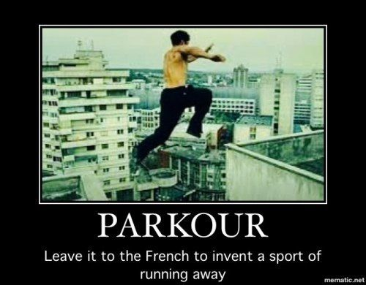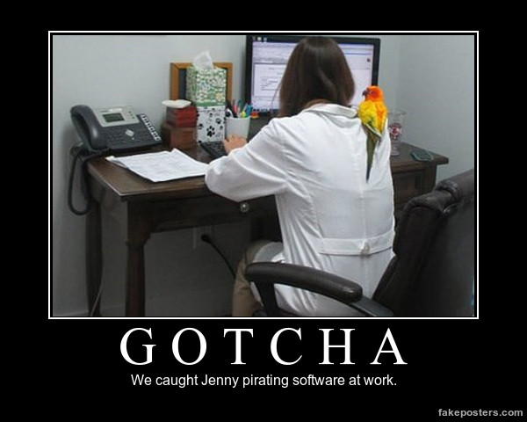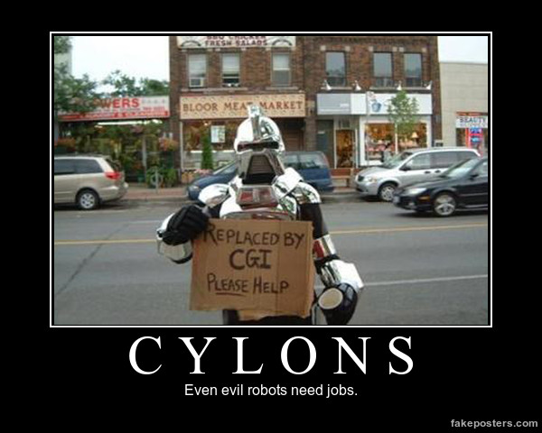
Attendees:
- James Taylor (JT)
- Neil Pickford (NCP)
- David McNeaney (DMcN)
- Alan Whitmore (AJW)
- Dave Swarbrook (DS)
- Andy Bradley (AMB)
Apologies:
- Mike Helm (MH) - Whine whine whine! Gonna call him Mrs Mike Helm from here-on in!
- Gareth Ekin (GE) - Who?
- Sridar Madadi (SM) - in the US of A! Careful now.
- Jes Challand (JC) - Still in Franceland - now has beaucoup travail and shares his initials with Sir John Cockcroft (1897-1967) - Nobel Physics prize winner in 1951 - for splitting the atomic nucleus! Some deft pen-knife work! 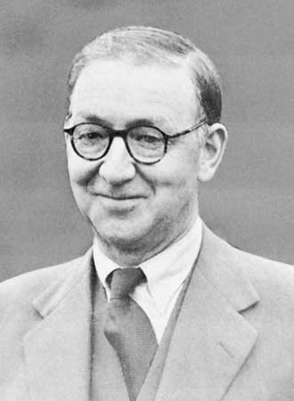
Agenda:
  - Okay previous minutes/ AGM
  - Previous Actions
  - Treasurers Report & current portfolio update
  - Investment strategy & Homework (share updates)
  - Fantasy Shares
  - Peston
  - AOB
8. Next Meeting
1. Okay Previous Minutes What, there were minutes -no way - seriously, does anyone read this molotov cocktail?
AGM - All positions resigned. New positions - Peston is AJW - Nom = NCP, 2nd = DMcN. Chair is AMB - Nom = JT, 2nd = DMcN. Vice Chair is DSW - Nom = AMB, 2nd = AJW. Secretary is NCP - Nom = DSW, 2nd = DMcN. Vice Sec is DMcN - Nom = DSW, 2nd = AJW. Treasurer is JT - Nom = AJW, 2nd = AMB. Vice-Treasurer is SM - Nom = JT, 2nd = AMB.
2. Previous Actions
26.4.1 - Neil P to buy £1,000 each of Astra, Glaxo and Sabmiller - also £500 each of Royal Mail and Randgold with a view to parity and sale. Done
3. Treasurers Report & current portfolio update  £7, 469.82 in TDW, £34.32 in Barcs. Divis from Royal Mail - £52.62 on 31/7 and Tate & Lyle - £60.19 on 31/7  4. Investment strategy & Homework (share updates)  Homework - Easyjet - we did Mike's work for him! - pass no.s up in July '15 by 9.4%. Rand - gold is go to again due to poor markets. Royal Mail - Labour would bring back public ownership. Tate - anger at new icing sugar ingredients! Astra - £1.5mn per hour of NHS budget spent on diabetes - hopefully cash in on AZN new medicines which are being pimped out in 50% of cases. Sab - losing money due to booze cruises still. Glaxo - shut major USA plant due to legionnaires - the disease, not the soldiers.  Meeting 9 - Good divi payers - BP, Royal Dutch Shell, Thomas Cook, Centrica - also Tate & Lyle and more Vodafone  Meeting 10 - Alent, Dart Group, Rurelec, CBG, Sable Mining, Topps Tiles, Air Partner, Dotdigital, JD Wetherspoon, James Halstead, Tracsis  Meeting 11 - Game (to float), Royal Mail, TmobileUSA, Optimal Payments, Balfour Beatty, Merliln  Meeting 12 - just discussed Pets @ home IPO  Meeting 13 - Topps Tiles, Aviva, L&G, Kingfisher, more of portfolio.  Meeting 14 - Astra Z, GAME IPO, B&M IPO, UK Mail, Merlin and TT Electronics (Motley tip)  Meeting 15 - more of same, TSB, TESLA, Arrow, Cineworld, Bellway, Bunzl  Meeting 16 - a chat about supermarkets  Meeting 17 - mort portfolio stuff, Just Eat, Colefax and Sell Vodafone  Meeting 18 - Lloyds - possible 7% divi by 2016, BHP Biliton, Glencore  Meeting 19 - brief discussion about Tullow Oil, EasyJet, De La Rue, Virgin Money, Stephen O'Hara and microbes to change health as a supplement.  Meeting 20 - discussed what to sell to fund the shortfall in cash to pay Matt - Tesco, Alent and Colefax placed on Neil P watch  Meeting 21 - discussed, Easyjet, Kaz minerals, BHP Billiton, Arm, Prudential, Unilever, Sabmiller, Trainline and Halfords.  Meeting 22 - discussed - VPC IPO, SCS IPO, DFS IPO, Center Parcs IPO, Aldermere IPO, Revolution Bars IPO. Laing IPO, Alumasc, Wentworth, United Utilities, Inland Homes, Afran and the divis on Vodafone, Centrica, Sky and BT. Sri suggested 10-20% of the portfolio should be high risk.  Meeting 23 - discussed - LSE, ARM, Persimmon, eg Solutions and BT.  Meeting 24 - discussed - Diageo, Unilever, Reckit Benkhauser for divis potentially. No purchases - pre election!  Meeting 25 - discussed IPOs - Easyproperty and Purple Bricks. Also Burberry. - no purchase decided.  Meeting 26 - discussed Astra Zeneca, Glaxo, BP, Centrica, Shell, Vodafone, Sabmiller, Dignity and Britvic. Along with reinvest in Royal Mail and Randgold.  Meeting 27 - Vodafone discussed and buying into existing shares from portfolio.  27.4.1 - Neil P to buy £500 each Glaxo and Sabmiller.  5. Fantasy Shares  First stabs in the dark by 10 intrepid men looking to put a bid in for Greece!  All prices paid except Sri who is on holiday - Spoon to be ordered for Gareth.  6. Peston  Peston reported on being out of ink! Guy on hold with BT for 14 hours. KFC offering pink coloured rose flavoured burgers. LA have released 96 million plastic balls into water supply to combat algae. New clubs in London where alcohol is consumed via the fact it is piped in via aerosol. Llandudno street lights turned off so glo-worms can have sex. Diesel is proced below Petrol - average is £1.09. "Goldfinger" conman shot on Essex had £6mn boat. Nevzat Idin - Turkey's Just Eat - sold company and shared the cash with staff. Studio flat in HAckney for £1K mnth was actually a garage with bed. 3 men sneaked into a showing of horror film the Gift in California and set off leaf blowers!  7. AOB  Dave McN did not Dilbert!  7.27.1 - Outstanding currency conversion at TDI for NCP to sort.  8. Next Meeting  Wednesday 16th September, 2015 at Mill Street Club, 210 Mill Street – with Pizza or possibly curry! Most likely pizza! | NCP  NCP
   | Meeting 14 | Meeting 15 | Meeting 16 | Meeting 17 | Meeting 18 | Meeting 19 | Meeting 20 | Meeting 21 | Meeting 22 | Meeting 23 | Meeting 24 | Meeting 25 | Meeting 26 | Meeting 27
  Club £ | £14,016.30 | £14,312.76 | £14,513.98 | £15,826.33 | £15,612.53 | £15,612.53 | £13,872.56 | £12,414.96 | £12,993.77 | £13,353.02 | £13,353.02 | £14,330.77 | £14,667.78 | £15,032.57
  Std units | 23 | 24 | 25 | 26 | 27 | 28 | 29 | 30 | 31 | 32 | 33 | 34 | 35 | 36
  Tot input | £13,885.32 | £15,019.47 | £15,518.62 | £15,518.62 | £16,285.30 | £16,885.32 | £16,885.32 | £11,444.00 | £11,700.00 | £12,000.00 | £12,300.00 | £12,600.00 | £12,900.00 | £13,200.00
  member input(*) | £690.00 | £720.00 | £750.00 | £780.00 | £810.00 | £840.00 | £870.00 | £900.00 | £930.00 | £960.00 | £990.00 | £1,020.00 | £1,050.00 | £1,080.00
  now worth | £697.78 | £712.67 | £722.81 | £788.28 | £777.75 | £871.36 | £845.21 | £980.13 | £1,032.84 | £1,068.24 | £1,122.24 | £1,160.11 | £1,193.89 | £1,193.89
  % increase | 1.13 | -1.02 | -3.63 | 1.06 | -3.98 | 3.73 | -2.85 | 8.9 | 11.06 | 11.28 | 13.36 | 13.74 | 13.7 | 13.88
  total units | 462 | 482 | 502 | 522 | 542 | 562 | 370 | 380 | 390 | 400 | 410 | 420 | 430 | 440
  unit worth | £30.34 | £29.69 | £28.91 | £30.32 | £28.81 | £31.12 | £29.15 | £29.15 | £33.32 | £33.38 | £34.01 | £34.12 | £34.11 | £34.16
  Name | Units | Invested | Value | Name | Units | Invested | Value
  Alan W | 68 | £2,057.60 | £2,323.22 | Dave M | 44 | £1,324.40 | £1,503.26
  Dave S | 52 | £1,568.80 | £1,776.58 | Mike H | 36 | £1,080.00 | £1,229.94
  Sri M | 44 | £1,324.40 | £1,503.26 | James T | 36 | £1,080.00 | £1,229.94
  Andy B | 44 | £1,324.40 | £1,503.26 | Jes C | 36 | £1,080.00 | £1,229.94
  Neil P | 44 | £1,324.40 | £1,503.26 | Gareth E | 36 | £1,080.00 | £1,229.94
  Symbol | Qty. | Description | Champion | Mid Price | Price Change | Market Value | Book Cost | Gain/Loss | Prev Month | Variance
  AZN | 23 | ASTRAZENECA | DSW | 4288.50p | -50.5 | 986.36 | 971.37 | 14.99 | 986.36 | 0
  EZJ | 44 | EASYJET | MH | 1661.00p | -19.33 | 730.84 | 744.05 | -13.21 | 696.52 | 34.32
  GSK | 35 | GLAXOSMITHKLINE | JT | 1419.00p | -18.5 | 496.65 | 488.7 | 7.95 | 496.65 | 0
  RRS | 21 | RANGOLD | AJW | 4166.00p | 214 | 874.86 | 1034.75 | -159.89 | 874.86 | 0
  RMG | 464 | ROYAL MAIL PLC | SM | 491.50p | -6.8 | 2280.56 | 2596.88 | -316.32 | 2280.56 | 0
  SAB | 14 | SABMILLER | DMcN | 3256.50p | -26 | 455.91 | 484.64 | -28.73 | 455.91 | 0
  TATE | 304 | TATE & LYLE | NCP | 541.00p | 0 | 1644.64 | 2091.1 | -446.46 | 1579.28 | 65.36
  Period - 2 | SHARE | EPIC | START PRICE
  Dave S | Astra Zeneca | AZN | 4277.00
  Gareth E | Qinetiq | QQ.L | 236.30
  Mike H | Apple ($) | AAPL | 116.04
  Neil P | Halfords | HFD | 533.50
  James T | Randgold | RRS | 4184.00
  Matt C | Deutsche Bank AG ($) | DB | 32.67
  Andy B | Nighthawk Energy | HAWK | 3.65
  Jes C | Marks and Spencer | MKS | 545.00
  Dave McN | Reed Elsevier | REL.L | 1081.00
  Glynn G | Punch Taverns | PUB | 127.00
  Alan W | Lloyds | LLOY | 80.19
  Sri M | Afren | AFR | In Administration

