The Strangemen III.0 Investment Club (HBHXX74T)
Minutes of the twenty-fifth meeting - Held Wednesday 1st July, 2015 at The Mill Street Club, Mill Street, Leek. Then curry or pIzza during (not fussy!)
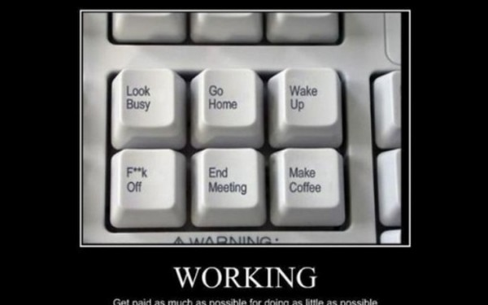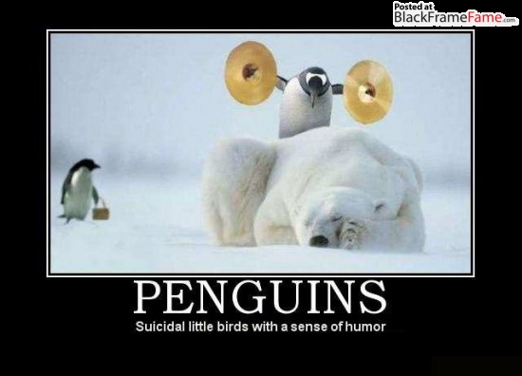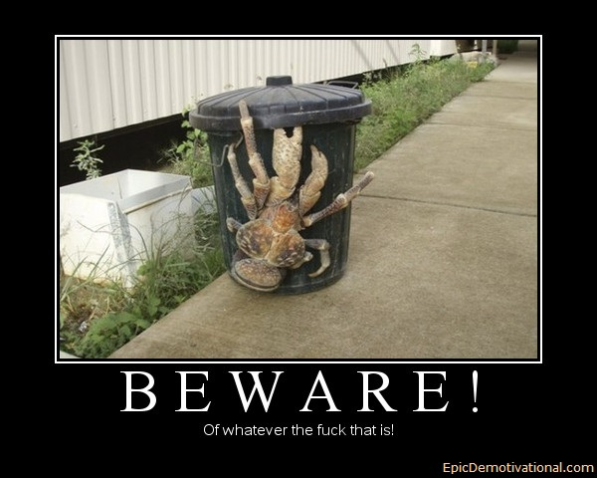
Attendees:
- James Taylor (JT)
- Neil Pickford (NCP)
- David McNeaney (DMcN)
- Alan Whitmore (AJW)
- Dave Swarbrook (DS)
Apologies:
- Mike Helm (MH) - Sue poorly - I can't believe he is using his wife as an excuse now - tut tut - chivalry is dead!
- Gareth Ekin (GE) - The mystery deepens! Scarlett Pimpernel mother-fucker!
- Sridar Madadi (SM) - Cubs again - he will start to get a reputation!
- Andy Bradley (AMB) - Not having the rub of the green! Neil P shared an e-mail from Andy - he is at a low ebb.
- Jes Challand (JC) - Still in Franceland - now has beaucoup travail and shares his initials with John Courage (1761-1793) - Founder of Courage brewery! 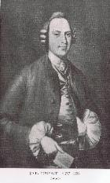
Agenda:
  - Okay previous minutes
  - Previous Actions
  - Treasurers Report & current portfolio update
  - Investment strategy & Homework (share updates)
  - Fantasy Shares
  - Peston
  - AOB
8. Next Meeting
1. Okay Previous Minutes What, there were minutes -no way - seriously, does anyone read this potato?
2. Previous Actions  26.4.1 - Neil P to buy £1,000 each of Astra, Glaxo and Sabmiller - also £500 each of Royal Mail and Randgold with a view to parity and sale.  Quick note, we need an AGM in July/ August! Extra item - resign and revote each position in!  Discuss IPOs and approach. | NCP
3. Treasurers Report & current portfolio update  £10,065.58 in TDW, £156.32 in Barcs. Randgold - £3.86 Dividend  4. Investment strategy & Homework (share updates)  Homework - Easyjet - no news from Helm central. Randgold - no news from AJ - just no news! Royal Mail - done by NCP- divi of 2.86% around 31/7. Tate & Lyle - divi of 3.39% on 31/7. Director given less money due to performance, but still a feckload of money! Should have £2.6m in shares, but only picked up £700K. only joined in June!!!!  Meeting 9 - Good divi payers - BP, Royal Dutch Shell, Thomas Cook, Centrica - also Tate & Lyle and more Vodafone  Meeting 10 - Alent, Dart Group, Rurelec, CBG, Sable Mining, Topps Tiles, Air Partner, Dotdigital, JD Wetherspoon, James Halstead, Tracsis  Meeting 11 - Game (to float), Royal Mail, TmobileUSA, Optimal Payments, Balfour Beatty, Merliln  Meeting 12 - just discussed Pets @ home IPO  Meeting 13 - Topps Tiles, Aviva, L&G, Kingfisher, more of portfolio.  Meeting 14 - Astra Z, GAME IPO, B&M IPO, UK Mail, Merlin and TT Electronics (Motley tip)  Meeting 15 - more of same, TSB, TESLA, Arrow, Cineworld, Bellway, Bunzl  Meeting 16 - a chat about supermarkets  Meeting 17 - mort portfolio stuff, Just Eat, Colefax and Sell Vodafone  Meeting 18 - Lloyds - possible 7% divi by 2016, BHP Biliton, Glencore  Meeting 19 - brief discussion about Tullow Oil, EasyJet, De La Rue, Virgin Money, Stephen O'Hara and microbes to change health as a supplement.  Meeting 20 - discussed what to sell to fund the shortfall in cash to pay Matt - Tesco, Alent and Colefax placed on Neil P watch  Meeting 21 - discussed, Easyjet, Kaz minerals, BHP Billiton, Arm, Prudential, Unilever, Sabmiller, Trainline and Halfords.  Meeting 22 - discussed - VPC IPO, SCS IPO, DFS IPO, Center Parcs IPO, Aldermere IPO, Revolution Bars IPO. Laing IPO, Alumasc, Wentworth, United Utilities, Inland Homes, Afran and the divis on Vodafone, Centrica, Sky and BT. Sri suggested 10-20% of the portfolio should be high risk.  Meeting 23 - discussed - LSE, ARM, Persimmon, eg Solutions and BT.  Meeting 24 - discussed - Diageo, Unilever, Reckit Benkhauser for divis potentially. No purchases - pre election!  Meeting 25 - discussed IPOs - Easyproperty and Purple Bricks. Also Burberry. - no purchase decided.  Meeting 26 - discussed Astra Zeneca, Glaxo, BP, Centrica, Shell, Vodafone, Sabmiller, Dignity and Britvic. Along with reinvest in Royal Mail and Randgold.  26.4.1 - Neil P to buy £1,000 each of Astra, Glaxo and Sabmiller - also £500 each of Royal Mail and Randgold with a view to parity and sale.  5. Fantasy Shares  First stabs in the dark by 10 intrepid men looking to put a bid in for Greece!  £60 for Alan, £40 for Jes and £20 for Sri, along with Gareth's spoons, will be dealt with by Neil P and James T.  6. Peston  Peston reported on supermarkets shutting stores, italian couple ran onto runway in Malta to stop plane, naked woman caused power outage, breast implant drug smuggling, canadian helicopter cope sex talk, german robbers chased away by person armed with vacuum, big 6ft rhea running around mottingham and Oregon men attacked by beavers. New IPOs - glitterbomb man makes BIG post-its, robotic bartenders and cocktailvending machines!  7. AOB  Dave McN dilberted!  8. Next Meeting  Wednesday 5th August, 2015 at Mill Street Club, 210 Mill Street – with Pizza or possibly curry! Most likely pizza! | NCP
   | Meeting 13 | Meeting 14 | Meeting 15 | Meeting 16 | Meeting 17 | Meeting 18 | Meeting 19 | Meeting 20 | Meeting 21 | Meeting 22 | Meeting 23 | Meeting 24 | Meeting 25 | Meeting 26
  Club £ | £7,364.31 | £14,016.30 | £14,312.76 | £14,513.98 | £15,826.33 | £15,612.53 | £15,612.53 | £13,872.56 | £12,414.96 | £12,993.77 | £13,353.02 | £13,353.02 | £14,330.77 | £14,667.78
  Std units | 21 | 23 | 24 | 25 | 26 | 27 | 28 | 29 | 30 | 31 | 32 | 33 | 34 | 35
  Tot input | £6,930.00 | £13,885.32 | £15,019.47 | £15,518.62 | £15,518.62 | £16,285.30 | £16,885.32 | £16,885.32 | £11,444.00 | £11,700.00 | £12,000.00 | £12,300.00 | £12,600.00 | £12,900.00
  member input(*) | £630.00 | £690.00 | £720.00 | £750.00 | £780.00 | £810.00 | £840.00 | £870.00 | £900.00 | £930.00 | £960.00 | £990.00 | £1,020.00 | £1,050.00
  now worth | £669.48 | £697.78 | £712.67 | £722.81 | £788.28 | £777.75 | £871.36 | £845.21 | £980.13 | £1,032.84 | £1,068.24 | £1,122.24 | £1,160.11 | £1,193.89
  % increase | 6.27 | 1.13 | -1.02 | -3.63 | 1.06 | -3.98 | 3.73 | -2.85 | 8.9 | 11.06 | 11.28 | 13.36 | 13.74 | 13.7
  total units | 220 | 462 | 482 | 502 | 522 | 542 | 562 | 370 | 380 | 390 | 400 | 410 | 420 | 430
  unit worth | £31.88 | £30.34 | £29.69 | £28.91 | £30.32 | £28.81 | £31.12 | £29.15 | £29.15 | £33.32 | £33.38 | £34.01 | £34.12 | £34.11
  Name | Units | Invested | Value | Name | Units | Invested | Value
  Alan W | 67 | £2,027.60 | £2,285.44 | Dave M | 43 | £1,294.40 | £1,466.78
  Dave S | 51 | £1,538.80 | £1,739.67 | Mike H | 35 | £1,050.00 | £1,193.89
  Sri M | 43 | £1,294.40 | £1,466.78 | James T | 35 | £1,050.00 | £1,193.89
  Andy B | 43 | £1,294.40 | £1,466.78 | Jes C | 35 | £1,050.00 | £1,193.89
  Neil P | 43 | £1,294.40 | £1,466.78 | Gareth E | 35 | £1,050.00 | £1,193.89
  Symbol | Qty. | Description | Champion | Mid Price | Price Change | Market Value | Book Cost | Gain/Loss | Prev Month | Variance
  EZJ | 44 | EASYJET | MH | 1583.00p | 40.54 | 696.52 | 744.05 | -47.53 | 725.56 | -29.04
  RRS | 10 | RANGOLD | AJW | 4215.00p | -70 | 421.5 | 562.37 | -140.87 | 479.9 | -58.4
  RMG | 368 | ROYAL MAIL PLC | SM | 517.50p | 3 | 1904.4 | 2098.5 | -194.1 | 1839.63 | 64.77
  TATE | 304 | TATE & LYLE | NCP | 519.50p | 4.07 | 1579.28 | 2091.1 | -511.82 | 1817.92 | -238.64
  Period - 1 | SHARE | EPIC | START PRICE
  Dave S | ARM | ARM | 1055.00
  Gareth E | Qinetiq | QQ.L | 228.50
  Mike H | Apple ($) | AAPL | 126.43
  Neil P | TT Electronics | TTG | 148.25
  James T | Randgold | RRS | 4169.00
  Matt C | Deutsche Bank AG ($) | DB | 31.55
  Andy B | Nighthawk Energy | HAWK | 5.55
  Jes C | Marks and Spencer | MKS | 545.00
  Dave McN | Reed Elsevie ($)r | RELX | 16.51
  Glynn G | Punch Taverns | PUB | 126.00
  Alan W | Lloyds | LLOY | 86.78
  Sri M | Afren | AFR | 1.90

