The Strangemen III.0 Investment Club (HBHXX74T)
Minutes of the twenty-fifth meeting - Held Wednesday 20th May, 2015 at The Mill Street Club, Mill Street, Leek. Then curry!
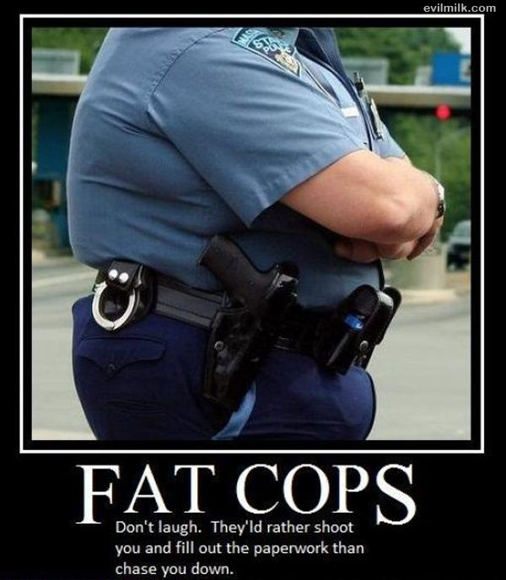
Attendees:
- James Taylor (JT)
- Neil Pickford (NCP)
- David McNeaney (DMcN)
- Mike Helm (MH)
- Alan Whitmore (AJW)
Apologies:
- Dave Swarbrrok (DS) - being indiscrete in Crete
- Gareth Ekin (GE) - 2 in a row - erm, no chance!
- Sridar Madadi (SM) - late coming home from Cubs - seriously thought he was old enough for Scouts now!
- Andy Bradley (AMB) - roamin' in Rome
- Jes Challand (JC) - Still in Franceland - now has beaucoup travail and shares his initials with Julian Cope - solo artist and former lead of Teardrop Explodes! 
Agenda:
  - Okay previous minutes
  - Previous Actions
  - Treasurers Report & current portfolio update
  - Investment strategy & Homework (share updates)
  - Fantasy Shares
  - Peston
  - AOB
8. Next Meeting
1. Okay Previous Minutes What, there were minutes -no way - seriously, does anyone read this potato?
2. Previous Actions  5.24.1 - Unsure of prize monies, as we cannot remember - James T to check the cheque book/ Barcs account!  Quick note, we need an AGM in July/ August! | JT
3. Treasurers Report & current portfolio update  £9,467.76 in TDW, £136.32 in Barcs.  4. Investment strategy & Homework (share updates)  Homework - Easyjet price plunge - cautious outlook - still buy. Randgold - 16% drop in Q1 profits - drop in gold price. Hold/Buy. Royal Mail - poor profits - need a kick up the arse or a miracle! Tate & lyle -selling european assets and tipped by Deutsche Bank to go up on revised business model.  Meeting 9 - Good divi payers - BP, Royal Dutch Shell, Thomas Cook, Centrica - also Tate & Lyle and more Vodafone  Meeting 10 - Alent, Dart Group, Rurelec, CBG, Sable Mining, Topps Tiles, Air Partner, Dotdigital, JD Wetherspoon, James Halstead, Tracsis  Meeting 11 - Game (to float), Royal Mail, TmobileUSA, Optimal Payments, Balfour Beatty, Merliln  Meeting 12 - just discussed Pets @ home IPO  Meeting 13 - Topps Tiles, Aviva, L&G, Kingfisher, more of portfolio.  Meeting 14 - Astra Z, GAME IPO, B&M IPO, UK Mail, Merlin and TT Electronics (Motley tip)  Meeting 15 - more of same, TSB, TESLA, Arrow, Cineworld, Bellway, Bunzl  Meeting 16 - a chat about supermarkets  Meeting 17 - mort portfolio stuff, Just Eat, Colefax and Sell Vodafone  Meeting 18 - Lloyds - possible 7% divi by 2016, BHP Biliton, Glencore  Meeting 19 - brief discussion about Tullow Oil, EasyJet, De La Rue, Virgin Money, Stephen O'Hara and microbes to change health as a supplement.  Meeting 20 - discussed what to sell to fund the shortfall in cash to pay Matt - Tesco, Alent and Colefax placed on Neil P watch  Meeting 21 - discussed, Easyjet, Kaz minerals, BHP Billiton, Arm, Prudential, Unilever, Sabmiller, Trainline and Halfords.  Meeting 22 - discussed - VPC IPO, SCS IPO, DFS IPO, Center Parcs IPO, Aldermere IPO, Revolution Bars IPO. Laing IPO, Alumasc, Wentworth, United Utilities, Inland Homes, Afran and the divis on Vodafone, Centrica, Sky and BT. Sri suggested 10-20% of the portfolio should be high risk.  Meeting 23 - discussed - LSE, ARM, Persimmon, eg Solutions and BT.  Meeting 24 - discussed - Diageo, Unilever, Reckit Benkhauser for divis potentially. No purchases - pre election!  Meeting 25 - discussed IPOs - Easyproperty and Purple Bricks. Also Burberry. - no purchase decided.  5. Fantasy Shares  Mr Whitmore took the plaudits in the monthly comp - with lloyds up 13.01% which means..................  It's all over for another year - Winning by 2 points on 96 is Alan Whitmore, followed by Jes on 94 and Sri on 91!  Full standings;-  Alan W - 96  Jes C - 94  Sri M - 91  Dave S - 88  Neil P - 85  James T - 82  Matt C - 81  Mike H - 79  Andy B - 75  Dave McN - 67  Gareth (The Spoon Collector) E - 47  5.24.1 - Unsure of prize monies, as we cannot remember - James T to check the cheque book/ Barcs account!  Next comp will start in July 1st meeting with any rule changes taking effect.  6. Peston  Peston reported on The Greeks heading for default, 5 global banks getting a $5,7bn fine for rate rigging, a wonderful picture of a mutant pig, £20 note to feature a new creative personage, 70 kilos of heroin found in an SUV in NYC worth $32m and an associated apartment with cash of $1.3m in too. Woman loves and intends to marry tree and land-speed record of 76.785mph for a bus powered by poo - load of shit if you ask me!  7. AOB  Dave McN dilberted!  8. Next Meeting  E-mail vote for next date based on 17/24 June or 1 July - Ad e Northcott to be invited along.  Wednesday 1st July, 2015 at Mill Street Club, 210 Mill Street – with Pizza or possibly curry! Most likely curry! | JT
   | Meeting 13 | Meeting 14 | Meeting 15 | Meeting 16 | Meeting 17 | Meeting 18 | Meeting 19 | Meeting 20 | Meeting 21 | Meeting 22 | Meeting 23 | Meeting 24 | Meeting 25
  Club £ | £7,364.31 | £14,016.30 | £14,312.76 | £14,513.98 | £15,826.33 | £15,612.53 | £15,612.53 | £13,872.56 | £12,414.96 | £12,993.77 | £13,353.02 | £13,353.02 | £14,330.77
  Std units | 21 | 23 | 24 | 25 | 26 | 27 | 28 | 29 | 30 | 31 | 32 | 33 | 34
  Tot input | £6,930.00 | £13,885.32 | £15,019.47 | £15,518.62 | £15,518.62 | £16,285.30 | £16,885.32 | £16,885.32 | £11,444.00 | £11,700.00 | £12,000.00 | £12,300.00 | £12,600.00
  member input(*) | £630.00 | £690.00 | £720.00 | £750.00 | £780.00 | £810.00 | £840.00 | £870.00 | £900.00 | £930.00 | £960.00 | £990.00 | £1,020.00
  now worth | £669.48 | £697.78 | £712.67 | £722.81 | £788.28 | £777.75 | £871.36 | £845.21 | £980.13 | £1,032.84 | £1,068.24 | £1,122.24 | £1,160.11
  % increase | 6.27 | 1.13 | -1.02 | -3.63 | 1.06 | -3.98 | 3.73 | -2.85 | 8.9 | 11.06 | 11.28 | 13.36 | 13.74
  total units | 220 | 462 | 482 | 502 | 522 | 542 | 562 | 370 | 380 | 390 | 400 | 410 | 420
  unit worth | £31.88 | £30.34 | £29.69 | £28.91 | £30.32 | £28.81 | £31.12 | £29.15 | £29.15 | £33.32 | £33.38 | £34.01 | £34.12
  Name | Units | Invested | Value | Name | Units | Invested | Value
  Alan W | 66 | £1,997.60 | £2,251.98 | Dave M | 42 | £1,264.40 | £1,433.08
  Dave S | 50 | £1,508.80 | £1,706.04 | Mike H | 34 | £1,020.00 | £1,160.11
  Sri M | 42 | £1,264.40 | £1,433.08 | James T | 34 | £1,020.00 | £1,160.11
  Andy B | 42 | £1,264.40 | £1,433.08 | Jes C | 34 | £1,020.00 | £1,160.11
  Neil P | 42 | £1,264.40 | £1,433.08 | Gareth E | 34 | £1,020.00 | £1,160.11
  Symbol | Qty. | Description | Champion | Mid Price | Price Change | Market Value | Book Cost | Gain/Loss | Prev Month | Variance
  EZJ | 44 | EASYJET | MH | 1649.00p | -25 | 725.56 | 744.05 | -18.49 | 799.48 | -73.92
  RRS | 10 | RANGOLD | AJW | 4799.00p | -3 | 479.9 | 562.37 | -82.47 | 509.5 | -29.6
  RMG | 368 | ROYAL MAIL PLC | SM | 499.90p | 0.7 | 1839.63 | 2098.5 | -258.87 | 1634.66 | 204.97
  TATE | 304 | TATE & LYLE | NCP | 598.00p | -15.5 | 1817.92 | 2091.1 | -273.18 | 1825.52 | -7.6

