The Strangemen III.0 Investment Club (HBHXX74T)
Minutes of the twenty-fourth meeting - Held Wednesday 29th April, 2015 at The Mill Street Club, Mill Street, Leek. Then curry!
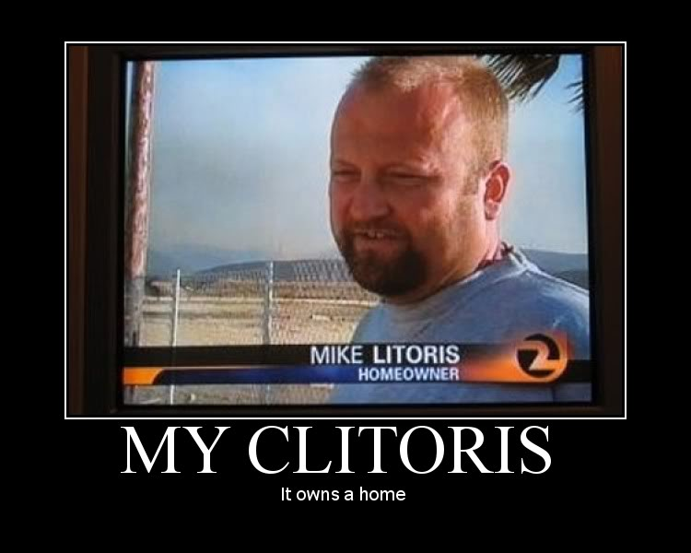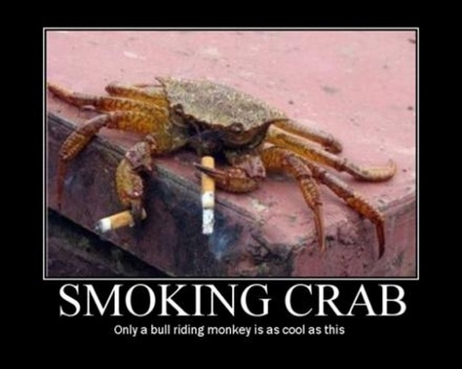
Attendees:
- James Taylor (JT)
- Neil Pickford (NCP)
- Sridar Madadi (SM)
- David McNeaney (DMcN)
- Mike Helm (MH)
- Gareth Ekin (GE) - Guest (no seriously)- Gareth Feckin' Ekin in da house!
Apologies:
- Dave Swarbrrok (DS) - watching Leek Town fail for the third time in four years!
- Alan Whitmore (AJW) - also watching Leek Town fail for the third time in four years!
- Andy Bradley (AMB) - culture vulture at the Theatre!
- Jes Challand (JC) - Still in Franceland - looking for travail and shares his initials with John Cooper - the inventor of the Mini Cooper! 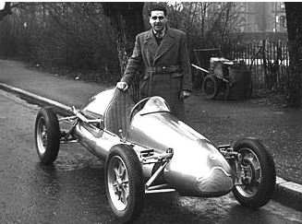
Agenda:
  - Okay previous minutes
  - Previous Actions
  - Treasurers Report & current portfolio update
  - Investment strategy & Homework (share updates)
  - Fantasy Shares
  - Peston
  - AOB
8. Next Meeting
1. Okay Previous Minutes What, there were minutes -no way!
2. Previous Actions  4.23.1Sell Barclays, Randgold if parity restored. - Barclays sold | NCP
3. Treasurers Report & current portfolio update
£8,295.23 in TDW, £343.32 in Barcs. BP sold for £2,104.50, Barclays sold for £2,087.49, Alent sold for £631.71. Divis - BP - £29.01 - 27/3, Barcs - £28.42 - 2/4, Colefax - £4.47 - 10/4
 | Meeting 11 | Meeting 12 | Meeting 13 |  | Meeting 14 |  | Meeting 15 |  | Meeting 16 |  | Meeting 17 |  | Meeting 18 |  | Meeting 19 | Meeting 20 | Meeting 21 | Meeting 22 | Meeting 23 | Meeting 24
Club £ | £7,080.02 | £7,051.52 | £7,364.31 |  | £14,016.30 |  | £14,312.76 |  | £14,513.98 |  | £15,826.33 |  | £15,612.53 |  | £15,612.53 | £13,872.56 | £12,414.96 | £12,993.77 | £13,353.02 | £13,353.02
Std units | 19 | 20 | 21 |  | 23 |  | 24 |  | 25 |  | 26 |  | 27 |  | 28 | 29 | 30 | 31 | 32 | 33
Tot input | £6,270.00 | £6,600.00 | £6,930.00 |  | £13,885.32 |  | £15,019.47 |  | £15,518.62 |  | £15,518.62 |  | £16,285.30 |  | £16,885.32 | £16,885.32 | £11,444.00 | £11,700.00 | £12,000.00 | £12,300.00
member input(*) | £570.00 | £600.00 | £630.00 |  | £690.00 |  | £720.00 |  | £750.00 |  | £780.00 |  | £810.00 |  | £840.00 | £870.00 | £900.00 | £930.00 | £960.00 | £990.00
now worth | £643.64 | £641.05 | £669.48 |  | £697.78 |  | £712.67 |  | £722.81 |  | £788.28 |  | £777.75 |  | £871.36 | £845.21 | £980.13 | £1,032.84 | £1,068.24 | £1,122.24
% increase | 12.92 | 6.84 | 6.27 |  | 1.13 |  | -1.02 |  | -3.63 |  | 1.06 |  | -3.98 |  | 3.73 | -2.85 | 8.9 | 11.06 | 11.28 | 13.36
total units | 209 | 220 | 220 |  | 462 |  | 482 |  | 502 |  | 522 |  | 542 |  | 562 | 370 | 380 | 390 | 400 | 410
unit worth | £33.88 | £32.05 | £31.88 |  | £30.34 |  | £29.69 |  | £28.91 |  | £30.32 |  | £28.81 |  | £31.12 | £29.15 | £29.15 | £33.32 | £33.38 | £34.01
Name | Units | Invested |  | Value |  | Name |  | Units |  | Invested |  | Value
Alan W | 65 | £1,967.60 |  | £2,210.48 |  | Dave M |  | 41 |  | £1,234.40 |  | £1,394.30
Dave S | 49 | £1,478.80 |  | £1,666.36 |  | Mike H |  | 33 |  | £990.00 |  | £1,122.24
Sri M | 41 | £1,234.40 |  | £1,394.30 |  | James T |  | 33 |  | £990.00 |  | £1,122.24
Andy B | 41 | £1,234.40 |  | £1,394.30 |  | Jes C |  | 33 |  | £990.00 |  | £1,122.24
Neil P | 41 | £1,234.40 |  | £1,394.30 |  | Gareth E |  | 33 |  | £990.00 |  | £1,122.24

4. Investment strategy & Homework (share updates)
Symbol | Qty. | Description | Champion | Mid Price | Price Change | Market Value | Book Cost | Gain/Loss | Prev Month | Variance
CFX | 213 | COLEFAX GROUP | DMcN | 412.50p | 12.5 | 878.63 | 747.35 | 131.28 | 846.68 | 31.95
EZJ | 44 | EASYJET | MH | 1817.00p | -11 | 799.48 | 744.05 | 55.43 | 831.6 | -32.12
RRS | 10 | RANGOLD | AJW | 5095.00p | 60 | 509.5 | 562.37 | -52.87 | 488.2 | 21.3
RMG | 368 | ROYAL MAIL PLC | SM | 444.20p | 6.6 | 1634.66 | 2098.5 | -463.84 | 1635.76 | -1.1
TATE | 304 | TATE & LYLE | NCP | 600.50p | -12 | 1825.52 | 2091.1 | -265.58 | 1824 | 1.52

Homework - Colefax - divi due - we have had it. Easyjet - new finance chief from Halfords - strong buy. Randgold - Ivory Coast mining back on track. Royal Mail - divi going down - TNT impacting on direct to door delivery. Tate & Lyle - selling european assets - potentially Spenda also.

Meeting 9 - Good divi payers - BP, Royal Dutch Shell, Thomas Cook, Centrica - also Tate & Lyle and more Vodafone

Meeting 10 - Alent, Dart Group, Rurelec, CBG, Sable Mining, Topps Tiles, Air Partner, Dotdigital, JD Wetherspoon, James Halstead, Tracsis

Meeting 11 - Game (to float), Royal Mail, TmobileUSA, Optimal Payments, Balfour Beatty, Merliln

Meeting 12 - just discussed Pets @ home IPO

Meeting 13 - Topps Tiles, Aviva, L&G, Kingfisher, more of portfolio.

Meeting 14 - Astra Z, GAME IPO, B&M IPO, UK Mail, Merlin and TT Electronics (Motley tip)

Meeting 15 - more of same, TSB, TESLA, Arrow, Cineworld, Bellway, Bunzl

Meeting 16 - a chat about supermarkets

Meeting 17 - mort portfolio stuff, Just Eat, Colefax and Sell Vodafone
Meeting 18 - Lloyds - possible 7% divi by 2016, BHP Biliton, Glencore
Meeting 19 - brief discussion about Tullow Oil, EasyJet, De La Rue, Virgin Money, Stephen O'Hara and microbes to change health as a supplement.
Meeting 20 - discussed what to sell to fund the shortfall in cash to pay Matt - Tesco, Alent and Colefax placed on Neil P watch
Meeting 21 - discussed, Easyjet, Kaz minerals, BHP Billiton, Arm, Prudential, Unilever, Sabmiller, Trainline and Halfords.
Meeting 22 - discussed - VPC IPO, SCS IPO, DFS IPO, Center Parcs IPO, Aldermere IPO, Revolution Bars IPO. Laing IPO, Alumasc, Wentworth, United Utilities, Inland Homes, Afran and the divis on Vodafone, Centrica, Sky and BT. Sri suggested 10-20% of the portfolio should be high risk.
Meeting 23 - discussed - LSE, ARM, Persimmon, eg Solutions and BT.
Meeting 24 - discussed - Diageo, Unilever, Reckit Benkhauser for divis potentially. No purchases - pre election!

5. Fantasy Shares
Interestingly the highest rise was by Ade (guest) Northcott at 32.55% up with Tullow Oil. Even odder was the biggest drop - Liam (guest) Duggan with another oiler - Falkland Oil - down -10.83%.
Of those in the hunt for glory - Dave McN grabbed tope points up 9.18%. Overall we now have (with 1 month left) - Dave S, Alan W and Jes C all on 85, Neil P on 83 and Sri on 80 - Matt C also in with a yodel on 77! Gareth is already guaranteed last place again!
Still wondering if voting Green was the right course of action this month are;-
Apr-15 | SHARE | EPIC | START PRICE
Dave S | ARM | ARM | 1126.00
Gareth E | Qinetiq | QQ.L | 203.50
Mike H | Apple ($) | AAPL | 128.64
Neil P | Vodafone | VOD | 231.40
James T | Unilever | ULVR | 2846.00
Matt C | TSB | TSB | 338.30
Andy B | Just Eat | JE.L | 453.10
Jes C | Marks and Spencer | MKS | 554.50
Dave McN | Dragon Oil | DGO | 635.00
Glynn G | Punch Taverns | PUB | 112.75
Alan W | Lloyds | LLOY | 77.87
Sri M | Perimmon | PSN | 1682.00

6. Peston
Peston reporting from Leek Town, but his report failed to materialise! Neil P talked about Apple Watch not working through tattoos - an update on Ade and Liam and bank holidays being bad for the economy as some banks are looking to open on these days in the future.
7. AOB
Gareth being presented with the Wooden Spoon for the previous year's share competition, with just 1 month left and being in last place in this year's!
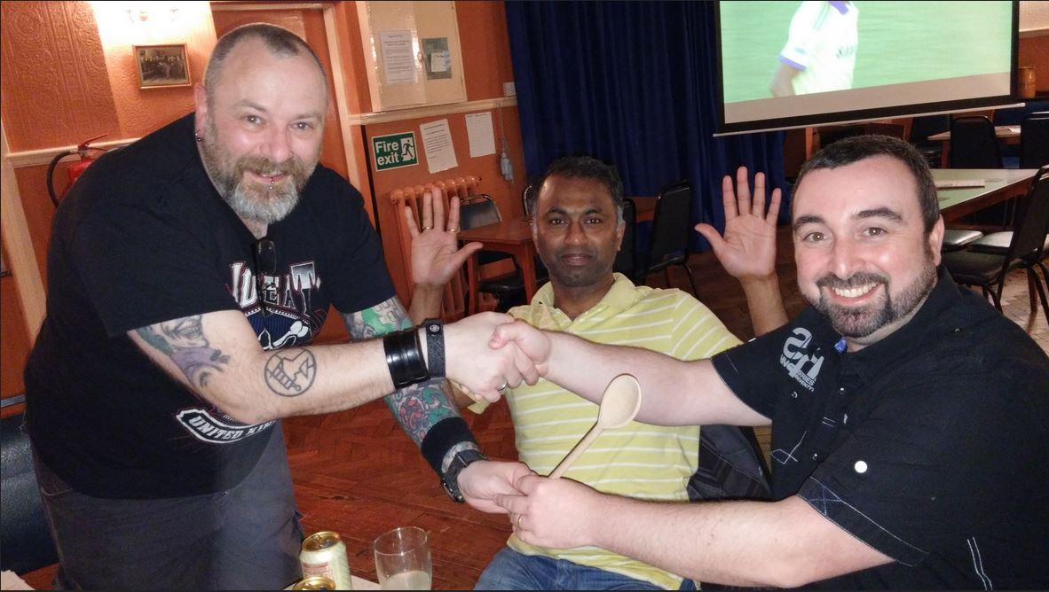
8. Next Meeting
Wednesday 20th Mayl, 2015 at Mill Street Club, 210 Mill Street – with Pizza or possibly curry! Most likely curry!

