The Strangemen III.0 Investment Club (8N93KW6E)
Minutes of the twenty-third meeting - Held Wednesday 25th March, 2015 at The Mill Street Club, Mill Street, Leek. Then neither curry or pizza, just Neil P and Dave McN in the Green Dragon!
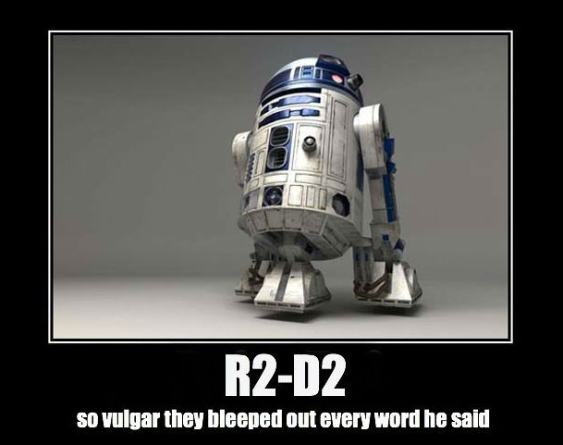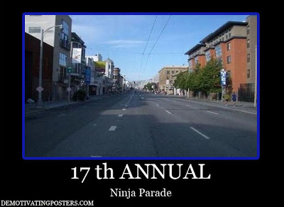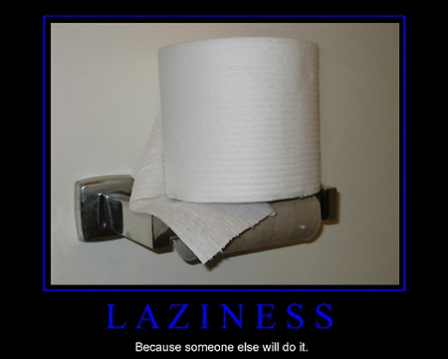
Attendees:
- James Taylor (JT)
- Neil Pickford (NCP)
- Sridar Madadi (SM)
- David McNeaney (DMcN)
- Mike Helm (MH)
- Alan Whitmore (AJW)
- Liam Duggan (LM) - Guest
- Adrian Northcott (AN) - Guest
Apologies:
- Dave Swarbrrok (DS) - Folkin' Folk!
- Mike Helm (MH) - long day, blah blah blah!
- Andy Bradley (AMB) - completely forgot what he said!
- Gareth Ekin (GE) - Here is spirit!
- Jes Challand (JC) - Still in Franceland - looking for travail and shares his initials with Jeff Cadiente - stuntman on such wonders as Con Air and The Crow!
Agenda:
  - Okay previous minutes
  - Previous Actions
  - Treasurers Report & current portfolio update
  - Investment strategy & Homework (share updates)
  - Fantasy Shares
  - Peston
  - AOB
8. Next Meeting
1. Okay Previous Minutes What, there were minutes -no way!
2. Previous Actions  4.14.2 - Due diligence by all over BP - and again  4.23.1Sell Barclays, Randgold if parity restored. | ALL  NCP
3. Treasurers Report & current portfolio update  £3, 109.63 in TDW, £271.32 in Barcs. Arm sold for £228.65 profit. Easyjet divi 20/3 - £19.97  4. Investment strategy & Homework (share updates)  Homework - Alent - profits up and ratings hike to buy. Barclays - downgraded - all LIBOR! BP - potential hold - results rumoured to be okay. Colefax - no news but tipped as buy. Randgold -scant news, but buy/hold. Royal Mail - increasing international signed for deliveries to 53 countries now. Tate & Lyle - new sugar being developed and sucralose costs up 20%.  Meeting 2 - Voted on shares - Vodafone, Aviva, ARM, RBS, RANDGOLD, Thomas Cook, SPH  Meeting 3 - Voted on Vodafone, Tesco and Next  Meeting 4 - Voted on Arm, Thomas Cook, Thorntons, Moneysupermarket.com, Ocado  Meeting 5 - Sabmiller, Bunzl, Thomas Cook, moneysupermarket, ultra electronics, Merlin IPO in 2014  Meeting 6 - nowt, but Alan listed good divi payers - HSBC, Shell and BP  Meeting 7 - Tate & Lyle, Barclays  Meeting 8 - Post Office, ITV, Barclays - DO NOT SELL VODAFONE!!  Meeting 9 - Good divi payers - BP, Royal Dutch Shell, Thomas Cook, Centrica - also Tate & Lyle and more Vodafone  Meeting 10 - Alent, Dart Group, Rurelec, CBG, Sable Mining, Topps Tiles, Air Partner, Dotdigital, JD Wetherspoon, James Halstead, Tracsis  Meeting 11 - Game (to float), Royal Mail, TmobileUSA, Optimal Payments, Balfour Beatty, Merliln  Meeting 12 - just discussed Pets @ home IPO  Meeting 13 - Topps Tiles, Aviva, L&G, Kingfisher, more of portfolio.  Meeting 14 - Astra Z, GAME IPO, B&M IPO, UK Mail, Merlin and TT Electronics (Motley tip)  Meeting 15 - more of same, TSB, TESLA, Arrow, Cineworld, Bellway, Bunzl  Meeting 16 - a chat about supermarkets  Meeting 17 - mort portfolio stuff, Just Eat, Colefax and Sell Vodafone  Meeting 18 - Lloyds - possible 7% divi by 2016, BHP Biliton, Glencore  Meeting 19 - brief discussion about Tullow Oil, EasyJet, De La Rue, Virgin Money, Stephen O'Hara and microbes to change health as a supplement.  Meeting 20 - discussed what to sell to fund the shortfall in cash to pay Matt - Tesco, Alent and Colefax placed on Neil P watch  Meeting 21 - discussed, Easyjet, Kaz minerals, BHP Billiton, Arm, Prudential, Unilever, Sabmiller, Trainline and Halfords.  Meeting 22 - discussed - VPC IPO, SCS IPO, DFS IPO, Center Parcs IPO, Aldermere IPO, Revolution Bars IPO. Laing IPO, Alumasc, Wentworth, United Utilities, Inland Homes, Afran and the divis on Vodafone, Centrica, Sky and BT. Sri suggested 10-20% of the portfolio should be high risk.  Meeting 23 - discussed - LSE, ARM, Persimmon, eg Solutions and BT.  4.23.1Sell Barclays, Randgold if parity restored.  5. Fantasy Shares  Recent leaver Matt C wins with a 28.46% hike in TSB. Alan W retains only a 1 point lead from Neil P.  Wondering which of the useless shower of shits in the election arena we are going to get stuck with this month are;-  6. Peston  He's back! With tales of;- man a millionaire for 10 days after bank error, legalised ecstasy in Ireland? - law changed in error! Serbian grenades found rotting in bin, Indian pupils using paper planes to chuck answers to each other, Clydesdale bank issues plastic fiver. Dutch wholesaler on trial at centre of horsemeat scandal, Clash of Clans revenue up yo $1.15bn euros, poo being mined for gold in Australia, China starting to deliver 3D printed car, AA floating, Kraft and Heinz merging, Ex Centrica box throws bonus to charity.  7. AOB  7.23.1 - Dave McN circulated some Dilberts as per.  7.23.2 - Ade and Liam to deliberate on whether to join after watching the carnival tonight!  8. Next Meeting  Wednesday 29th April, 2015 at Mill Street Club, 210 Mill Street – with Pizza or possibly curry! Most likely curry! | NCP
   | Meeting 10 |  | Meeting 11 | Meeting 12 |  | Meeting 13 | Meeting 14 |  |  | Meeting 15 |  | Meeting 16 |  | Meeting 17 | Meeting 18 |  | Meeting 19 | Meeting 20 | Meeting 21 | Meeting 22 | Meeting 23
  Club £ | £6,175.21 |  | £7,080.02 | £7,051.52 |  | £7,364.31 | £14,016.30 |  |  | £14,312.76 |  | £14,513.98 |  | £15,826.33 | £15,612.53 |  | £15,612.53 | £13,872.56 | £12,414.96 | £12,993.77 | £13,353.02
  Std units | 17 |  | 19 | 20 |  | 21 | 23 |  |  | 24 |  | 25 |  | 26 | 27 |  | 28 | 29 | 30 | 31 | 32
  Tot input | £5,610.00 |  | £6,270.00 | £6,600.00 |  | £6,930.00 | £13,885.32 |  |  | £15,019.47 |  | £15,518.62 |  | £15,518.62 | £16,285.30 |  | £16,885.32 | £16,885.32 | £11,444.00 | £11,700.00 | £12,000.00
  member input(*) | £510.00 |  | £570.00 | £600.00 |  | £630.00 | £690.00 |  |  | £720.00 |  | £750.00 |  | £780.00 | £810.00 |  | £840.00 | £870.00 | £900.00 | £930.00 | £960.00
  now worth | £561.38 |  | £643.64 | £641.05 |  | £669.48 | £697.78 |  |  | £712.67 |  | £722.81 |  | £788.28 | £777.75 |  | £871.36 | £845.21 | £980.13 | £1,032.84 | £1,068.24
  % increase | 10.08 |  | 12.92 | 6.84 |  | 6.27 | 1.13 |  |  | -1.02 |  | -3.63 |  | 1.06 | -3.98 |  | 3.73 | -2.85 | 8.9 | 11.06 | 11.28
  total units | 187 |  | 209 | 220 |  | 220 | 462 |  |  | 482 |  | 502 |  | 522 | 542 |  | 562 | 370 | 380 | 390 | 400
  unit worth | £33.02 |  | £33.88 | £32.05 |  | £31.88 | £30.34 |  |  | £29.69 |  | £28.91 |  | £30.32 | £28.81 |  | £31.12 | £29.15 | £29.15 | £33.32 | £33.38
  Name | Units | Invested |  |  | Value |  |  | Name | Units |  | Invested |  | Value
  Alan W | 64 | £1,937.60 |  |  | £2,136.48 |  |  | Dave M | 40 |  | £1,204.40 |  | £1,335.30
  Dave S | 48 | £1,448.80 |  |  | £1,602.36 |  |  | Mike H | 32 |  | £960.00 |  | £1,068.24
  Sri M | 40 | £1,204.40 |  |  | £1,335.30 |  |  | James T | 32 |  | £960.00 |  | £1,068.24
  Andy B | 40 | £1,204.40 |  |  | £1,335.30 |  |  | Jes C | 32 |  | £960.00 |  | £1,068.24
  Neil P | 40 | £1,204.40 |  |  | £1,335.30 |  |  | Gareth E | 32 |  | £960.00 |  | £1,068.24
  Symbol | Qty. | Description | Champion | Mid Price | Price Change | Market Value | Book Cost | Gain/Loss | Prev Month | Variance
  ALNT | 164 | ALENT PLC | AMB | 378.90p | -4.7 | 621.4 | 598.04 | 23.36 | 595.81 | 25.59
  BARC | 812 | BARCLAYS | JT | 251.90p | -6.55 | 2045.43 | 2096.44 | -51.01 | 2134.75 | -89.32
  BP. | 435 | BP | DMcN | 448.35p | 4.2 | 1950.32 | 2094.99 | -144.67 | 1954.89 | -4.57
  CFX | 213 | COLEFAX GROUP | DMcN | 397.50p | -6.25 | 846.68 | 747.35 | 99.33 | 788.1 | 58.58
  EZJ | 44 | EASYJET | MH | 1890.00p | 6 | 831.6 | 744.05 | 87.55 | 797.72 | 33.88
  RRS | 10 | RANGOLD | AJW | 4882.00p | 14 | 488.2 | 562.37 | -74.17 | 504.5 | -16.3
  RMG | 368 | ROYAL MAIL PLC | SM | 444.50p | 0.8 | 1635.76 | 2098.5 | -462.74 | 1577.98 | 57.78
  TATE | 304 | TATE & LYLE | NCP | 600.00p | -1.09 | 1824 | 2091.1 | -267.1 | 1802.72 | 21.28
  Mar-15 | SHARE | EPIC | START PRICE
  Dave S | ARM | ARM | 1104.00
  Gareth E | Sable Mining | SBLM | 0.83
  Mike H | Afren | AFR | 3.45
  Neil P | eg Solutions | EGS | 75.00
  James T | Persimmon | PSN | 1682.00
  Matt C | TSB | TSB | 333.70
  Andy B | Serco | SRP | 146.42
  Jes C | Marks and Spencer | MKS | 536.00
  Dave McN | Dragon Oil | DGO | 588.00
  Glynn G | Punch Taverns | PUB | 101.00
  Alan W | Lloyds | Lloyds | 80.00
  Sri M | Tri-star | TSTR | 0.12
  Liam | Falkland Oil | FOGL | 30.00
  Ade | Tullow Oil | TLW | 321.00

