The Strangemen III.0 Investment Club (8N93KW6E)
Minutes of the twenty-first meeting - Held Wednesday 21st January 2015 at The Mill Street Club, Mill Street, Leek.
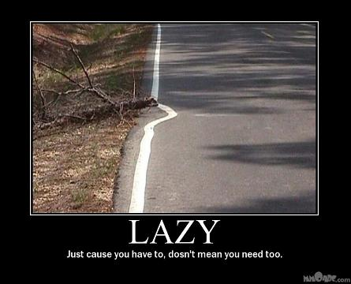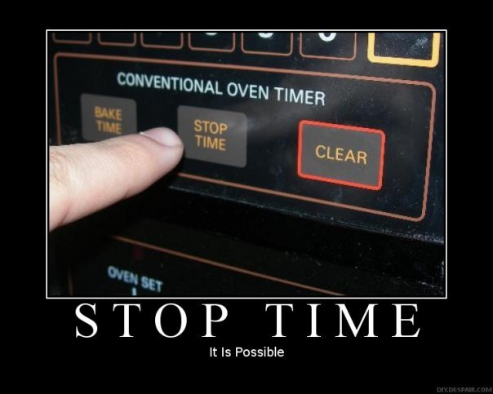
Attendees:
- James Taylor (JT)
- Neil Pickford (NCP)
- Sridar Madadi (SM)
- David McNeaney (DMcN)
- Mike Helm (MH)
- Andrew Bradley (AMB)
- Dave Swarbrook (DS)
Apologies:
- Alan Whitmore (AJW) - plain forgot! Old age kicks in early with no work to do
- Gareth Ekin (GE) - Bristol bound for more hush hush mercenary work!
- Jes Challand (JC) - Still in Franceland - looking for travail and shares his initials with Jack Cohen - founder of Tesco in 1924 - same year as Jes was born!
Agenda:

  - Okay previous minutes
  - Previous Actions
  - Treasurers Report & current portfolio update
  - Investment strategy & Homework (share updates)
  - Fantasy Shares
  - Peston
  - AOB
8. Next Meeting
1. Okay Previous Minutes What, there were minutes -no way!
2. Previous Actions  4.14.2 - Due diligence by all over BP - and again  4.1.20 - Matt leaving COB Dec 1st balance. Neil P to email re: Member unit purchase, James to sort out values, Matt to reduce debit to £1 for competition. Done - folks have opted to purchase additional shares. Still owe Matt £1070.53.  5.21.1 - Neil P to purchase £750 of Easyjet  7.21.1 - Social for March 27/28 (Fri/Sat) - check availability. | ALL  JT  NCP  ALL
3. Treasurers Report & current portfolio update  £2038.84 in TDW, £91.85 in Barcs. Just Eat sold for £844.43, Tesco sold for £756.95. Matt C owes us £4 from final payment for share comp.  Divis - 19/12 - Tesco - £4.36, 19/12 - BP - £27.73, 2/1 - Tate & Lyle - £24.92 - 14/1 - Royal Mail - £24.65  4. Investment strategy & Homework (share updates)  Homework - Alent - Voting rights breach and extensions to new purchasing deals. ARM - new CFO from Easyjet, Network and server growth. Barcs - PRA hitting banks, macro-economic issues, new brokers app launched. BP - please fine us less as we will have lower profits! Colefax - tip to buy. Randgold - nowt. Royal Mail - Ebay deal currently. Tate & Lyle - fairtade syrup.  Meeting 2 - Voted on shares - Vodafone, Aviva, ARM, RBS, RANDGOLD, Thomas Cook, SPH  Meeting 3 - Voted on Vodafone, Tesco and Next  Meeting 4 - Voted on Arm, Thomas Cook, Thorntons, Moneysupermarket.com, Ocado  Meeting 5 - Sabmiller, Bunzl, Thomas Cook, moneysupermarket, ultra electronics, Merlin IPO in 2014  Meeting 6 - nowt, but Alan listed good divi payers - HSBC, Shell and BP  Meeting 7 - Tate & Lyle, Barclays  Meeting 8 - Post Office, ITV, Barclays - DO NOT SELL VODAFONE!!  Meeting 9 - Good divi payers - BP, Royal Dutch Shell, Thomas Cook, Centrica - also Tate & Lyle and more Vodafone  Meeting 10 - Alent, Dart Group, Rurelec, CBG, Sable Mining, Topps Tiles, Air Partner, Dotdigital, JD Wetherspoon, James Halstead, Tracsis  Meeting 11 - Game (to float), Royal Mail, TmobileUSA, Optimal Payments, Balfour Beatty, Merliln  Meeting 12 - just discussed Pets @ home IPO  Meeting 13 - Topps Tiles, Aviva, L&G, Kingfisher, more of portfolio.  Meeting 14 - Astra Z, GAME IPO, B&M IPO, UK Mail, Merlin and TT Electronics (Motley tip)  Meeting 15 - more of same, TSB, TESLA, Arrow, Cineworld, Bellway, Bunzl  Meeting 16 - a chat about supermarkets  Meeting 17 - mort portfolio stuff, Just Eat, Colefax and Sell Vodafone  Meeting 18 - Lloyds - possible 7% divi by 2016, BHP Biliton, Glencore  Meeting 19 - brief discussion about Tullow Oil, EasyJet, De La Rue, Virgin Money, Stephen O'Hara and microbes to change health as a supplement.  Meeting 20 - discussed what to sell to fund the shortfall in cash to pay Matt - Tesco, Alent and Colefax placed on Neil P watch  Meeting 21 - discussed, Easyjet, Kaz minerals, BHP Billiton, Arm, Prudential, Unilever, Sabmiller, Trainline and Halfords.  5.21.1 - Neil P to purchase £750 of Easyjet  5. Fantasy Shares  James T sneaks a win with Royal Mail up 7.14%, but Alan W retains a 3 point overall lead.  Wondering just where that HSBC ISA has vanished to this month are;-  6. Peston  No Peston, so no Peston!  7. AOB  7.21.1 - Dave McN circulated some Dilberts as per.  7.21.1 - Social for March 27/28 (Fri/Sat) - check availability.  8. Next Meeting  Wednesday 25th February 2015 at Mill Street Club, 210 Mill Street – with Pizza! | NCP  ALL
   | Meeting 8 |  | Meeting 9 |  | Meeting 10 |  | Meeting 11 |  | Meeting 12 |  | Meeting 13 |  | Meeting 14 |  | Meeting 15 |  | Meeting 16 | Meeting 17 | Meeting 18 | Meeting 19 | Meeting 20 | Meeting 21
  Club £ | £5,338.64 |  | £5,846.90 |  | £6,175.21 |  | £7,080.02 |  | £7,051.52 |  | £7,364.31 |  | £14,016.30 |  | £14,312.76 |  | £14,513.98 | £15,826.33 | £15,612.53 | £15,612.53 | £13,872.56 | £12,414.96
  Std units | 15 |  | 16 |  | 17 |  | 19 |  | 20 |  | 21 |  | 23 |  | 24 |  | 25 | 26 | 27 | 28 | 29 | 30
  Tot input | £4,950.00 |  | £5,280.00 |  | £5,610.00 |  | £6,270.00 |  | £6,600.00 |  | £6,930.00 |  | £13,885.32 |  | £15,019.47 |  | £15,518.62 | £15,518.62 | £16,285.30 | £16,885.32 | £16,885.32 | £11,444.00
  member input(*) | £450.00 |  | £480.00 |  | £510.00 |  | £570.00 |  | £600.00 |  | £630.00 |  | £690.00 |  | £720.00 |  | £750.00 | £780.00 | £810.00 | £840.00 | £870.00 | £900.00
  now worth | £485.33 |  | £531.54 |  | £561.38 |  | £643.64 |  | £641.05 |  | £669.48 |  | £697.78 |  | £712.67 |  | £722.81 | £788.28 | £777.75 | £871.36 | £845.21 | £980.13
  % increase | 7.85 |  | 10.74 |  | 10.08 |  | 12.92 |  | 6.84 |  | 6.27 |  | 1.13 |  | -1.02 |  | -3.63 | 1.06 | -3.98 | 3.73 | -2.85 | 8.9
  total units | 165 |  | 176 |  | 187 |  | 209 |  | 220 |  | 220 |  | 462 |  | 482 |  | 502 | 522 | 542 | 562 | 370 | 380
  unit worth | £32.36 |  | £33.22 |  | £33.02 |  | £33.88 |  | £32.05 |  | £31.88 |  | £30.34 |  | £29.69 |  | £28.91 | £30.32 | £28.81 | £31.12 | £29.15 | £32.67
  Name |  | Units |  | Invested |  | Value |  | Name |  | Units |  | Invested |  | Value
  Alan W |  | 62 |  | £1,877.60 |  | £2,025.60 |  | Dave M |  | 38 |  | £1,144.40 |  | £1,241.50
  Dave S |  | 46 |  | £1,388.80 |  | £1,502.86 |  | Mike H |  | 30 |  | £900.00 |  | £980.13
  Sri M |  | 38 |  | £1,144.40 |  | £1,241.50 |  | James T |  | 30 |  | £900.00 |  | £980.13
  Andy B |  | 38 |  | £1,144.40 |  | £1,241.50 |  | Jes C |  | 30 |  | £900.00 |  | £980.13
  Neil P |  | 38 |  | £1,144.40 |  | £1,241.50 |  | Gareth E |  | 30 |  | £900.00 |  | £980.13
  EPIC | Qty. | Description | Champion | Mid Price | Price Change | Market Value | Book Cost | Gain/Loss | Prev Month | Variance
  ALNT | 164 | ALENT PLC | AMB | 374.00p | -1.5 | 613.36 | 598.04 | 15.32 | 557.6 | 55.76
  ARM | 201 | ARM HLDGS | DS | 1059.00p | 31 | 2128.59 | 2085.22 | 43.37 | 1869.3 | 259.29
  BARC | 812 | BARCLAYS | JT | 237.90p | 2.65 | 1931.75 | 2096.44 | -164.69 | 1852.17 | 79.58
  BP. | 435 | BP | DMcN | 426.00p | 13.8 | 1853.1 | 2094.99 | -241.89 | 1729.34 | 123.76
  CFX | 213 | COLEFAX GROUP | DMcN | 372.50p | 0 | 793.43 | 747.35 | 46.08 | 793.43 | 0
  RRS | 10 | RANGOLD | AJW | 5525.00p | -35 | 552.5 | 562.37 | -9.87 | 411.7 | 140.8
  RMG | 368 | ROYAL MAIL PLC | SM | 430.50p | 4.3 | 1584.24 | 2098.5 | -514.26 | 1450.66 | 133.58
  TATE | 304 | TATE & LYLE | NCP | 654.50p | 9.5 | 1989.68 | 2091.1 | -101.42 | 1769.28 | 220.4
  Jan-15 | SHARE | EPIC | START PRICE
  Dave S | ARM | ARM | 1061.00
  Gareth E | Sable Mining | SBLM | 0.75
  Mike H | EasyJet | EZJ | 1632.00
  Neil P | Air Partner | AIP | 260.41
  James T | Prudential | Prudential | 1583.50
  Matt C | TSB | TSB | 280.70
  Andy B | Sports Direct | SPD | 716.50
  Jes C | Marks and Spencer | MKS | 472.40
  Dave McN | Halfords | HFD | 446.60
  Glynn G | Punch Taverns | PUB | 110.25
  Alan W | Lloyds | LLOY | 75.84
  Sri M | De La Rue | DLAR | 517.50

