The Strangemen III.0 Investment Club (8N93KW6E)
Minutes of the twentieth meeting - Held Wednesday 18th December 2014 at The Mill Street Club, Mill Street, Leek.
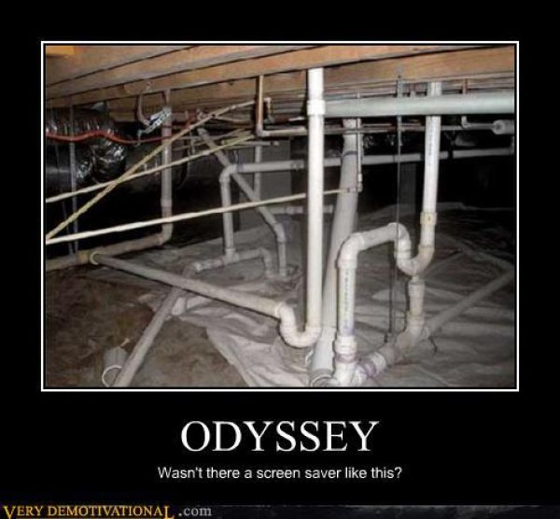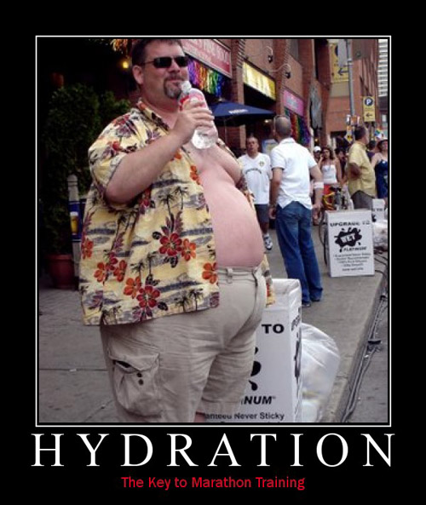
Attendees:
- James Taylor (JT)
- Neil Pickford (NCP)
- Matt Culverwell (MC) - last meeting for the Share Options and let's buy a property legend!
- Alan Whitmore (AJW)
- Sridar Madadi (SM)
- David McNeaney (DMcN)
- Dave Swarbrook (DS)
Apologies:
- Matt Helm (MH) - I'm coming honest. Oh, it's when? Erm...silence................
- Andrew Bradley - poorly lady!

- Gareth Ekin (GE) - working for British Secret Service in his Ocean going suit! actually on holiday in Portugal!
- Jes Challand (JC) – Ooh la la etc,....and bugger me, his initials are the same as old school Revillos and Human League guitarist Jo Callissinger!
Agenda:

  - Okay previous minutes
  - Previous Actions
  - Treasurers Report & current portfolio update
  - Investment strategy & Homework (share updates)
  - Fantasy Shares
  - Peston
  - AOB
8. Next Meeting
1. Okay Previous Minutes What, there were minutes -no way!
2. Previous Actions  4.14.2 - Due diligence by all over BP - and again  4.19.1 - Decided to sell Merlin - in order to fund Matt's exit - Done  4.1.20 - Matt leaving COB Dec 1st balance. Neil P to email re: Member unit purchase, James to sort out values, Matt to reduce debit to £1 for competition. Done - folks have opted to purchase additional shares. Still owe Matt £1070.53. | ALL
3. Treasurers Report & current portfolio update  £55.80 in TDW, £100ish in Barcs. Merlin sold for £1535.16. Paid Matt C £5,100. Divis - 12/12 £8.12. Not sure of all of the figures in this chart!  4. Investment strategy & Homework (share updates)  Homework - Alent - no news. ARM - slow news, still buy. Barc - not enough cash for FOREX issues. BP - possible large merger coming as BP look to shrink. Colefax - no news. Just Eat - director offloased shares and buggered rising share price. Randgold - up on Deutche Bank recommendation. Royal Mail - limited time Amazon deal and property/land sales in London. Tate - looking at joint ventur ein South America - Brazil. Tesco - well - new man, new ideas!  Meeting 2 - Voted on shares - Vodafone, Aviva, ARM, RBS, RANDGOLD, Thomas Cook, SPH  Meeting 3 - Voted on Vodafone, Tesco and Next  Meeting 4 - Voted on Arm, Thomas Cook, Thorntons, Moneysupermarket.com, Ocado  Meeting 5 - Sabmiller, Bunzl, Thomas Cook, moneysupermarket, ultra electronics, Merlin IPO in 2014  Meeting 6 - nowt, but Alan listed good divi payers - HSBC, Shell and BP  Meeting 7 - Tate & Lyle, Barclays  Meeting 8 - Post Office, ITV, Barclays - DO NOT SELL VODAFONE!!  Meeting 9 - Good divi payers - BP, Royal Dutch Shell, Thomas Cook, Centrica - also Tate & Lyle and more Vodafone  Meeting 10 - Alent, Dart Group, Rurelec, CBG, Sable Mining, Topps Tiles, Air Partner, Dotdigital, JD Wetherspoon, James Halstead, Tracsis  Meeting 11 - Game (to float), Royal Mail, TmobileUSA, Optimal Payments, Balfour Beatty, Merliln  Meeting 12 - just discussed Pets @ home IPO  Meeting 13 - Topps Tiles, Aviva, L&G, Kingfisher, more of portfolio.  Meeting 14 - Astra Z, GAME IPO, B&M IPO, UK Mail, Merlin and TT Electronics (Motley tip)  Meeting 15 - more of same, TSB, TESLA, Arrow, Cineworld, Bellway, Bunzl  Meeting 16 - a chat about supermarkets  Meeting 17 - mort portfolio stuff, Just Eat, Colefax and Sell Vodafone  Meeting 18 - Lloyds - possible 7% divi by 2016, BHP Biliton, Glencore  Meeting 19 - brief discussion about Tullow Oil, EasyJet, De La Rue, Virgin Money, Stephen O'Hara and microbes to change health as a supplement.  Meeting 20 - discussed what to sell to fund the shortfall in cash to pay Matt - Tesco, Alent and Colefax placed on Neil P watch  5. Fantasy Shares  Dave S wins with his ARMs up 5.59%. Alan W retains a 6 point overall lead.  Wondering if the fire in channel tunnel may be a good thing this month are;-  6. Peston  Peston gave us car smoking ban from Oct 2015 (if under 18s in the car and only in England), companies hit by Amazon pricing software glitch as products are sold for 1p, 25% tax payers owning of Lloyds - Divi for the nation? Rouble fall calls a halt to Apple sales in Russia - website temporarily closed, Petrol could drop below £1 per litre, BT wants to buy EE for £12.5bn to get back into mobiles and finally....black friday, cyver monday give retailers a 14% boost in online sales during Novermber  7. AOB  7.19.1 - Dave McN circulated some Dilberts as per.  8. Next Meeting  Wednesday 21st January 2015 at Mill Street Club, 210 Mill Street – with Pizza! | NCP
   | Meeting 7 | Meeting 8 | Meeting 9 | Meeting 10 | Meeting 11 | Meeting 12 | Meeting 13 | Meeting 14 | Meeting 15 | Meeting 16 | Meeting 17 | Meeting 18 | Meeting 19 | Meeting 20
  Club £ | £4,354.61 | £5,338.64 | £5,846.90 | £6,175.21 | £7,080.02 | £7,051.52 | £7,364.31 | £14,016.30 | £14,312.76 | £14,513.98 | £15,826.33 | £15,612.53 | £15,612.53 | £13,872.56
  tot std units | 143 | 165 | 176 | 187 | 209 | 220 | 231 | 253 | 264 | 275 | 286 | 297 | 308 | 318
  Std units | 13 | 15 | 16 | 17 | 19 | 20 | 21 | 23 | 24 | 25 | 26 | 27 | 28 | 29
  Tot input | £4,290.00 | £4,950.00 | £5,280.00 | £5,610.00 | £6,270.00 | £6,600.00 | £6,930.00 | £13,885.32 | £15,019.47 | £15,518.62 | £15,518.62 | £16,285.30 | £16,885.32 | ?
  member input(*) | £390.00 | £450.00 | £480.00 | £510.00 | £570.00 | £600.00 | £630.00 | £690.00 | £720.00 | £750.00 | £780.00 | £810.00 | £840.00 | £870.00
  now worth | £395.85 | £485.33 | £531.54 | £561.38 | £643.64 | £641.05 | £669.48 | £697.78 | £712.67 | £722.81 | £788.28 | £777.75 | £871.36 | £845.21
  % increase | 1.51 | 7.85 | 10.74 | 10.08 | 12.92 | 6.84 | 6.27 | 1.13 | -1.02 | -3.63 | 1.06 | -3.98 | 3.73 | -2.85
  total units | 143 | 165 | 176 | 187 | 209 | 220 | 220 | 462 | 482 | 502 | 522 | 542 | 562 | 370
  unit worth | £30.45 | £32.36 | £33.22 | £33.02 | £33.88 | £32.05 | £31.88 | £30.34 | £29.69 | £28.91 | £30.32 | £28.81 | £31.12 | £29.15
  Symbol | Qty. | Description | Champion | Mid Price | Price Change | Market Value | Book Cost | Gain/Loss | Prev Month | Variance
  ALNT | 164 | ALENT PLC | AMB | 340.00p | 2.5 | 557.6 | 598.04 | -40.44 | 560.06 | -2.46
  ARM | 201 | ARM HLDGS | DS | 930.00p | -5 | 1869.3 | 2085.22 | -215.92 | 1770.81 | 98.49
  BARC | 812 | BARCLAYS | JT | 228.10p | -2.05 | 1852.17 | 2096.44 | -244.27 | 1928.5 | -76.33
  BP. | 435 | BP | DMcN | 397.55p | 13.6 | 1729.34 | 2094.99 | -365.65 | 1903.56 | -174.22
  CFX | 213 | COLEFAX GROUP | DMcN | 372.50p | 0 | 793.43 | 747.35 | 46.08 | 793.43 | 0
  JR. | 251 | JUST EAT PLC | NCP | 291.90p | -4 | 732.67 | 749.64 | -16.97 | 815.25 | -82.58
  RRS | 10 | RANGOLD | AJW | 4117.00p | 77 | 411.7 | 562.37 | -150.67 | 442.8 | -31.1
  RMG | 368 | ROYAL MAIL PLC | SM | 394.20p | -3 | 1450.66 | 2098.5 | -647.84 | 1726.66 | -276
  TATE | 304 | TATE & LYLE | NCP | 582.00p | 18.5 | 1769.28 | 2091.1 | -321.82 | 1957.76 | -188.48
  TSCO | 376 | TESCO | NCP | 183.80p | -2.65 | 632.24 | 748.91 | -116.67 | 724.55 | -92.31
  Dec-14 | SHARE | EPIC | START PRICE
  Dave S | ARM | ARM | 965.00
  Gareth E | Sable Mining | SBLM | 0.85
  Mike H | Apple | AAPL ($) | 111.87
  Neil P | Cineworld | CINE | 392.80
  James T | Royal Mail | RMG | 397.80
  Matt C | TSB | TSB | 274.00
  Andy B | Shire | SHP | 4618.00
  Jes C | Marks and Spencer | MKS | 462.70
  Dave McN | Colefax | CFX | 385.00
  Glynn G | Punch Taverns | PUB | 110.00
  Alan W | Lloyds | LLOY | 75.51
  Sri M | De La Rue | DLAR | 506.50

