The Strangemen III.0 Investment Club (8N93KW6E)
Minutes of the nineteenth meeting - Held Tuesday 19th November 2014 at The Mill Street Club, Mill Street, Leek.
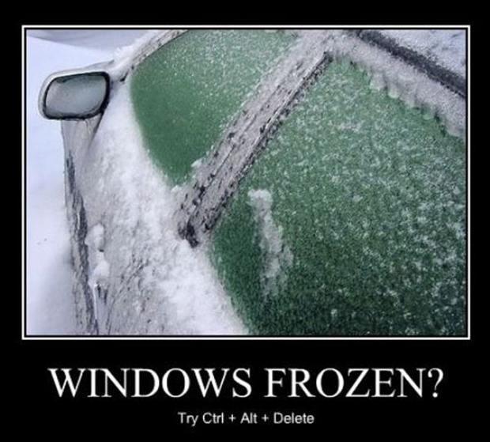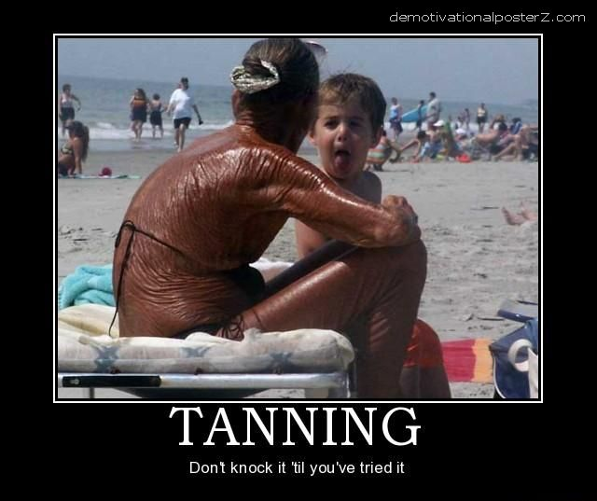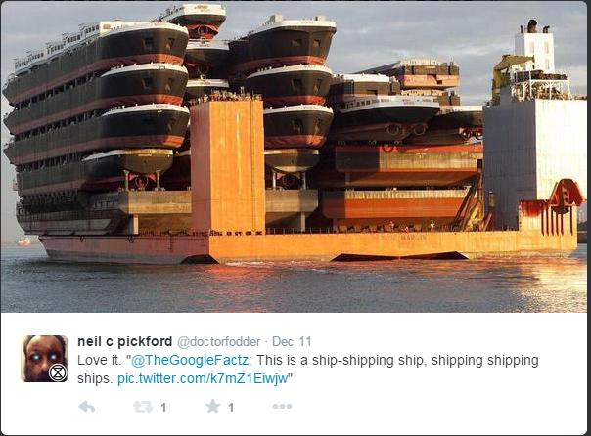

Attendees:
- James Taylor (JT)
- Neil Pickford (NCP)
- Matt Culverwell (MC)
- Alan Whitmore (AJW)
- Sridar Madadi (SM)
- David McNeaney (DMcN)
- Dave Swarbrook (DS)
Apologies:
- Matt Helm (MH) - henpecked hubby
- Andrew Bradley - gotta catch Pokemon at Rochdale!

- Gareth Ekin (GE) - is he even real? Is he a corporate tax write off for the Club?
- Jes Challand (JC) – Ooh la la etc,....and bugger me, his initials are the same as chunky Gavin and Stacey comedian and Broadway star James Corden!
Agenda:

  - Okay previous minutes
  - Previous Actions
  - Treasurers Report & current portfolio update
  - Investment strategy & Homework (share updates)
  - Fantasy Shares
  - Peston
  - AOB
8. Next Meeting
1. Okay Previous Minutes What, there were minutes -no way!
2. Previous Actions  4.14.2 - Due diligence by all over BP - and again  4.19.1 - Decided to sell Merlin - in order to fund Matt's exit.  4.1.20 - Matt leaving COB Dec 1st balance. Neil P to email re: Member unit purchase, James to sort out values, Matt to reduce debit to £1 for competition.  7.17.4 - Agreed a night out around Leek (with food) for Friday November 14th - done and done!  Neil P realised afterwards that we had failed to pay James for the PIzza! | ALL  NCP  NCP/ JT/MC
3. Treasurers Report & current portfolio update  £3312.52 in TDW, £106.85 in Barcs. Divis - 17/10 - Alent - £5.16 and then 20/10 - Alent (again) - £25.80  Matt C to leave the club on Dec 1st - exit strategy agreed.  *MC is (tot units - tot std units) + std units  4. Investment strategy & Homework (share updates)  Homework - Alent - no news just buy! ARM - revenue up 12% - 3 billion chips shipped in last quarter, Barcs - bought in NYSE top bods to stop the rot in the US, BP - good buy still oil slick rumblings, Just Eat - James rambled about microbe based diets, Merlin - CEO is now Chair of British Hospitality Association, Gold gaining and Congo output up, Royal Mail - no news, Tate and Lyle - sucrose furniture coating with DuPont, Tesco - no news.  Meeting 2 - Voted on shares - Vodafone, Aviva, ARM, RBS, RANDGOLD, Thomas Cook, SPH  Meeting 3 - Voted on Vodafone, Tesco and Next  Meeting 4 - Voted on Arm, Thomas Cook, Thorntons, Moneysupermarket.com, Ocado  Meeting 5 - Sabmiller, Bunzl, Thomas Cook, moneysupermarket, ultra electronics, Merlin IPO in 2014  Meeting 6 - nowt, but Alan listed good divi payers - HSBC, Shell and BP  Meeting 7 - Tate & Lyle, Barclays  Meeting 8 - Post Office, ITV, Barclays - DO NOT SELL VODAFONE!!  Meeting 9 - Good divi payers - BP, Royal Dutch Shell, Thomas Cook, Centrica - also Tate & Lyle and more Vodafone  Meeting 10 - Alent, Dart Group, Rurelec, CBG, Sable Mining, Topps Tiles, Air Partner, Dotdigital, JD Wetherspoon, James Halstead, Tracsis  Meeting 11 - Game (to float), Royal Mail, TmobileUSA, Optimal Payments, Balfour Beatty, Merliln  Meeting 12 - just discussed Pets @ home IPO  Meeting 13 - Topps Tiles, Aviva, L&G, Kingfisher, more of portfolio.  Meeting 14 - Astra Z, GAME IPO, B&M IPO, UK Mail, Merlin and TT Electronics (Motley tip)  Meeting 15 - more of same, TSB, TESLA, Arrow, Cineworld, Bellway, Bunzl  Meeting 16 - a chat about supermarkets  Meeting 17 - mort portfolio stuff, Just Eat, Colefax and Sell Vodafone  Meeting 18 - Lloyds - possible 7% divi by 2016, BHP Biliton, Glencore  Meeting 19 - brief discussion about Tullow Oil, EasyJet, De La Rue, Virgin Money, Stephen O'Hara and microbes to change health as a supplement.  4.19.1 - Decided to sell Merlin - in order to fund Matt's exit.  4.1.20 - Matt leaving COB Dec 1st balance. Neil P to email re: Member unit purchase, James to sort out values, Matt to reduce debit to £1 for competition.  5. Fantasy Shares  Andy Bradley records a rare win up 24.51% but doesn't turn up! Overall winner now by 4 points is Alan still.  Not asking for the Heimlich from New York cops this month are;-  6. Peston  Peston gave us very little due to no ink in his printer and an inability to write on paper that comes from Computer Operating for 20 years! His one nugget was 1,400 folks caught speeding ion a month an a 12 mile section of the A1, that has a reduced speed limit of 50mph due to road works. Sting!  7. AOB  7.19.1 - Dave McN circulated some Dilberts as per.  Whatsapp was discussed as a potential comms tool for the club.  8. Next Meeting  Wednesday 17th December 2014 at Mill Street Club, 210 Mill Street – with Pizza! Matt can pay! | NCP  NCP/ JT/ MC
   | Meeting 6 | Meeting 7 | Meeting 8 | Meeting 9 | Meeting 10 | Meeting 11 | Meeting 12 | Meeting 13 | Meeting 14 | Meeting 15 | Meeting 16 | Meeting 17 | Meeting 18 | Meeting 19
  Club £ | £3,819.97 | £4,354.61 | £5,338.64 | £5,846.90 | £6,175.21 | £7,080.02 | £7,051.52 | £7,364.31 | £14,016.30 | £14,312.76 | £14,513.98 | £15,826.33 | £15,612.53 | £15,612.53
  tot std units | 132 | 143 | 165 | 176 | 187 | 209 | 220 | 231 | 253 | 264 | 275 | 286 | 297 | 308
  Std units | 12 | 13 | 15 | 16 | 17 | 19 | 20 | 21 | 23 | 24 | 25 | 26 | 27 | 28
  Tot input | £3,960.00 | £4,290.00 | £4,950.00 | £5,280.00 | £5,610.00 | £6,270.00 | £6,600.00 | £6,930.00 | £13,885.32 | £15,019.47 | £15,518.62 | £15,518.62 | £16,285.30 | £16,885.32
  member input(*) | £360.00 | £390.00 | £450.00 | £480.00 | £510.00 | £570.00 | £600.00 | £630.00 | £690.00 | £720.00 | £750.00 | £780.00 | £810.00 | £840.00
  now worth | £347.27 | £395.85 | £485.33 | £531.54 | £561.38 | £643.64 | £641.05 | £669.48 | £697.78 | £712.67 | £722.81 | £788.28 | £777.75 | £871.36
  % increase | -3.54 | 1.51 | 7.85 | 10.74 | 10.08 | 12.92 | 6.84 | 6.27 | 1.13 | -1.02 | -3.63 | 1.06 | -3.98 | 3.73
  total units | 132 | 143 | 165 | 176 | 187 | 209 | 220 | 220 | 462 | 482 | 502 | 522 | 542 | 562
  unit worth | £28.94 | £30.45 | £32.36 | £33.22 | £33.02 | £33.88 | £32.05 | £31.88 | £30.34 | £29.69 | £28.91 | £30.32 | £28.81 | £31.12
  Symbol | Qty. | Description | Champion | Mid Price | Price Change | Market Value | Book Cost | Gain/Loss | Prev Month | Variance
  ALNT | 164 | ALENT PLC | AMB | 341.50p | -1.1 | 560.06 | 598.04 | -37.98 | 499.22 | 60.84
  ARM | 201 | ARM HLDGS | DS | 881.00p | -9 | 1770.81 | 2085.22 | -314.41 | 1670.31 | 100.5
  BARC | 812 | BARCLAYS | JT | 237.50p | 3.3 | 1928.5 | 2096.44 | -167.94 | 1723.06 | 205.44
  BP. | 435 | BP | DMcN | 437.60p | 5.15 | 1903.56 | 2094.99 | -191.43 | 1812.65 | 90.91
  CFX | 213 | COLEFAX GROUP | DMcN | 372.50p | 0 | 793.43 | 747.35 | 46.08 | 782.78 | 10.65
  JR. | 251 | JUST EAT PLC | MC | 324.80p | 11.1 | 815.25 | 749.64 | 65.61 | 641.81 | 173.44
  MERL | 421 | MERLIN ENTERTAINMENT | NCP | 369.00p | 1.1 | 1553.49 | 1495.72 | 57.77 | 1427.61 | 125.88
  RRS | 10 | RANGOLD | AJW | 4428.00p | 109 | 442.8 | 562.37 | -119.57 | 432.2 | 10.6
  RMG | 368 | ROYAL MAIL PLC | SM | 469.20p | 1.5 | 1726.66 | 2098.5 | -371.84 | 1499.23 | 227.43
  TATE | 304 | TATE & LYLE | NCP | 644.00p | 6 | 1957.76 | 2091.1 | -133.34 | 1784.48 | 173.28
  TSCO | 376 | TESCO |  | 192.70p | 0 | 724.55 | 748.91 | -24.36 | 657.62 | 66.93
  Nov-14 | SHARE | EPIC | START PRICE
  Dave S | ARM | ARM | 885.50
  Gareth E | Sable Mining | SBLM | 1.28
  Mike H | Apple | AAPL ($) | 115.44
  Neil P | Tullow Oil | TLW | 475.00
  James T | Optimal Payments | OPAY | 370.00
  Matt C | TSB | TSB | 272.80
  Andy B | Shire | SHP | 4420.00
  Jes C | Marks and Spencer | MKS | 475.90
  Dave McN | Colefax | CFX | 377.50
  Glynn G | Punch Taverns | PUB | 107.00
  Alan W | Lloyds | LLOY | 78.40
  Sri M | De La Rue | DLAR | 553.50

