The Strangemen III.0 Investment Club (8N93KW6E)
Minutes of the eighteenth meeting - Held Wednesday 15th October 2014 at The Mill Street Club, Mill Street, Leek.
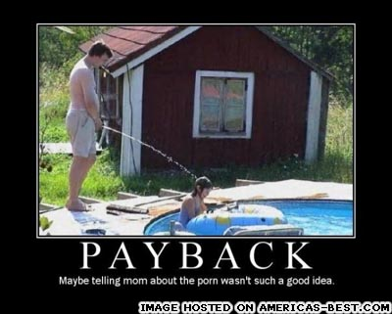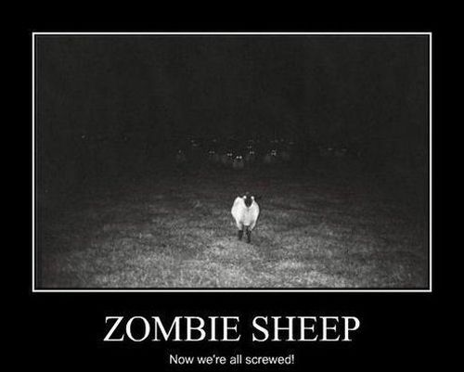

Attendees:
- James Taylor (JT)
- Neil Pickford (NCP)
- Matt Culverwell (MC)
- Mike Helm (MH) - Yes - Mike 'effin Helm!
- Alan Whitmore (AJW)
- Andrew Bradley (AMB)
- Dave Swarbrook (DS)
Apologies:
- David McNeaney (DMcN) - poorly gout ridden Prague bound boy
- Sridar Madadi (SM) - just not there?! or here?!

- Gareth Ekin (GE) - is he even real? Is he a corporate tax write off for the Club?
- Jes Challand (JC) – Ooh la la etc,....and bugger me, his initials are the same as Snickers (formerly marathon) pimper - Joan Collins!
Agenda:

  - Okay previous minutes
  - Previous Actions
  - Treasurers Report & current portfolio update
  - Investment strategy & Homework (share updates)
  - Fantasy Shares
  - Peston
  - AOB
8. Next Meeting
1. Okay Previous Minutes What, there were minutes -no way!
2. Previous Actions  4.14.2 - Due diligence by all over BP - and again  7.16.1 - Neil P to email TDW re: Share Perks - emailed them and they said to call if we had any specific requirements | ALL
3. Treasurers Report & current portfolio update
£2681.56 in TDW, £95.89 in Barcs. Divis - 19/9 - BP - £25.92, 19/9 - BARC - £8.12, 25/9 - Merl - £8.42, 3/10 - ARM - £5.06, 9/10 - Colefax - £4.68.
Sold Optimal - 19/9 - £728.29. Bought - Tesco - 24/9 - £748.91
Matt C to leave the club - exit strategy to be decided next month.
FTSE lost £46bn today Alan W reported - down 2.8%.
*MC is (tot units - tot std units) + std units
 | Meeting 6 | Meeting 7 | Meeting 8 | Meeting 9 | Meeting 10 | Meeting 11 | Meeting 12 | Meeting 13 | Meeting 14 | Meeting 15 | Meeting 16 | Meeting 17 | Meeting 18
Club £ | £3,819.97 | £4,354.61 | £5,338.64 | £5,846.90 | £6,175.21 | £7,080.02 | £7,051.52 | £7,364.31 | £14,016.30 | £14,312.76 | £14,513.98 | £15,826.33 | £15,612.53
tot std units | 132 | 143 | 165 | 176 | 187 | 209 | 220 | 231 | 253 | 264 | 275 | 286 | 297
Std units | 12 | 13 | 15 | 16 | 17 | 19 | 20 | 21 | 23 | 24 | 25 | 26 | 27
Tot input | £3,960.00 | £4,290.00 | £4,950.00 | £5,280.00 | £5,610.00 | £6,270.00 | £6,600.00 | £6,930.00 | £13,885.32 | £15,019.47 | £15,518.62 | £15,518.62 | £16,285.30
member input(*) | £360.00 | £390.00 | £450.00 | £480.00 | £510.00 | £570.00 | £600.00 | £630.00 | £690.00 | £720.00 | £750.00 | £780.00 | £810.00
now worth | £347.27 | £395.85 | £485.33 | £531.54 | £561.38 | £643.64 | £641.05 | £669.48 | £697.78 | £712.67 | £722.81 | £788.28 | £777.75
% increase | -3.54 | 1.51 | 7.85 | 10.74 | 10.08 | 12.92 | 6.84 | 6.27 | 1.13 | -1.02 | -3.63 | 1.06 | -3.98
total units | 132 | 143 | 165 | 176 | 187 | 209 | 220 | 220 | 462 | 482 | 502 | 522 | 542
unit worth | £28.94 | £30.45 | £32.36 | £33.22 | £33.02 | £33.88 | £32.05 | £31.88 | £30.34 | £29.69 | £28.91 | £30.32 | £28.81

4. Investment strategy & Homework (share updates)
Symbol | Qty. | Description | Champ | Mid Price | Price Change | Market Value | Book Cost | Gain/Loss | Prev Month | Variance
ALNT | 164 | ALENT PLC | AMB | 304.40p | -3.2 | 499.22 | 598.04 | -98.82 | 603.72 | -104.5
ARM | 201 | ARM HLDGS | DS | 831.00p | -22 | 1670.31 | 2085.22 | -414.91 | 1954.73 | -284.42
BARC | 812 | BARCLAYS | JT | 212.20p | -9.8 | 1723.06 | 2096.44 | -373.38 | 1852.17 | -129.11
BP. | 435 | BP | DMcN | 416.70p | -9.95 | 1812.65 | 2094.99 | -282.34 | 2104.31 | -291.66
CFX | 213 | COLEFAX | DMcN | 367.50p | 0 | 782.78 | 747.35 | 35.43 | 782.78 | 0
JR. | 251 | JUST EAT PLC | MC | 255.70p | -17.1 | 641.81 | 749.64 | -107.83 | 641.81 | 0
MERL | 421 | MERLIN | NCP | 339.10p | -3.2 | 1427.61 | 1495.72 | -68.11 | 1478.55 | -50.94
RRS | 10 | RANGOLD | AJW | 4322.00p | -46 | 432.2 | 562.37 | -130.17 | 495.5 | -63.3
RMG | 368 | ROYAL MAIL | SM | 407.40p | 7.5 | 1499.23 | 2098.5 | -599.27 | 1604.11 | -104.88
TATE | 304 | TATE & LYLE | NCP | 587.00p | 0 | 1784.48 | 2091.1 | -306.62 | 2114.32 | -329.84
TSCO | 376 | TESCO |  | 174.90p | -4.9 | 657.62 | 748.91 | -91.29 | 657.62 | 0

Homework - Alent - chief exec steps down! ARM - focus on 64 bit processors and free software. Barcs 19% tumble in profits in 2014! Merlin Legoland Dubai, sponsor for London wheel is Coke. Randgold - upgraded to buy then fell! Tate & Lyle mighty tumble being investigated for possible creative accounting.

Meeting 2 - Voted on shares - Vodafone, Aviva, ARM, RBS, RANDGOLD, Thomas Cook, SPH

Meeting 3 - Voted on Vodafone, Tesco and Next

Meeting 4 - Voted on Arm, Thomas Cook, Thorntons, Moneysupermarket.com, Ocado

Meeting 5 - Sabmiller, Bunzl, Thomas Cook, moneysupermarket, ultra electronics, Merlin IPO in 2014

Meeting 6 - nowt, but Alan listed good divi payers - HSBC, Shell and BP

Meeting 7 - Tate & Lyle, Barclays

Meeting 8 - Post Office, ITV, Barclays - DO NOT SELL VODAFONE!!

Meeting 9 - Good divi payers - BP, Royal Dutch Shell, Thomas Cook, Centrica - also Tate & Lyle and more Vodafone

Meeting 10 - Alent, Dart Group, Rurelec, CBG, Sable Mining, Topps Tiles, Air Partner, Dotdigital, JD Wetherspoon, James Halstead, Tracsis

Meeting 11 - Game (to float), Royal Mail, TmobileUSA, Optimal Payments, Balfour Beatty, Merliln

Meeting 12 - just discussed Pets @ home IPO

Meeting 13 - Topps Tiles, Aviva, L&G, Kingfisher, more of portfolio.

Meeting 14 - Astra Z, GAME IPO, B&M IPO, UK Mail, Merlin and TT Electronics (Motley tip)

Meeting 15 - more of same, TSB, TESLA, Arrow, Cineworld, Bellway, Bunzl

Meeting 16 - a chat about supermarkets

Meeting 17 - mort portfolio stuff, Just Eat, Colefax and Sell Vodafone
Meeting 18 - Lloyds - possible 7% divi by 2016, BHP Biliton, Glencore

Decided not to purchase.

5. Fantasy Shares
Alan slips in a 1.90% shuffle to win again. Overall winner now by 9 points.
Ebola, Bird Flu, Paedos and another recession? Worst winter in 100 years? Worse still, these guesses! :-
Oct-14 | SHARE | EPIC | START PRICE
Dave S | ARM | ARM | 840.00
Gareth E | Sable Mining | SBLM | 1.50
Mike H | Apple | AAPL ($) | 95.55
Neil P | Glencore | GLEN | 319.15
James T | Merlin | MERL | 340.30
Matt C | TSB | TSB | 257.00
Andy B | Shire | SHP | 3500.00
Jes C | Marks and Spencer | MKS | 393.20
Dave McN | Royal Dutch Shell | RDSA.L | 2130.50
Glynn G | Punch Taverns | PUB | 0.48
Alan W | Hyder Consulting | HYC | 0.00
Sri M | Hargreaves Lansdown | HL | 860.00

6. Peston
Peston gave us HBO to launch streaming service in UK, oil prices tumble, Toyota recall 1.75 million cars! various issues. Virgin money raise £150 million in IPO. LSE wants to pinch IPO work from NY and HK by hosting more Chinese IPOs - big business looms.

7. AOB
7.17.4 - Agreed a night out around Leek (with food) for Friday November 14th. - Still on

8. Next Meeting
Tuesday 19th November 2014 at Mill Street Club, 210 Mill Street – with Pizza!

