The Strangemen III.0 Investment Club (8N93KW6E)
Minutes of the seventeenth meeting - Held Wednesday 3rd September 2014 at The Mill Street Club, Mill Street, Leek.
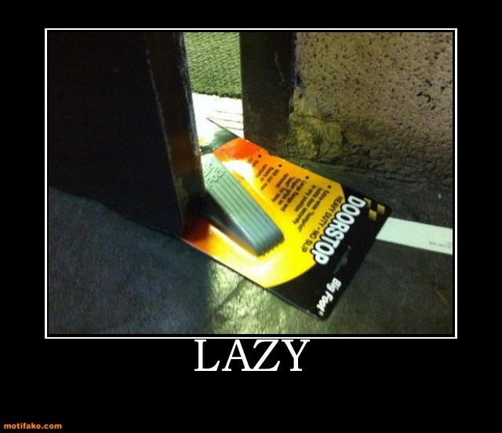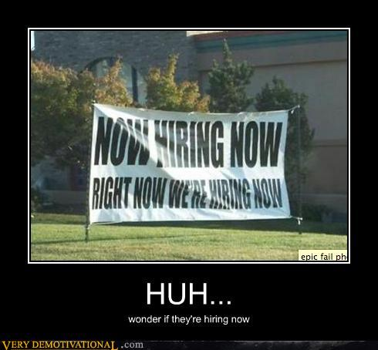
Attendees:
- James Taylor (JT)
- Neil Pickford (NCP)
- David McNeaney (DMcN)
- Matt Culverwell (MC)
- Alan Whitmore (AJW)
- Dave Swarbrook (DS)
Apologies:
- Andrew Bradley (AMB) - poorly boy
- Mike Helm (MH) - allegedly has another social life where he goes out on other nights!
- Sridar Madadi (SM) - an international man of mystery

- Gareth Ekin (GE) - echo echo echo..........
- Jes Challand (JC) – Ooh la la etc,....and bugger me, his initials are the same as Romeo's squeeze - Juliet Capulet!
Agenda:

  - Okay previous minutes
  - Previous Actions
  - Treasurers Report & current portfolio update
  - Investment strategy & Homework (share updates)
  - Fantasy Shares
  - Peston
  - AOB
8. Next Meeting
1. Okay Previous Minutes What, there were minutes -no way!
2. Previous Actions  4.14.2 - Due diligence by all over BP - and again  7.16.1 - Neil P to email TDW re: Share Perks - emailed them and they said to call if we had any specific requirements | ALL
3. Treasurers Report & current portfolio update  £2455.28 in TDW, £overdrawn in Barcs. No payment from Sri for 2 months - James to chase - sorted - Sri paying today (3rd Sep)!  *MC is (tot units - tot std units) + std units  4. Investment strategy & Homework (share updates)  Homework -Alent corp action 22 shares for 23 shares, ARM -analyst buy good long forecast, Barclays - £500m loss sale of Spanish ops, potential to ring fence retail, BP - buying 2 jet fuel businesses and Halliburton paying part of the oils slick fines, Merlin - doing well looking at Lego expansion, Optimal - N/A - Ta Mike, Rangold - Ebola affecting mining ops and gold price static, Royal Mail - N/A - cheers Sri, Tate & Lyle - price rise due to isoglucose EU reg proposal, Vodafone - decent divi, chance of takeover still rumoured  Meeting 2 - Voted on shares - Vodafone, Aviva, ARM, RBS, RANDGOLD, Thomas Cook, SPH  Meeting 3 - Voted on Vodafone, Tesco and Next  Meeting 4 - Voted on Arm, Thomas Cook, Thorntons, Moneysupermarket.com, Ocado  Meeting 5 - Sabmiller, Bunzl, Thomas Cook, moneysupermarket, ultra electronics, Merlin IPO in 2014  Meeting 6 - nowt, but Alan listed good divi payers - HSBC, Shell and BP  Meeting 7 - Tate & Lyle, Barclays  Meeting 8 - Post Office, ITV, Barclays - DO NOT SELL VODAFONE!!  Meeting 9 - Good divi payers - BP, Royal Dutch Shell, Thomas Cook, Centrica - also Tate & Lyle and more Vodafone  Meeting 10 - Alent, Dart Group, Rurelec, CBG, Sable Mining, Topps Tiles, Air Partner, Dotdigital, JD Wetherspoon, James Halstead, Tracsis  Meeting 11 - Game (to float), Royal Mail, TmobileUSA, Optimal Payments, Balfour Beatty, Merliln  Meeting 12 - just discussed Pets @ home IPO  Meeting 13 - Topps Tiles, Aviva, L&G, Kingfisher, more of portfolio.  Meeting 14 - Astra Z, GAME IPO, B&M IPO, UK Mail, Merlin and TT Electronics (Motley tip)  Meeting 15 - more of same, TSB, TESLA, Arrow, Cineworld, Bellway, Bunzl  Meeting 16 - a chat about supermarkets  Meeting 17 - mort portfolio stuff, Just Eat, Colefax and Sell Vodafone  4.17.1 - Neil P to buy Colefax and Just Eat and sell Vodafone  A discussion took place as to whether an individual could purchase during an IPO and then transfer the holding to the share club.  5. Fantasy Shares  Alan pulls out a 14.98% rise on Hyder to claim the win and slips into overall lead too!  Wanting to keep their heads given the IS, IL ISIL and mainly ITIL threat abounds this month are;-  6. Peston  Peston gave us expensive thin houses, narrow houses, uninhabitable houses for £600Km Fukishima no danger pay for clear up workers and the HMRC naming and shaming tax dodgers.  7. AOB  7.17.1 - Dave McN tables some timely Dilberts  7.17.2 - James T mentioned an email from TDI re: single payments/better rate/ DD payments for regular traders - we don't do enough to benefit  7.17.3 - New shares will be home-worked by Colefax - Dave McN and Just Eat - Matt C.  7.17.4 - Agreed a night out around Leek (with food) for Friday November 14th.  8. Next Meeting  Wednesday 8th October 2014 at Mill Street Club, 210 Mill Street – with Pizza! | NCP
   | Meeting 6 | Meeting 7 | Meeting 8 | Meeting 9 | Meeting 10 | Meeting 11 | Meeting 12 | Meeting 13 | Meeting 14 | Meeting 15 | Meeting 16 | Meeting 17
  Club £ | £3,819.97 | £4,354.61 | £5,338.64 | £5,846.90 | £6,175.21 | £7,080.02 | £7,051.52 | £7,364.31 | £14,016.30 | £14,312.76 | £14,513.98 | £15,826.33
  tot std units | 132 | 143 | 165 | 176 | 187 | 209 | 220 | 231 | 253 | 264 | 275 | 286
  Std units | 12 | 13 | 15 | 16 | 17 | 19 | 20 | 21 | 23 | 24 | 25 | 26
  Tot input | £3,960.00 | £4,290.00 | £4,950.00 | £5,280.00 | £5,610.00 | £6,270.00 | £6,600.00 | £6,930.00 | £13,885.32 | £15,019.47 | £15,518.62 | £15,518.62
  member input(*) | £360.00 | £390.00 | £450.00 | £480.00 | £510.00 | £570.00 | £600.00 | £630.00 | £690.00 | £720.00 | £750.00 | £780.00
  now worth | £347.27 | £395.85 | £485.33 | £531.54 | £561.38 | £643.64 | £641.05 | £669.48 | £697.78 | £712.67 | £722.81 | £788.28
  % increase | -3.54 | 1.51 | 7.85 | 10.74 | 10.08 | 12.92 | 6.84 | 6.27 | 1.13 | -1.02 | -3.63 | 1.06
  total units | 132 | 143 | 165 | 176 | 187 | 209 | 220 | 220 | 462 | 482 | 502 | 522
  unit worth | £28.94 | £30.45 | £32.36 | £33.22 | £33.02 | £33.88 | £32.05 | £31.88 | £30.34 | £29.69 | £28.91 | £30.32
  Symbol | Qty. | Description | Champion | Mid Price | Price Change | Market Value | Book Cost | Gain/Loss | Prev Month | Variance
  ALNT | 172 | ALENT PLC | AMB | 351.00p | -2.7 | 603.72 | 598.04 | 5.68 | 580.33 | 23.39
  ARM | 201 | ARM HLDGS | DS | 972.50p | -10.98 | 1954.73 | 2085.22 | -130.49 | 1712.52 | 242.21
  BARC | 812 | BARCLAYS | JT | 228.10p | 5.75 | 1852.17 | 2096.44 | -244.27 | 1854.61 | -2.44
  BP. | 435 | BP | DMcN | 483.75p | 6.45 | 2104.31 | 2094.99 | 9.32 | 2095.61 | 8.7
  MERL | 421 | MERLIN ENTERTAINMENT | NCP | 351.20p | -1.1 | 1478.55 | 1495.72 | -17.17 | 1477.29 | 1.26
  OPAY | 136 | OPTIMAL PAYMENTS | MH | 485.75p | -0.25 | 660.62 | 599.2 | 61.42 | 621.86 | 38.76
  RRS | 10 | RANGOLD | AJW | 4955.00p | -36 | 495.5 | 562.37 | -66.87 | 514 | -18.5
  RMG | 368 | ROYAL MAIL PLC | SM | 435.90p | -4.1 | 1604.11 | 2098.5 | -494.39 | 1547.81 | 56.3
  TATE | 304 | TATE & LYLE | NCP | 695.50p | 1 | 2114.32 | 2091.1 | 23.22 | 1939.52 | 174.8
  VOD | 526 | VODAFONE | MC | 209.70p | 0.8 | 1103.02 | 1797.04 | -694.02 | 1063.57 | 39.45
  Sep-14 | SHARE | EPIC | START PRICE
  Dave S | Just Eat | JE.L | 292.40
  Gareth E | Sable Mining | SBLM | 4.50
  Mike H | Apple | AAPL ($) | 98.85
  Neil P | Cineworld | CINE.L | 322.50
  James T | Royal Mail | RMG | 435.90
  Matt C | Lloyds | LLOY | 74.83
  Andy B | Admiral Group | ADM.L | 1283.00
  Jes C | Marks and Spencer | MKS | 440.20
  Dave McN | Royal Dutch Shell | RDSA.L | 2452.50
  Glynn G | Punch Taverns | PUB | 8.95
  Alan W | Hyder Consulting | HYC | 735.50
  Sri M | Hargreaves Lansdown | HL | 1070.00

