The Strangemen III.0 Investment Club (8N93KW6E)
Minutes of the fifteenth meeting - Held Wednesday 25th June 2014 at The Mill Street Club, Mill Street, Leek.
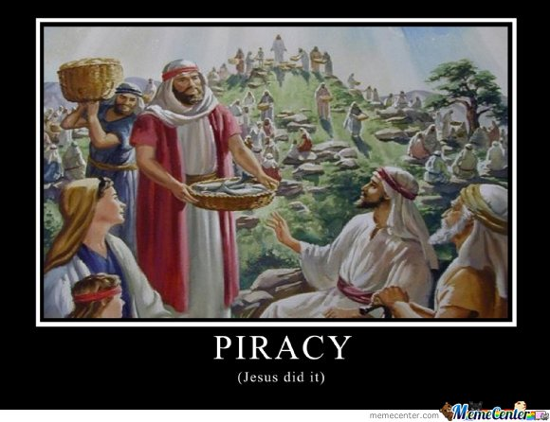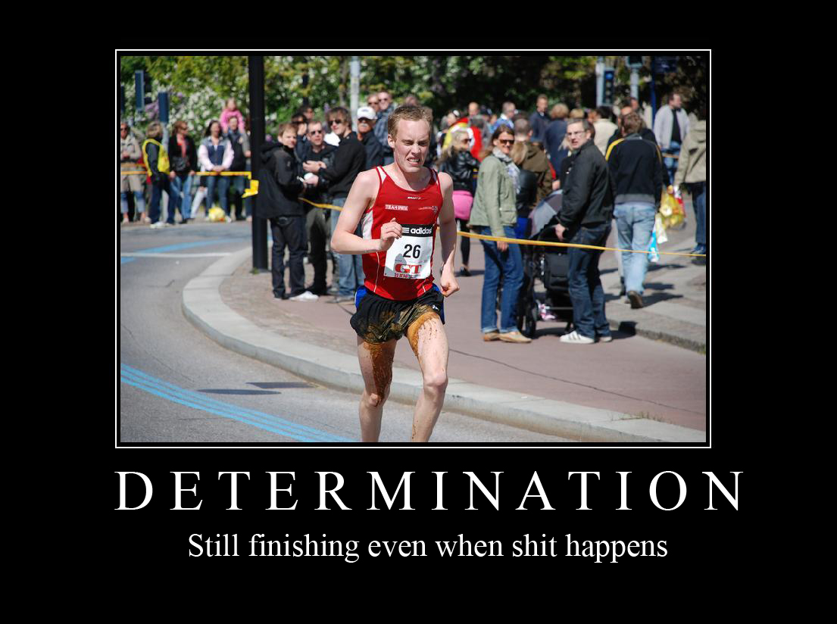
Attendees:
- James Taylor (JT)
- Neil Pickford (NCP)
- David McNeaney (DMcN)
- Andrew Bradley (AMB)
- Matt Culverwell (MC)
- Sridar Madadi (SM)
- Mike Helm (MH)
Apologies:
- Dave Swarbrook (DS)
- Alan Whitmore (AJW)

- Gareth Ekin (GE) - rarer than a Co-op profit!
- Jes Challand (JC) – Ooh la la etc,....and bugger me, his initials are the same as "Heart of Darkness (the inspiration behind Apocalypse Now)" author Joseph Conrad - educational as well as entertaining!
Agenda:

  - Okay previous minutes
  - Previous Actions
  - Treasurers Report & current portfolio update
  - Investment strategy & Homework (share updates)
  - Fantasy Shares
  - Peston
  - AOB
8. Next Meeting
1. Okay Previous Minutes What, there were minutes -no way!
2. Previous Actions  4.7.1 - Clear out time. Social. Mike failed. Now with James - think we said discuss as next meeting - nothing minuted! - June 14th - will it be Burslem or Stone? Discuss in April - Burslem on June 14th go go go - Done Leek June 14th - yum!  4.14.2 - Due diligence by all over BP - and again  4.15.1 - NCP to buy £500 each of Barclays and Royal Mail | ALL  NCP
3. Treasurers Report & current portfolio update
£1356.46 in TDW, £forgot in Barcs. Divis - £7.23 ARM, £1.24 Voda part shares, £7.47 BP
 | Meeting 6 | Meeting 7 | Meeting 8 | Meeting 9 | Meeting 10 | Meeting 11 | Meeting 12 | Meeting 13 | Meeting 14 | Meeting 15
Club £ | £3,819.97 | £4,354.61 | £5,338.64 | £5,846.90 | £6,175.21 | £7,080.02 | £7,051.52 | £7,364.31 | £14,016.30 | £14,312.76
tot std units | 132 | 143 | 165 | 176 | 187 | 209 | 220 | 231 | 253 | 264
Std units | 12 | 13 | 15 | 16 | 17 | 19 | 20 | 21 | 23 | 24
Tot input | £3,960.00 | £4,290.00 | £4,950.00 | £5,280.00 | £5,610.00 | £6,270.00 | £6,600.00 | £6,930.00 | £13,885.32 | £15,019.47
member input(*) | £360.00 | £390.00 | £450.00 | £480.00 | £510.00 | £570.00 | £600.00 | £630.00 | £690.00 | £720.00
now worth | £347.27 | £395.85 | £485.33 | £531.54 | £561.38 | £643.64 | £641.05 | £669.48 | £697.78 | £712.67
% increase | -3.54 | 1.51 | 7.85 | 10.74 | 10.08 | 12.92 | 6.84 | 6.27 | 1.13 | -1.02
total units | 132 | 143 | 165 | 176 | 187 | 209 | 220 | 220 | 462 | 482
unit worth | £28.94 | £30.45 | £32.36 | £33.22 | £33.02 | £33.88 | £32.05 | £31.88 | £30.34 | £29.69

*MC is (tot units - tot std units) + std units
4. Investment strategy & Homework (share updates)  Homework - Alent (12.3% holding), ARM (take-over rumours abound!), BP (strong buy), Tate & Lyle (all over the place in different markets), Barcs (Barclaycard provides 41% of profit total), Voda (revenue flat - looking at car telematics), Royal Mail (cost cutting and Sunday deliveries)  Meeting 2 - Voted on shares - Vodafone, Aviva, ARM, RBS, RANDGOLD, Thomas Cook, SPH  Meeting 3 - Voted on Vodafone, Tesco and Next  Meeting 4 - Voted on Arm, Thomas Cook, Thorntons, Moneysupermarket.com, Ocado  Meeting 5 - Sabmiller, Bunzl, Thomas Cook, moneysupermarket, ultra electronics, Merlin IPO in 2014  Meeting 6 - nowt, but Alan listed good divi payers - HSBC, Shell and BP  Meeting 7 - Tate & Lyle, Barclays  Meeting 8 - Post Office, ITV, Barclays - DO NOT SELL VODAFONE!!  Meeting 9 - Good divi payers - BP, Royal Dutch Shell, Thomas Cook, Centrica - also Tate & Lyle and more Vodafone  Meeting 10 - Alent, Dart Group, Rurelec, CBG, Sable Mining, Topps Tiles, Air Partner, Dotdigital, JD Wetherspoon, James Halstead, Tracsis  Meeting 11 - Game (to float), Royal Mail, TmobileUSA, Optimal Payments, Balfour Beatty, Merliln  Meeting 12 - just discussed Pets @ home IPO  Meeting 13 - Topps Tiles, Aviva, L&G, Kingfisher, more of portfolio.  Meeting 14 - Astra Z, GAME IPO, B&M IPO, UK Mail, Merlin and TT Electronics (Motley tip)  Meeting 15 - more of same, TSB, TESLA, Arrow, Cineworld, Bellway, Bunzl  4.14.1 - NCP to buy £1000 of Merlin Entertainment - done  4.14.2 - Due diligence by all over BP - and again  4.15.1 - NCP to buy £500 each of Barclays and Royal Mail | ALL  NCP
  EPIC | Qty. | Name | Champ | Mid Price | Price Change | Market Value | Book Cost | Gain/Loss | Prev Month | Variance
  ALNT | 172 | ALENT PLC | AMB | 352.50p | 6.5 | 606.3 | 598.04 | 8.26 | 533.37 | 72.93
  ARM | 201 | ARM HLDGS | DS | 886.00p | -22 | 1780.86 | 2085.22 | -304.36 | 1730.61 | 50.25
  BARC | 812 | BARCLAYS | JT | 230.00p | -3.7 | 1867.6 | 2096.44 | -228.84 | 1962.6 | -95
  BP. | 435 | BP | DMcN | 516.90p | -7 | 2248.52 | 2094.99 | 153.53 | 2215.46 | 33.06
  MERL | 281 | MERLIN ENTERTAINMENT | NCP | 345.50p | 4.5 | 970.86 | 996.57 | -25.71 | 970.86 | 0
  OPAY | 136 | OPTIMAL PAYMENTS | MH | 386.50p | -3.75 | 525.64 | 599.2 | -73.56 | 488.58 | 37.06
  RRS | 10 | RANGOLD | AJW | 4867.00p | -38 | 486.7 | 562.37 | -75.67 | 445.5 | 41.2
  RMG | 368 | ROYAL MAIL PLC | SM | 495.00p | -1.5 | 1821.6 | 2098.5 | -276.9 | 2116 | -294.4
  TATE | 304 | TATE & LYLE | NCP | 658.00p | -7.2 | 2000.32 | 2091.1 | -90.78 | 2091.52 | -91.2
  VOD | 526 | VODAFONE | MC | 189.80p | -0.85 | 998.35 | 1797.04 | -798.69 | 1076.2 | -77.85
5. Fantasy Shares
Alan W wins with just over 8% up on Hyder.
Wondering wether that holiday flight on Malaysian airways is a good idea this month are ;-

May-14 | SHARE | EPIC | START PRICE
Dave S | Merlin | MERL | 344.40
Gareth E | Sable Mining | SBLM | 6.50
Mike H | Thorntons | THT | 106.25
Neil P | Tullow Oil | TLW | 846.00
James T | UK Mail | UKM | 612.50
Matt C | Astra Zeneca | AZN | 4402.00
Andy B | Morrisons | MRW | 205.00
Jes C | Marks and Spencer | MKS | 451.40
Dave McN | Xeros | XSG | 83.00
Glynn G | Punch Taverns | PUB | 14.50
Alan W | Hyder Consultancy | HYC | 439.00
Sri M | Lancashire Holdings | LRE | 622.50

6. Peston
Peston was poorly. Poorly Peston. Piss Poor.
7. AOB
No AOB.
8. Next Meeting
Wednesday 30th July 2014 at Mill Street Club, 210 Mill Street – then curry.

