The Strangemen III.0 Investment Club (8N93KW6E)
Minutes of the fourteenth meeting - Held Wednesday 22nd May 2014 at The Mill Street Club, Mill Street, Leek.
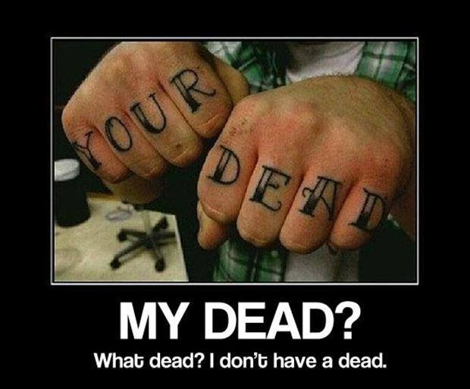
Attendees:
- James Taylor (JT)
- Neil Pickford (NCP)
- David McNeaney (DMcN)
- Andrew Bradley (AMB)
- Dave Swarbrook (DS)
- Matt Culverwell (MC)
- Sridar Madadi (SM)
- Alan Whitmore (AJW)
Apologies:
- Gareth Ekin (GE) - Being a luvvy. A mother-luvvy!
- Mike Helm (MH) - Sick. Sick! only married 5 minutes and already got a headache!
- Jes Challand (JC) – Ooh la la etc,....and bugger me, his initials are the same as "current" Mr Sulu in the rebooted Star Trek - John Cho
Agenda:

  - Okay previous minutes
  - Previous Actions
  - Treasurers Report & current portfolio update
  - Investment strategy & Homework (share updates)
  - Fantasy Shares
  - Peston
  - AOB
8. Next Meeting
1. Okay Previous Minutes What, there were minutes -no way!
2. Previous Actions  4.7.1 - Clear out time. Social. Mike failed. Now with James - think we said discuss as next meeting - nothing minuted! - June 14th - will it be Burslem or Stone? Discuss in April - Burslem on June 14th go go go  4.14.1 - NCP to buy £1000 of Merlin Entertainment  4.14.2 - Due diligence by all over BP  7.13.1 - Matt C to xfer £6,025.32 to Barcs and then James T to xfer to TDW and advise Neil P to buy shares. Matt also increasing monthly contribution to £331 (10 units and £1 comp money). Should be monthly £301 - not £331 - NCP typo! | JT  NCP  ALL
3. Treasurers Report & current portfolio update
£1356.46 in TDW, £forgot in Barcs. Divis - £7.23 ARM, £1.24 Voda part shares, £7.47 BP
 | Meeting 6 | Meeting 7 | Meeting 8 | Meeting 9 | Meeting 10 | Meeting 11 | Meeting 12 | Meeting 13 | Meeting 14
Club £ | £3,819.97 | £4,354.61 | £5,338.64 | £5,846.90 | £6,175.21 | £7,080.02 | £7,051.52 | £7,364.31 | £14,016.30
tot std units | 132 | 143 | 165 | 176 | 187 | 209 | 220 | 231 | 253
Std units | 12 | 13 | 15 | 16 | 17 | 19 | 20 | 21 | 23
Tot input | £3,960.00 | £4,290.00 | £4,950.00 | £5,280.00 | £5,610.00 | £6,270.00 | £6,600.00 | £6,930.00 | £13,885.32
member input(*) | £360.00 | £390.00 | £450.00 | £480.00 | £510.00 | £570.00 | £600.00 | £630.00 | £690.00
now worth | £347.27 | £395.85 | £485.33 | £531.54 | £561.38 | £643.64 | £641.05 | £669.48 | £697.78
% increase | -3.54 | 1.51 | 7.85 | 10.74 | 10.08 | 12.92 | 6.84 | 6.27 | 1.13
total units | 132 | 143 | 165 | 176 | 187 | 209 | 220 | 220 | 462
unit worth | £28.94 | £30.45 | £32.36 | £33.22 | £33.02 | £33.88 | £32.05 | £31.88 | £30.34

*MC is (tot units - tot std units) + std units
4. Investment strategy & Homework (share updates)  Homework - Alent (still a buy/hold recomended), ARM (take-over rumours abound!), BP (possibility of share price doubling, but legal issues still), Tate & Lyle (low sales of sugar, looking at sugar subs)  Meeting 2 - Voted on shares - Vodafone, Aviva, ARM, RBS, RANDGOLD, Thomas Cook, SPH  Meeting 3 - Voted on Vodafone, Tesco and Next  Meeting 4 - Voted on Arm, Thomas Cook, Thorntons, Moneysupermarket.com, Ocado  Meeting 5 - Sabmiller, Bunzl, Thomas Cook, moneysupermarket, ultra electronics, Merlin IPO in 2014  Meeting 6 - nowt, but Alan listed good divi payers - HSBC, Shell and BP  Meeting 7 - Tate & Lyle, Barclays  Meeting 8 - Post Office, ITV, Barclays - DO NOT SELL VODAFONE!!  Meeting 9 - Good divi payers - BP, Royal Dutch Shell, Thomas Cook, Centrica - also Tate & Lyle and more Vodafone  Meeting 10 - Alent, Dart Group, Rurelec, CBG, Sable Mining, Topps Tiles, Air Partner, Dotdigital, JD Wetherspoon, James Halstead, Tracsis  Meeting 11 - Game (to float), Royal Mail, TmobileUSA, Optimal Payments, Balfour Beatty, Merliln  Meeting 12 - just discussed Pets @ home IPO  Meeting 13 - Topps Tiles, Aviva, L&G, Kingfisher, more of portfolio.  Meeting 14 - Astra Z, GAME IPO, B&M IPO, UK Mail, Merlin and TT Electronics (Motley tip)  4.14.1 - NCP to buy £1000 of Merlin Entertainment  4.14.2 - Due diligence by all over BP | NCP  ALL
  Symbol | Qty. | Desc. | Champ | Mid Price | Price Change | Market Value | Book Cost | Gain/ Loss | Prev Month | Variance
  ALNT | 172 | ALENT PLC | AMB | 310.10p | 0 | 533.37 | 598.04 | -64.67 | 548.16 | -14.79
  ARM | 201 | ARM HLDGS | DS | 861.00p | 16 | 1730.61 | 2085.22 | -354.61 | 2085.22 | -354.61
  BARC | 812 | BARCLAYS | JT | 241.70p | 3.15 | 1962.6 | 2096.44 | -133.84 | 2096.44 | -133.84
  BP. | 435 | BP | DMcN | 509.30p | 3 | 2215.46 | 2094.99 | 120.47 | 2094.99 | 120.47
  OPAY | 136 | OPTIMAL PAYMENTS | GE | 359.25p | 21.25 | 488.58 | 599.2 | -110.62 | 557.94 | -69.36
  RRS | 10 | RANGOLD | AJW | 4455.00p | -15 | 445.5 | 562.37 | -116.87 | 460.8 | -15.3
  RMG | 368 | ROYAL MAIL PLC | SM | 575.00p | 5.5 | 2116 | 2098.5 | 17.5 | 2098.5 | 17.5
  TATE | 304 | TATE & LYLE | NCP | 688.00p | 2 | 2091.52 | 2091.1 | 0.42 | 2091.1 | 0.42
  VOD | 526 | VODAFONE | MC | 204.60p | -0.7 | 1076.2 | 1797.04 | -720.84 | 1173.77 | -97.57
5. Fantasy Shares
Well, a winning start for Neil P with a miserly 4% rise on BUNZL, just beating Andy B's 3.65% Barclays.
Wondering where Andy Haywood is going to pop up "magnificently" next are ;-

May-14 | SHARE | EPIC | START PRICE
Dave S | Merlin | MERL | 344.40
Gareth E | Sable Mining | SBLM | 6.50
Mike H | Thorntons | THT | 106.25
Neil P | Tullow Oil | TLW | 846.00
James T | UK Mail | UKM | 612.50
Matt C | Astra Zeneca | AZN | 4402.00
Andy B | Morrisons | MRW | 205.00
Jes C | Marks and Spencer | MKS | 451.40
Dave McN | Xeros | XSG | 83.00
Glynn G | Punch Taverns | PUB | 14.50
Alan W | Hyder Consultancy | HYC | 439.00
Sri M | Lancashire Holdings | LRE | 622.50

6. Peston
Peston talked about red wine as as investment up 4%. French trains too big for the stations! David James - ex England goalkeeper declared bankrupt! Six garages fetch £700k each as dwelling at auction! Spanish house prices collapse! Star Wars shooting in Abu Dhabi! and finally Esther... Royal Mail trialling Sunday parcel deliveries.
7. AOB
AGM was a quick proposal and seconding that all roles remain as is.
8. Next Meeting
Wednesday 18th June 2014 at Mill Street Club, 210 Mill Street – then curry.

