The Strangemen III.0 Investment Club (8N93KW6E)
Minutes of the tenth meeting - Held Wednesday 27th November 2013 at The Mill Street Club, Mill Street, Leek.
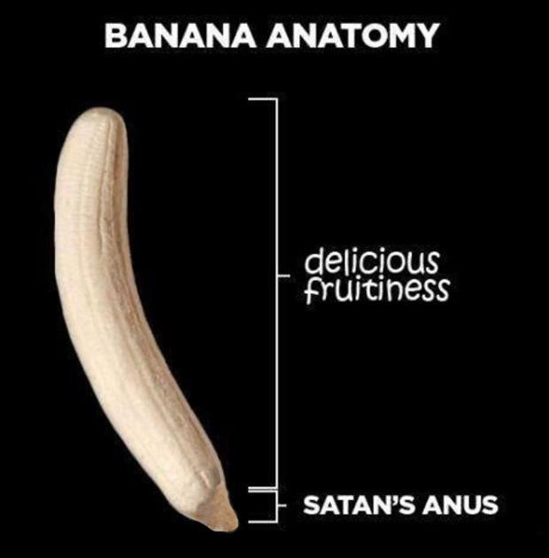
Attendees:
- James Taylor (JT)
- Neil Pickford (NCP)
- David McNeaney (DMcN)
- Andrew Bradley (AMB)
- Matt Culverwell (MC)
- Alan Whitmore (AJW)
- Dave Swarbrook (DS)
- Gareth Ekin (GE)
- Sridar Madadi (SM)
Apologies:
- Mike Helm (MH) - piss poor show.
- Jes Challand (JC) – Ooh la la etc,....and bugger me, his initials are the same as former World light-heavyweight boxing champ and former Sweep lookalike - John Conteh!
Agenda:
  - Okay previous minutes
  - Actions
  - Treasurers Report & current portfolio update
  - Investment strategy & Homework (share updates)
  - Fantasy Shares
  - Peston
  - AOB
8. Next Meeting
1. Okay Previous Minutes
What, there were minutes -no way!
2. Actions  4.7.1 - Mike to arrange a social - possibly in Stone - and invite Glynn and get a hint if Jes is around - maybe even arrange something around his availability (if any)? - James to contact Glynn, Neil P to contact Jes - Glynn yes, Jes "Angleterre? Non." - JT to create as an objective for MH 11th Jan - JT to confirm with Glynn and ask about eateries in Stone  4.5.1 - Meeting 5 - Sabmiller, Bunzl, Thomas Cook, moneysupermarket, ultra electronics - also Merlin IPO in 2014 - Andy B to look into pre-registration - No sign of pre-reg for Merlin IPO - but AMB will keep eyes open! Eyes still open - passed to NCP as AMB on hols. Not purchased as TDInvesting not on approved broker list.  4.9.1 - NCP to buy £600 each of Tate & Lyle and BP - Done  4.10.1 - NCP to buy £600 each of Topps Tiles and Alent | JT/MH  NCP
3. Treasurers Report & current portfolio update
£1172.08 in TDW, £115.87 in Barcs. Aviva Divi of £9.24 on 15th Nov
 | Meeting 5 |  | Meeting 6 |  | Meeting 7 |  | Meeting 8 |  | Meeting 9 |  | Meeting 10
club value | £3,748.26 |  | £3,819.97 |  | £4,354.61 |  | £5,338.64 |  | £5,846.90 |  | £6,175.21
units | 121 |  | 132 |  | 143 |  | 165 |  | 176 |  | 187
units per mem | 11 |  | 12 |  | 13 |  | 15 |  | 16 |  | 17
total input | £3,630.00 |  | £3,960.00 |  | £4,290.00 |  | £4,950.00 |  | £5,280.00 |  | £5,610.00
member input | £330.00 |  | £360.00 |  | £390.00 |  | £450.00 |  | £480.00 |  | £510.00
now worth | £340.75 |  | £347.27 |  | £395.85 |  | £485.33 |  | £531.54 |  | £561.38
% increase | 3.26 |  | -3.54 |  | 1.51 |  | 7.85 |  | 10.74 |  | 10.08
total units | 121 |  | 132 |  | 143 |  | 165 |  | 176 |  | 187
unit worth | £30.98 |  | £28.94 |  | £30.45 |  | £32.36 |  | £33.22 |  | £33.02

4. Investment strategy & Homework (share updates)  Vodafone - nowt  Aviva - sold  Randgold - analyst say hold  ARM - analyst say hold  BP - possible 16% return for divi?!  Tate & Lyle - no champ - handed to Neil P  Barclays - analyst say on course for £3 per share  Meeting 2 - Voted on shares - Vodafone, Aviva, ARM, RBS, RANDGOLD, Thomas Cook, SPH  Meeting 3 - Voted on Vodafone, Tesco and Next  Meeting 4 - Voted on Arm, Thomas Cook, Thorntons, Moneysupermarket.com, Ocado  Meeting 5 - Sabmiller, Bunzl, Thomas Cook, moneysupermarket, ultra electronics, Merlin IPO in 2014  Meeting 6 - nowt, but Alan listed good divi payers - HSBC, Shell and BP  Meeting 7 - Tate & Lyle, Barclays  Meeting 8 - Post Office, ITV, Barclays - DO NOT SELL VODAFONE!!  Meeting 9 - Good divi payers - BP, Royal Dutch Shell, Thomas Cook, Centrica - also Tate & Lyle and more Vodafone  Meeting 10 - Alent, Dart Group, Rurelec, CBG, Sable Mining, Topps Tiles, Air Partner, Dotdigital, JD Wetherspoon, James Halstead, Tracsis  4.10.1 - NCP to buy £600 each of Topps Tiles and Alent | NCP
  Share | EPIC | Qty Held | Champ | Mid Price | Price Change | Market Value | Book Cost | Months Gain/Loss | Previous Month | Variance
  ARM HLDGS | ARM | 59 | DAVE | £10.04 | £0.01 | £592.36 | £593.27 | -£0.91 | £607.70 | -£15.34
  TATE & LYLE | AV. | 165 | NEIL | £7.87 | -£0.35 | £598.12 | £597.55 | £0.57 | £598.12 | £0.00
  RANGOLD | RRS | 10 | ALAN | £42.35 | £0.34 | £423.50 | £562.37 | -£138.87 | £447.80 | -£25.90
  VODAFONE | VOD | 966 | MIKE | £2.29 | £0.01 | £2,211.66 | £1,797.04 | £41.46 | £2,173.50 | £38.16
  BARCLAYS | BARC | 208 | JAMES | £2.63 | £0.17 | £546.00 | £597.78 | -£51.78 | £589.99 | -£43.99
  BP. | BP | 131 | ALAN | £4.83 | -£0.05 | £631.49 | £597.78 | £33.71 | £631.49 | £0.00
5. Fantasy Shares
Matt C breaks his duck with a 27.78 rise with SkyPharma. Overall lead still with invisible man Helm.
Not travelling to the Winter Olympics, as they are gay, this month are ;-
November | Share | EPIC | Start Price
Dave S | ARM | ARM | 1003.00
Gareth E | Sable Mining | SBLM | 10.50
Mike H | Thorntons | THT | 136.25
Neil P | DotDigital | DOTD | 22.25
James T | Booker | BOK | 162.00
Matt C | TBC
Andy B | Kenmare Resources | KMR | 19.26
Jes C | Marks and Spencer | MKS | 489.20
Dave McN | Vodafone | Vodafone | 228.55
Glynn G | Punch Taverns | PUB | 11.00
Alan W | Hyder Consulting | HYC | 624.00
Sri M | Co-op | CPBB | 65.20
Narayan | Lloyds | LLOY | 77.49
John H | Microsoft | MSFT($) | 37.57
Matt W | De La Rue | DLAR | 851.50

6. Peston
Peston talked about the Bitcoins being worth a $1000. A chap getting a refund from itunes as a James Arthur track had homophobic lyrics. $83 million diamond found (record value). Nationwide shareholders vote to stay mutual. £4million worth of bitcoins chucked on a tip in Wales in error!
7. AOB
Paul Flowers looks like Jack Dempsey (or the other way around!)
Sri treated us to a wonderful homemade curry - the club and the guests (Matt Windsor and John Haigh). We treated him to a charity donation for a cause local to him.
7.10.1 - Mill St Club Membership due in Jan - shall we pay for out of funds as per previous years? discuss next meeting
8. Next Meeting
Wednesday 15th January 2014 at Mill Street Club, 210 Mill Street – then curry.

