The Strangemen III.0 Investment Club (8N93KW6E)
Minutes of the ninth meeting - Held Wednesday 16th October 2013 at The Mill Street Club, Mill Street, Leek.
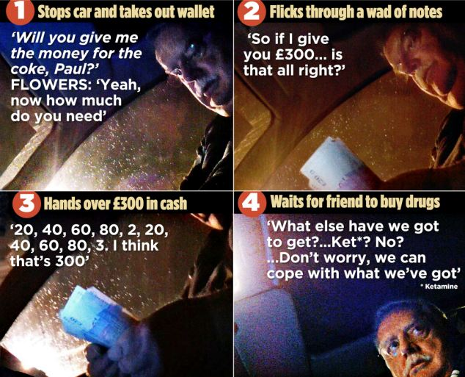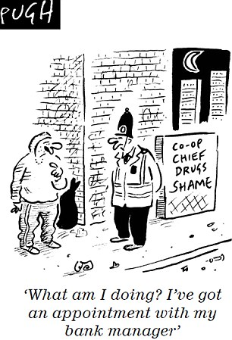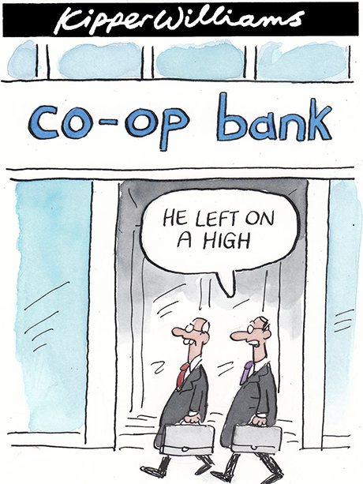
And they told us that there was no bonus this year!
Attendees:
- James Taylor (JT)
- Neil Pickford (NCP)
- David McNeaney (DMcN)
- Andrew Bradley (AMB)
- Matt Culverwell (MC)
- Alan Whitmore (AJW)
- Dave Swarbrook (DS)
Apologies:
- Mike Helm (MH) - burning the boss candle!
- Sridar Madadi (SM) - Londinium
- Gareth Ekin - the number you have dialled has not been recognised, please hang up and try again.
- Jes Challand (JC) – Ooh la la etc,....and bugger me, his initials are the same as Snoopys alter ego - Joe Cool 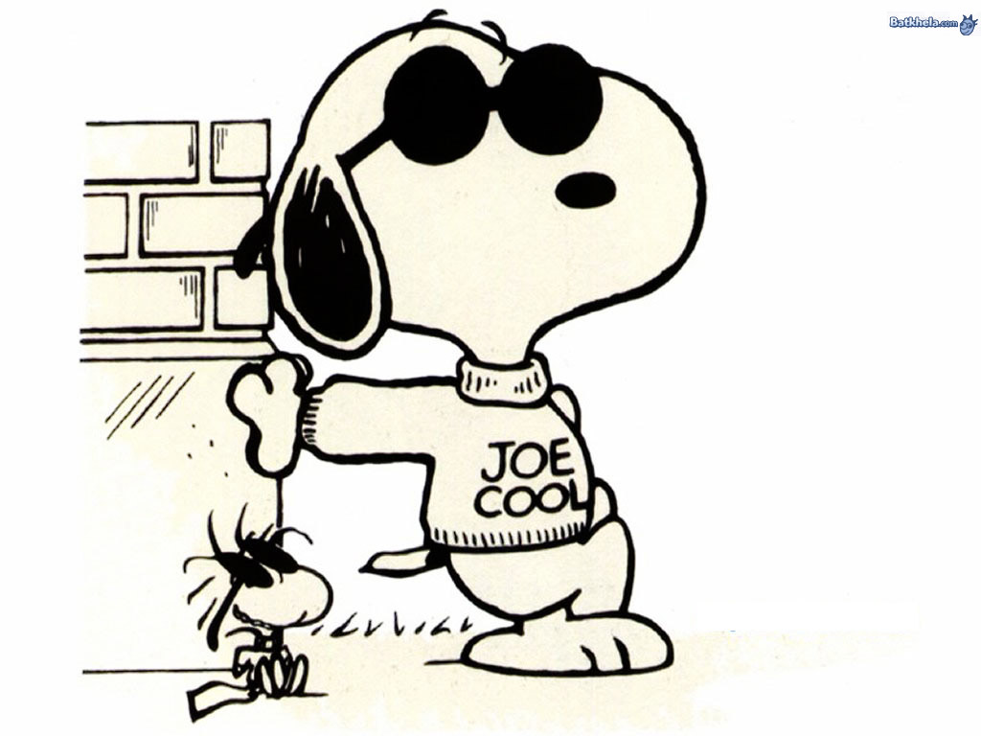
Agenda:
  - Okay previous minutes
  - Actions
  - Treasurers Report & current portfolio update
  - Investment strategy & Homework (share updates)
  - Fantasy Shares
  - Peston
  - AOB
8. Next Meeting
1. Okay Previous Minutes
Yay!
2. Actions  4.7.1 - Mike to arrange a social - possibly in Stone - and invite Glynn and get a hint if Jes is around - maybe even arrange something around his availability (if any)? - James to contact Glynn, Neil P to contact Jes - Glynn yes, Jes "Angleterre? Non." - JT to create as an objective for MH 11th Jan - JT to confirm with Glynn and ask about eateries in Stone  4.5.1 - Meeting 5 - Sabmiller, Bunzl, Thomas Cook, moneysupermarket, ultra electronics - also Merlin IPO in 2014 - Andy B to look into pre-registration - No sign of pre-reg for Merlin IPO - but AMB will keep eyes open! Eyes still open - passed to NCP as AMB on hols.  4.9.1 - NCP to buy £600 each of Tate & Lyle and BP | JT  AMB  NCP
3. Treasurers Report & current portfolio update
£1318 in TDW, £104.87 in Barcs.
 | Meeting 5 |  | Meeting 6 |  | Meeting 7 |  | Meeting 8 |  | Meeting 9
Value of Club | £3,748.26 |  | £3,819.97 |  | £4,354.61 |  | £5,338.64 |  | £5,846.90
Units | 121 |  | 132 |  | 143 |  | 165 |  | 176
Units per mem | 11 |  | 12 |  | 13 |  | 15 |  | 16
Total input | £3,630.00 |  | £3,960.00 |  | £4,290.00 |  | £4,950.00 |  | £5,280.00
member input | £330.00 |  | £360.00 |  | £390.00 |  | £450.00 |  | £480.00
now worth | £340.75 |  | £347.27 |  | £395.85 |  | £485.33 |  | £531.54
Percentage increase | 3.26 |  | -3.54 |  | 1.51 |  | 7.85 |  | 10.74
Total units | 121 |  | 132 |  | 143 |  | 165 |  | 176
One unit is worth | £30.98 |  | £28.94 |  | £30.45 |  | £32.36 |  | £33.22

4. Investment strategy & Homework (share updates)  Homework:-  Vodafone - nowt  Aviva - $800 million from asset sales  Randgold - No update  ARM - no new info - No update  Barclays - handed to Dave McN  Meeting 2 - Voted on shares - Vodafone, Aviva, ARM, RBS, RANDGOLD, Thomas Cook, SPH  Meeting 3 - Voted on Vodafone, Tesco and Next  Meeting 4 - Voted on Arm, Thomas Cook, Thorntons, Moneysupermarket.com, Ocado  Meeting 5 - Sabmiller, Bunzl, Thomas Cook, moneysupermarket, ultra electronics, Merlin IPO in 2014  Meeting 6 - nowt, but Alan listed good divi payers - HSBC, Shell and BP  Meeting 7 - Tate & Lyle, Barclays  Meeting 8 - Post Office, ITV, Barclays - DO NOT SELL VODAFONE!!  Meeting 9 - Good divi payers - BP, Royal Dutch Shell, Thomas Cook, Centrica - also Tate & Lyle and more Vodafone  4.9.1 - NCP to buy £600 each of Tate & Lyle and BP | NCP
  Description | Symbol | Qty Held | Champion | Mid Price | Price Change | Market Value | Book Cost | Months Gain/Loss | Previous Month | Variance
  ARM HLDGS | ARM | 59 | DAVE | 984.00p | £30.50 | £580.56 | £593.27 | -£12.71 | £524.22 | £56.34
  AVIVA | AV. | 165 | JAMES | 414.60p | -£0.50 | £684.09 | £599.52 | £84.57 | £606.04 | £78.05
  RANGOLD | RRS | 10 | ALAN | 4478.00p | -£67.00 | £447.80 | £562.37 | -£114.57 | £473.70 | -£25.90
  VODAFONE | VOD | 966 | MIKE | 211.35p | £0.10 | £2,041.64 | £1,797.04 | £244.60 | £1,870.18 | £171.46
5. Fantasy Shares
Big Boss Helm wins with Thorntons, up 9.11%, sliding into a 1 point lead over Dave S.
Wishing they had cracked the "Meth"odist minister joke this month are ;-
OCTOBER | SHARE | EPIC | START PRICE
Dave S | ARM | ARM | 1018.00
Gareth E | Man Group | EMG | 86.65
Mike H | Thorntons | THT | 108.00
Neil P | Tate & Lyle | TATE | 771.00
James T | Booker | BOK | 142.70
Matt C | Skypharma | SKP | 90.00
Andy B | Kenmare Resources | KMR | 23.74
Jes C | Marks and Spencer | MKS | 491.00
Dave McN | Vodafone | Vodafone | 229.50
Glynn G | Punch Taverns | PUB | 14.75
Alan W | BP | BP | 445.30
Sri M | Barclays | BARC | 279.05
Narayan | Lloyds | LLOY | 77.22

6. Peston
Peston talked about the new Argos tablet and also Argos and Ebay hookup for parcel pick-up.
7. AOB
NCP talked about Lee Beaumony who had managed tp live without gas, electric and trying to remove his relaince on water supply too - dickhead!
8. Next Meeting
Wednesday 27th November 2013 at Mill Street Club, 210 Mill Street – then curry.

