The Strangemen III.0 Investment Club (8N93KW6E)
Minutes of the sixth meeting - Held Wednesday 16th September 2013 at The Mill Street Club, Mill Street, Leek.
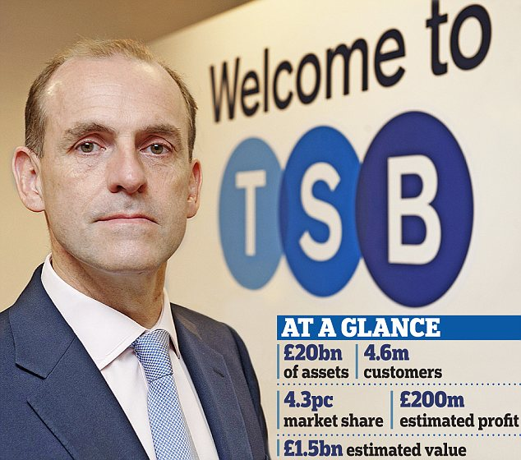
The dream is still alive for some - others could have been this happy. Neville Richardson could have been this happy!
Attendees:
- James Taylor (JT)
- Neil Pickford (NCP)
- David McNeaney (DMcN)
- Andrew Bradley (AMB)
- Matt Culverwell (MC) - back and wanting to be that dirty landlord!
- Mike Helm (MH)
Apologies:
- Alan Whitmore (AJW) - Work - while he still can - again -scrat arse!
- Sridar Madadi (SM) - flu'd up family. surely better out of the way?!
- Gareth Ekin - post meeting, explained that mobile phones do not work in Scotland or during the hours of 12am to 11.59pm.
- Dave Swarbrook (DS) - Got the blues - a meeting about the same!
- Jes Challand (JC) – Ooh la la etc,....and bugger me, his initials are the same as chunky TV funny-man - James Corden
Agenda:
  - Okay previous minutes
  - Actions
  - Treasurers Report & current portfolio update
  - Investment strategy & Homework (share updates)
  - Fantasy Shares
  - Peston
  - AOB
8. Next Meeting
1. Okay Previous Minutes
Yay!
2. Actions  4.7.1 - Mike to arrange a social - possibly in Stone - and invite Glynn and get a hint if Jes is around - maybe even arrange something around his availability (if any)? - James to contact Glynn, Neil P to contact Jes - Glynn yes, Jes "Angleterre? Non." - JT to create as an objective for MH 11th Jan - JT to confirm with Glynn and ask about eateries in Stone  4.5.1 - Meeting 5 - Sabmiller, Bunzl, Thomas Cook, moneysupermarket, ultra electronics - also Merlin IPO in 2014 - Andy B to look into pre-registration - No sign of pre-reg for Merlin IPO - but AMB will keep eyes open! Eyes still open!  4.8.1 - Neil P to puchase £600 in Barclays | JT  AMB  NCP
3. Treasurers Report & current portfolio update
£1584.55 in TDW, £93.87 in Barcs.
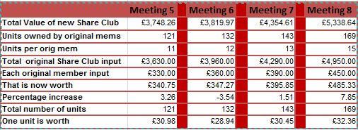
4. Investment strategy & Homework (share updates)  Homework:-  Vodafone - 45% sale of Verizon stuff - choices coming as to how we get our windfall  Aviva - clearing house by selling eastern european assets  Randgold - No update  ARM - no new info - No update  Meeting 2 - Voted on shares - Vodafone, Aviva, ARM, RBS, RANDGOLD, Thomas Cook, SPH  Meeting 3 - Voted on Vodafone, Tesco and Next  Meeting 4 - Voted on Arm, Thomas Cook, Thorntons, Moneysupermarket.com, Ocado  Meeting 5 - Sabmiller, Bunzl, Thomas Cook, moneysupermarket, ultra electronics, Merlin IPO in 2014  Meeting 6 - nowt, but Alan listed good divi payers - HSBC, Shell and BP  Meeting 7 - Tate & Lyle, Barclays  Meeting 8 - Post Office, ITV, Barclays - DO NOT SELL VODAFONE!!  4.8.1 - Neil P to puchase £600 in Barclays | NCP
  Description | Symbol | Qty Held | Champion | Mid Price | Price Change | Market Value | Book Cost | Months Gain/Loss | Previous Month | Variance
  ARM HLDGS | ARM | 59 | DAVE | 984.00p | £30.50 | £580.56 | £593.27 | -£12.71 | £524.22 | £56.34
  AVIVA | AV. | 165 | JAMES | 414.60p | -£0.50 | £684.09 | £599.52 | £84.57 | £606.04 | £78.05
  RANGOLD | RRS | 10 | ALAN | 4478.00p | -£67.00 | £447.80 | £562.37 | -£114.57 | £473.70 | -£25.90
  VODAFONE | VOD | 966 | MIKE | 211.35p | £0.10 | £2,041.64 | £1,797.04 | £244.60 | £1,870.18 | £171.46
5. Fantasy Shares
Dave S flexed his "ARM" muscles and won with a 10.87% rise and sneaks into an overall 2 point lead.

Scratching their heads in bewilderment at the US shutdown this month are ;-
Sept | SHARE | EPIC | START PRICE
Dave S | ARM | ARM | 996.50
Gareth E | Man Group | EMG | 91.15
Mike H | Thorntons | THT | 96.00
Neil P | Tullow Oil | TLW | 1054.00
James T | Thomas Cook | TCG | 157.30
Matt C | Cyprotex | CRX | 6.00
Andy B | Intercontinental Hotels | IHG | 1860.00
Jes C | Marks and Spencer | MKS | 508.50
Dave McN | Vodafone | Vodafone | 212.00
Glynn G | Punch Taverns | PUB | 13.75
Alan W | ElectroComponents | ECM | 279.80
Sri M | Barclays | BARC | 282.20
Narayan | Lloyds | LLOY | 77.12

6. Peston
Peston was otherwise engaged.
7. AOB
Nothing
8. Next Meeting
Wednesday 16th October 2013 at Mill Street Club, 210 Mill Street – then curry.

