The Strangemen III.0 Investment Club (8N93KW6E)
Minutes of the fifth
Held Wednesday 22 May 2013 at The Mill Street Club, Mill Street, Leek.
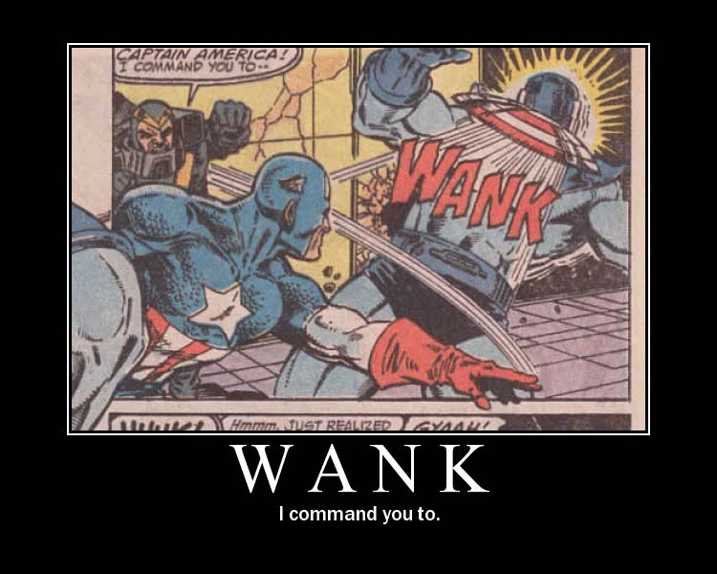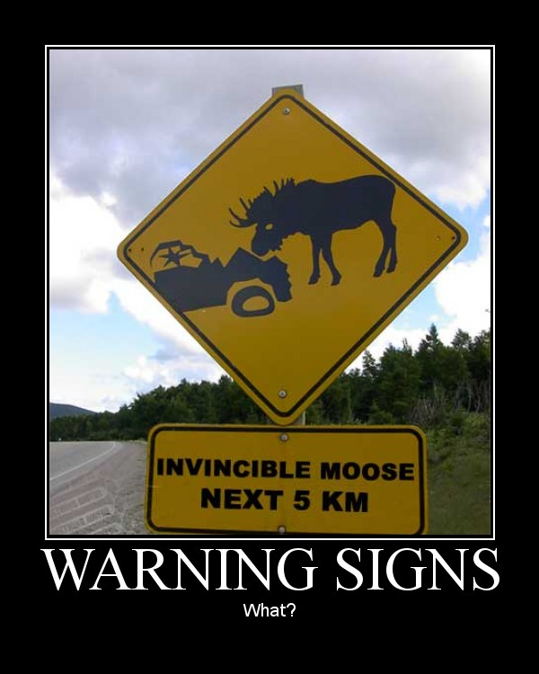

This month, pics of that start with a victorious "w".
Attendees:
- Andrew Bradley (AMB)
- James Taylor (JT)
- Neil Pickford (NCP)
- Sridar Madadi (SM) - fashionably late and with father Narayan in tow again!
- Mike Helm (MH)
- David Swarbrook (DS)

Apologies:
- Alan Whitmore (AJW) - shift working - but not for long!

- Matt Culverwell (MC) - still roaming the streets homeless.
- Jes Challand (JC) – Real proper francophile now! ....and bugger me, his initials are the same as bespectacled a970's PM - James Callaghan.
- Gareth Ekin (GJE) – Whatever.
- David McNeaney (DMcN) - playing with ladyboys.
Agenda:
  - Okay previous minutes
  - Actions
  - Treasurers Report & current portfolio update
  - Investment strategy & Homework (share updates)
  - Fantasy Shares
  - Peston
  - AOB
8. Next Meeting
1. Okay Previous Minutes
Yay!
2. Actions  1.3.1 - Matt C to be registered with TDW - NCP to sort - got the form, will do when Matt has a real house c/f  1.7.2 - TDW needs updating - memberships - done barring Matt C  1.7.3 - Andy B to see Matt C re: website action - something to do with DNS? - Now on Neil P for WordPress stuff. - All folks setup on the site now  3.3.1 - Gareth owes £15 due to incorrect monthly payments - now £20!! - all paid  4.4.1 - NCP to purchase £600 of ARM - done  3.7.2 - Mike volunteered to investigate Gold, Silver and Coltan purchasing - carried forward - presented here tonight!  4.7.1 - Mike to arrange a social - possibly in Stone - and invite Glynn and get a hint if Jes is around - maybe even arrange something around his availability (if any)? - James to contact Glynn, Neil P to contact Jes  3.5.1. - £49.87 in Barclays - spotted here that Gareth's monies were wrong and he owes £31 - James.......  4.5.1 - Meeting 5 - Sabmiller, Bunzl, Thomas Cook, moneysupermarket, ultra electronics - also Merlin IPO in 2014 - Andy B to look into pre-registration | NCP  NCP  MHe/NCP/JT  JT  AMB
3. Treasurers Report & current portfolio update  £815.59 in TDW  3.5.1. - £49.87 in Barclays - spotted here that Gareth's monies were wrong and he owes £31 - James....... | JT
  Meeting 4 |  |  | Meeting 5
  Total Value of new Share Club | £3,305.41 |  | Total Value of new Share Club | £3,748.26
  Units owned by original mems | 110 |  | Units owned by original mems | 121
  Units per orig mem | 10 |  | Units per orig mem | 11
  Total original Share Club input | £3,300.00 |  | Total original Share Club input | £3,630.00
  Each original member has put in | £300.00 |  | Each original member input | £330.00
  That is now worth | £0.00 |  | That is now worth | £340.75
  Percentage increase | 0.16 |  | Percentage increase | 3.26
  Total number of units | 110 |  | Total number of units | 121
  One unit is worth | £30.05 |  | One unit is worth | £30.98
4. Investment strategy & Homework (share updates)  Homework:-  Vodafone - POssible huge divi from Verizon sale  Aviva - £400 million cost saving underway  Randgold - n/a  ARM - n/a  Meeting 2 - Voted on shares - Vodafone, Aviva, ARM, RBS, RANDGOLD, Thomas Cook, SPH  Meeting 3 - Voted on Vodafone, Tesco and Next  Meeting 4 - Voted on Arm, Thomas Cook, Thorntons, Moneysupermarket.com, Ocado  4.5.1 - Meeting 5 - Sabmiller, Bunzl, Thomas Cook, moneysupermarket, ultra electronics - also Merlin IPO in 2014 - Andy B to look into pre-registration | AMB
  Share | Champ | Value Now | Change in Value from bought | Value Last Month | Previous Change
  Vodafone | Mike | 1253.62 | +54.92 | 1230.68 | n/a
  Aviva | James | 556.05 | -43.47 | 506.22 | -13.53
  ARM | Dave S | 619.50 | n/a | n/a | n/a
  Randgold | Alan | 503.50 | -58.87 | 504.50 | -45.00
5. Fantasy Shares
April is here and Sri strikes out, as Dave McN gets the win with 88.96% rise with Ocado - jammy basket!

Checking their dead-pools for a Mandela/ Prince Phillip double or quits this month are;-
May | SHARE | EPIC | START PRICE
Dave S | ARM | ARM | 980.00
Gareth E | Man Group | EMG | 127.50
Mike H | Thorntons | THT | 95.50
Neil P | Premier Oil | MONY | 372.80
James T | Thomas Cook | TCG | 151.90
Matt C | Qualcomm | QCOM ($) | 65.63
Andy B | Sabmiller | SAB | 3529.00
Jes C | Marks and Spencer | MKS | 470.00
Dave McN | Ocado | OCDO | 286.90
Glynn G | Punch Taverns | PUB | 11.50
Alan W | RBS | RBS | 343.00
Sri M | DeLaRue | DLAR | 987.50
Narayan | Lloyds | LLOY | 62.08

6. Peston
No Peston - so, no Peston.
7. AOB
Nowt
8. Next Meeting
Wednesday 19th June 2013 at Mill Street Club, 210 Mill Street – then curry.

