The Strangemen III.0 Investment Club
Minutes of the third
Held Wednesday 20th March 2013 at The Mill Street Club, Mill Street, Leek.


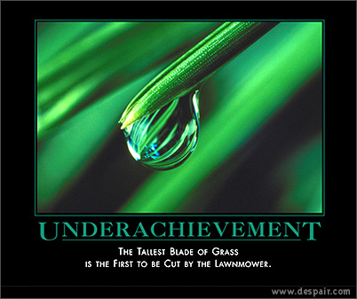

This month, pics of that start with a undulating "u".
Attendees:
- Andrew Bradley (AMB)
- James Taylor (JT)
- Neil Pickford (NCP)
- Sridar Madadi (SM) - fashionably late
- Alan Whitmore (AJW)
- Mike Helm (MH)

Apologies:
- David Swarbrook (DS) - away with the fairies
- Matt Culverwell (MC) - A roof A roof, my Kingdom for a Roof!
- David McNeaney (DMcN) - scratting for ovies
- Jes Challand (JC) – Real proper francophile now! ....and bugger me, his initials are the same as James Fenimore Cooper - author of Last of the Mohicans - good film!
- Gareth Ekin (GJE) – Partridge lite.
Agenda:
  - Okay previous minutes
  - Actions
  - Treasurers Report & current portfolio update
  - Investment strategy & Homework (share updates)
  - Fantasy Shares
  - Peston
  - AOB
8. Next Meeting
1. Okay Previous Minutes
Yay!
2. Actions  1.3.1 - Matt C to be registered with TDW - NCP to sort - got the form, will do when Matt has a real house c/f  1.8.2 - TDW needs updating - memberships - done barring Matt C  1.8.3 - Andy B to see Matt C re: website action - something to do with DNS? | NCP  NCP  MC/AMB
3. Treasurers Report & current portfolio update  £1932.71 in TDW  £12.87 in Barclays  3.3.1 - Gareth owes £15 due to incorrect monthly payments | GJE/JT
  Total Value of new Share Club | £3,001.96
  Units owned by original mems | 99
  Units per orig mem | 9
  Total original Share Club input | £2,970.00
  Each original member input | £270.00
  That is now worth | £272.91
  Percentage increase | 1.08
  Total number of units | 99
  One unit is worth | £30.32
4. Investment strategy & Homework (share updates)  Meeting 2 - Voted on shares - Vodafone, Aviva, ARM, RBS, RANDGOLD, Thomas Cook, SPH  Meeting 3 - Voted on Vodafone, Tesco and Next  3.4.1 - NCP to purchase £1200 of Vodafone | NCP
  Share | Champ | Value Now | Change in Value | Value Last Month | Previous Change
  Vodafone | Mike
  Aviva | James | 519.75
  Randgold | Alan | 549.50
5. Fantasy Shares
Feb winner was Sri with Thomas Cook up 16.79%

Putting off using the old Pressure Cooker this month are;-
March | SHARE | EPIC | START PRICE
Dave S | ARM | ARM | 901.50
Gareth E | Man Group | EMG | 96.75
Mike H | Oxus Gold | OXS | 2.67
Neil P | Premier Oil | PMO | 387.10
James T | RandGold | RRS | 5520.00
Matt C | Qualcomm | QCOM ($) | 65.70
Andy B | Anglo American | AAL | 1779.00
Jes C | Marks and Spencer | MKS | 391.50
Dave McN | HTC | 2498.TW | 245.50
Glynn G | Punch Taverns | PUB | 11.75
Alan W | RBS | RBS | 300.30
Sri M | Thomas Cook | TCG | 108.00

6. Peston
Peston updated us with tales of empty property council tax hikes (here here) - folks' bills will raise by 200%!
UK Savers protected from Cyprus shenanigans
Joe Swash - Easter-ender, I am a Celeb winner and asswipe has declared himself bankrupt for a second time!!
7. AOB
Nowt
8. Next Meeting  1.8.3 - Andy B to see Matt C re: website action - something to do with DNS?  3.8.2 - Mike volunteered to investigate Gold, Silver and Coltan purchasing | AMB/MC
9. Next Meeting
Wednesday 24th April 2013 at Mill Street Club, 210 Mill Street – then curry.

