The Strangemen III.0 Investment Club
Minutes of the first second
Held Wednesday 27th February 2013 at The Mill Street Club, Mill Street, Leek.
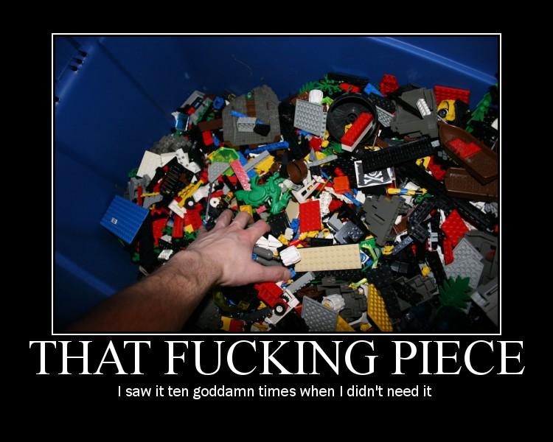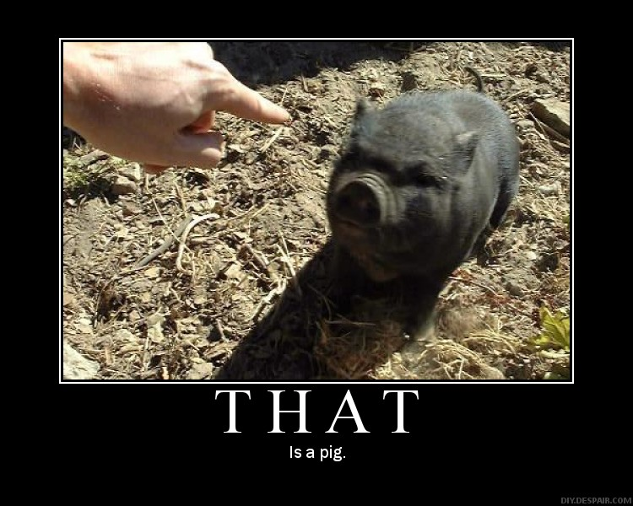
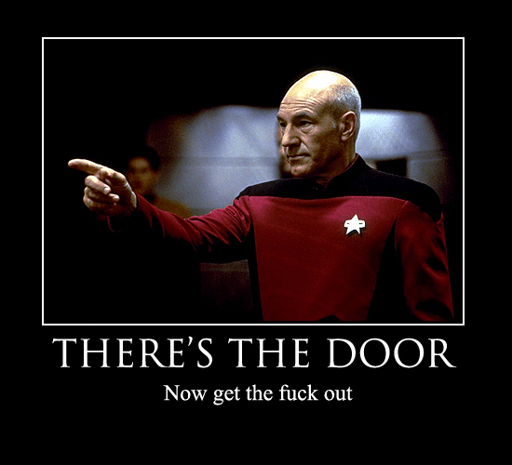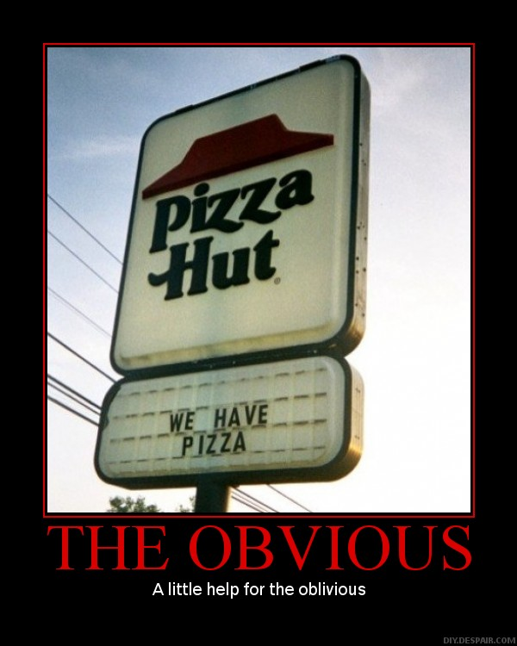

This month, pics of that start with a shiny "t".
Attendees:
- David Swarbrook (DS)
- Andrew Bradley (AMB)
- James Taylor (JT)
- Neil Pickford (NCP)
- David McNeaney (DMcN)
- Sridar Madadi (SM) - fashionably late
- Alan Whitmore (AJW)

Apologies:
- Matt Culverwell (MC) - bothering surveryors again!
- Jes Challand (JC) – Still Frenching it! ....and bugger me, his initials are the same as – vastly over-rated and bloody irritating voice artist Jon Culshaw!
- Gareth Ekin (GJE) – Slightly bearded gent I recall?
- Mike Helm (MH) – Last minute pull out - this is why he hath no kids
Agenda:
  - Okay previous minutes
  - Actions
  - Treasurers Report & current portfolio update
  - Investment strategy & Homework (share updates)
  - Fantasy Shares
  - Peston
  - AOB
8. Next Meeting
1. Okay Previous Minutes
Yay!
2. Actions  Matt C to be registered with TDW - NCP to sort - got the form, will do when Matt has a real house  £1980 to be transferred from Barclays to TDW - £2100 transferred due to monthly debit not being changed  Transfer needs to be upped to £330 from £300 - done  Dave McN owes £5 - done  Club membership - will the share club pay Dog n Rot club memberships - yes - paid  TDW needs updating - memberships - done barring Matt C  Cheque to be written for Dave S as he has overpaid by £26 - paid by cheque | NCP
3. Treasurers Report & current portfolio update
£2764.60 in TDW
£329.87 in Barclays
£105 Vodafone divi paid

4. Investment strategy & Homework (share updates)  No current portfolio  Voted on shares - Vodafone, Aviva, ARM, RBS, RANDGOLD, Thomas Cook, SPH  To purchase - £600 each of Vod, Aviva, SPH and Randgold | NCP
5. Fantasy Shares
Wooden spoon presented to James.
Jan's winner was Mike H with Herncia Resources up just over £24%

Avoiding drinking from the same cup as the Queen this month;-
Feb | SHARE | EPIC | START PRICE
Dave S | ARM | ARM | 956.50
Gareth E | Man Group | EMG | 101.00
Mike H | Oxus Gold | OXS | 2.62
Neil P | Avon Rubber | AVON | 398.00
James T | RandGold | RRS | 5600.00
Matt C | Qualcomm | QCOM | 65.82
Andy B | Croda | BYG | 2570.00
Jes C | Marks and Spencer | MKS | 371.00
Dave McN | HTC | 2498.TW | 277.00
Glynn G | Punch Taverns | PUB | 11.50
Alan W | RBS | RBS | 344.50
Sri M | Thomas Cook | Thomas Cook | 90.25

6. Peston
A short story about a chap finding a huge chunk of ambergris (whale vomit) and another lucky effer finding a large y shaped hunk of gold - worth £180k
And ITV have paid an extra divi - the sods!
7. AOB
Nowt
8. Next Meeting  Andy B to see Matt C re: website action | AMB/MC
9. Next Meeting
Wednesday 20th March 2013 at Mill Street Club, 210 Mill Street – then curry.

