poodoo1969
The Strangemen III.0 Investment Club
Minutes of the first meeting
Held Wednesday 23rd January 2013 at The Mill Street Club, Mill Street, Leek.
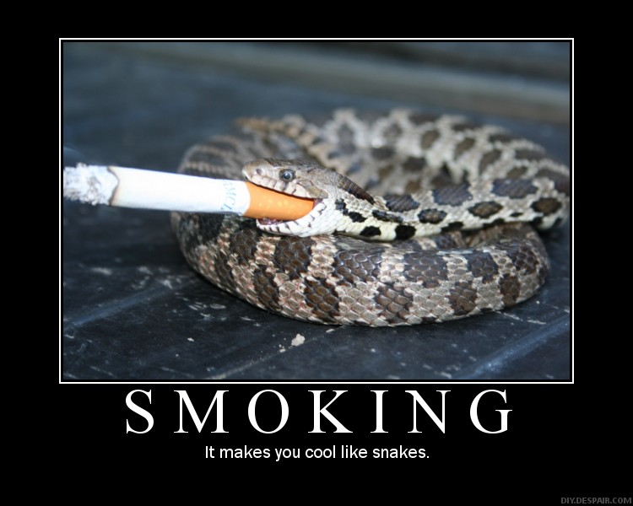
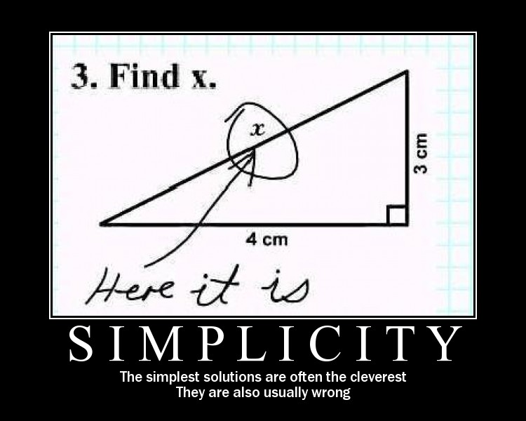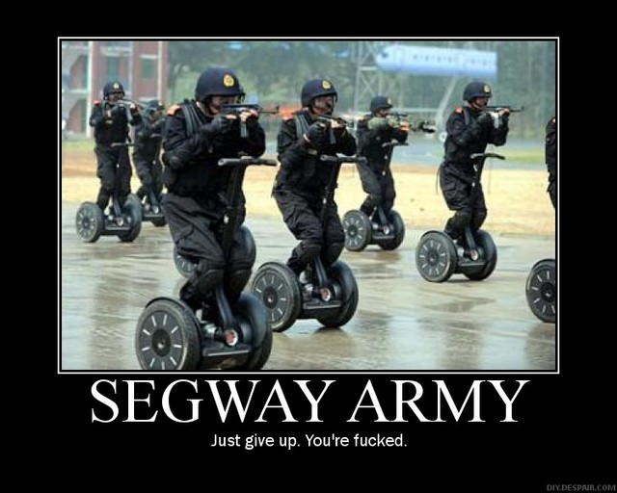
This month, pics of an "s" nature.
Attendees:
- David Swarbrook (DS)
- Andrew Bradley (AMB)
- James Taylor (JT)
- Neil Pickford (NCP)
- David McNeaney (DMcN)
- Mike Helm (MH)

Apologies:
- Matt Culverwell (MC) - back in the club, but not in his own property!
- Jes Challand (JC) – Still Frenching it! ....and bugger me, his initials are the same as – just about retired Liverpool FC defender Jamie Carragher!
- Gareth Ekin (GJE) – 100% Horse
- Sridhar Madadi (SM) – He did say, but it slips my mind
- Alan Whitmore (AJW) - Shift Monkeying
Agenda:
- What Are We Called?

- Roll Call and Roles

- New Members – TDW etc update

- Treasurers Report & current portfolio update

- Investment strategy & Homework (share updates)

- Fantasy Shares

- Peston

- AOB

- Next Meeting Date & Time

1. What Are We Called
After a very brief discussion, it was decided we will be known as Strangemen iii point o (3.0)
2. Roll Call and roles
Full membership is;- Matt Culverwell, Mike Helm, Andy Bradley, Dave McNeaney, James Taylor, Dave Swarbrook, Neil Pickford, Jes Challand, Gareth Ekin, Alan Whitmore and Sri Madadi.

Simplified roles;- Treasurer - James/ Secretary - Neil/ Chair - Andy/ Deputy Chair - Dave S/ Dilbert - Dave McN

3. New Members - TDW etc  Matt C to be registered with TDW - NCP to sort | NCP
4. Treasurers Report & current portfolio update  No current portfolio  £356.59 in TDW  £1980 to be transferred from Barclays to TDW  Transfer needs to be upped to £330 from £300  Dave McN owes £5. | JT
5. Investment Strategy & Homework (share updates)
A discussion took place around where the FTSE is and has been over the last 10 years.
SABMILLER and EASYJET were discussed as FTSE trackers.
6. Fantasy Shares
Winners of 2012 announced - Mike Helm, 2nd - Matt Hawkins and 3rd Dave McN. James was the Wooden Spoon winner.
This month's papal candidates are;-
Jan | SHARE | EPIC | START PRICE
Dave S | ARM | ARM | 840.00
Gareth E | Man Group | EMG | 93.00
Mike H | Herencia Resources | HER | 0.79
Neil P | SAGE | SGE | 312.30
James T | Angel Mining | ANGM | 0.54
Matt C | Vodafone | VOD | 164.95
Andy B | Big Yellow Group | BYG | 368.20
Jes C | Marks and Spencer | MKS | 379.60
Dave McN | Rio Tnito | RIO | 3539.50
Glynn G | Punch Taverns | PUB | 11.00
Alan W | ITV | ITV | 113.00
Sri M | Segro | SGRO | 247.20

7. Peston
Not here today
8. AOB  Club membership - will the share club pay Dog n Rot club memberships - yes  TDW needs updating - memberships  Cheque to be written for Dave S as he has overpaid by £26 | NCP  NCP  JT
9. Next Meeting
Wednesday 27th February 2013 at Mill Street Club, 210 Mill Street – then curry.

